NexaRetail Business Findings Report

Business Observation 1 – Monthly Revenue Trend
Chart:
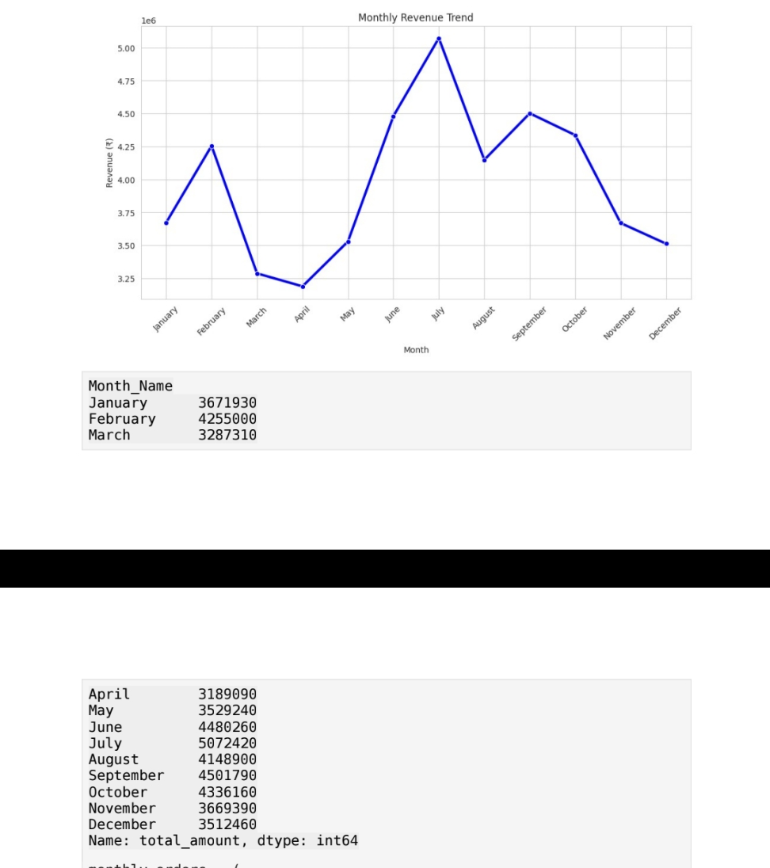

- Revenue increased after May and peaked in July (₹5,072,420), while April recorded the lowest revenue (₹3,189,090). This indicates strong mid-year seasonality and the need for proactive inventory planning.
Recommendation: Increase inventory and marketing before June–July and use promotions during lower-demand months.

Business Observation 2 – Offline Kirana Dominance
Chart:
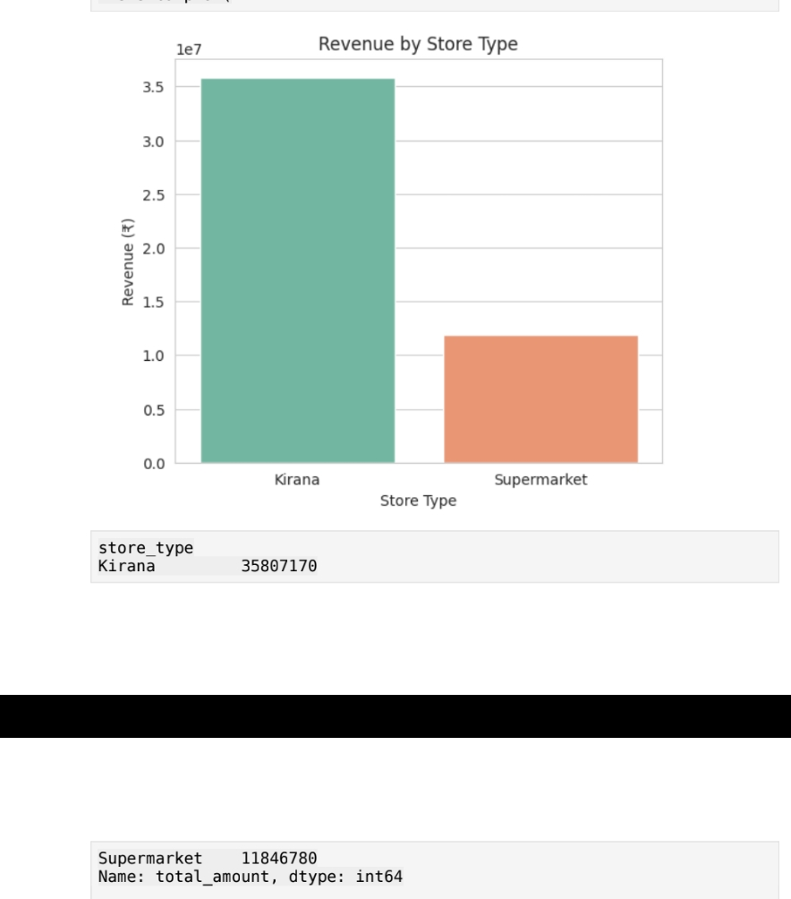

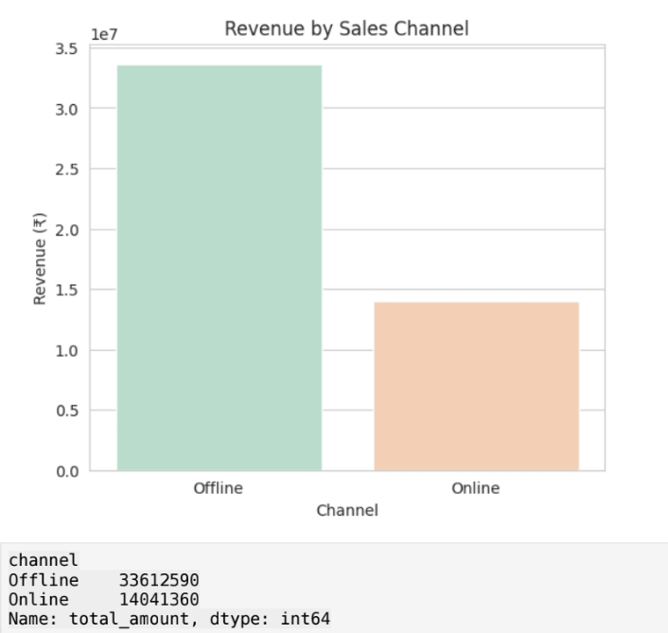

- Kirana stores generated about ₹35.81 million compared with ₹11.85 million from supermarkets. Offline sales (₹33.61 million) substantially exceeded online sales (₹14.04 million), showing dependence on traditional retail channels.
Recommendation: Strengthen digital marketing and online fulfillment while maintaining Kirana partnerships.

Business Observation 3 – Product Return Analysis
Chart:
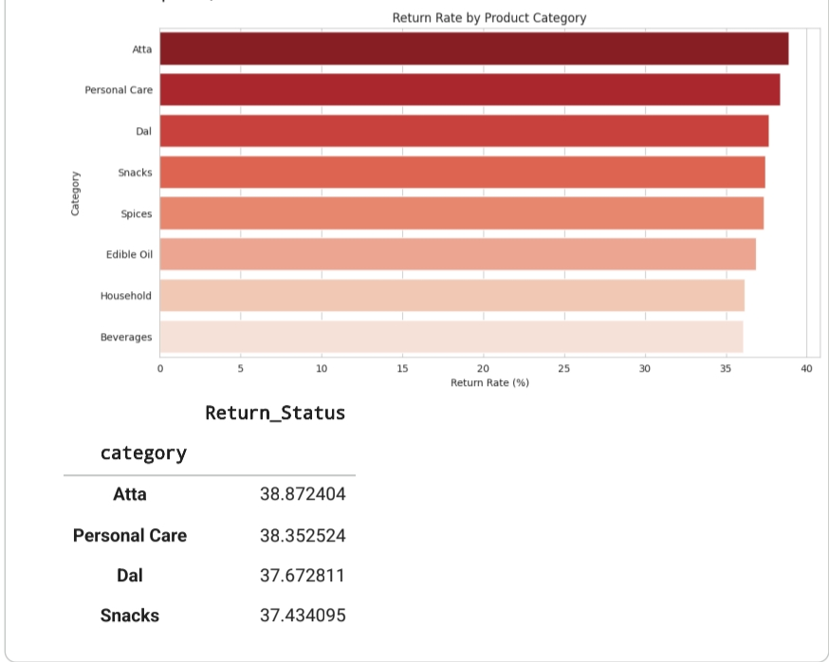

- Atta had the highest return rate (38.87%), while Beverages had the lowest (36.08%). Return rates were similar across channels and store types, suggesting product-level factors are more important.
Recommendation: Review product quality, packaging and supplier performance for high-return categories.
Conclusion
The analysis identifies seasonal demand, strong dependence on offline Kirana stores, and category-specific return patterns. These insights can help improve inventory planning, channel strategy, and product quality.

