Page No .: 1

Account Branch : FORT

Address : H DFC BAN K LTD ., G ROUN D F LO OR,

City : MUMBAI 400001

State : MAHARASHTRA

P ho ne n o. : 0 22 -6 16 06 16 1

OD Limit : 0.00

Currency : INR

E ma il : pramaniksandee p@ gmail.com

Cust ID : 36062847

Account No : 00601130009324 VRM POTENTIAL

A/C Open Date : 12/07/2010

Account Status : Regular

RTGS/NEFT IFSC: H DF C00000 60 M ICR : 40024 00 15

Branch Code : 60 Product Code : 113

MR. SANDEEP PRAMANIK

From : 01/02/2021

To : 25/02/2021

Date

Narration

Chq./Ref.No. Value Dt Withdrawal Amt. Deposit Amt. Closing Balance

01/02/21 UPI-SHOUMEN R PRAMANIK-9967530912@YBL-IC

0000103215361308 01/02/21

2,000.00

29,991.18

01/02/21 SALARY JAN 2021

0000102015085828 01/02/21

51,684.00

81,675.18

01/02/21 UPI-SHOUMEN R PRAMANIK-9967530912@YBL-IC

0000103219031505 01/02/21

1,400.00

80,275.18

01/02/21 UPI-CRED-CREDCC@YESBANK-YESB0000022-1032 0000103221859815 01/02/21

1,877.00

78,398.18

03/02/21 APY15974793_022021_500446145244_INSTALLM

000000000000000 03/02/21

1,318.00

77,080.18

03/02/21 POS 541919XXXXXX7575 SAURABH JEWELLER

0000000000336203 03/02/21

1,310.00

75,770.18

03/02/21 UPI-DEEPA MAHENDRA KEJAR-GPAY-1117446596

0000103419695823 03/02/21

40.00

75,730.18

2@OKBIZAXIS-UTIB0000000-103419695823-SAM

03/02/21 UPI-INSTAMOJOQR-INSTA-QR@ICICI-ICIC00003

0000103421870580 03/02/21

99.00

75,631.18

93-103421870580-SEMINAR

04/02/21 NEFT CR-CITI0100000-PAYPAL PAYMENTS PL I

CITIN21119483576 04/02/21

1.02

75,632.20

9483576

04/02/21 NEFT CR-CITI0100000-PAYPAL PAYMENTS PL I

CITIN21119489948 04/02/21

1.12

75,633.32

9489948

04/02/21 EMI 44147948 CHQ S441479480492 02214414

000000000000000 04/02/21

6,826.00

68,807.32

7948

04/02/21 IMPS-103510195716-BIJENDRA SINGH-ICIC-XX

0000103510195716 04/02/21

12,000.00

56,807.32

04/02/21 NWD-541919XXXXXX7575-CNM9011-THANE

0000103519323720 04/02/21

1,500.00

55,307.32

04/02/21 ATW-541919XXXXXX7575-S1ANMM66-THANE

0000000000004583 04/02/21

3,500.00

51,807.32

05/02/21 UPI-VISHAL VIDEO NETWORK-MHATREM258-1@OK 0000103613698903 05/02/21

500.00

51,307.32

**Related**

Contents of this statement will be

correct if no error is

within 30 days of receipt of statement.The

[address on this statement is that on](https://www.scribd.com/doc/301483174/Nester-Bank-Statement)

rec[ord with the Bank as at the day of request](https://www.scribd.com/document/336257358/AGICL-AXIS-BANK-Statement-JULY-2016-pdf)[ing](https://www.scribd.com/document/345137554/bank-statement)

s are available at

Bank House,Sen

JEHANGIR BUILDING,M G ROAD,

FORT, MUMBAI

T-501 SONAM NARMADA

NEW NAVGHAR ROAD

NR SONAM HEIGHTS

THANE 401105

MAHARASHTRA INDIA

JOINT HOLDERS : Nomination : Not Registered

RTGS/NEFT IFSC:

Statement of account

IC0000393-103215361308-PAYMENT FROM PHON

IC0000393-103219031505-PAYMENT FROM PHON

21859815-CREDIT CARD BILL P

OSA

NR FBO CUR AC-SANDEEP PRAMANIK-CITIN2111

NR FBO CUR AC-SANDEEP PRAMANIK-CITIN2111

XXXXXX6094-RENT FOR FEBUARY

AXIS-UTIB0002900-103613698903-BILL FOR J

[HDFC BANK LIMITED](https://www.scribd.com/doc/187967483/38369794-1384677961951)

*Closing balance includes

funds

[earmarked for hold and](https://www.scribd.com/document/203396975/SampleForm19-English)

uncleared

[funds](https://www.scribd.com/doc/265511967/OutputMessage-5897051709141509-PDF)

considered

reported

this statement.

State account branch

GSTN:27AAACH2702H1Z0

HDFC Bank GSTIN number

details

<https://www.hdfcbank.com/personal/making-payments/online-tax-payment/goods-and-service-tax>.

Registered Office Address:

HDFC

House,Senapati Bapat

Marg,Lower

Parel,Mumbai 400013

**Bank Statement**

Nomination : Not Registered

From

: 01/02/2021

ANUARY

05/02/21

47,307.32

05/02/21

94,935.32

05/02/21

109,885.32

06/02/21

99,886.32

06/02/21

99,781.32

07/02/21

21,667.33

07/02/21

19,167.33

10/02/21

20,667.33

CI

10/02/21

18,667.33

10/02/21

20,667.33

10/02/21

19,167.33

11/02/21

24,167.33

12/02/21

25,667.33

OU CR SAH LTD CHIKODI-SANDEEP PRAMANIK

-CMS1812857341

12/02/21 POS 541919XXXXXX7575 SHRI RAM SAGAR

0000000000003815 12/02/21

553.00

25,114.33

14/02/21 UPI-MAHENDRA BHAGARAM

0000104516606396 14/02/21

280.00

24,834.33

MA-MAHENDRA819@OKA

XIS-BARB0MIRBHA-104516606396-UPI

14/02/21 UPI-MAHENDRA BHAGARAM

470.00

24,364.33

MA-MAHENDRA819@OKA

XIS-BARB0MIRBHA-104518740342-HARDWARE

14/02/21 IMPS-104523304643-SHOUMEN R PRAMANIK-HDF

0000104523304643 15/02/21

HDFC BANK LIMITED

*Closing balance includes funds earmarked for hold and uncleared funds

Contents of this statement will be considered correct if no error is reported within 30 days of receipt of statement.The address on this statement is that on record with the Bank as at the day of requesting

this statement.

State account branch GSTN:27AAACH2702H1Z0

HDFC Bank GSTIN number details are available at <https://www.hdfcbank.com/personal/making-payments/online-tax-payment/goods-and-service-tax>. Registered Office Address: HDFC Bank House,Senapati Bapat Marg,Lower Parel,Mumbai 400013

|  |  |  |
| --- | --- | --- |
|  | tatement of accoun | t |
|  | | |

|  |  |  |  |
| --- | --- | --- | --- |
|  |  |  | |
| MR. SANDEEP PRAMANIK | | |  |
| T-501 SONAM NARMADA | |  |  |
| NEW NAVGHAR ROAD |  |  |  |
| NR SONAM HEIGHTS |  |  | |
| THANE 401105 |  |  | |

|  |  |  |  |  |  |
| --- | --- | --- | --- | --- | --- |
|  | |  |  | |  |
| 2,100.00 |  |  |  | 26,464.33 |  |

0000104518740342 14/02/21

,464.33

MR. SANDEEP PRAMANIK T-501 SONAM NARMADA NEW NAVGHAR ROAD NR SONAM HEIGHTS THANE 401105 MAHARASHTRA INDIA

JOINT HOLDERS :

Statement of account

To : 25/02/2021

H D- KRISHNABUILDCONCORP-KBC-HG--018-0  
PS-103615617179-MUTHOOT FINANCE LIMI-H  
C-XXXXXXXXXXX1090-10499958  
PS-103617717492-MUTHOOT FINANCE LIMI-H

C-XXXXXXXXXXX1090-10500656

5BAA572483D9F/ZAAKINSTAMOJOTECHNOL

I-PANKAJ JAGAT MAHESH-PANKAJ024975@OK

IS-KKBK0001365-10371474327 Upl

RX65MLAN425NOUDY/PAYUCREDCLUB  
W-541919XXXXXX7575-P3ENMI23-THANE

I-SHOUMEN R PRAMANIK-SHOU7US@OKICICI-I

C0000393-104109046500-UPI  
I-XXXXXX4776-UCBA0RRBPBG-104111314472-  
SH

FT CR-UTIB0001842-RUPA PRAMANIK-SANDEE  
RAMANIK-AXMB210419369788  
W-541919XXXXXX7575-P3ENMM84-MUMBAI

I-KEVALKUMAR KANTILAL -KEVAL.KOTWAL198

OKHDFCBANK-HDFC0000170-104212879618-UP

0000008020304036 05/02/21 0000103615617179 05/02/21

0000103617717492 05/02/21

4,000.00

TYECoHNuOL're Re0a000d21i03n705g38 6a90 P06r/02e/21view  
TECHNOL 0000210370538690 06/02/21

J024975@OK 0000103714743273 06/02/21

oad your documents to download

0000210381083156 07/02/21  
0000000000004234 07/02/21

Upload0 to Download CI-I 0000104109046500 10/02/21

9,999.00

105.00

78,113.99

2,500.00

0000104111314472 10/02/21

2,000.00

d member3 to read/ a nd download

full 0documents.02/21

Start 8Your0 30 Day FREE0Tri al

1,500.00

FT CR-ICIC0000104-SHRI SIDDHIVINAYAK S

47,628.00

14,950.00

1,500.00

000CMS1812857341 12/02/21

2,000.00

5,000.00

1,500.00

City State P ho ne n o.

OD Limit Currency Email Cust ID Account No A/C Open Date : Account Status : RTGS/NEFT IFSC: B ra nc h Co de :

JEHANGIR BUILDING,M G ROAD, FORT, MUMBAI MUMBAI 400001 MAHARASHTRA 022-61606161 0.00

[pramanik.sandeep@gmail.com](mailto:pramanik.sandeep@gmail.com)

00601130009324 VRM POTENTIAL 12/07/2010 Regular

H DF C00000 60 M ICR : 40024 00 15

60 Product Code : 113

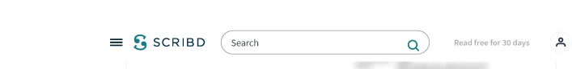

You're reading a preview 

**Unlock full access (page 3) by  
uploading documents or with a  
30 Day Free Trial**

**Continue for Free**

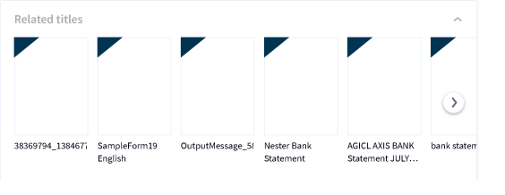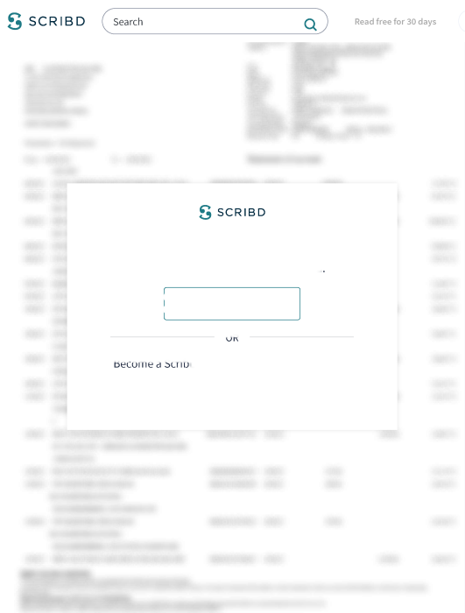

|  |  |  |  |
| --- | --- | --- | --- |
|  |  |  | |
| MR. SANDEEP PRAMANIK | | |  |
| T-501 SONAM NARMADA | |  |  |
| NEW NAVGHAR ROAD |  |  |  |
| NR SONAM HEIGHTS |  |  | |
| THANE 401105 |  |  | |

A/C Open Date : Account Status : RTGS/NEFT IFSC: B ra nc h Co de :

ity  
tate

P ho ne n o.  
OD Limit  
Currency  
Email  
Cust ID

Account No

FORT

H DFC BAN K LTD ., G ROUN D F LO OR,  
JEHANGIR BUILDING,M G ROAD,  
FORT, MUMBAI  
MUMBAI 400001  
MAHARASHTRA  
022-61606161  
0.00

[pramanik.sandeep@gmail.com](mailto:pramanik.sandeep@gmail.com)

00601130009324 VRM POTENTIAL 12/07/2010 Regular

H DF C00000 60 M ICR : 40024 00 15

60 Product Code : 113

25/02/21 UPI-DILEEP KUMAR-DILIPKUMARC71@OKSBI-SB

IN0008993-105609560628-CASH FOR DHEERAJ

STATEMENT SUMMARY :- Opening Balance 31,991.18

|  |  |  |  |  |
| --- | --- | --- | --- | --- |
|  |  |  |  |  |
|  | 94,392.88 | | |

Dr Count  
35

Cr Count  
11

Debits

163,962.44

Credits

226,364.14

Closing Bal

94,392.88

Generated On: 25-Feb-2021 Up

You're Reading a Preview

load yourGdocum ents7 to download

**Upload to Download**

OR

. equesting Branch Code: NET



Become a Scribd member to read and download  
full documents.

**Start Your 30 Day FREE Trial**

HDFC BANK LIMITED

*Closing balance includes funds earmarked for hold and uncleared funds

Contents of this statement will be considered correct if no error is reported within 30 days of receipt of statement.The address on this statement is that on record with the Bank as at the day of requesting this statement.

State account branch GSTN:27AAACH2702H1Z0

HDFC Bank GSTIN number details are available at <https://www.hdfcbank.com/personal/making-payments/online-tax-payment/goods-and-service-tax>.

Registered Office Address: HDFC Bank House,Senapati Bapat Marg,Lower Parel,Mumbai 400013

**Reward Your Curiosity**

Everything you want to read.

Anytime. Anywhere. Any device.

**Read free for 30 days**

Cancel Anytime



[**You might also like**](https://www.scribd.com/doc/187967483/38369794-1384677961951)

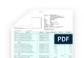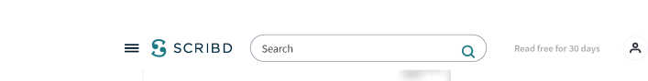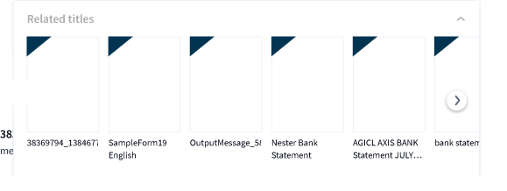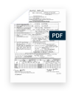

[**SampleForm19 English**](https://www.scribd.com/document/203396975/SampleForm19-English)

d0101

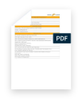

[**OutputMessage_5897051709141509.PDF**](https://www.scribd.com/doc/265511967/OutputMessage-5897051709141509-PDF)

Athar Khan

[Business](https://www.scribd.com/interest/Business/explore) [Financial Services](https://www.scribd.com/interest/Financial-Services/explore) [Banking](https://www.scribd.com/interest/Banking/explore) [Service Industries](https://www.scribd.com/interest/Service-Industries/explore)

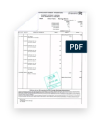

[**Nester Bank Statement**](https://www.scribd.com/doc/301483174/Nester-Bank-Statement)

Simbarashe Marisa

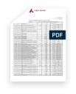

[**AGICL AXIS BANK Statement JULY 2016.pdf**](https://www.scribd.com/document/336257358/AGICL-AXIS-BANK-Statement-JULY-2016-pdf)

Sagar Asati

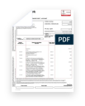

[**bank statement**](https://www.scribd.com/document/345137554/bank-statement)

esseesse76

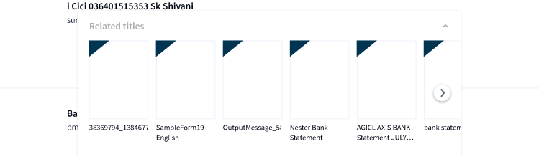

[**Bank Statement Sept 2017**](https://www.scribd.com/document/382394758/Bank-Statement-Sept-2017)

Yogesh Pangare

[**Credit Card Cancellation Form**](https://www.scribd.com/document/407131926/Credit-Card-Cancellation-Form)

wms_klang

[**Radha Bank Statement**](https://www.scribd.com/document/411695954/Radha-Bank-Statement)

rama krishn

[**HDFC BANK DEPOSIT ONLINE RECEIPT FORMAT**](https://www.scribd.com/document/415968435/HDFC-BANK-DEPOSIT-ONLINE-RECEIPT-FORMAT)

Ajay Ajay

[**IDFC FIRST Bank statement as of 08 AUG 2019.pdf**](https://www.scribd.com/document/431051582/IDFC-FIRST-Bank-statement-as-of-08-AUG-2019-pdf)

Suhail Ameer

[**Daftar 231 Fintech P2P Lending i (1)**](https://www.scribd.com/document/437908583/Daftar-231-Fintech-P2P-Lending-i-1)

rekky andry

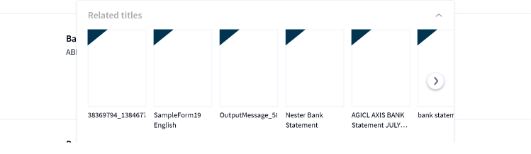

[**Read free for 30 days**](https://www.scribd.com/archive/pmp_checkout?doc=518635153&metadata=%7B%22context%22%3A%22pmp%22%2C%22action%22%3A%22start_trial%22%2C%22logged_in%22%3Atrue%2C%22platform%22%3A%22web%22%7D)



[**HDFC BANK STATEMENT.pdf**](https://www.scribd.com/document/451843314/HDFC-BANK-STATEMENT-pdf)

Shivam Gond

[**3months bank statement rgvrdy (1).pdf**](https://www.scribd.com/document/452308633/3months-bank-statement-rgvrdy-1-pdf)

Nikhilreddy Singireddy

[**APPLI FORM.xlsx**](https://www.scribd.com/document/473356018/APPLI-FORM-xlsx)

Youki Nakagawa

[**Bank statement**](https://www.scribd.com/document/486347031/Bank-statement)

Rajesh pvk

[**PI 28-2102S-SINGLE HIGH SPEED SKD - PI-B ROTOR**](https://www.scribd.com/document/489836590/PI-28-2102S-SINGLE-HIGH-SPEED-SKD-PI-B-ROTOR)

Rajesh Roy

[**ELECTICITY TRANSACTION.pdf**](https://www.scribd.com/document/489910955/ELECTICITY-TRANSACTION-pdf)

thislenovo 12

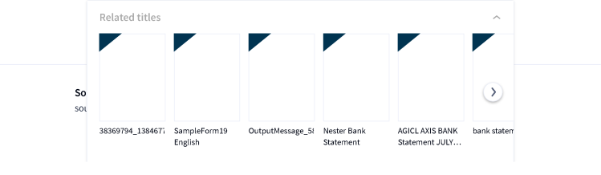

[**Scholarship_Received_Format**](https://www.scribd.com/document/507632342/Scholarship-Received-Format)

Gaurav Yadav

**TransferGo aš**

[Asta Kasperavičiutė](https://www.scribd.com/document/517342336/TransferGo-a%C5%A1)

**uuu yuu**

[Aliashim Albani Allian](https://www.scribd.com/document/519171570/uuu-yuu)

[**11A. HDFC Feb 2021 eStatement**](https://www.scribd.com/document/522022502/11A-HDFC-Feb-2021-eStatement)

Nanu Patel

[**PI-LM SWAB20200906**](https://www.scribd.com/document/522546583/PI-LM-SWAB20200906)

Alejandro Martinez

[**eTendering System Government of Kerala**](https://www.scribd.com/document/535439899/eTendering-System-Government-of-Kerala)

Syam G Krishnan

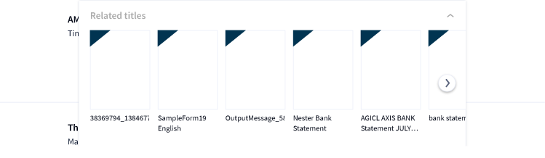

[**Shoe Dog: A Memoir by the Creator of Nike**](https://www.scribd.com/book/309859835/Shoe-Dog-A-Memoir-by-the-Creator-of-Nike)

Phil Knight

[**Never Split the Difference: Negotiating As If Your Life Depended On It**](https://www.scribd.com/book/310560108/Never-Split-the-Difference-Negotiating-As-If-Your-Life-Depended-On-It)

Chris Voss

[**Yes Please**](https://www.scribd.com/book/244157917/Yes-Please)

Amy Poehler

[**Devil in the Grove: Thurgood Marshall, the Groveland Boys, and the Dawn of a New America**](https://www.scribd.com/book/163646054/Devil-in-the-Grove-Thurgood-Marshall-the-Groveland-Boys-and-the-Dawn-of-a-New-America)

Gilbert King

[**The Hard Thing About Hard Things: Building a Business When There Are No Easy Answers**](https://www.scribd.com/book/211302755/The-Hard-Thing-About-Hard-Things-Building-a-Business-When-There-Are-No-Easy-Answers)

Ben Horowitz

[**Principles: Life and Work**](https://www.scribd.com/book/357813054/Principles-Life-and-Work)

Ray Dalio

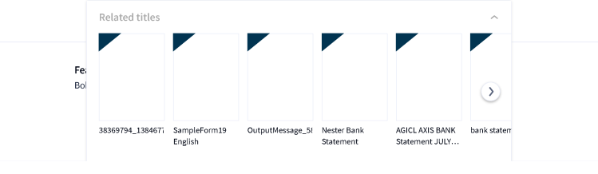

Search

[**Ris**](https://www.scribd.com/book/239588474/Rise-of-ISIS-A-Threat-We-Can-t-Ignore)[**e of ISIS: A Threat**](https://www.scribd.com/) [**We Can't Ignore**](https://www.scribd.com/book/239588474/Rise-of-ISIS-A-Threat-We-Can-t-Ignore)

Jay Sekulow

[**Read free for 30 days**](https://www.scribd.com/archive/pmp_checkout?doc=518635153&metadata=%7B%22context%22%3A%22pmp%22%2C%22action%22%3A%22start_trial%22%2C%22logged_in%22%3Atrue%2C%22platform%22%3A%22web%22%7D)



[**The Gifts of Imperfection: Let Go of Who You Think You're Supposed to Be and Embrace Who You Are**](https://www.scribd.com/book/335808746/The-Gifts-of-Imperfection-Let-Go-of-Who-You-Think-You-re-Supposed-to-Be-and-Embrace-Who-You-Are)

Brené Brown

[**Bad Feminist: Essays**](https://www.scribd.com/book/234028503/Bad-Feminist-Essays)

Roxane Gay

[**The Alice Network: A Novel**](https://www.scribd.com/book/348571030/The-Alice-Network-A-Novel)

Kate Quinn

**Bel Canto**

[Ann Patchett](https://www.scribd.com/book/163580087/Bel-Canto)

**Little Women**

[Louisa May Alcott](https://www.scribd.com/book/224756706/Little-Women)

