Assignment 2

NAME- SAKSHAM KUMAR

ID- 2022UCP1700

SECTION- A4

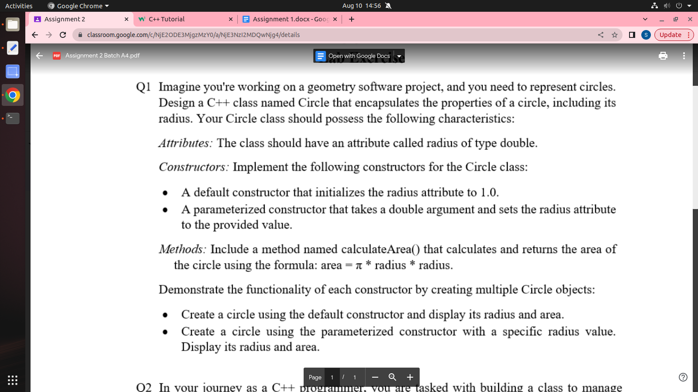

  #include<iostream>

#include<cmath>

using namespace std;

class Circle

{

double radius;

public:

Circle()

{

this->radius=1.0;

}

Circle(double r)

{

this->radius=r;

}

double calculateArea()

{

return M_PI*radius*radius;

}

};

int main()

{

Circle c1;

cout<<"Area of the circle with radius 1.0:- "<<c1.calculateArea()<<endl;

double r;

cout<<"Enter radius of the circle:- ";

cin>>r;

Circle c2(r);

cout<<"Area of the Circle whit radius "<<r<<":- "<<c2.calculateArea()<<endl;

return 0;

}

//output:-

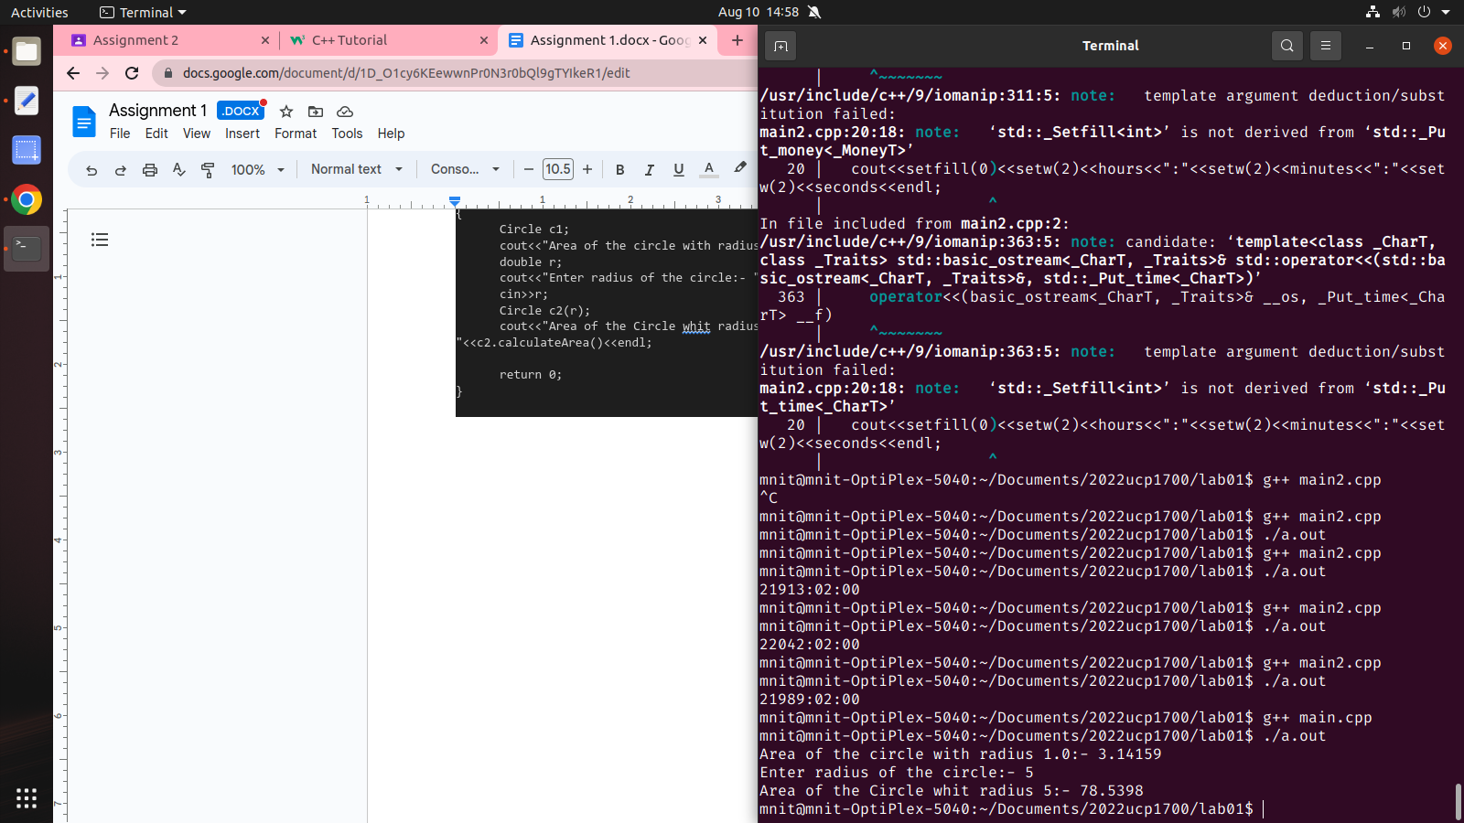

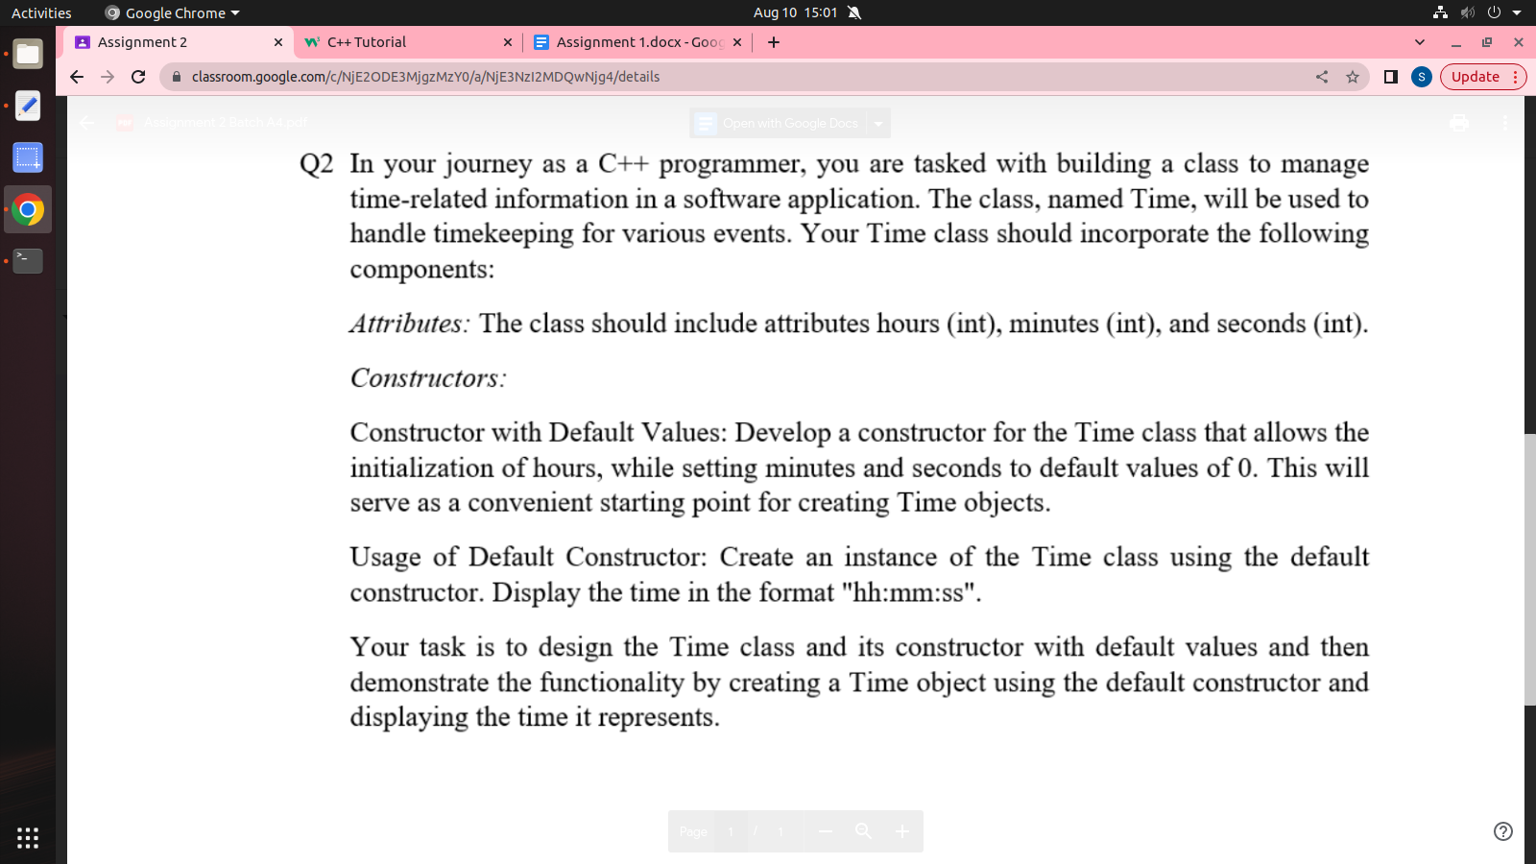

#include<iostream>

#include<iomanip>

using namespace std;

class Time

{

int hours;

int minutes;

int seconds;

public:

Time(int hrs):minutes(0),seconds(0)

{

hours=(hrs<0||hrs>24)?0:hrs;

cout<<setfill('0')<<setw(2)<<hours<<":"

<<setfill('0')<<setw(2)<<minutes<<":"

<<setfill('0')<<setw(2)<<seconds<<endl;

}

};

int main()

{

Time t1(3),t2(12),t3(23);

return 0;

}

//output:-