CODE AND TRACE TABLES

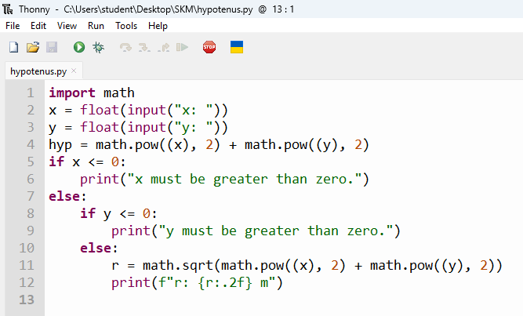
Line | Statement | length | width | area | output
1 | float(input("please enter length:")) | 4.8
2 | float(input("please enter width:")) | 4.8 | 6
3 | length*width | 4.8 | 6 | 28.8
4 | print("area: | 4.8 | 6 | 28.8 | 28.80 m^2

