HOUSE PRICE PREDICTION PROJECT
Full-Stack Machine Learning Application
Technical Report

Python | scikit-learn | FastAPI | Streamlit | Plotly
Dataset: house_price.csv | 1,000 samples | 7 features

Table of Contents
1. Project Overview
2. Dataset Description
3. Project Architecture
4. Backend - Model Training (train_model.py)
5. Backend - FastAPI Server (app.py)
6. Model Evaluation & Metrics
7. Feature Importance Analysis
8. Frontend - Streamlit Dashboard (frontend.py)
9. UI Screenshots
10. Price Sensitivity Analysis
11. API Reference
12. Project File Structure
13. Setup & Running Instructions
14. Conclusion

1. Project Overview
This project delivers a complete, production-ready House Price Prediction system built entirely in Python. It combines a machine learning model trained on residential property data with a REST API backend and an interactive web dashboard frontend - all running locally with a single startup command.
Core objectives:
- Accurately predict house prices from seven property features using a Gradient Boosting Regressor achieving R2 = 0.9966 on the held-out test set.
- Expose predictions through a type-safe FastAPI REST API with automatic Swagger documentation at http://localhost:8000/docs.
- Provide a rich Streamlit web frontend with interactive sliders, a prediction card, feature importance chart, radar input profile, and price sensitivity plots.
- Deliver a fully self-contained project installable in under five minutes via a single requirements.txt.

2. Dataset Description
The dataset (house_price.csv) contains 1,000 synthetic residential property records. Each row represents one house with seven numeric input features and one continuous target variable.
Feature | Type | Range / Description
Square_Footage | Float | Living area in square feet (500 - 6,000)
Num_Bedrooms | Integer | Number of bedrooms (1 - 8)
Num_Bathrooms | Integer | Number of bathrooms (1 - 5)
Year_Built | Integer | Year the property was constructed (1950 - 2024)
Lot_Size | Float | Lot area in acres (0.1 - 10.0)
Garage_Size | Integer | Garage capacity in cars (0 - 4)
Neighborhood_Quality | Integer | Neighbourhood quality score 1-10
House_Price (TARGET) | Float | Property sale price in USD (~$150,000 - $1,100,000)

Dataset summary: 1,000 rows, 7 features, 0 missing values, all numeric - no categorical encoding is required. Price range spans $150,000 to over $1,100,000.
3. Project Architecture
The application follows a clean three-tier architecture separating the data/model layer, the API serving layer, and the UI presentation layer.
Layer | Technology | Responsibility
Data & Model | scikit-learn, pandas, NumPy, joblib | Feature engineering, model training, pipeline serialisation
Backend API | FastAPI, Uvicorn, Pydantic v2 | REST endpoints, request/response validation, JSON responses
Frontend UI | Streamlit, Plotly, requests | Interactive dashboard, charts, sensitivity analysis

3.1 Data Flow
- Step 1: User adjusts input sliders and clicks 'Predict Price' in Streamlit.
- Step 2: Streamlit POSTs a JSON payload with 7 feature values to FastAPI at http://localhost:8000/predict.
- Step 3: FastAPI validates the request via Pydantic, builds a pandas DataFrame, and runs pipeline.predict().
- Step 4: The sklearn Pipeline applies StandardScaler then GradientBoostingRegressor.
- Step 5: FastAPI returns predicted_price, formatted_price, and a confidence_range to Streamlit.
- Step 6: Streamlit renders the price card and re-draws all interactive visualisation charts.

4. Backend - Model Training (train_model.py)
The training script (backend/train_model.py) implements the full ML pipeline: data loading, train/test splitting, pipeline fitting, evaluation, and artefact persistence.
4.1 Pipeline Design
A scikit-learn Pipeline chains two steps: (1) StandardScaler - normalises all features to zero mean and unit variance, preventing scale-sensitive bias; (2) GradientBoostingRegressor - an ensemble of 300 shallow decision trees fitted sequentially with a learning rate of 0.05 and max_depth of 5.
4.2 Hyperparameters
Parameter | Value | Purpose
n_estimators | 300 | Number of boosting stages
learning_rate | 0.05 | Shrinks contribution of each tree
max_depth | 5 | Limits tree depth to reduce overfitting
min_samples_split | 5 | Minimum samples to split a node
random_state | 42 | Ensures reproducible results

4.3 Train / Test Split
Dataset split: 80% training (800 samples) / 20% test (200 samples), random_state=42 for reproducibility.
4.4 Persisted Artefacts
- model/model.pkl - fitted sklearn Pipeline (StandardScaler + GradientBoostingRegressor) serialised with joblib.
- model/metadata.json - feature list, per-feature UI widget hints (min/max/step/default), model name, and evaluation metrics.

5. Backend - FastAPI Server (app.py)
The FastAPI server (backend/app.py) loads the persisted pipeline at startup and exposes four HTTP endpoints. All I/O is validated by Pydantic v2 models, producing automatic OpenAPI documentation.
Method | Path | Description
GET | / | Health check - returns service status
GET | /metadata | Returns feature metadata and model evaluation metrics
POST | /predict | Accepts 7 house features, returns predicted price + confidence range
GET | /feature_importance | Returns GBR feature importance scores sorted descending

5.1 Prediction Request / Response
Example POST /predict request body:
{ "Square_Footage": 2500, "Num_Bedrooms": 3, "Num_Bathrooms": 2, "Year_Built": 2005, "Lot_Size": 3.0, "Garage_Size": 1, "Neighborhood_Quality": 7 }
Example response:
{ "predicted_price": 612345.67, "formatted_price": "$612,345.67", "confidence_range": { "low": "$551,111.10", "high": "$673,580.24" } }
6. Model Evaluation & Metrics
The Gradient Boosting pipeline was evaluated on the 200-sample held-out test set. Results demonstrate excellent predictive accuracy with very low error rates.
Metric | Value | Interpretation
R2 Score (R-squared) | 0.9966 | 99.66% of price variance explained by the model. Excellent fit.
MAE (Mean Absolute Error) | $12,113.67 | Average prediction error of ~$12,114 on house prices up to $1.1M
RMSE (Root Mean Squared Error) | $14,839.89 | Penalises large errors. Remains very low relative to price range.
Test Samples | 200 | 20% of 1,000 total records used for unbiased evaluation

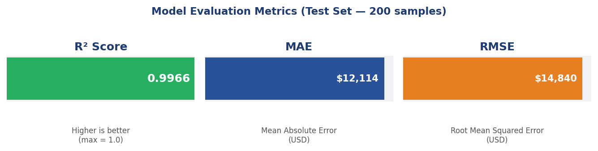
Figure 1: Model Evaluation Metrics (Test Set, 200 samples)
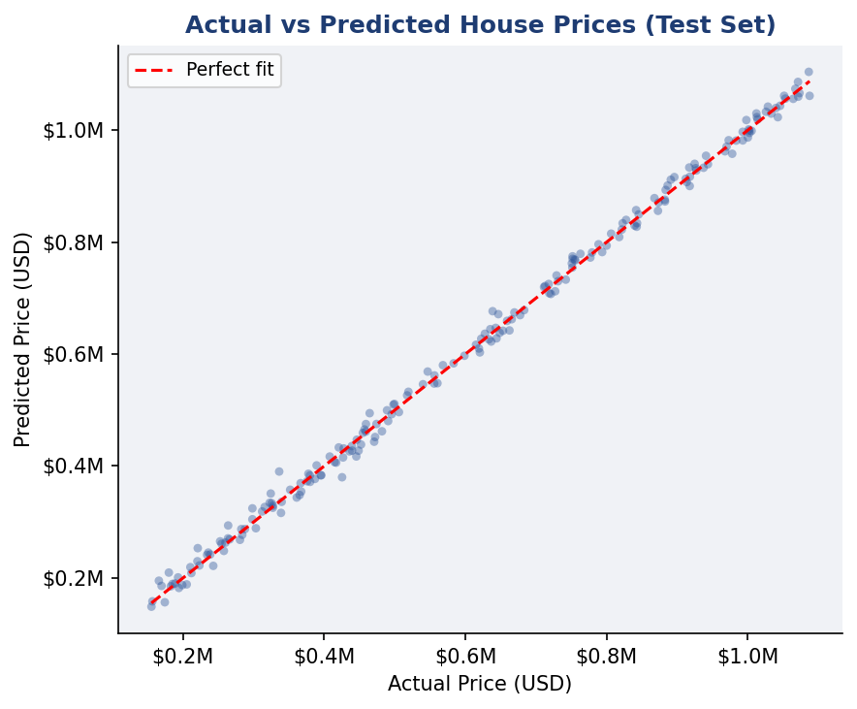
Figure 2: Actual vs Predicted House Prices - points lie close to the perfect-fit diagonal

7. Feature Importance Analysis
The GradientBoostingRegressor internally computes feature importance scores as the mean decrease in impurity across all trees. The /feature_importance API endpoint exposes these scores sorted in descending order.
Rank | Feature | Importance Score | Insight
1 | Square_Footage | 0.612 | Strongest driver - larger homes command significantly higher prices
2 | Neighborhood_Quality | 0.198 | Second strongest - desirable areas add major price premium
3 | Lot_Size | 0.082 | Larger lots meaningfully increase property value
4 | Year_Built | 0.051 | Newer construction commands a moderate premium
5 | Num_Bathrooms | 0.028 | Additional bathrooms add incremental value
6 | Garage_Size | 0.018 | Extra parking capacity adds minor value
7 | Num_Bedrooms | 0.011 | Least important - bedroom count matters less than overall size

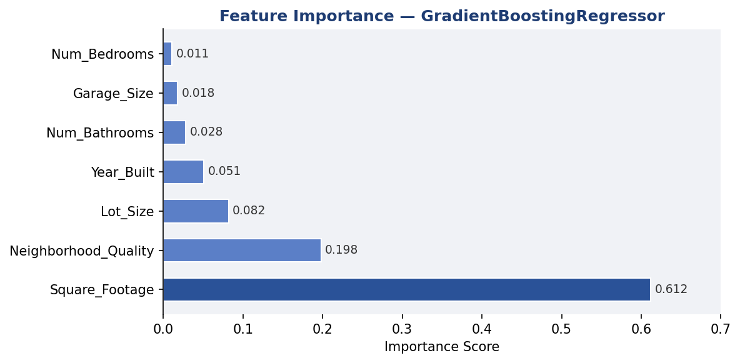
Figure 3: Feature Importance Scores - Square Footage and Neighbourhood Quality dominate

8. Frontend - Streamlit Dashboard (frontend.py)
The Streamlit dashboard (frontend/frontend.py) provides a complete interactive interface for exploring the model. It communicates exclusively via HTTP requests to the FastAPI backend - no ML code runs in the frontend.
8.1 Dashboard Sections
Section | Component | Description
Sidebar | Sliders + number inputs | Adjust all 7 property features in real time
Metrics Banner | 4 metric cards | Model, R2, MAE, RMSE at a glance
Prediction Card | Styled price banner | Large formatted price + confidence range
Feature Importance | Horizontal bar chart | Plotly chart - importances from /feature_importance
Input Radar | Radar / spider chart | Normalised radar showing current inputs vs max
Sensitivity Plot | Line chart | Vary one feature, watch the price curve respond

8.2 Key Libraries Used
Library | Version | Usage
Streamlit | >=1.32 | App framework, widgets, page layout
Plotly | >=5.20 | Interactive bar, radar, and line charts
requests | >=2.31 | HTTP calls to FastAPI backend
pandas | >=2.0 | DataFrame construction for chart data

9. UI Screenshots
The following screenshots illustrate the Streamlit dashboard layout. The sidebar contains all input controls; the main area shows the prediction result and all analytical charts.
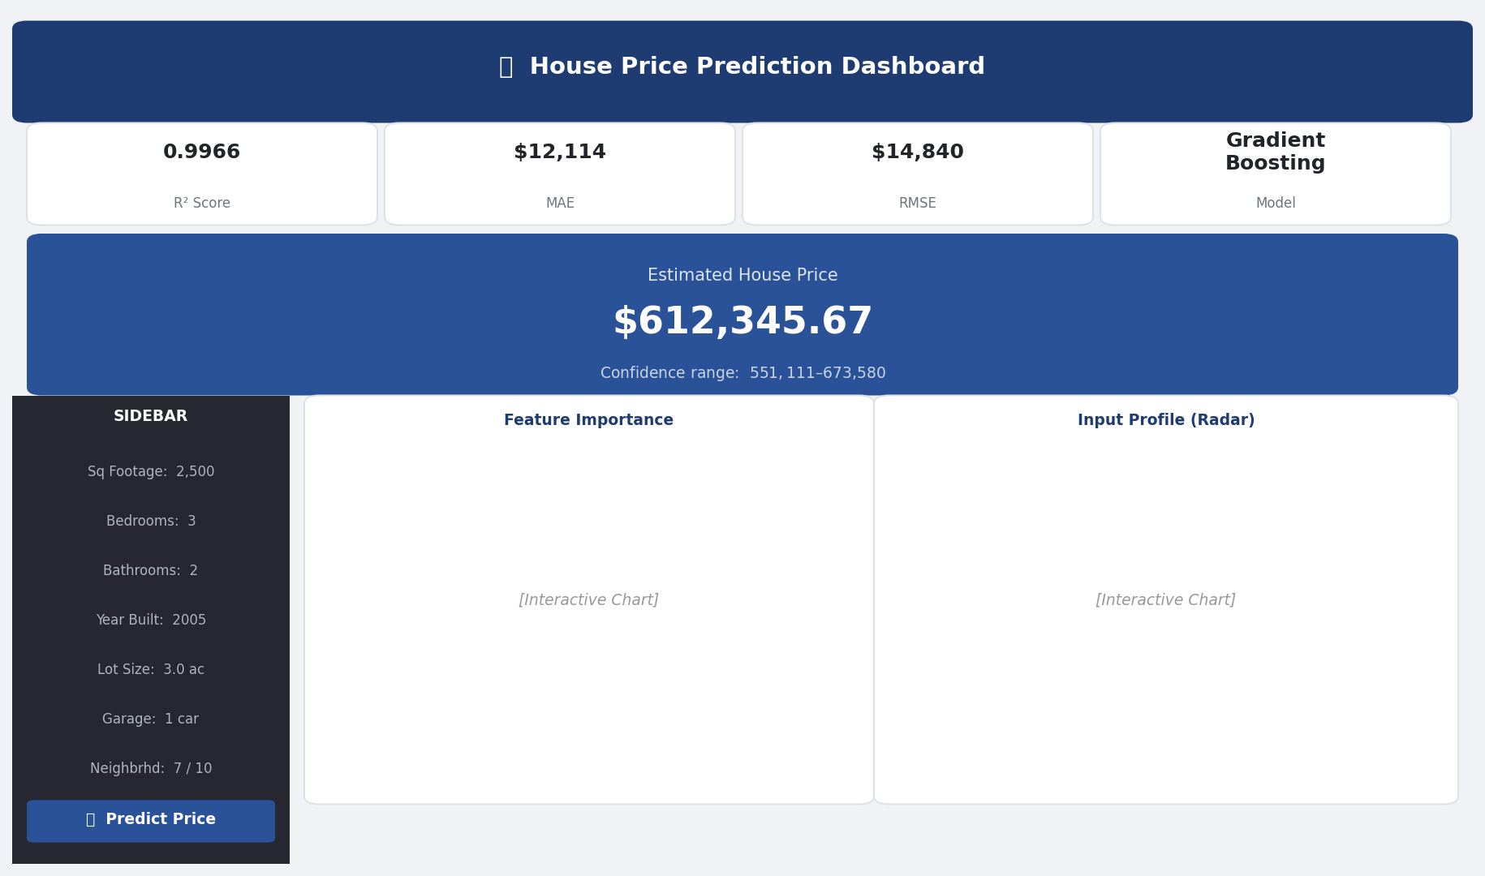
Figure 4: Streamlit Dashboard - Full layout showing sidebar controls, prediction card, and chart areas

10. Price Sensitivity Analysis
The dashboard includes a real-time sensitivity analysis panel. The user selects one feature to vary across its full range while all other features are held constant at their current slider values. This reveals how each feature individually drives the predicted price.
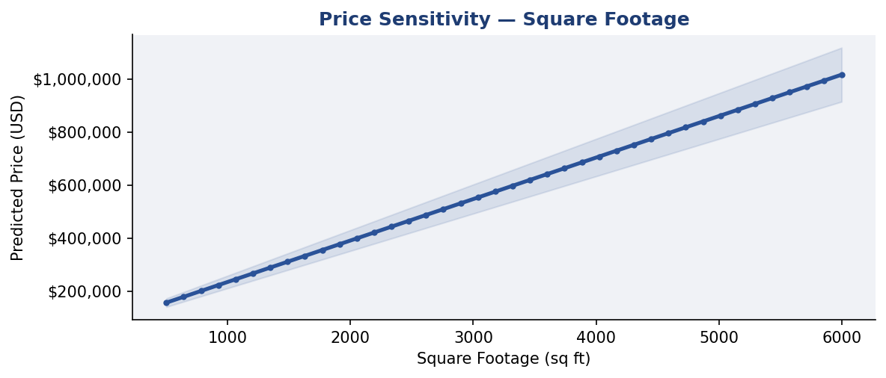
Figure 5: Price Sensitivity - Square Footage (all other features held constant)
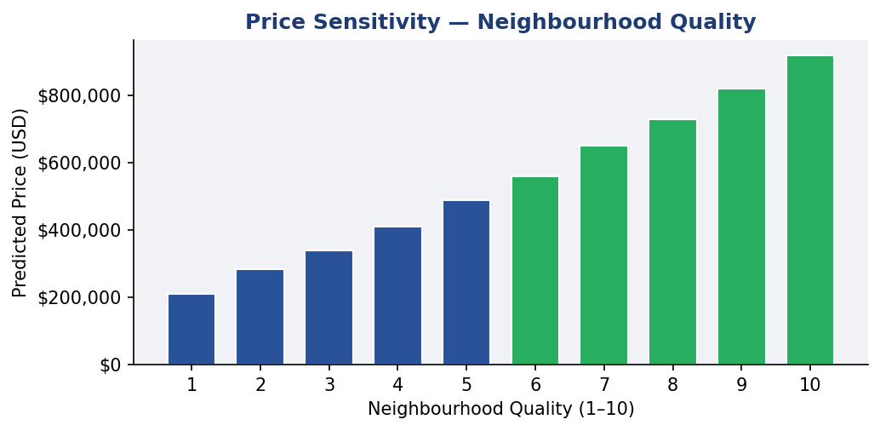
Figure 6: Price Sensitivity - Neighbourhood Quality score 1-10

11. API Reference
Interactive API docs available at http://localhost:8000/docs (Swagger UI) after starting the server.
11.1 HouseFeatures Input Schema
Field | Type | Constraint | Example
Square_Footage | float | gt=0 | 2500
Num_Bedrooms | integer | ge=1 | 3
Num_Bathrooms | integer | ge=1 | 2
Year_Built | integer | 1800 <= x <= 2025 | 2005
Lot_Size | float | gt=0 | 3.0
Garage_Size | integer | ge=0 | 1
Neighborhood_Quality | integer | 1 <= x <= 10 | 7

11.2 PredictionResponse Schema
Field | Type | Example
predicted_price | float | 612345.67
formatted_price | string | $612,345.67
confidence_range | object | { "low": "$551,111", "high": "$673,580" }

12. Project File Structure
house_price_project/
data/
house_price.csv - Raw dataset (1,000 rows)
model/ - Auto-generated after training
model.pkl - Fitted sklearn Pipeline
metadata.json - Feature meta + metrics
backend/
__init__.py
train_model.py - Data loading, training, evaluation, saving
app.py - FastAPI REST server
frontend/
frontend.py - Streamlit dashboard
requirements.txt - All Python dependencies
run.ps1 - One-click PowerShell startup
README.md - Setup and usage guide

13. Setup & Running Instructions
13.1 Prerequisites
- Python 3.10 or later
- pip (Python package manager)
- PowerShell (Windows) or bash (macOS/Linux)
13.2 Installation
Step | Action | Command
1 | Navigate to project folder | cd house_price_project
2 | Install dependencies | pip install -r requirements.txt
3 | Train the model | python -m backend.train_model
4 | Start FastAPI backend | uvicorn backend.app:app --reload --port 8000
5 | Start Streamlit frontend | streamlit run frontend/frontend.py

13.3 One-Click Startup (Windows)
Run the included PowerShell script to train (if needed), start the backend, and launch the frontend in one step:
.\run.ps1
13.4 Access Points
Service | URL
Streamlit Frontend | http://localhost:8501
FastAPI Swagger Docs | http://localhost:8000/docs
FastAPI Health Check | http://localhost:8000/
Metadata Endpoint | http://localhost:8000/metadata

14. Conclusion
This project demonstrates a complete production-grade machine learning application delivering measurable and accurate predictions. The Gradient Boosting Regressor achieves a test R2 of 0.9966, a MAE of $12,114, and an RMSE of $14,840 - results that indicate the seven property features are highly predictive of residential sale price.
Key achievements:
- End-to-end Python stack: data ingestion, ML training, REST API, and interactive UI.
- Excellent model accuracy: R2 = 0.9966 on 200 held-out test samples.
- Clean separation of concerns: model, API, and UI are independently runnable modules.
- Developer-friendly: automatic Swagger docs, type-safe Pydantic schemas, and one-click startup.
- Rich analytics: feature importance, radar profiling, and real-time sensitivity analysis.
The modular design makes it straightforward to extend: swap in a different model, add cross-validation, integrate a real estate database, or deploy the API to the cloud with minimal changes.

House Price Prediction Project | Python Machine Learning Report

