Hello Sir,

I detailed the test below in 2 parts :

- UI / API

- All the technical UI/Api Framework are available at below GitHub link:

https://github.com/skmdmpasha/Ornikar_TecnicalTest.git

TEST :

Part I : Make an analysis of the insurance Ornikar site (https://www.ornikar.com/) :

1. In a few words describe the website and explain the purpose of the company.?

About company :
Ornikar, is an online driving school: a platform primarily for younger people
on mobility.
with Ornikar, one can revise their code lessons and train online where and when they want, then book their driving hours online with the teacher.

At Ornikar we support you in training in the highway code and driving and we offer you fair and appropriate car insurance.

Site provide links Code de la route, Permis de conduire, Assurance auto
where user can get enrolled into the desired service he or she interested in.

2. Explain what you will test first and why..?

Test :
- I test Front site portal visible of all important links which are important to our bussiness flow like

* Code de la route
* Permis de conduire
* Assurance auto

- I test if a new client could enroll to desired service or not
- I test client login page properly working or not
-I test if the payment service is correctly working or not

3. Imagine you are with your three amigos, how do you explain to them what we have to test.

I highly recommend to test all user behaviors, as behavior is the action ,and interaction of an individual on the site like:

-logging into a web page
-follow the links for navigation
-submitting forms

- I join the PO in a joint session (as in the « three amigos » approach) and talk about testing the feature’s requirements before the feature is developed

-I discuss and sujest th mainly focus scenarios like
user signup, and identify few positive and negetive tests on the fields on user form data

4. Write a test strategy of your choice and explain it.

Ornikar’s online E-learning driving school

Table of Contents

1. Introduction
1.1 Background
2. Testing Strategy Overview
2.1. Objectives
2.2. Testing Levels
3. Scope
3.1. In Scope
3.2. Out of Scope
4. Test Approach
4.1. Entry and Exit Criteria
4.2. Team Responsibilities
4.3. Testing Environments
4.4. Testing Tools
4.5. Defect Management
5. Release Information
6. Reporting and Metrics
7. Risk
8. Summary
1. Introduction
Ornikar’s the feature’s requirements is to have PayPal as an optional payment option for their website. This integration involves allowing a user to be redirected to PayPal to log in before being returned to the checkout page.

1.1 Background
The current checkout flow is relatively simple; once a user has selected service, they click checkout. Next, the user enters their name, address, email address, phone number, and address (if different). Then the user enters their credit card information and makes the purchase.

2. Testing Strategy Overview

2.1. Objectives
- The first objective is to ensure all requested changes have been developed according to the client's request.
- The second objective is to verify existing code and functions have not been negatively affected by the code changes.
- The third objective is to ensure the change improves the user's experience. If the user does not choose PayPal when making a purchase, then they should not have a negative experience with the checkout flow.

2.2. Testing Levels
- Unit testing takes place in the development environment before deploying into the test environment.
- The test team will be responsible for integration and system testing.
- The client will perform user acceptance testing in the staging environment once the code has passed QA.

3. Scope

3.1. In Scope
The project's only features in scope are the current checkout flow and the integration with PayPal.
- Acceptance Tests
- API Tests
- Automation of Tests

3.2. Out of Scope
Non-Functional tests.

4. Test Approach
This project will use a methodical approach to testing since the client has provided a checklist of requested changes.

4.1. Entry and Exit Criteria
Entry: The client is required to provide their sandbox PayPal account information before testing. Unit testing coverage must be at 85% before QA testing can begin.

Exit: When the user can successfully checkout using PayPal, and the existing checkout flow remains as-is, this feature can be considered complete.

4.2. Team Responsibilities
Team A will perform all manual testing for the user interface. They are responsible for reporting any defects found.

Team B will perform all testing on the API or payment gateway. They are also responsible for reporting any defects found.

The test manager will provide status updates during testing. She will also provide a complete test report with metrics when testing has concluded.

4.3. Testing Environments
- Developers perform unit testing in the development environment.
- Integration and system testing take place in the test environment.
- User testing is performed in the staging environment.
- PayPal has a sandbox environment for testing, which is used for development, testing, and staging environments.

4.4. Testing Tools
Test case management | Jira
Automation Framework | Python Behave
API testing | Postman
Test reporting and metrics | Jira
Unit test coverage | GitHub actions

4.5. Defect Management
Defects should be reported in TestLodge and prioritized based on their impact. For example, if the defect is considered a 'Blocker' or 'Critical,' the tester should report it to the test manager immediately for further review.

All other status levels will be reviewed by the project manager daily and prioritized into the sprint as needed.

5. Release Information
Tickets must be moved to 'Done' status and tagged with a release number before they can be released. All 'Blocker' or 'Critical' tickets must be resolved before a release.

6. Reporting and Metrics
The test manager will provide test reporting each day during the daily stand-up meeting. They will also report at the end of each sprint. Reports will be derived from data stored in Jira.

Metrics to be reported daily:
- Number of open defects
- Status of test case coverage
- Status of any 'Blocker' or 'Critical' tickets

Metrics to be reported each sprint:
- Number of open defects for the project
- Status of test case coverage for planned work during sprint

7. Risk
It is a known risk that the timeline is optimistic. The team has agreed to work extra hours to meet the project deadline.

The point of contact at Ornikar’s will be going on personal leave the first week of the project. If any issues arise where her assistance is required, this could impact a timely delivery.

8. Summary
All The project at Ornikar has the potential to get future business with the new clients globally. The project has importance as key player as a service provider to make driving a positive experience for everyone.

5. What kind of framework automation do you like and explain why you want to use it (pros / con)

I like to work in bdd framework bcoz

Behavior-driven(or BDD) is an agile software devlopment technique that encourages collaboration between devlopers, QA and non-technixal or business participants in a software project.

Pros:
- BDD uses Gherkin langage which is a plain text reprensation making it easy for all bussiness stakeholders and non-technical individuals who have no coding knowledge.

- it is a part of the development process that takes the Agile principles into account. It reduces communication gap between bussiness analyst, dev and qa in an agile environment.

Cons:
- The communications between the user and the developer are essential, if the user is not available, it will be difficult to work.

- The second disadvantage is the need to dedicate a team of developers to work with the client.In fact, an Agile approach must be used in order for BDD to be effective.

6. Explain your automation process for the UI

For any WebUI testing. I follow the below approach

Once acceptance criteria for high-priority user stories are identified
and Acceptance Criteria defined and validated by PO and dev.

- Project creation :
- I clone my project onto local branch,
- Creating the configuration Settings (behave.ini | setup.cfg)
- Creating helper functions to manage my framework
- Creating environmental controls file (environment.py)
- For each page corresponding Page objects are identify and located and maintained.
- Set up your .yml file fo CI/CD
- Feature file creation :
- I use use Gherkin language to defile all my acceptance criterias in the form of scenarios
- Implement Step Definitions for each Scenario defined inside features folder.
- Execution and Reporting:
- I integrate project in gitlab or github. for immediate execution by Ci tool. So that i give immediate feeback to dev.

7. Send us an example that you use of QA report

ALLURE REPORT SCREENSHOT

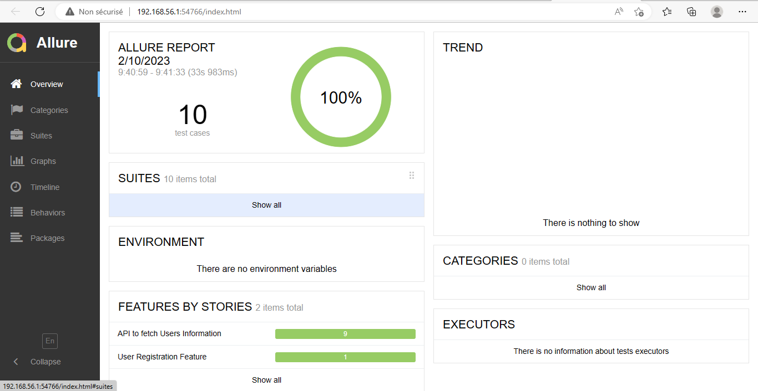

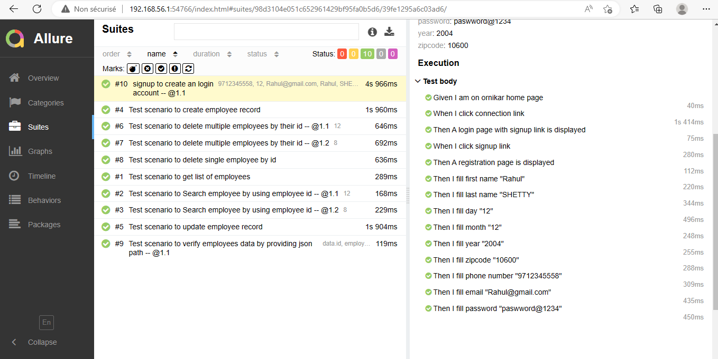

8. (optional but much appreciated) Use your framework for Automate all the tests you think are relevant for the UI

8.1. Use the Page Objects
8.2. Use Gherkin language
8.3. Set your .yml file
8.4. create an execution report
8.5. Save your project in gitlab or github.

Part II : Make an analysis of the API (http://dummy.restapiexample.com/):

1. Explain to the new product owner what are the api’s for and their purpose

Api’s essentially allow excanhge of information/data , APIs are a set of functions and procedures that allow for the creation update information related to employee, we use these employee details in our application for our bussiness.

DUMMY provide you a way to query an external application to get that data so that you can view or use it in our application. this dummy api is providing all the employees details of the company

through this api we make updates on a given employee details and delete any non existing emlployee in the data base.

So The API provides access to data, so this data can be included in our different applications. Instead of attempting to format a big file in a local application to extract a little bit of data, an API delivers the data you’re looking for without needing additional investigation or manipulation. It’s a much more efficient way to find the information you’re seeking and plug it in.

2. Write a test strategy

3. What kind of framework automation do you like and explain why you want to use it (pros / con)

4. Explain your automation process for the API

Web service (Rest/API) testing.

I get all the required resource endpoints w.r.t the request to send

I create all repected business related features in feature folder
and write down corresponding step definitions
I do primarily POST request operation first and later POST, PUT, GET, DELETE
I validate all Media type in the api Response
I validate headers, cookies..etc
I perform Schema validations

5. Send us an example that you use for a QA report.

6. (Optional but much appreciated) Use your framework to Automate all the tests you think are relevant for API Rest.

ALLURE EXECUTION REPORT

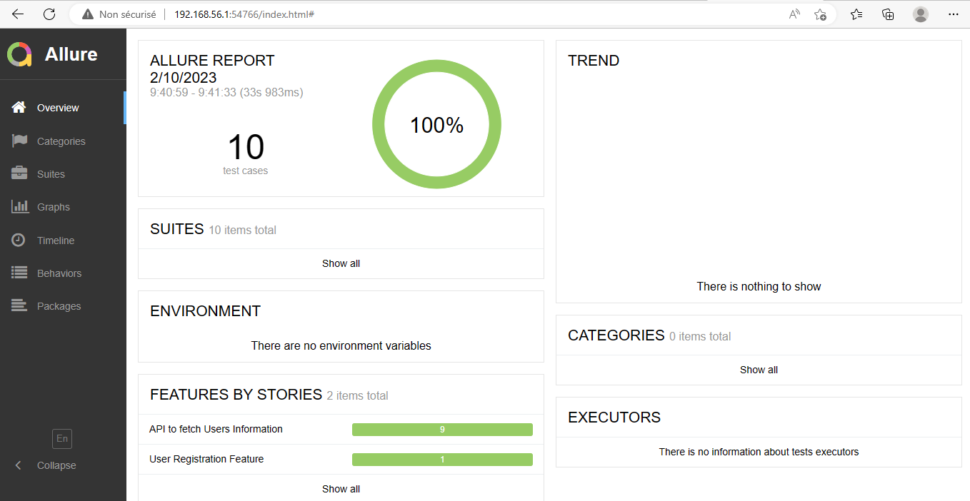

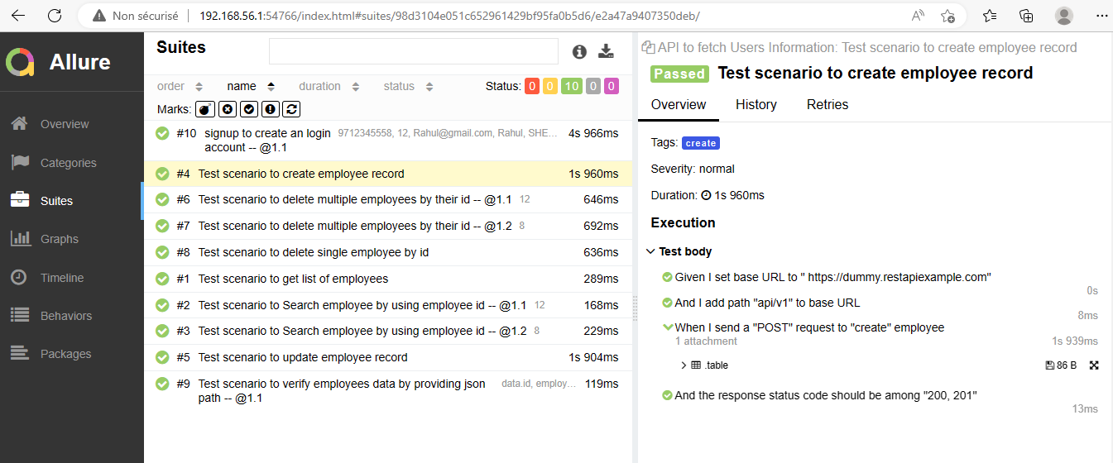

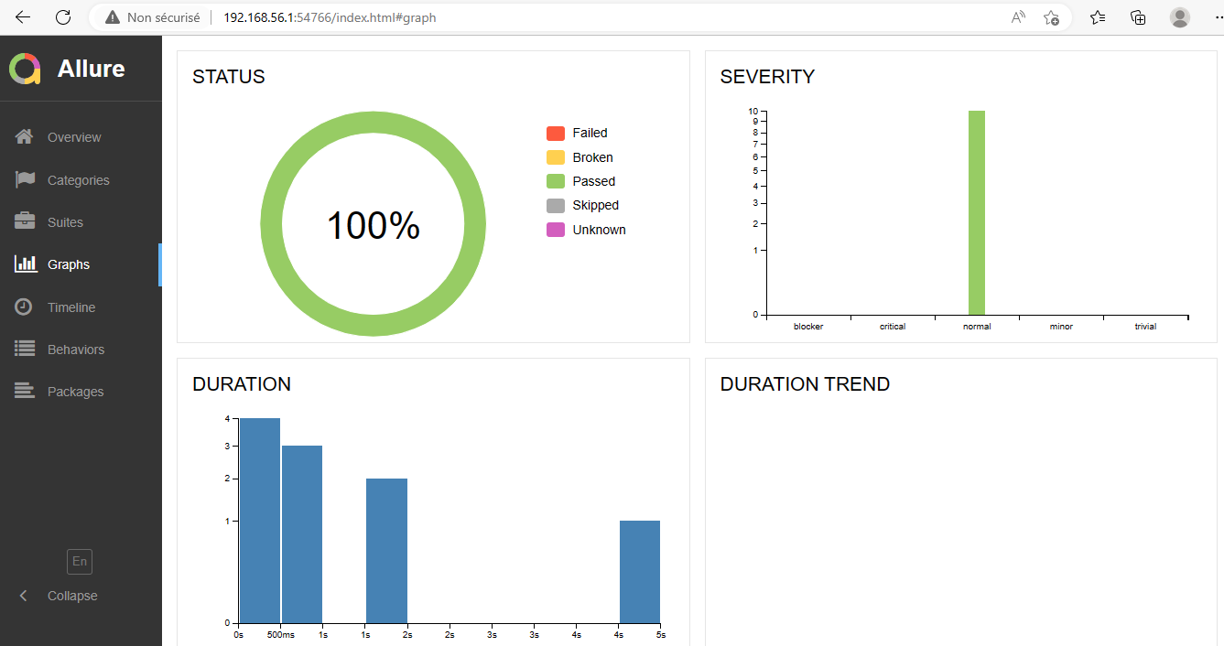

6.4. Save your project in Gitlab or Github.

https://github.com/skmdmpasha/Ornikar_TecnicalTest.git

regards,
Pasha SHAIK (QA Engineer)

