# FERRA FILTER CANDIDATE PROJECT ASSIGNMENT

## Column Titles and Usage Areas in ferra_orjinal_muadil.xlsx Data

• Ferra_no_b = The number assigned by Ferra Filter

• firma_adi = Manufacturer company name

• filtre_no_b = The number reflected to the customer in the catalog

• filtre_no_goster = The column where the search will be conducted

• hangi_katalog = The catalog from which the data originates in our catalog

• orjinal_muadil =

- 0 - Numbers assigned by Ferra Filter

- 1 - Original Manufacturer (OEM)

- 2 - Aftermarket Manufacturer (PRODUCER)

- 3 - Aftermarket Manufacturers in Turkey (PRODUCERS)

## Column Titles and Usage Areas in Filtreler.xlsx Data

• foto1 = The column containing the photo information provided to you.

• ferra_no_bosluksuz = The number assigned by Ferra Filter

• filtre_tipi_tr = The column indicating the filter type

• filtre_durumu = Information on the current status of the filter

## Candidate Expectations

Using the provided data, a search function should be implemented where the filter number can be entered in the search field (filtre_no_goster).

Special characters and/or spaces (/,-,(,),. etc.) will be included in the text entered into the search textbox. The candidate must match this information with the filtre_no_goster field and perform the search using a "contains" method.

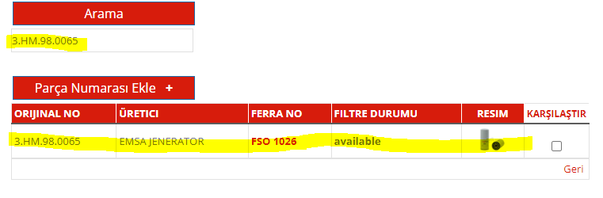

## Search Rules

• The search results should include the following columns from the ferra_orjinal_muadil.xlsx table:

- filtre_no_b

- firma_adi

- Ferra_no_b

• The matched Ferra_no_b value should be searched in the ferra_no_bosluksuz column in Filtreler.xlsx data, and the corresponding filtre_durumu and a thumbnail of the image in foto1 should be displayed.

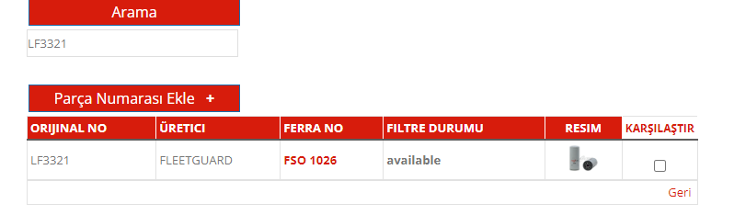

## Query Results Listing Rules

Among the query results, filtering should be performed based on the sabit_degisken column as follows:

• If RD is present, list only RD

• If RD is absent but ND is present, list only ND

• If neither RD nor ND is present but SD is present, list only SD

• If RD, ND, and SD are absent but YD is present, list only YD

• If none of RD, ND, SD, and YD are present, list only DD

## Detailed Listing by Clicking Ferra No

When clicking on the number in the Ferra No field, two separate pages should be created to list relevant information:

### Page 1 (Ferra Filter)

All data from Filtreler.xlsx should be listed in the order and layout shown in the reference image.

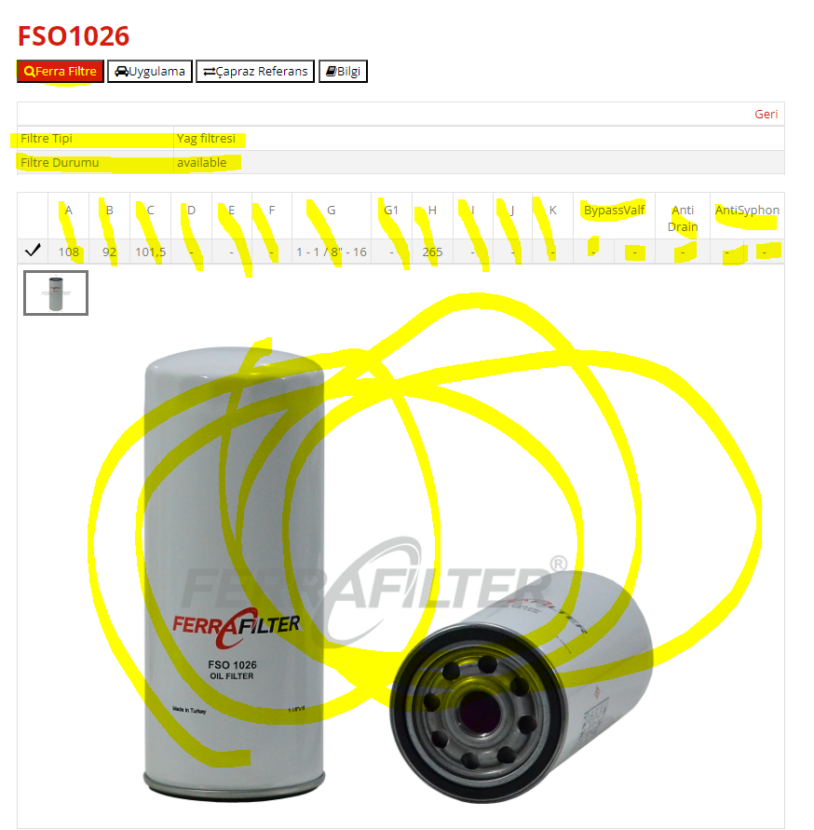

### Page 2 (Cross Reference)

This page should list the firma_adi and filtre_no_b columns from ferra_orjinal_muadil.xlsx, grouped as follows:

• OEM NO Section: This section should include records where orjinal_muadil is 1.

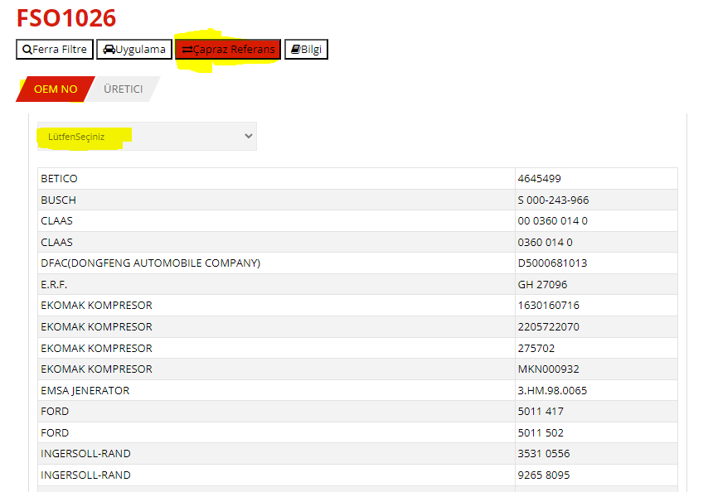

• MANUFACTURER Section: This section should include records where orjinal_muadil is 2.

