

**Title of the project:** *A BLACK JACK GAME*

**Group name and Ids:**

Sk Mohammad Asem(sec 3)

2017-3-60-068

Sayed Shafa(sec 3)

2017-3-60-016

Shimanto chakroborty(sec 3)

2017-2-68-001

Department: Computer Science and Engineering

University: East West University

Country: Bangladesh

Session: Summer 18

Date: August 2018

**CSE107 – Object Oriented Programming**

**Project Evaluation Rubrics**

|  |  |  |  |  |
| --- | --- | --- | --- | --- |
|  |  | **Max.** |  | **Awarded** |
|  | |  |  |  |
| **A. Report** | |  |  |  |
|  |  |  |  |  |
| i. | Introduction / Problem statement |  |  |  |
|  |  |  |  |  |
| iv. | System Design |  |  |  |
|  |  |  |  |  |
| v. | Program output (Screen shots) |  |  |  |
|  |  |  |  |  |
| vi. | Source code |  |  |  |
|  | |  |  |  |
| vii. Disk/CD neatly attached (Y/N) | |  |  |  |
|  | |  |  |  |
|  | |  |  |  |
| **B. Source Code** | |  |  |  |
|  |  |  |  |  |
| i. | Style |  |  |  |
|  |  |  |  |  |
|  | Indentation |  |  |  |
|  |  |  |  |  |
|  | Self-documentation |  |  |  |
|  |  |  |  |  |
| ii. | Modularity (small size functions) |  |  |  |
|  |  |  |  |  |
| iii. | Error reporting capabilities |  |  |  |
|  |  |  |  |  |
| iv. | Code efficiency, strategy, and originality |  |  |  |
|  | |  |  |  |
|  | |  |  |  |
| **C. Program Execution** | |  |  |  |
|  |  |  |  |  |
| i. | Compile without errors |  |  |  |
|  |  |  |  |  |
| ii. | User friendly |  |  |  |
|  |  |  |  |  |
| iii. | Error free during runtime |  |  |  |
|  |  |  |  |  |
| iv. | Program output |  |  |  |
|  | |  |  |  |
|  | |  |  |  |
| **D. Presentation and Demonstration [Psychomotor Domain]** | |  |  |  |
|  | |  |  |  |
| i. Presentation and communication skills (**Soft skill)** | |  |  |  |
|  | |  |  |  |
|  | |  |  |  |
| **E. Bonus** | |  |  |  |
|  |  |  |  |  |
| i. | Extra significant features |  |  |  |
|  |  |  |  |  |
|  | **TOTAL** |  | **10** |  |
|  |  |  |  |  |

2

**CSE107 – Object Oriented Programming**

**Project Declaration**

**(Student 1)**

**Student ID 2017-3-60-068**

**Name Sk Mohammad Asem**

**Session Summer18**

**Project No. 08**

**Date submitted 30-08-2018**

**Deadline of the project 30-08-2018**

**My contribution in doing this 40%**

**project (in percentage) in the group**

**Description of my contribution in this Working on project programming and logical**

**project in the group part and cooperate with group members.**

**Number of hours I spent in doing this Daily 1 hour after submission my proposal**

**project**

**(Student 2)**

**Student ID 2017-3-60-016**

**Name Sayed Shafa**

**Session Summer18**

**Project No. 08**

**Date submitted 30-08-2018**

**Deadline of the project 30-08-2018**

**My contribution in doing this 30%**

**project (in percentage) in the group**

**Description of my contribution in this Making game proposal and cooperate with**

**project in the group group members to make the project.**

3

**Number of hours I spent in doing this Daily 1 hour after submission my proposal**

**project**

**(Student 3)**

**Student ID 2017-2-60-001**

**Name** Shimanto chakroborty

**Session Summer18**

**Project No. 08**

**Date submitted 30-08-2018**

**Deadline of the project 30-08-2018**

**My contribution in doing this 30%**

**project (in percentage) in the group**

**Description of my contribution in this Making report of the project and helping logical**

**project in the group part of the project.**

**Number of hours I spent in doing this Daily 1 hour after submission my proposal**

**project**

**We hereby certify that this project represents the work done by all our group members with our contribution clearly stated above without copying from any other resources. We declare that no part of our work has been copied from or by other groups, and that no collusion has taken place with any other persons or groups.**

**We certify that any disks submitted with this project have been virus checked and have no viruses on them.**

(1) Signature: …………………………… Date: ........................................

(2) Signature: …………………………… Date: ........................................

(3) Signature: …………………………… Date: ........................................

4

**Introduction:**

Blackjack is a comparing card game between usually a player and a dealer, where player in turn competes against the dealer. It is played with 13 cards and is the most widely played casino banking game in the world.

**Basic Mode of playing:**

* Each player will have 1000 dollars at the beginning.
* Player will randomly get the first and second card
* Then the player will be asked for stand or hit
* If the total sum of the two cards is greater than the dealer’s card , he will win or otherwise

**System Design:**

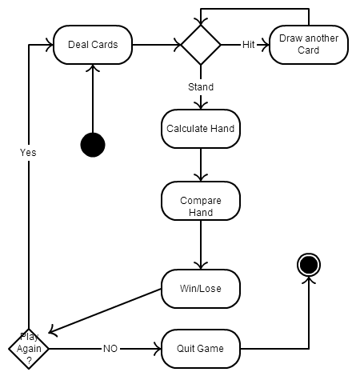

Fig: Blackjack diagram

**Program Output (screenshot of the game):**

Before the game started

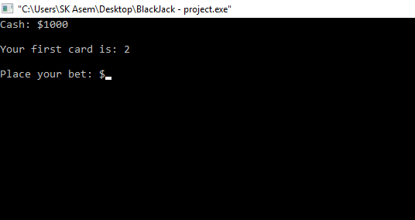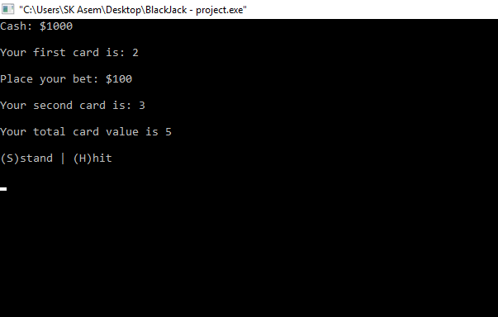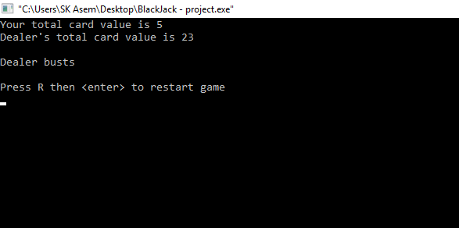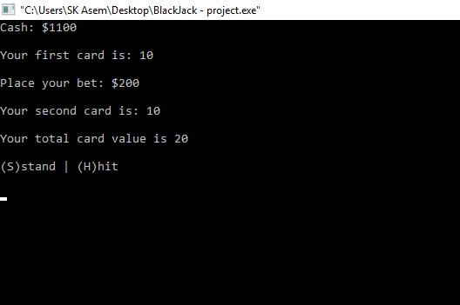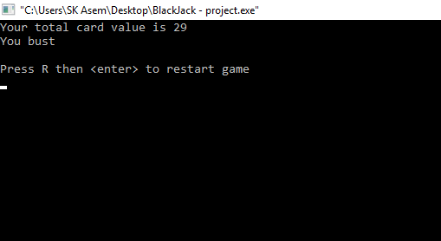

**Limitations of the program:**

* It is a one player game
* The start menu of the game is not created yet
* It is a console game

**Appendix (Source Code):**

