**EAST WEST UNIVERSITY**

**Project Report**

Project Title: Blood Donation Database

Course Code: CSE435

Course Title: Software Quality Assurance  
Section: 02

**Submitted by:**

Sk Mohammad Asem

ID:2017-3-60-068

Nazibullah MD Aynan

ID:2017-3-60-073

Md Abdullah Al mamun

ID:2017-3-60-024

Shebu Dhar

ID:2017-1-60-137

Rokeya Sharmin

ID:2017-2-60-020

**Submitted to:**

Dr. Shamim H Ripon

Department of Computer Science & Engineering,

East West University

Date of Submission: 15 September 2022

**Project Description:**

In our proposed project, we want to develop a Blood Donation Database to help people, who need blood quickly and easiest way. Because Blood Donation Database is designed web-based to store, retrieve, process and analyze information connected with the administrative.

We made a direct connection between donors and customers through this website. So that the customers can easily find the exact blood group and contact the donor who is in the nearest area possible. The search area would be district and ‘Thana’ wise. The customers and donors need to create an account using t`heir name, email id, phone number, location nationality, blood group, password, etc information and after that, they can log in anytime they need.

The donors need to give some extra information such as weight, gender, no of the previous donation, date of birth, etc. This information of donors and customers will be store in a database. The admin also can log in separately and can add or edit data. The customers can search for necessary blood groups after login and can see the numbers and details of the donors available in the nearest area. Then they can contact the donors so that blood donation can be possible. Thus the Blood Donation Database can help people finding emergency blood in the quickest and easiest way possible.

**Sequence Diagram Of The Project:**

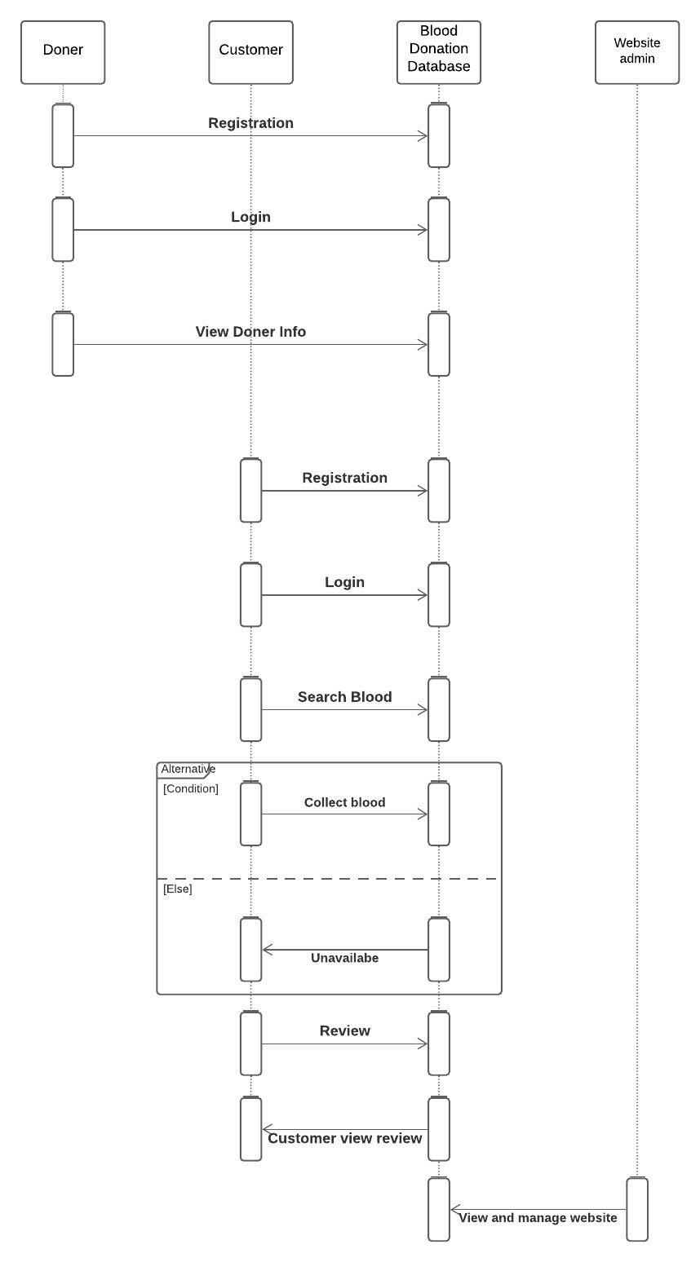

Figure-1:Blood Donation Database Sequence Diagram

**Sequence Diagram 1:**

Patient make an appointment and search for donor.

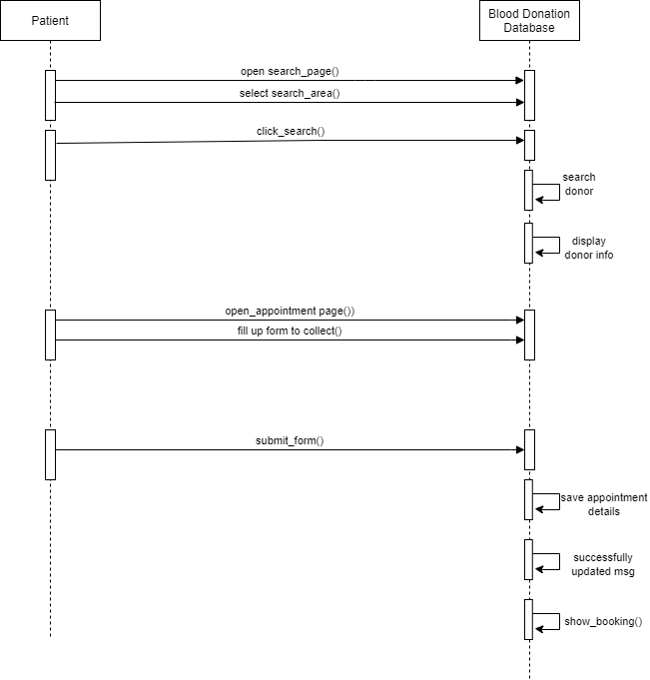

Figure-2: Sequence Diagram No 1

**Description 1:**

The patient is visiting the search page and entering the term in this diagram. The system will search for the keyword and will immediately display any nearby doner that may be found. The systems work as both the database component and the frontend. The patient will access the appointment page, provide his or her information, and submit the form to receive an acknowledgment from the system. The computer will store the data and display a success message before giving the patient their reservation once more.

**FPS code 1:**

Patient = (open_search_page -> select_search_area -> click_search -> open_appointment_page -> required_to_fillup_form -> submit_form -> Patient).

System = (search_doner -> doner_info -> display_doner_info -> save_appointment_details -> success_message -> show_booking -> System).

||Patient_System_AppointmentSearch = (Patient || System)

/{click_search/search_doner,click_search/display_doner_info,submit_form/show_booking}.

**State Transition Diagrams and Combined Diagram 1:**

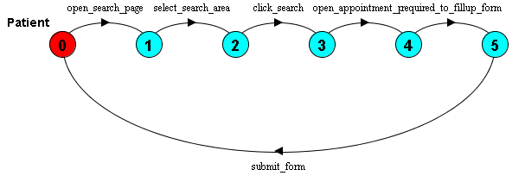

Figure-3: Patient State Transition Diagram

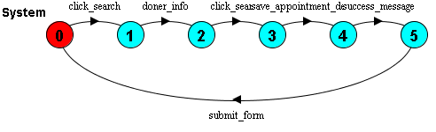

Figure-4: System State Transition Diagram

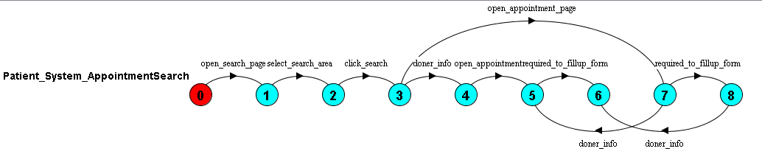

Figure-5:Patient_System_AppoinmentSearch State Transition Diagram

**Sequence Diagram 2:**

**Admin login and add new donor.**

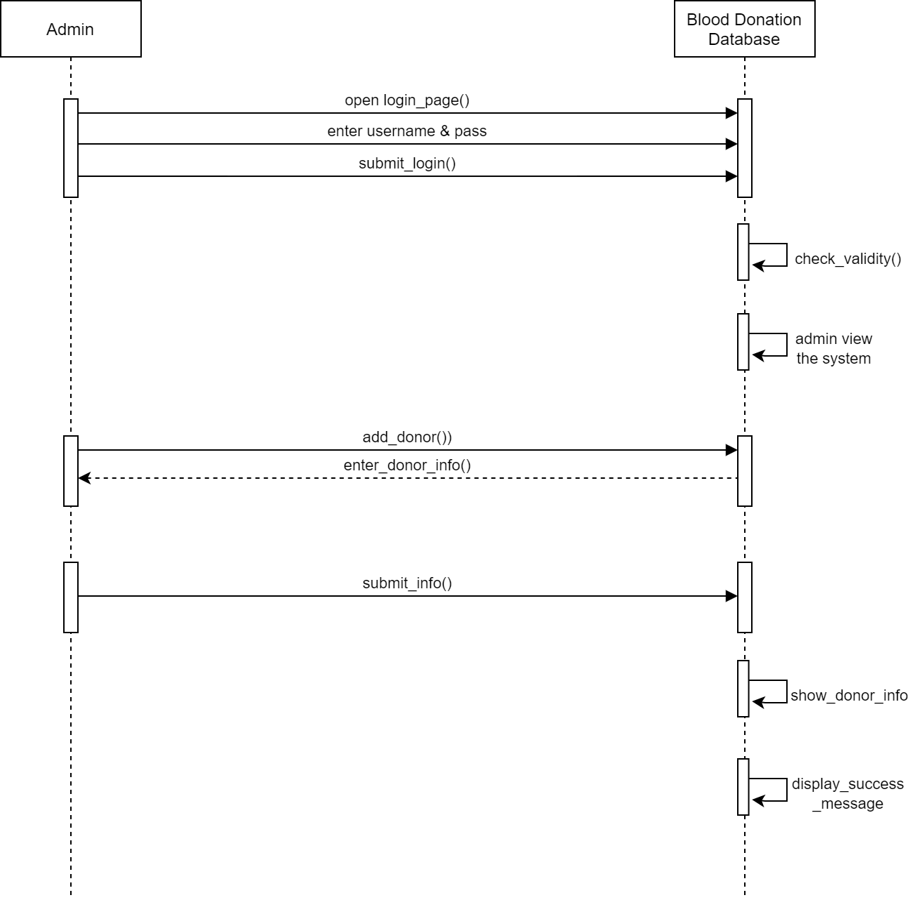

Figure-6: Sequence Diagram No 2

**Description 2:**

In this sequence diagram, an donor is visiting the login page. After entering the username and password, the form is submitting to the System. The system checks the validity and admin view the system to the Admin view page. On this page, an admin can also add another donor. For adding, the donor will enter information and submit the information to the System, and the System will check and run the function and it will display a success message.

**FPS code 2:**

Admin = (open_login_page -> enter_username_password -> submit_login -> add_doner -> enter_info -> submit_info -> Admin).

Blood_donation_system = (check_validity -> admin_view -> add_doner -> checkError -> display_success_message -> Blood_donation_system ).

||Admin_Blood_donation_system = (Admin ||Blood_donation_system )

/{submit_login/check_validity,submit_info/checkError}.

**State Transition Diagrams and Combined Diagram 2:**

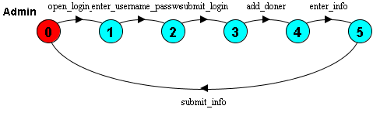

Figure-7: Admin State Transition Diagram

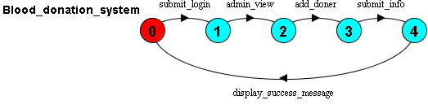

Figure-8: Blood_Donation_System State Transition Diagram

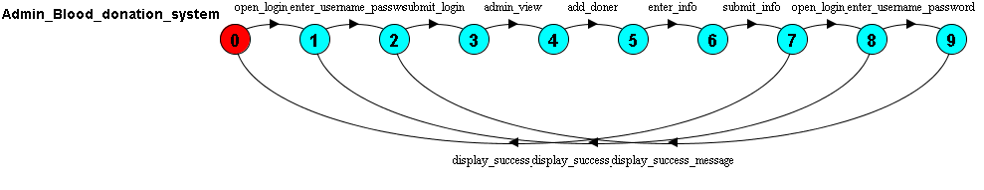

Figure-9: Admin_Blood_Donation_System State Transition Diagram