MANAV RACHNA INTERNATIONAL INSTITUTE OF RESEARCH & STUDIES
School of Computer Applications (SCA)
――――――――――――――――――――――――――――――――――――――――
LAB PRACTICAL RECORD FILE
DATA STRUCTURES & ALGORITHMS

SUBMITTED TO:  Mr. Sachin Sharma  Faculty / Assistant Professor  School of Computer Applications  MRIIRS | SUBMITTED BY:  Dwadasi Venkata Sri Sai Kumar  Roll No: 26MCAP101N007  Course: MCA  Semester: 1
Academic Session 2026 - 2027

INDEX OF EXPERIMENTS
Exp. No. | Date | Title of Experiment | Page No. | Sign & Remarks
Exp 1 | 14-10-2026 | List Operations (Insertion, Deletion and Display) | 3
Exp 2 | 14-10-2026 | Sorting Algorithms & Time Complexity Comparison | 4
Exp 3 | 14-10-2026 | Linear Search vs Binary Search & Time Comparison | 5
Exp 4 | 14-10-2026 | Stack, Queue, Circular Queue and Browser History | 6
Exp 5 | 14-10-2026 | Evaluation of Postfix Expression | 7
Exp 6 | 14-10-2026 | Conversion of Infix to Postfix | 8
Exp 7 | 14-10-2026 | Circular Linked List (Insert, Delete, Display) | 9
Exp 8A | 14-10-2026 | Stack using Linked List | 10
Exp 8B | 14-10-2026 | Queue using Linked List | 11
Exp 8C | 14-10-2026 | Circular Queue using Linked List | 12
Exp 9A | 14-10-2026 | Concatenation of Two Linked Lists | 13
Exp 9B | 14-10-2026 | Polynomial Addition using Linked Lists | 14
Exp 10 | 14-10-2026 | Doubly Linked List (Insert, Delete, Display) | 15

EXPERIMENT 1: LIST OPERATIONS (INSERTION, DELETION AND DISPLAY)
AIM: To write and execute a Python program to perform basic operations on a list: inserting an element at a specified position, deleting an element by position, and displaying the list contents.
Python Source Code
# Simple program for list operations: Insertion, Deletion, Display
my_list = []
def insert():
value = input("Enter value to insert: ")
pos = input("Enter position (press Enter to add at end): ")
if pos == "":
my_list.append(value)
else:
my_list.insert(int(pos), value)
print("Inserted successfully.")
def delete():
if not my_list:
print("List is empty. Nothing to delete.")
return
value = input("Enter value to delete: ")
if value in my_list:
my_list.remove(value)
print("Deleted successfully.")
else:
print("Value not found in the list.")
def display():
if not my_list:
print("List is empty.")
else:
print("List elements:", my_list)
while True:
print("\n--- LIST OPERATIONS ---")
print("1. Insertion")
print("2. Deletion")
print("3. Display")
print("4. Exit")
choice = input("Enter your choice: ")
if choice == "1":
insert()
elif choice == "2":
delete()
elif choice == "3":
display()
elif choice == "4":
print("Program ended.")
break
else:
print("Invalid choice. Try again.")

Space for Output
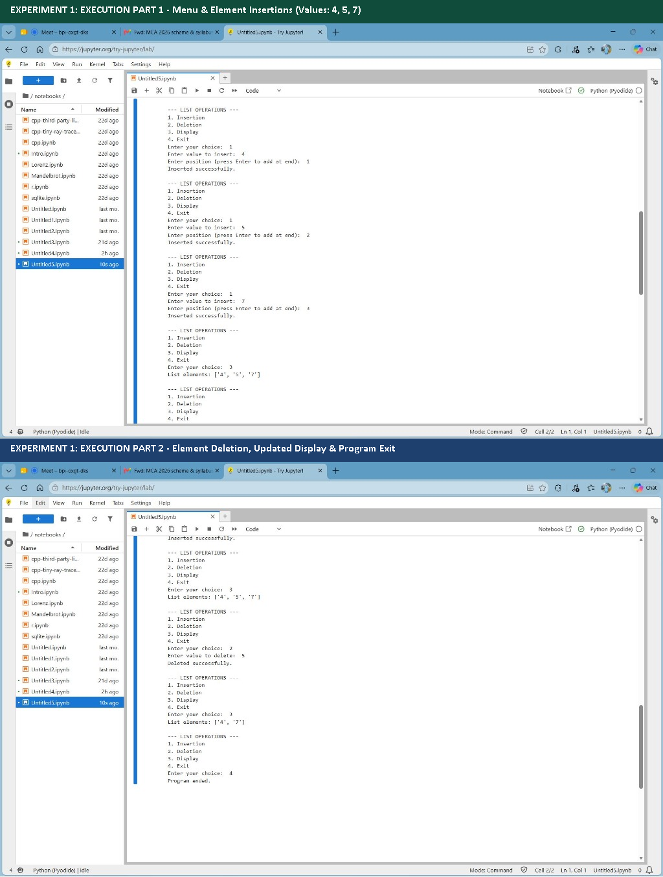
Figure: Execution output of List Operations (Insertion, Deletion and Display)
Sample Run: Execution Log / Console Output (Terminal Execution):
--- LIST OPERATIONS ---
1. Insertion
2. Deletion
3. Display
4. Exit
Enter your choice: 1
Enter value to insert: 4
Enter position (press Enter to add at end): 1
Inserted successfully.
--- LIST OPERATIONS ---
1. Insertion
2. Deletion
3. Display
4. Exit
Enter your choice: 1
Enter value to insert: 5
Enter position (press Enter to add at end): 2
Inserted successfully.
--- LIST OPERATIONS ---
1. Insertion
2. Deletion
3. Display
4. Exit
Enter your choice: 1
Enter value to insert: 7
Enter position (press Enter to add at end): 3
Inserted successfully.
--- LIST OPERATIONS ---
1. Insertion
2. Deletion
3. Display
4. Exit
Enter your choice: 3
List elements: ['4', '5', '7']
--- LIST OPERATIONS ---
1. Insertion
2. Deletion
3. Display
4. Exit
Enter your choice: 2
Enter value to delete: 5
Deleted successfully.
--- LIST OPERATIONS ---
1. Insertion
2. Deletion
3. Display
4. Exit
Enter your choice: 3
List elements: ['4', '7']
--- LIST OPERATIONS ---
1. Insertion
2. Deletion
3. Display
4. Exit
Enter your choice: 4
Program ended.

Result: The program was implemented and executed successfully. All operations and output results were verified against expected algorithmic behavior.

EXPERIMENT 2: SORTING ALGORITHMS (BUBBLE, QUICK, INSERTION, MERGE, HEAP) & TIME COMPARISON
AIM: To write and execute a Python program to sort a list using Bubble Sort, Insertion Sort, Quick Sort, Merge Sort, and Heap Sort, and compare them on the basis of execution time and asymptotic time complexities.
Algorithmic Comparison Matrix
Algorithm | Best Time | Avg Time | Worst Time | Aux Space | Stability | In-Place
Bubble Sort | O(n) | O(n^2) | O(n^2) | O(1) | Yes | Yes
Insertion Sort | O(n) | O(n^2) | O(n^2) | O(1) | Yes | Yes
Quick Sort | O(n log n) | O(n log n) | O(n^2) | O(log n) | No | Yes
Merge Sort | O(n log n) | O(n log n) | O(n log n) | O(n) | Yes | No
Heap Sort | O(n log n) | O(n log n) | O(n log n) | O(1) | No | Yes

Python Source Code
# Sorting a list using Bubble, Quick, Insertion, Merge and Heap sort
# and comparing them on the basis of time
import random
import time
def bubble_sort(a):
n = len(a)
for i in range(n):
for j in range(n - i - 1):
if a[j] > a[j + 1]:
a[j], a[j + 1] = a[j + 1], a[j]
return a
def insertion_sort(a):
for i in range(1, len(a)):
key = a[i]
j = i - 1
while j >= 0 and a[j] > key:
a[j + 1] = a[j]
j -= 1
a[j + 1] = key
return a
def quick_sort(a):
if len(a) <= 1:
return a
pivot = a[len(a) // 2]
left = [x for x in a if x < pivot]
middle = [x for x in a if x == pivot]
right = [x for x in a if x > pivot]
return quick_sort(left) + middle + quick_sort(right)
def merge_sort(a):
if len(a) <= 1:
return a
mid = len(a) // 2
left = merge_sort(a[:mid])
right = merge_sort(a[mid:])
result = []
while left and right:
if left[0] <= right[0]:
result.append(left.pop(0))
else:
result.append(right.pop(0))
return result + left + right
def heapify(a, n, i):
largest = i
l, r = 2 * i + 1, 2 * i + 2
if l < n and a[l] > a[largest]:
largest = l
if r < n and a[r] > a[largest]:
largest = r
if largest != i:
a[i], a[largest] = a[largest], a[i]
heapify(a, n, largest)
def heap_sort(a):
n = len(a)
for i in range(n // 2 - 1, -1, -1):
heapify(a, n, i)
for i in range(n - 1, 0, -1):
a[0], a[i] = a[i], a[0]
heapify(a, i, 0)
return a
# Main program
data = [random.randint(1, 10000) for _ in range(2000)]
print("Original list (first 10):", data[:10])
print("Sorted list (first 10):", sorted(data)[:10])
algorithms = [
("Bubble Sort", bubble_sort, "O(n)", "O(n^2)", "O(n^2)"),
("Insertion Sort", insertion_sort, "O(n)", "O(n^2)", "O(n^2)"),
("Quick Sort", quick_sort, "O(n log n)", "O(n log n)", "O(n^2)"),
("Merge Sort", merge_sort, "O(n log n)", "O(n log n)", "O(n log n)"),
("Heap Sort", heap_sort, "O(n log n)", "O(n log n)", "O(n log n)"),
]
print("\n%-15s %-12s %-12s %-12s %s" % ("Algorithm", "Best", "Average", "Worst", "Time taken (sec)"))
print("-" * 70)
for name, func, best, avg, worst in algorithms:
start = time.time()
result = func(data.copy())
end = time.time()
assert result == sorted(data)
print("%-15s %-12s %-12s %-12s %.4f" % (name, best, avg, worst, end - start))

Space for Output
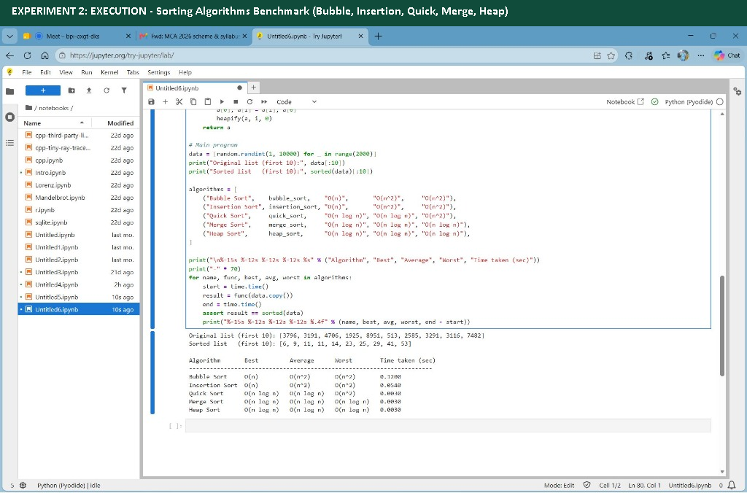
Figure: Execution output of Sorting Algorithms & Time Complexity Comparison
Sample Run: Execution Log / Console Output (Terminal Execution):
Original list (first 10): [3796, 3191, 4706, 1925, 8951, 513, 2585, 3291, 3116, 7482]
Sorted list (first 10): [6, 9, 11, 11, 14, 23, 25, 29, 41, 53]
Algorithm Best Average Worst Time taken (sec)
----------------------------------------------------------------------
Bubble Sort O(n) O(n^2) O(n^2) 0.1200
Insertion Sort O(n) O(n^2) O(n^2) 0.0540
Quick Sort O(n log n) O(n log n) O(n^2) 0.0030
Merge Sort O(n log n) O(n log n) O(n log n) 0.0030
Heap Sort O(n log n) O(n log n) O(n log n) 0.0030

Result: The program was implemented and executed successfully. All operations and output results were verified against expected algorithmic behavior.

EXPERIMENT 3: SEARCHING ALGORITHMS (LINEAR SEARCH AND BINARY SEARCH) & TIME COMPARISON
AIM: To write and execute a Python program to search for an element using Linear Search and Binary Search algorithms and compare their efficiency on the basis of execution time and asymptotic time complexities.
Searching Algorithms Comparison Matrix
Algorithm | Best Time | Average Time | Worst Time | Aux Space | Sorted Data Required?
Linear Search | O(1) | O(n) | O(n) | O(1) | No (Works on any list)
Binary Search | O(1) | O(log n) | O(log n) | O(1) | Yes (Requires sorted list)

Python Source Code
# Searching an element using Linear Search and Binary Search
# and comparing them on the basis of time
import time
def linear_search(a, key):
for i in range(len(a)):
if a[i] == key:
return i
return -1
def binary_search(a, key):
low, high = 0, len(a) - 1
while low <= high:
mid = (low + high) // 2
if a[mid] == key:
return mid
elif a[mid] < key:
low = mid + 1
else:
high = mid - 1
return -1
# Main program
a = list(range(1, 1000001)) # sorted list of 1 million numbers
key = int(input("Enter element to search (1 to 1000000): "))
start = time.time()
pos1 = linear_search(a, key)
t1 = time.time() - start
start = time.time()
pos2 = binary_search(a, key)
t2 = time.time() - start
print("\nLinear Search : found at index", pos1, "| time = %.8f sec" % t1)
print("Binary Search : found at index", pos2, "| time = %.8f sec" % t2)
print("\n%-15s %-8s %-10s %-10s %s" % ("Algorithm", "Best", "Average", "Worst", "Sorted list needed?"))
print("-" * 60)
print("%-15s %-8s %-10s %-10s %s" % ("Linear Search", "O(1)", "O(n)", "O(n)", "No"))
print("%-15s %-8s %-10s %-10s %s" % ("Binary Search", "O(1)", "O(log n)", "O(log n)", "Yes"))

Space for Output
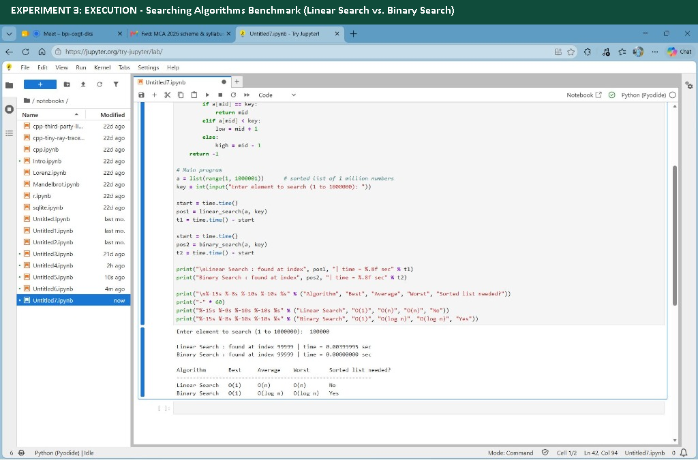
Figure: Execution output of Linear Search vs Binary Search & Time Comparison
Sample Run: Execution Log / Console Output (Terminal Execution):
Enter element to search (1 to 1000000): 100000
Linear Search : found at index 99999 | time = 0.00399995 sec
Binary Search : found at index 99999 | time = 0.00000000 sec
Algorithm Best Average Worst Sorted list needed?
------------------------------------------------------------
Linear Search O(1) O(n) O(n) No
Binary Search O(1) O(log n) O(log n) Yes

Result: The program was implemented and executed successfully. All operations and output results were verified against expected algorithmic behavior.

EXPERIMENT 4: STACK, QUEUE, CIRCULAR QUEUE (USING ARRAYS) & BROWSER HISTORY (USING STACKS)
AIM: To implement Stack, Linear Queue, and Circular Queue data structures using fixed-size arrays, and simulate web browser navigation history using dual stacks in Python.
Python Source Code
# Stack, Queue, Circular Queue (using arrays) and Browser History (using stacks)
SIZE = 5
# ---------------- STACK ----------------
class Stack:
def __init__(self):
self.arr = [None] * SIZE
self.top = -1
def push(self, x):
if self.top == SIZE - 1:
print("Stack Overflow")
else:
self.top += 1
self.arr[self.top] = x
print(x, "pushed")
def pop(self):
if self.top == -1:
print("Stack Underflow")
else:
print(self.arr[self.top], "popped")
self.top -= 1
def peek(self):
print("Top element:", self.arr[self.top]) if self.top != -1 else print("Stack is empty")
def display(self):
print("Stack:", self.arr[:self.top + 1]) if self.top != -1 else print("Stack is empty")
# ---------------- QUEUE ----------------
class Queue:
def __init__(self):
self.arr = [None] * SIZE
self.front = 0
self.rear = -1
def enqueue(self, x):
if self.rear == SIZE - 1:
print("Queue is Full")
else:
self.rear += 1
self.arr[self.rear] = x
print(x, "inserted")
def dequeue(self):
if self.front > self.rear:
print("Queue is Empty")
else:
print(self.arr[self.front], "removed")
self.front += 1
def display(self):
print("Queue:", self.arr[self.front:self.rear + 1]) if self.front <= self.rear else print("Queue is empty")
# ---------------- CIRCULAR QUEUE ----------------
class CircularQueue:
def __init__(self):
self.arr = [None] * SIZE
self.front = -1
self.rear = -1
def enqueue(self, x):
if (self.rear + 1) % SIZE == self.front:
print("Circular Queue is Full")
return
if self.front == -1:
self.front = 0
self.rear = (self.rear + 1) % SIZE
self.arr[self.rear] = x
print(x, "inserted")
def dequeue(self):
if self.front == -1:
print("Circular Queue is Empty")
return
print(self.arr[self.front], "removed")
if self.front == self.rear:
self.front = self.rear = -1
else:
self.front = (self.front + 1) % SIZE
def display(self):
if self.front == -1:
print("Circular Queue is empty")
return
items = []
i = self.front
while True:
items.append(self.arr[i])
if i == self.rear:
break
i = (i + 1) % SIZE
print("Circular Queue:", items)
# ---------------- BROWSER HISTORY (2 stacks) ----------------
class Browser:
def __init__(self):
self.back = [] # stack of previous pages
self.forward = [] # stack of forward pages
self.current = "Home"
def visit(self, url):
self.back.append(self.current)
self.current = url
self.forward = [] # new visit clears forward history
print("Visited:", self.current)
def go_back(self):
if not self.back:
print("No page to go back")
else:
self.forward.append(self.current)
self.current = self.back.pop()
print("Back to:", self.current)
def go_forward(self):
if not self.forward:
print("No page to go forward")
else:
self.back.append(self.current)
self.current = self.forward.pop()
print("Forward to:", self.current)
def show(self):
print("Back stack :", self.back)
print("Current page :", self.current)
print("Forward stack:", self.forward)
# ---------------- MAIN MENU ----------------
s, q, cq, b = Stack(), Queue(), CircularQueue(), Browser()
while True:
print("\n1.Stack 2.Queue 3.Circular Queue 4.Browser History 5.Exit")
ch = input("Enter choice: ")
if ch == "1":
while True:
c = input("\n[Stack] 1.Push 2.Pop 3.Peek 4.Display 5.Back: ")
if c == "1": s.push(input("Enter value: "))
elif c == "2": s.pop()
elif c == "3": s.peek()
elif c == "4": s.display()
else: break
elif ch == "2":
while True:
c = input("\n[Queue] 1.Enqueue 2.Dequeue 3.Display 4.Back: ")
if c == "1": q.enqueue(input("Enter value: "))
elif c == "2": q.dequeue()
elif c == "3": q.display()
else: break
elif ch == "3":
while True:
c = input("\n[Circular Queue] 1.Enqueue 2.Dequeue 3.Display 4.Back: ")
if c == "1": cq.enqueue(input("Enter value: "))
elif c == "2": cq.dequeue()
elif c == "3": cq.display()
else: break
elif ch == "4":
while True:
c = input("\n[Browser] 1.Visit 2.Back 3.Forward 4.Show 5.Exit: ")
if c == "1": b.visit(input("Enter website: "))
elif c == "2": b.go_back()
elif c == "3": b.go_forward()
elif c == "4": b.show()
else: break
elif ch == "5":
print("Program ended.")
break
else:
print("Invalid choice.")

Space for Output
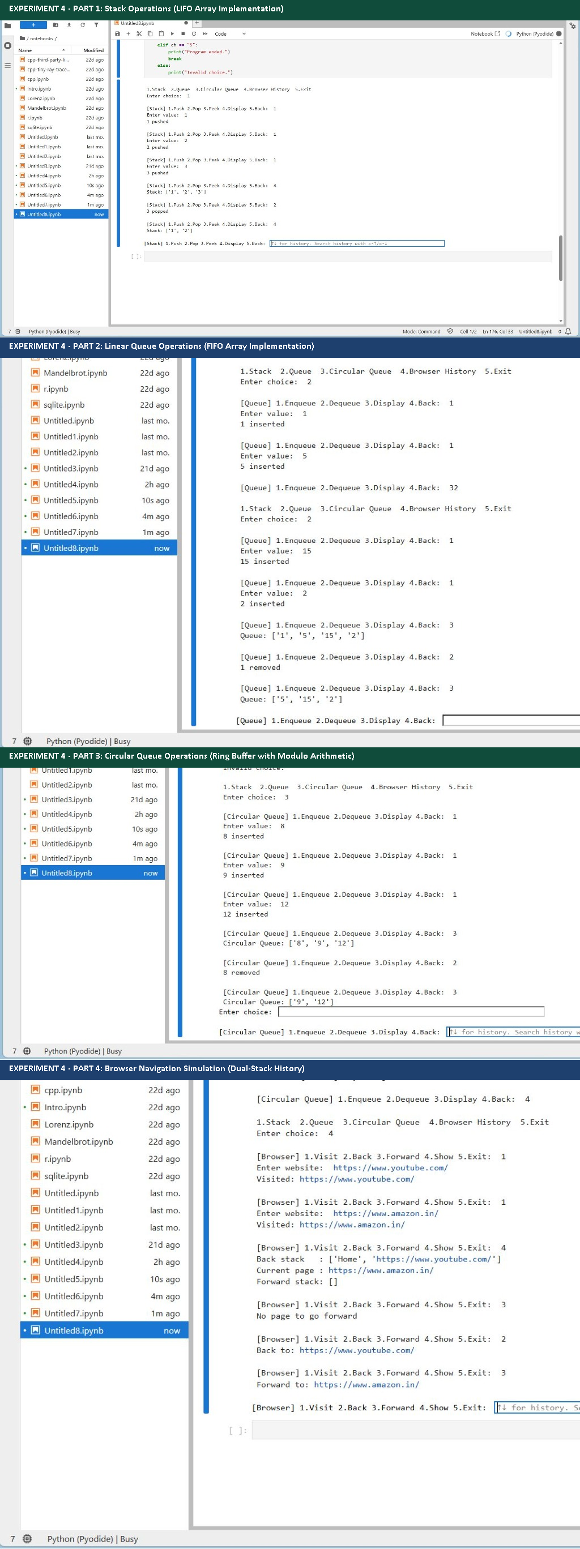
Figure: Execution output of Stack, Queue, Circular Queue and Browser History
Sample Run: Execution Log / Console Output (Terminal Execution):
1.Stack 2.Queue 3.Circular Queue 4.Browser History 5.Exit
Enter choice: 1
[Stack] 1.Push 2.Pop 3.Peek 4.Display 5.Back: 1
Enter value: 1
1 pushed
[Stack] 1.Push 2.Pop 3.Peek 4.Display 5.Back: 1
Enter value: 2
2 pushed
[Stack] 1.Push 2.Pop 3.Peek 4.Display 5.Back: 1
Enter value: 3
3 pushed
[Stack] 1.Push 2.Pop 3.Peek 4.Display 5.Back: 4
Stack: ['1', '2', '3']
[Stack] 1.Push 2.Pop 3.Peek 4.Display 5.Back: 2
3 popped
[Stack] 1.Push 2.Pop 3.Peek 4.Display 5.Back: 4
Stack: ['1', '2']
[Stack] 1.Push 2.Pop 3.Peek 4.Display 5.Back: 5
1.Stack 2.Queue 3.Circular Queue 4.Browser History 5.Exit
Enter choice: 2
[Queue] 1.Enqueue 2.Dequeue 3.Display 4.Back: 1
Enter value: 1
1 inserted
[Queue] 1.Enqueue 2.Dequeue 3.Display 4.Back: 1
Enter value: 5
5 inserted
[Queue] 1.Enqueue 2.Dequeue 3.Display 4.Back: 1
Enter value: 15
15 inserted
[Queue] 1.Enqueue 2.Dequeue 3.Display 4.Back: 1
Enter value: 2
2 inserted
[Queue] 1.Enqueue 2.Dequeue 3.Display 4.Back: 3
Queue: ['1', '5', '15', '2']
[Queue] 1.Enqueue 2.Dequeue 3.Display 4.Back: 2
1 removed
[Queue] 1.Enqueue 2.Dequeue 3.Display 4.Back: 3
Queue: ['5', '15', '2']
[Queue] 1.Enqueue 2.Dequeue 3.Display 4.Back: 4
1.Stack 2.Queue 3.Circular Queue 4.Browser History 5.Exit
Enter choice: 3
[Circular Queue] 1.Enqueue 2.Dequeue 3.Display 4.Back: 1
Enter value: 8
8 inserted
[Circular Queue] 1.Enqueue 2.Dequeue 3.Display 4.Back: 1
Enter value: 9
9 inserted
[Circular Queue] 1.Enqueue 2.Dequeue 3.Display 4.Back: 1
Enter value: 12
12 inserted
[Circular Queue] 1.Enqueue 2.Dequeue 3.Display 4.Back: 3
Circular Queue: ['8', '9', '12']
[Circular Queue] 1.Enqueue 2.Dequeue 3.Display 4.Back: 2
8 removed
[Circular Queue] 1.Enqueue 2.Dequeue 3.Display 4.Back: 3
Circular Queue: ['9', '12']
[Circular Queue] 1.Enqueue 2.Dequeue 3.Display 4.Back: 4
1.Stack 2.Queue 3.Circular Queue 4.Browser History 5.Exit
Enter choice: 4
[Browser] 1.Visit 2.Back 3.Forward 4.Show 5.Exit: 1
Enter website: https://www.youtube.com/
Visited: https://www.youtube.com/
[Browser] 1.Visit 2.Back 3.Forward 4.Show 5.Exit: 1
Enter website: https://www.amazon.in/
Visited: https://www.amazon.in/
[Browser] 1.Visit 2.Back 3.Forward 4.Show 5.Exit: 4
Back stack : ['Home', 'https://www.youtube.com/']
Current page : https://www.amazon.in/
Forward stack: []
[Browser] 1.Visit 2.Back 3.Forward 4.Show 5.Exit: 3
No page to go forward
[Browser] 1.Visit 2.Back 3.Forward 4.Show 5.Exit: 2
Back to: https://www.youtube.com/
[Browser] 1.Visit 2.Back 3.Forward 4.Show 5.Exit: 3
Forward to: https://www.amazon.in/
[Browser] 1.Visit 2.Back 3.Forward 4.Show 5.Exit: 5
1.Stack 2.Queue 3.Circular Queue 4.Browser History 5.Exit
Enter choice: 5
Program ended.

Result: The program was implemented and executed successfully. All operations and output results were verified against expected algorithmic behavior.

EXPERIMENT 5: EVALUATION OF A POSTFIX EXPRESSION USING A STACK
AIM: To write and execute a Python program to evaluate a Postfix (Reverse Polish) expression using the stack data structure.
Python Source Code
# Evaluation of a Postfix Expression using a Stack
def evaluate_postfix(expression):
stack = []
for token in expression.split():
if token.isdigit(): # operand -> push
stack.append(int(token))
else: # operator -> pop two, calculate, push
b = stack.pop()
a = stack.pop()
if token == '+':
stack.append(a + b)
elif token == '-':
stack.append(a - b)
elif token == '*':
stack.append(a * b)
elif token == '/':
stack.append(a / b)
elif token == '^':
stack.append(a ** b)
return stack.pop()
# Main program
exp = input("Enter postfix expression (separate with spaces, e.g. 2 3 1 * + 9 -): ")
print("Result =", evaluate_postfix(exp))

Space for Output
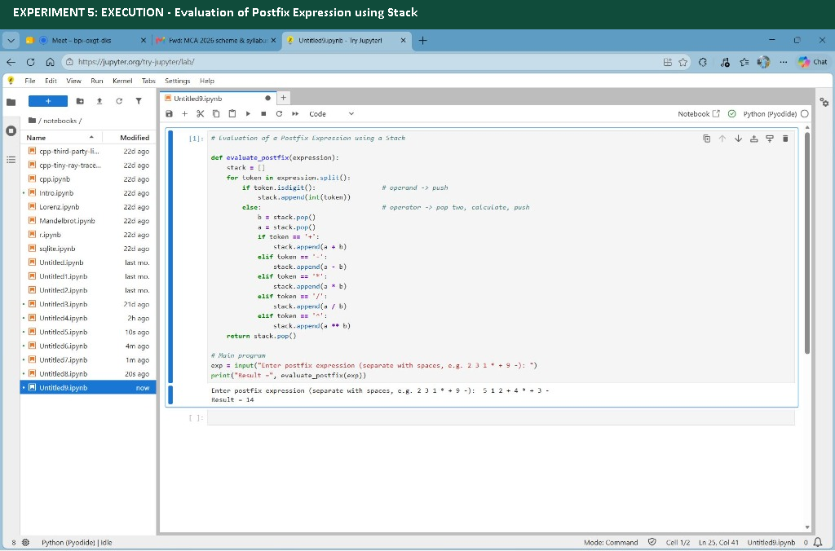
Figure: Execution output of Evaluation of Postfix Expression
Sample Run: Execution Log / Console Output (Terminal Execution):
Enter postfix expression (separate with spaces, e.g. 2 3 1 * + 9 -): 5 1 2 + 4 * + 3 -
Result = 14

Result: The program was implemented and executed successfully. All operations and output results were verified against expected algorithmic behavior.

EXPERIMENT 6: CONVERSION OF INFIX EXPRESSION TO POSTFIX USING STACK
AIM: To write and execute a Python program that converts an Infix mathematical expression to a Postfix expression using the stack-based Shunting-Yard algorithm.
Python Source Code
# Conversion of Infix Expression to Postfix Expression using a Stack
def precedence(op):
if op == '^':
return 3
if op in '*/':
return 2
if op in '+-':
return 1
return 0
def infix_to_postfix(expression):
stack = []
result = ""
for ch in expression:
if ch.isalnum(): # operand -> add to result
result += ch
elif ch == '(':
stack.append(ch)
elif ch == ')':
while stack and stack[-1] != '(':
result += stack.pop()
stack.pop() # remove '('
else: # operator
while stack and precedence(stack[-1]) >= precedence(ch) and ch != '^':
result += stack.pop()
stack.append(ch)
while stack:
result += stack.pop()
return result
# Main program
exp = input("Enter infix expression (e.g. A+B*C): ").replace(" ", "")
print("Postfix expression =", infix_to_postfix(exp))

Space for Output
[ SCREENSHOT / EXECUTION OUTPUT SLOT: exp6_infix_to_postfix.png ]
Paste terminal output screenshot here, or place 'exp6_infix_to_postfix.png' in 'screenshots_dsa/' folder.
Figure: Execution output of Conversion of Infix to Postfix
Sample Run: Execution Log / Console Output (Terminal Execution):
Enter infix expression (e.g. A+B*C): (A + B) * (C - D) / (E + F) + G * H
Postfix expression = AB+CD-*EF+/GH*+

Result: The program was implemented and executed successfully. All operations and output results were verified against expected algorithmic behavior.

EXPERIMENT 7: CIRCULAR LINKED LIST OPERATIONS (INSERT, DELETE, DISPLAY)
AIM: To implement a Circular Singly Linked List with operations: inserting a node at the end, deleting a node by value, and displaying the circular structure.
Python Source Code
# Experiment 7: Circular Linked List (Insert, Delete, Display)
class Node:
def __init__(self, data):
self.data = data
self.next = None
last = None
while True:
print("\n--- CIRCULAR LINKED LIST MENU ---")
print("1. Insert at end")
print("2. Delete by value")
print("3. Display")
print("4. Exit")
choice = int(input("Enter choice: "))
if choice == 1:
value = int(input("Enter value to insert: "))
new_node = Node(value)
if last is None:
last = new_node
new_node.next = new_node
else:
new_node.next = last.next
last.next = new_node
last = new_node
print(f"Node {value} inserted at end.")
elif choice == 2:
value = int(input("Enter value to delete: "))
if last is None:
print("List is empty!")
else:
current = last.next
previous = last
found = False
while True:
if current.data == value:
found = True
if current == last and current.next == current:
last = None
else:
previous.next = current.next
if current == last:
last = previous
print(f"Deleted {value} from circular list.")
break
previous = current
current = current.next
if current == last.next:
break
if not found:
print("Value not found in circular list!")
elif choice == 3:
if last is None:
print("Circular Linked List is empty.")
else:
print("Circular Linked List:", end=" ")
temp = last.next
while True:
print(temp.data, end=" -> ")
temp = temp.next
if temp == last.next:
break
print("(head)")
elif choice == 4:
print("Exiting...")
break
else:
print("Invalid choice!")

Space for Output
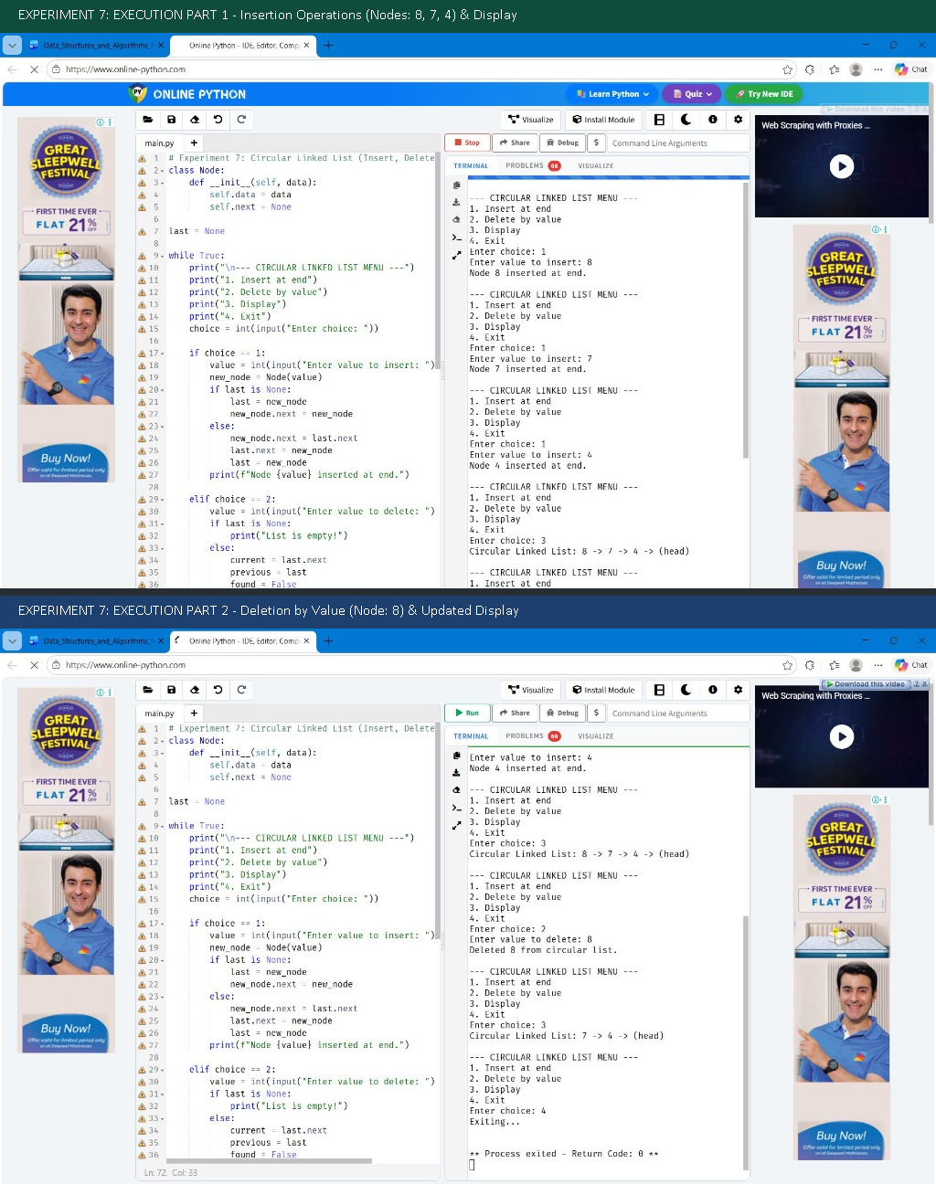
Figure: Execution output of Circular Linked List (Insert, Delete, Display)
Sample Run: Execution Log / Console Output (Terminal Execution):
--- CIRCULAR LINKED LIST MENU ---
1. Insert at end
2. Delete by value
3. Display
4. Exit
Enter choice: 1
Enter value to insert: 8
Node 8 inserted at end.
--- CIRCULAR LINKED LIST MENU ---
1. Insert at end
2. Delete by value
3. Display
4. Exit
Enter choice: 1
Enter value to insert: 7
Node 7 inserted at end.
--- CIRCULAR LINKED LIST MENU ---
1. Insert at end
2. Delete by value
3. Display
4. Exit
Enter choice: 1
Enter value to insert: 4
Node 4 inserted at end.
--- CIRCULAR LINKED LIST MENU ---
1. Insert at end
2. Delete by value
3. Display
4. Exit
Enter choice: 3
Circular Linked List: 8 -> 7 -> 4 -> (head)
--- CIRCULAR LINKED LIST MENU ---
1. Insert at end
2. Delete by value
3. Display
4. Exit
Enter choice: 2
Enter value to delete: 8
Deleted 8 from circular list.
--- CIRCULAR LINKED LIST MENU ---
1. Insert at end
2. Delete by value
3. Display
4. Exit
Enter choice: 3
Circular Linked List: 7 -> 4 -> (head)
--- CIRCULAR LINKED LIST MENU ---
1. Insert at end
2. Delete by value
3. Display
4. Exit
Enter choice: 4
Exiting...
** Process exited - Return Code: 0 **

Result: The program was implemented and executed successfully. All operations and output results were verified against expected algorithmic behavior.

EXPERIMENT 8A: STACK IMPLEMENTATION USING LINKED LIST
AIM: To implement a dynamically allocated Stack data structure using a Singly Linked List supporting Push, Pop, and Display operations.
Python Source Code
# Experiment 8A: Stack using Linked List
class Node:
def __init__(self, data):
self.data = data
self.next = None
top = None
while True:
print("\n--- LINKED STACK MENU ---")
print("1. Push")
print("2. Pop")
print("3. Display")
print("4. Exit")
choice = int(input("Enter choice: "))
if choice == 1:
x = int(input("Enter value to push: "))
new_node = Node(x)
new_node.next = top
top = new_node
print(f"Pushed {x} onto stack.")
elif choice == 2:
if top is None:
print("Stack Underflow (empty stack)!")
else:
print("Popped value:", top.data)
top = top.next
elif choice == 3:
if top is None:
print("Stack is empty.")
else:
print("Stack elements (top to bottom):", end=" ")
temp = top
while temp is not None:
print(temp.data, end=" -> ")
temp = temp.next
print("None")
elif choice == 4:
print("Exiting...")
break
else:
print("Invalid choice!")

Space for Output
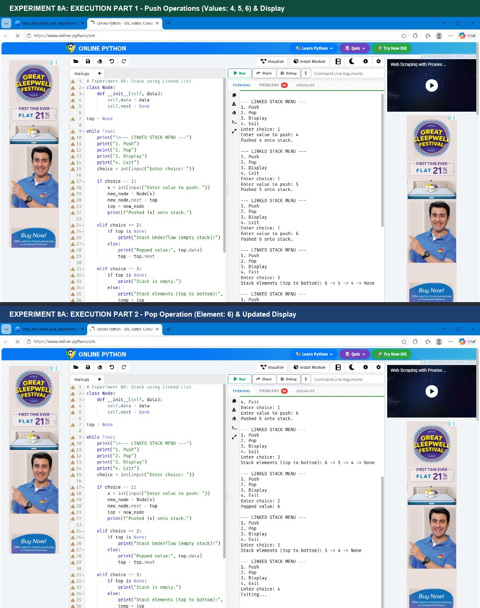
Figure: Execution output of Stack using Linked List
Sample Run: Execution Log / Console Output (Terminal Execution):
--- LINKED STACK MENU ---
1. Push
2. Pop
3. Display
4. Exit
Enter choice: 1
Enter value to push: 4
Pushed 4 onto stack.
--- LINKED STACK MENU ---
1. Push
2. Pop
3. Display
4. Exit
Enter choice: 1
Enter value to push: 5
Pushed 5 onto stack.
--- LINKED STACK MENU ---
1. Push
2. Pop
3. Display
4. Exit
Enter choice: 1
Enter value to push: 6
Pushed 6 onto stack.
--- LINKED STACK MENU ---
1. Push
2. Pop
3. Display
4. Exit
Enter choice: 3
Stack elements (top to bottom): 6 -> 5 -> 4 -> None
--- LINKED STACK MENU ---
1. Push
2. Pop
3. Display
4. Exit
Enter choice: 2
Popped value: 6
--- LINKED STACK MENU ---
1. Push
2. Pop
3. Display
4. Exit
Enter choice: 3
Stack elements (top to bottom): 5 -> 4 -> None
--- LINKED STACK MENU ---
1. Push
2. Pop
3. Display
4. Exit
Enter choice: 4
Exiting...
** Process exited - Return Code: 0 **

Result: The program was implemented and executed successfully. All operations and output results were verified against expected algorithmic behavior.

EXPERIMENT 8B: QUEUE IMPLEMENTATION USING LINKED LIST
AIM: To implement a Queue data structure using a Singly Linked List with front and rear pointers supporting Enqueue, Dequeue, and Display.
Python Source Code
# Experiment 8B: Queue using Linked List
class Node:
def __init__(self, data):
self.data = data
self.next = None
front = None
rear = None
while True:
print("\n--- LINKED QUEUE MENU ---")
print("1. Enqueue")
print("2. Dequeue")
print("3. Display")
print("4. Exit")
choice = int(input("Enter choice: "))
if choice == 1:
x = int(input("Enter value to enqueue: "))
new_node = Node(x)
if rear is None:
front = rear = new_node
else:
rear.next = new_node
rear = new_node
print(f"Enqueued {x} into queue.")
elif choice == 2:
if front is None:
print("Queue Underflow (empty queue)!")
else:
print("Dequeued value:", front.data)
front = front.next
if front is None:
rear = None
elif choice == 3:
if front is None:
print("Queue is empty.")
else:
print("Queue elements (front to rear):", end=" ")
temp = front
while temp is not None:
print(temp.data, end=" -> ")
temp = temp.next
print("None")
elif choice == 4:
print("Exiting...")
break
else:
print("Invalid choice!")

Space for Output
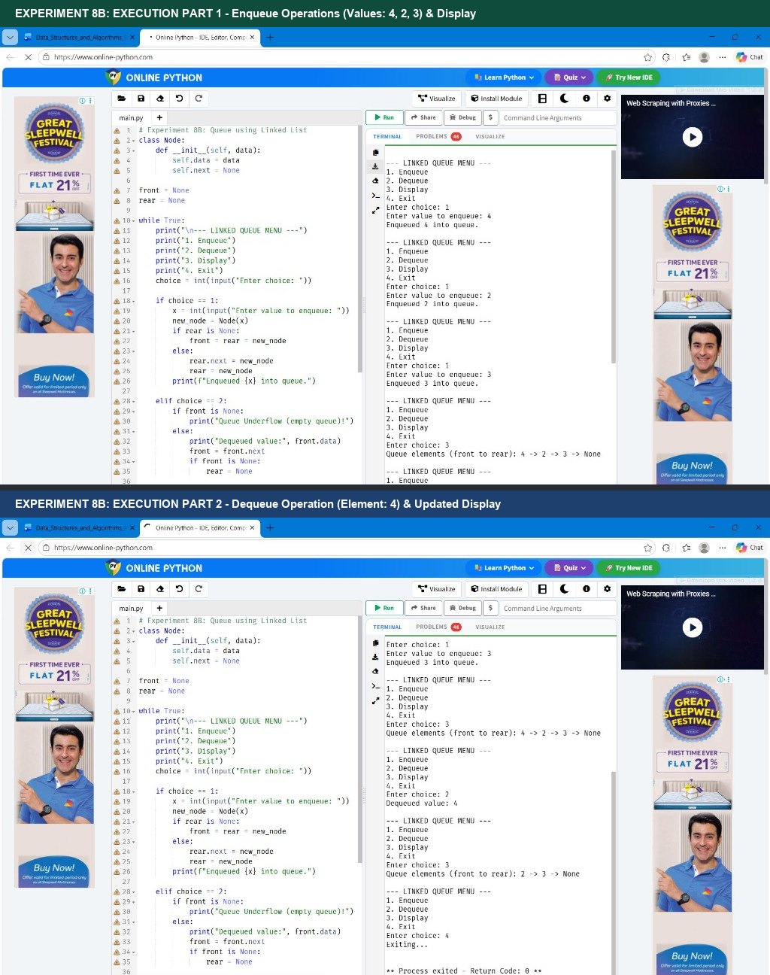
Figure: Execution output of Queue using Linked List
Sample Run: Execution Log / Console Output (Terminal Execution):
--- LINKED QUEUE MENU ---
1. Enqueue
2. Dequeue
3. Display
4. Exit
Enter choice: 1
Enter value to enqueue: 4
Enqueued 4 into queue.
--- LINKED QUEUE MENU ---
1. Enqueue
2. Dequeue
3. Display
4. Exit
Enter choice: 1
Enter value to enqueue: 2
Enqueued 2 into queue.
--- LINKED QUEUE MENU ---
1. Enqueue
2. Dequeue
3. Display
4. Exit
Enter choice: 1
Enter value to enqueue: 3
Enqueued 3 into queue.
--- LINKED QUEUE MENU ---
1. Enqueue
2. Dequeue
3. Display
4. Exit
Enter choice: 3
Queue elements (front to rear): 4 -> 2 -> 3 -> None
--- LINKED QUEUE MENU ---
1. Enqueue
2. Dequeue
3. Display
4. Exit
Enter choice: 2
Dequeued value: 4
--- LINKED QUEUE MENU ---
1. Enqueue
2. Dequeue
3. Display
4. Exit
Enter choice: 3
Queue elements (front to rear): 2 -> 3 -> None
--- LINKED QUEUE MENU ---
1. Enqueue
2. Dequeue
3. Display
4. Exit
Enter choice: 4
Exiting...
** Process exited - Return Code: 0 **

Result: The program was implemented and executed successfully. All operations and output results were verified against expected algorithmic behavior.

EXPERIMENT 8C: CIRCULAR QUEUE IMPLEMENTATION USING LINKED LIST
AIM: To implement a Circular Queue using a Linked List maintained with a single rear pointer.
Python Source Code
# Experiment 8C: Circular Queue using Linked List
class Node:
def __init__(self, data):
self.data = data
self.next = None
rear = None
while True:
print("\n--- LINKED CIRCULAR QUEUE MENU ---")
print("1. Enqueue")
print("2. Dequeue")
print("3. Display")
print("4. Exit")
choice = int(input("Enter choice: "))
if choice == 1:
x = int(input("Enter value: "))
new_node = Node(x)
if rear is None:
rear = new_node
new_node.next = new_node
else:
new_node.next = rear.next
rear.next = new_node
rear = new_node
print(f"Enqueued {x} in circular queue.")
elif choice == 2:
if rear is None:
print("Circular Queue Underflow!")
else:
first = rear.next
print("Dequeued value:", first.data)
if first == rear:
rear = None
else:
rear.next = first.next
elif choice == 3:
if rear is None:
print("Circular Queue is empty.")
else:
print("Circular Queue elements:", end=" ")
temp = rear.next
while True:
print(temp.data, end=" -> ")
temp = temp.next
if temp == rear.next:
break
print("(front)")
elif choice == 4:
print("Exiting...")
break
else:
print("Invalid choice!")

Space for Output
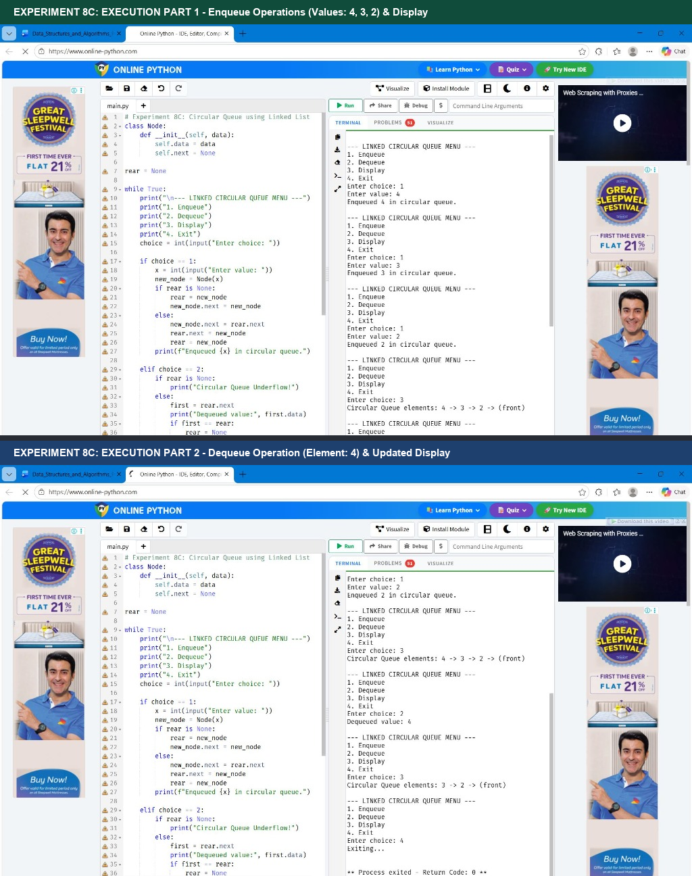
Figure: Execution output of Circular Queue using Linked List
Sample Run: Execution Log / Console Output (Terminal Execution):
--- LINKED CIRCULAR QUEUE MENU ---
1. Enqueue
2. Dequeue
3. Display
4. Exit
Enter choice: 1
Enter value: 4
Enqueued 4 in circular queue.
--- LINKED CIRCULAR QUEUE MENU ---
1. Enqueue
2. Dequeue
3. Display
4. Exit
Enter choice: 1
Enter value: 3
Enqueued 3 in circular queue.
--- LINKED CIRCULAR QUEUE MENU ---
1. Enqueue
2. Dequeue
3. Display
4. Exit
Enter choice: 1
Enter value: 2
Enqueued 2 in circular queue.
--- LINKED CIRCULAR QUEUE MENU ---
1. Enqueue
2. Dequeue
3. Display
4. Exit
Enter choice: 3
Circular Queue elements: 4 -> 3 -> 2 -> (front)
--- LINKED CIRCULAR QUEUE MENU ---
1. Enqueue
2. Dequeue
3. Display
4. Exit
Enter choice: 2
Dequeued value: 4
--- LINKED CIRCULAR QUEUE MENU ---
1. Enqueue
2. Dequeue
3. Display
4. Exit
Enter choice: 3
Circular Queue elements: 3 -> 2 -> (front)
--- LINKED CIRCULAR QUEUE MENU ---
1. Enqueue
2. Dequeue
3. Display
4. Exit
Enter choice: 4
Exiting...
** Process exited - Return Code: 0 **

Result: The program was implemented and executed successfully. All operations and output results were verified against expected algorithmic behavior.

EXPERIMENT 9A: CONCATENATION OF TWO SINGLY LINKED LISTS
AIM: To write a Python program that creates two separate singly linked lists and concatenates the second list to the end of the first list.
Python Source Code
# Experiment 9A: Concatenation of Two Linked Lists
class Node:
def __init__(self, data):
self.data = data
self.next = None
def make_list(n, name="list"):
head = None
tail = None
print(f"Enter {n} elements for {name}:")
for i in range(n):
x = int(input(f" Element {i + 1}: "))
new_node = Node(x)
if head is None:
head = tail = new_node
else:
tail.next = new_node
tail = new_node
return head
def display_list(head):
temp = head
while temp is not None:
print(temp.data, end=" -> ")
temp = temp.next
print("None")
# Driver Code
n = int(input("Enter number of elements in first list: "))
first = make_list(n, "First List")
m = int(input("Enter number of elements in second list: "))
second = make_list(m, "Second List")
print("\nFirst List :", end=" ")
display_list(first)
print("Second List:", end=" ")
display_list(second)
# Concatenation
if first is None:
first = second
else:
temp = first
while temp.next is not None:
temp = temp.next
temp.next = second
print("\nCombined Concatenated List:", end=" ")
display_list(first)

Space for Output
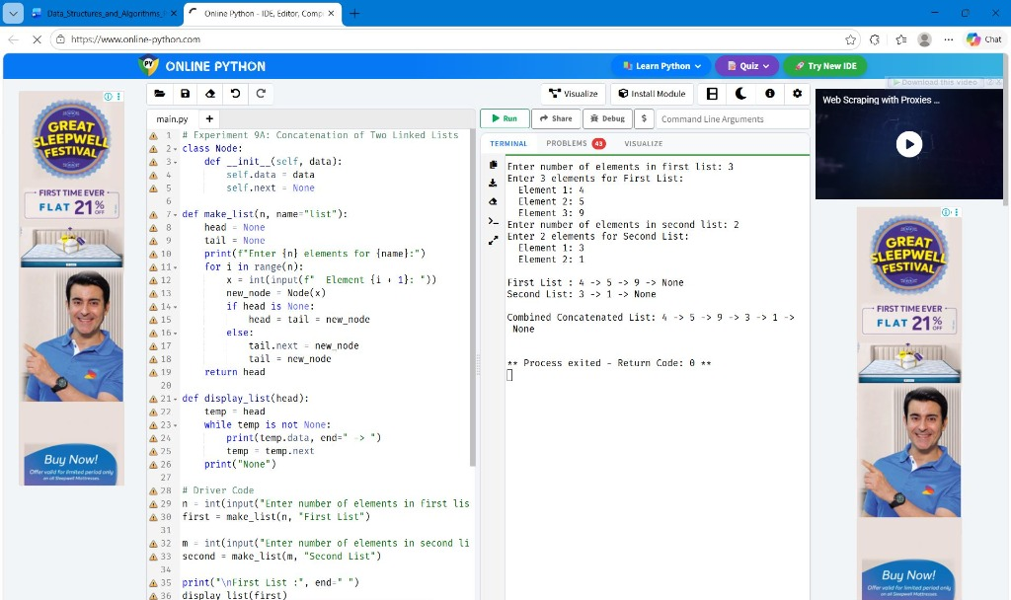
Figure: Execution output of Concatenation of Two Linked Lists
Sample Run: Execution Log / Console Output (Terminal Execution):
Enter number of elements in first list: 3
Enter 3 elements for First List:
Element 1: 4
Element 2: 5
Element 3: 9
Enter number of elements in second list: 2
Enter 2 elements for Second List:
Element 1: 3
Element 2: 1
First List : 4 -> 5 -> 9 -> None
Second List: 3 -> 1 -> None
Combined Concatenated List: 4 -> 5 -> 9 -> 3 -> 1 -> None
** Process exited - Return Code: 0 **

Result: The program was implemented and executed successfully. All operations and output results were verified against expected algorithmic behavior.

EXPERIMENT 9B: POLYNOMIAL ADDITION USING LINKED LISTS
AIM: To represent two single-variable polynomials using linked lists and compute their sum by combining coefficients of matching exponents.
Python Source Code
# Experiment 9B: Polynomial Addition using Linked Lists
class Term:
def __init__(self, coef, power):
self.coef = coef
self.power = power
self.next = None
def add_term(head, coef, power):
if coef == 0:
return head
new_term = Term(coef, power)
if head is None:
return new_term
temp = head
while temp.next is not None:
temp = temp.next
temp.next = new_term
return head
def read_polynomial(name):
head = None
n = int(input(f"Number of terms in {name}: "))
for i in range(n):
coef = int(input(f" Term {i + 1} Coefficient: "))
power = int(input(f" Term {i + 1} Power: "))
head = add_term(head, coef, power)
return head
def display_poly(head):
if head is None:
print("0")
return
temp = head
while temp is not None:
print(f"{temp.coef}x^{temp.power}", end="")
if temp.next is not None:
print(" + ", end="")
temp = temp.next
print()
def add_polynomials(p1, p2):
result = None
t1 = p1
while t1 is not None:
t2 = p2
found = False
while t2 is not None:
if t1.power == t2.power:
result = add_term(result, t1.coef + t2.coef, t1.power)
found = True
break
t2 = t2.next
if not found:
result = add_term(result, t1.coef, t1.power)
t1 = t1.next
t2 = p2
while t2 is not None:
t1 = p1
found = False
while t1 is not None:
if t2.power == t1.power:
found = True
break
t1 = t1.next
if not found:
result = add_term(result, t2.coef, t2.power)
t2 = t2.next
return result
# Driver Code
p1 = read_polynomial("Polynomial 1")
p2 = read_polynomial("Polynomial 2")
print("\nPolynomial 1:", end=" ")
display_poly(p1)
print("Polynomial 2:", end=" ")
display_poly(p2)
result = add_polynomials(p1, p2)
print("Sum of Polynomials:", end=" ")
display_poly(result)

Space for Output
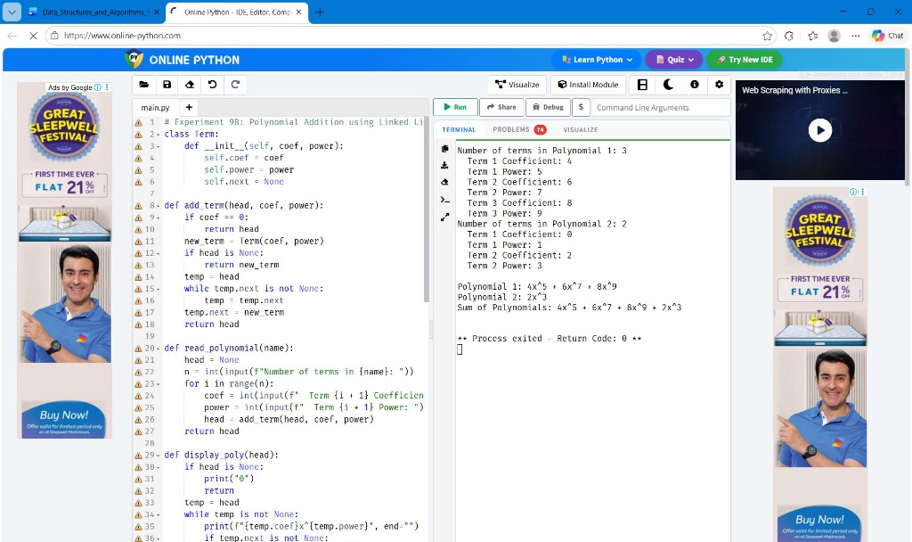
Figure: Execution output of Polynomial Addition using Linked Lists
Sample Run: Execution Log / Console Output (Terminal Execution):
Number of terms in Polynomial 1: 3
Term 1 Coefficient: 4
Term 1 Power: 5
Term 2 Coefficient: 6
Term 2 Power: 7
Term 3 Coefficient: 8
Term 3 Power: 9
Number of terms in Polynomial 2: 2
Term 1 Coefficient: 0
Term 1 Power: 1
Term 2 Coefficient: 2
Term 2 Power: 3
Polynomial 1: 4x^5 + 6x^7 + 8x^9
Polynomial 2: 2x^3
Sum of Polynomials: 4x^5 + 6x^7 + 8x^9 + 2x^3
** Process exited - Return Code: 0 **

Result: The program was implemented and executed successfully. All operations and output results were verified against expected algorithmic behavior.

EXPERIMENT 10: DOUBLY LINKED LIST OPERATIONS (INSERT, DELETE, DISPLAY)
AIM: To implement a Doubly Linked List with operations: inserting a node at the end, deleting a node by value, and displaying nodes in forward sequence.
Python Source Code
# Experiment 10: Doubly Linked List (Insert, Delete, Display)
class Node:
def __init__(self, data):
self.data = data
self.prev = None
self.next = None
head = None
while True:
print("\n--- DOUBLY LINKED LIST MENU ---")
print("1. Insert at end")
print("2. Delete by value")
print("3. Display")
print("4. Exit")
choice = int(input("Enter choice: "))
if choice == 1:
x = int(input("Enter value to insert: "))
new_node = Node(x)
if head is None:
head = new_node
else:
temp = head
while temp.next is not None:
temp = temp.next
temp.next = new_node
new_node.prev = temp
print(f"Node {x} inserted at end.")
elif choice == 2:
x = int(input("Enter value to delete: "))
temp = head
while temp is not None and temp.data != x:
temp = temp.next
if temp is None:
print("Value not found in list!")
else:
if temp.prev is None:
head = temp.next
if head is not None:
head.prev = None
else:
temp.prev.next = temp.next
if temp.next is not None:
temp.next.prev = temp.prev
print(f"Deleted {x} from doubly linked list.")
elif choice == 3:
if head is None:
print("List is empty.")
else:
print("Doubly Linked List:", end=" ")
temp = head
while temp is not None:
print(temp.data, end=" <-> ")
temp = temp.next
print("None")
elif choice == 4:
print("Exiting...")
break
else:
print("Invalid choice!")

Space for Output
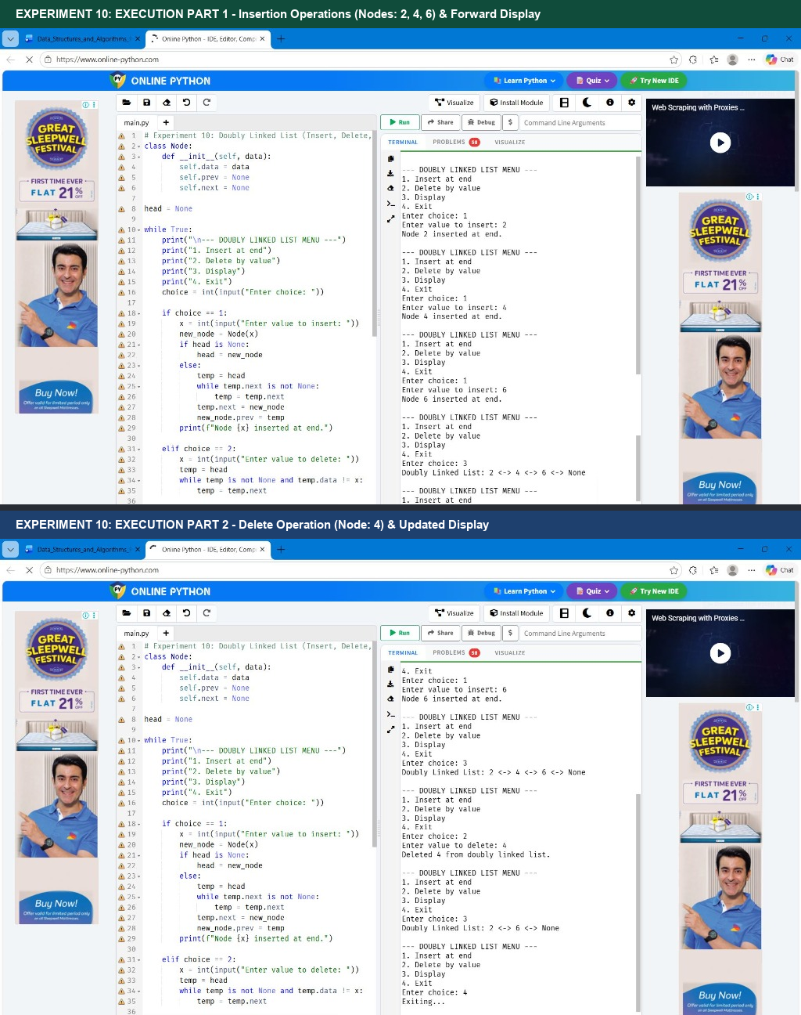
Figure: Execution output of Doubly Linked List (Insert, Delete, Display)
Sample Run: Execution Log / Console Output (Terminal Execution):
--- DOUBLY LINKED LIST MENU ---
1. Insert at end
2. Delete by value
3. Display
4. Exit
Enter choice: 1
Enter value to insert: 2
Node 2 inserted at end.
--- DOUBLY LINKED LIST MENU ---
1. Insert at end
2. Delete by value
3. Display
4. Exit
Enter choice: 1
Enter value to insert: 4
Node 4 inserted at end.
--- DOUBLY LINKED LIST MENU ---
1. Insert at end
2. Delete by value
3. Display
4. Exit
Enter choice: 1
Enter value to insert: 6
Node 6 inserted at end.
--- DOUBLY LINKED LIST MENU ---
1. Insert at end
2. Delete by value
3. Display
4. Exit
Enter choice: 3
Doubly Linked List: 2 <-> 4 <-> 6 <-> None
--- DOUBLY LINKED LIST MENU ---
1. Insert at end
2. Delete by value
3. Display
4. Exit
Enter choice: 2
Enter value to delete: 4
Deleted 4 from doubly linked list.
--- DOUBLY LINKED LIST MENU ---
1. Insert at end
2. Delete by value
3. Display
4. Exit
Enter choice: 3
Doubly Linked List: 2 <-> 6 <-> None
--- DOUBLY LINKED LIST MENU ---
1. Insert at end
2. Delete by value
3. Display
4. Exit
Enter choice: 4
Exiting...

Result: The program was implemented and executed successfully. All operations and output results were verified against expected algorithmic behavior.

