Class : Laravel Inventory Project Step-19 (Live Class 1)

JWT Token Generate for LOGIN : <https://jwt.io/>

JWT for PHP : <https://github.com/firebase/php-jwt>

JWT Installation from Command prompt : composer require firebase/php-jwt

Create a Directory : helper within app folder to keep utility functions

Create a file naming JWTToken.php in helper folder

write code within the file

edit .env file, keep a jwt Key : example –

JWT_KEY = "abc1234567890xyz"

Create mail for OTP : php artisan make:mail OTPEmail (1.40 minute)

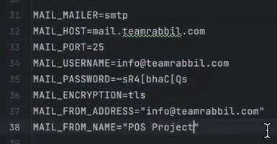

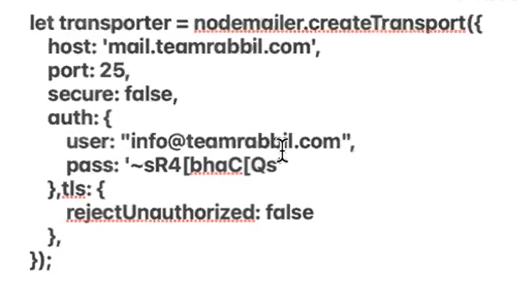

Create mail template in views folder

Problem / Question :

* Password not updating