Assignment

Q 1. How do you evaluate the performance of a project in agile?

ANSWER

Agile project is purely based mindset. And most importent is that it accept rapid change in user requirements. Agile project performance evaluation is based on the project monitoring, it consisit of
- Frequent delivery : primary measure of progress is working software and high priority is to customer satisfaction.
- Colocation : it ensure that all developing teanm and business people are work together.
- Daily team meeting : it deals with daily improvements and suggestions such as what done yesterday, what tom do today, and what is our dependancy.
- Time box review meeting : all other meeting such as release planning, sprint planning. Sprint review etc.

Based on this monitoring techniques we can evaluate the project performance in agile. Some key measures are obtained through monitoring the project. Using this key measures we can evaluate the project such as it is good or bad or with in scope or out of the scope. Key measures such as,
- velocity : it determin how many user stories contain in one sprint. Velocity of new release plan depends on the historical data. After that we can obtain the actual velocity.
- Hit rate : it is the percentage of work allocated to a timebox that was actually completed.
- Working on task : Each day the team estimates the work remaining on each active Task. The estimate of work remaining Task will hopefully go down over time.
- Project cost : project cost can be done in person days or currency. First fix a baseline project cost after that estimate the actual cost.

Business value involves major role in evaluating the performance of project. It based on customer satisfaction. When we achieve more business value for a project it become great success.EV evaluation is not based on SPI and CPI. Evaluating SPI (schedule performance index) and CPI(cost perform index) tells project is on time and on cost, in this evaluation story point involves important role. According to the monitoring and control business value is the most performance evaluating criteria.

Q 2.Compare traditional monitoring & control with agile monitoring & control with respect to metrics generation.

ANSWER

Traditional monitoring & control | Agile monitoring & control
It is linear process oriented | It is based on mindset
Monitoring and control is done in last phase | Monitoring and controling is done in each phase
Product delivery only in last | Each interval (sprint) can deliver a product part
Project success evaluation is based SPI and CPI | Project success evaluation is based on business value
Projct team size depends on the planning and fucntions, no limit in size | Project team size depends on the story point and print, team size with in 3-9
Project team can allocate in different remote area | Project team can allocate together in room
Project meeting is done in particular intervals or end of each phase | Project meeting is done every day
Customer requirement change is very difficult to add | Customer requirement change is very easy to add
Total Scheduling is done in planning phase | Scheduling is done in each phase

Q 3. With a total project budget of $ 175,000, and having completed one out of four Iterations, we have this product backlog and these actuals:

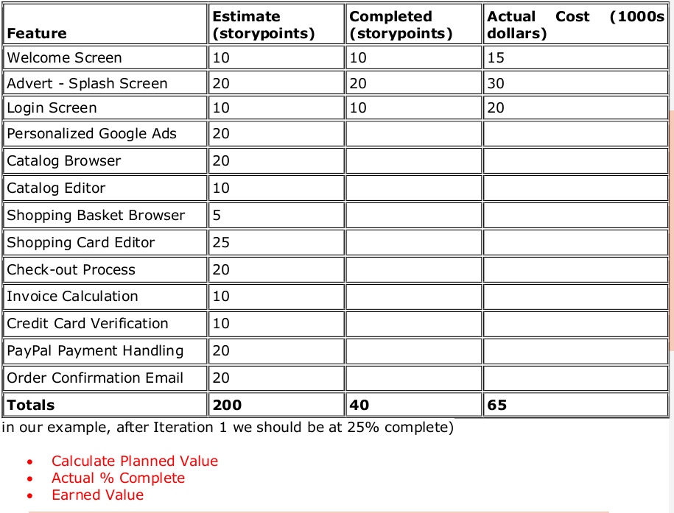
ANSWER

- planned value (PV) = Budget at Complete(BAC) * Expected Percent Complete(EPC)

Budget at Complete(BAC) = 175,000

Expected Percent Complete(EPC) = Current sprint(n) / Total planned sprints
= 1/4

planned valu= 175000 * (1/4)= $ 43,750.

- Actual % complete = Story points completed / Total planned story points

Story points completed = 40

Total planned story points=200
Actual % complete =40/200 = 1/5= 0.2 = 20%

- Earned value(EV) = Budget at Complete (BAC) * Actual Percent Complete (APC)

Budget at Complete (BAC) = $ 175,000

Actual Percent Complete (APC) = 1/5

Earned value(EV) = 175000 * (1/5)= $ 35,000.

planned value (PV) = $ 43,750.

Actual % complete = 20%.

Earned value(EV) = $ 35,000.

