Assignment

1. Consider the user story: “As a customer I want to use ATM”. What would be my acceptance criteria (“so that......)”? List all possible acceptance criteria.

ANSWER

so that ,
- I need to use credit card for transaction
- I need to know about current balance
- I need conformation message when using the ATM
- I need to know about the transaction limit (how much money and how many time in a month)
- I need a printed receipt at the time of tranaction
- I need a double conformation when type the amount for widthdraw
- I need a help disk in ATM
- I need a option for change PIN number
- I need to know about new scheme in bank (peovide a option)
- I need more security

2. What are the advanced Scrum Master skills?

ANSWER

- Open communication : it is a face to face communication with PO and developement team. It will reduce the complexity of project work and it can reduce the gap between concept of features and user story.SM will ensure that proper open communication happen in scrum.

- Alignemt : it is the collaboration of the team. It will lead to daily meeting and it ensure that the team focus on project scope. So SM will ensure that.

- Creativity and innovation : After getting user stories (user requirement) the team will generate new idea for implementing the user requirements. So SM will give the coaching for that. Team need more new idea and cteativities.

- Ownership : SM have power to coaches the team. Scrum must adapt changes and work properly.

- Organization and leadership : all the team members must be self organizing and have good leadership skills. SM ensure that and provide guidlines.

- Competences : each srucm have different sprint, so each sprint release complete part of product and all meeting and other actions are become perfect. SM check it become true.

- Achievement : SM ensure that each sprint is an achievement and celebrate the achievement and appraisal for good team member.

- Individual learning : learn the root of each task and implement it with full of customer satisfaction.

3.How do you think you can use Agile practices in large projects? (Given that the team can have no more than 9 people, do you think large projects with large teams can be involved in agile practices?)

ANSWER

We can use Agile practices in large projects. That is we can use srum model, for large project it become scrum of srcum. A scrum contain different number of scrum. Large project is divided in to different module and each module handled by scrum. Each scrum contain different sprint this sprint contain 3-9 members. Each scrum have SM and development team. But only one PO in total project that scrum of scrum. Each SM are lead by scrum of scrum master . Each scrum group contain one architect, he/she will design for one scrum . An authority person architect head will lead the architect team. The scrum of scrum design shown as below,

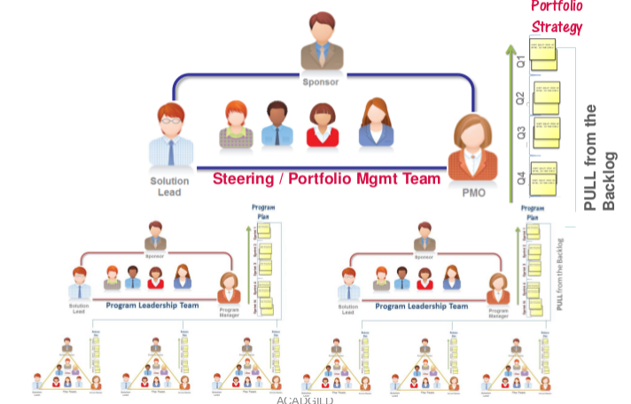

This picture give the total discrebtion about the scrum of scrum.

4.What are the Possible options for tracking project performance in Agile?

ANSWER

Tracking project performance in agile can be done in some proper way. Scrum is organize development in to time boxed sprint. So tracking is based on the sprint. Evaluating each sprint we will get total performance tracking of the project.

- A burndown report then tracks the completion of work throughout the sprint. The x-axis represents time, and the y-axis refers to the amount of work left to complete. It measured in hours. The goal is to have all the forecasted work completed by the end of the sprint.

- A burnup chart tracks progress towards a projects completion.The Y axis is amount of work and is measured in number of tasks, estimated hours. The X axis is time, usually measured in days.

- Visualization of the project management schedule also help to tracking the scrum project.

- Agile matrics such as baseline velocity, baseline cost per sprint, Pcs, TPC, Acs,AC/SP, earned value, planed value and CPI , SPI have importent role in evaluating the performance of the agile project

- Business value have major role in evaluation of the project that is customer is satisfied or not. Business value can be generated from must have, should have, could have, would have.

5. In Agile, the team always picks up business value user stories in every sprint. Do we still need to know earned value?

ANSWER

In agile earned value is one of the matrics so which is used to evaluate the project in the case of cost and time. Business value is the major element of evaluation which is based on the customer satisfation. The matrics like SPI and CPI tells the performance on the based on the cost and time.
We need eaned value because we have a planed value that is value of the work planned to be accomplished based on the budget (in dollars or hours) . Earned value that is The value of the work planned to be accomplished based on the budget (in dollars or hours). Using this two value we can calculate tha CPI and SPI. It will tell project on time or not and cost efficitive or not.
Cost Performance Index (CPI) = EV/AC
This metric indicates how many cents have been "earned" out of every dollar spent. It measures cost efficiencies.

