Assignment

Q 1. When to use (Rapid Application Development) RAD model. When not to use (Rapid Application Development) RAD model.

ANSWER

RAD is based on prototying and it focus on how fast develop an application not on deliverables. So we can use the RAD model
- Customer is not focus on quality, they only focus on fast delivery.
- A develop softaware with in a short span of time.
- When business requirement are change rapdily .
- A system can be modularized to be delivered in incremental manner.
- There is a high avalability of expert for modeling and coding.
- It use only when enough budget is required.
- The itreation in 2-3 month durathion.

RAD not used
- Developement is no support the prototying.
- Organization contain no expert for modeling and coding
- Budget is not enoguh for purchasing developing tool.
- Customer only focus on qulity.
- Software does not support increment model.

Q 2. Define an ER diagram of a software Organization with all the relationship model that was discussed in the classroom.

ANSWER
dept_name
location
empoyyee_id
empoyee_id
employee
include
name
Date of birth
location
Department
dept_id

M
M
1
control
M
M

Project
project_id
project_name
budget
works_on

Recruitment
And
manage
M
M

HR
M
Client
position
Name
Location
Review
And
Delivery
1
M

: Entities

: Attribute

: Action

1
M
: one to many

M
M
: many to one
1
1
: one to one

Q 3. Describe the Entity Relationships for the following diagram.

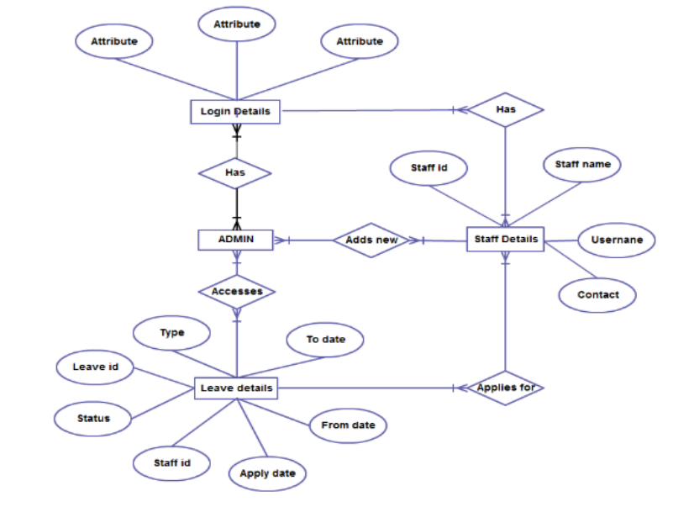
ANSWER
ER diagram is a graphical representation of entities and relationship.

Different entities are
- Login Details.
- Admin.
- Staff Details.
- Leave Details.

Each entities have different attribute
- login details have 3 attribute(attribute like username, password)
- leave details have 7 attribute
    - type
    - leave id(perimary key)
    - status
    - staff id(foreign key)
    - apply date
    - from date
    - to date
- staff details
    - staff id(perimary key)
    - staff name
    - username
    - contact

Different relationship are in the ER diagram

- Realtionship between login details and admin
    - There exists a many to many realation
    - Different employees can have different login details and they can login as diferent Amdin.
- Relationship between login details and staff details
    - There exists a many to many realation
    - Different employees can have different login details and they can login as diferent Staff.
- Realtionship between Admin and staff details
    - There exists a many to many realation
    - Different employees (staff) can be added by different admin in branch level.
- Realtionship between staff details and leave details
    - There exists a many to many realation
    - Different employees(staff) can submit different leave request .
- Realtionship between Admin and leave details
    - There exists a many to many realation
    - Different Admin can access and approve the different leave request in branch level .

