**What are some characteristic demographic/geographic elements about the country (3rd world, is it an island, what is the population etc.)?**

* Island
* Located in east Asia, in the northwest Pacific Ocean.
* Population of 126 million. Very densely populated. High average age.
* Developed country
* 63,000 total cases,14,000 active, 49,000 recovered, 1200 dead
* First case 15th January 2020
* General refrain from physical contact and social distancing habits. Bowing rather than hand shaking, the use of masks before the presence of virus, hand sanitizing habits and a strong immunity. People in Japan are also vaccinated against a virus known as BCG tuberculosis that builds their general immunity [1].

**What and when was the country’s immediate and long term response?**

* First case was reported 15th January 2020.
* Japan’s focus was split into 3 stages. 1. Prevention of domestic spread. 2. Prevention of spread of infection. 3. Prevention of serious spread. [2]. Idk what these mean exactly.
* Most companies were not equipped to accommodate working from home. Plus, the residential house sizes in Japan made it very difficult to work from home.
* Use of analysing the mobility levels of people within an area using mobile data.
* A forced lockdown is not possible in Japan due to their laws.

Immediate:

* Focus on stopping one cluster to spreading and creating multiple other clusters. Selective testing performed. This method proved to be in effective in the long run.
* Public transport operated as normal.
* Japan took a relatively weak approach and only applied travel restrictions to those who stayed in Hubei, China within the last 14 days, from 1st February. Applied travel restrictions to 73 countries/regions from 2nd April 2020.

Long term:

* 27th February, Japan announced closure of schools from 2nd March.

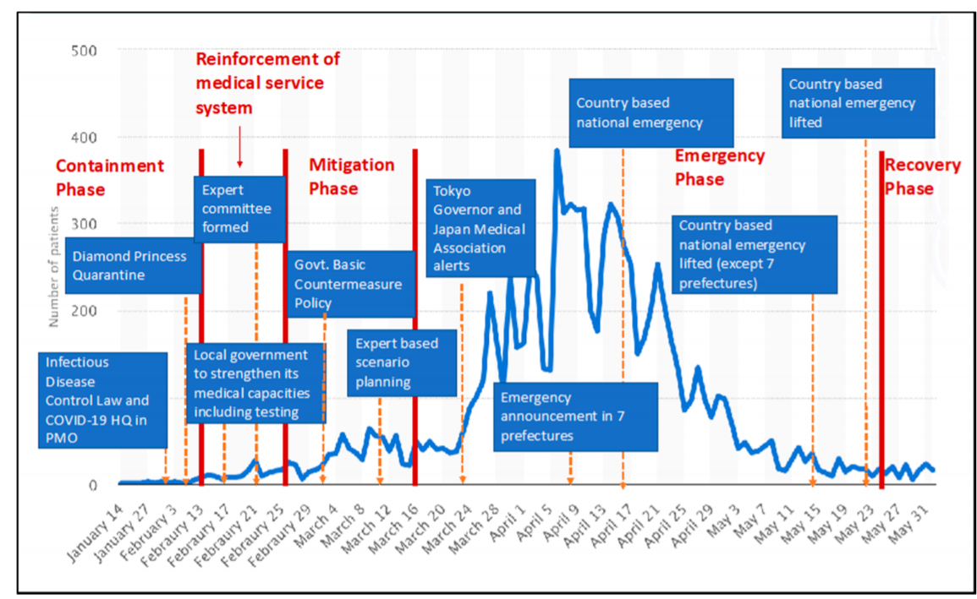

Figure 1 Timeline of Japans cases annotated with its policy plans

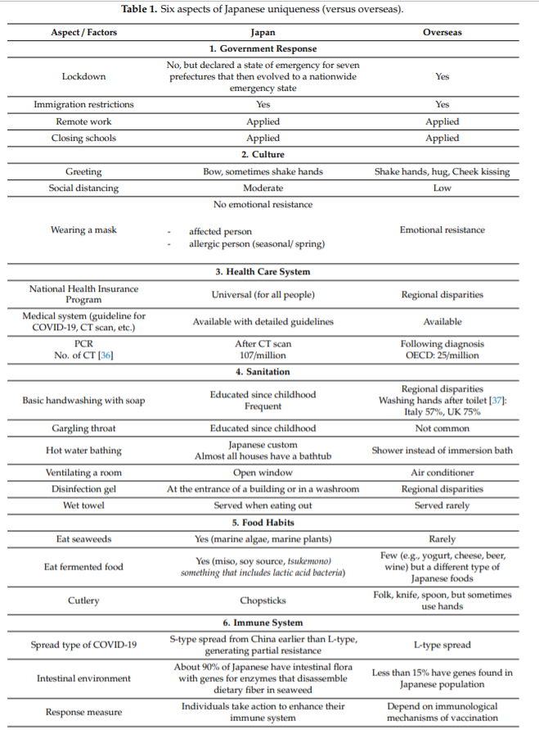

**General trends observed in the last 6 months (statistics of cases/graphs etc)**:

* 1/3 of cases in Tokyo 2-3 months following the first case was linked to sports clubs, pubs, and other night entertainment establishments. This was because tracing was difficult in these events.

|  |  |  |  |  |  |
| --- | --- | --- | --- | --- | --- |
|  | **Consequences** | | | | |
| **Response** | **Health** | **Economy** | **Ethics** | **Political** | **Social** |
| School closure |  |  |  |  |  |
| Travel restrictions |  |  |  |  |  |
| Expand National health Insurance system to cover COVID testing |  |  |  |  |  |
|  |  |  |  |  |  |

# References

1. Iwasaki, Akiko; Grubaugh, Nathan D. (2020). [*"Why does Japan have so few cases of COVID‐19?"*](https://www.ncbi.nlm.nih.gov/pmc/articles/PMC7207161). EMBO Molecular Medicine. **12**(5): e12481. [*doi*](https://en.wikipedia.org/wiki/Doi_(identifier)):[*10.15252/emmm.202012481*](https://doi.org/10.15252%2Femmm.202012481). [*PMC*](https://en.wikipedia.org/wiki/PMC_(identifier)) [*7207161*](https://www.ncbi.nlm.nih.gov/pmc/articles/PMC7207161). [*PMID*](https://en.wikipedia.org/wiki/PMID_(identifier)) [*32275804*](https://pubmed.ncbi.nlm.nih.gov/32275804).
2. Ai Tashiro ; Rajib Shaw (2020). “COVID‐19 Pandemic Response in Japan: What Is behind the Initial Flattening of the Curve?”. Sustainability (Basel, Switzerland), 01 June 2020, Vol.12(5250), p.5250.