**Project 1**

**Dataset:** (<https://www.kaggle.com/datasets/ikynahidwin/depression-student-dataset> )

This dataset links mental health with demographic, academic, and lifestyle factors like gender, age, sleep, diet, study hours, and financial stress. It helps identify patterns in mental well-being and supports strategies for improving mental health outcomes across different groups.

library(dplyr)

library(ggplot2)

library(tidyr)

library(ROSE)

library(VIM)

file_path <- "/Users/skmuktadir/Desktop/Semester11/Data Science/Project_Depression_V2/Midterm_Dataset_Section(B).csv"

df <- read.csv(file_path, stringsAsFactors = FALSE)

names(df)

str(df)

df[df == ""] <- NA

missing_counts <- colSums(is.na(df))

missing_counts

if(any(missing_counts > 0)) {

barplot(missing_counts[missing_counts > 0],

main = "Missing Values in Each Column",

xlab = "Columns", ylab = "Number of Missing Values",

col = "steelblue")

} else {

cat("No missing values.\n")

}

if("Have.you.ever.had.suicidal.thoughts." %in% names(df)) {

df$Have.you.ever.had.suicidal.thoughts. <- gsub("Yess", "Yes", df$Have.you.ever.had.suicidal.thoughts.)

df$Have.you.ever.had.suicidal.thoughts. <- gsub("Noo", "No", df$Have.you.ever.had.suicidal.thoughts.)

}

colSums(is.na(df))

df_original <- df

Mode <- function(x) {

ux <- unique(x)

ux[which.max(tabulate(match(x, ux)))]

}

df_mean_mode <- df_original

for (col_name in names(df_mean_mode)) {

if (is.numeric(df_mean_mode[[col_name]])) {

df_mean_mode[[col_name]][is.na(df_mean_mode[[col_name]])] <- mean(df_mean_mode[[col_name]], na.rm = TRUE)

} else {

df_mean_mode[[col_name]][is.na(df_mean_mode[[col_name]])] <- Mode(df_mean_mode[[col_name]])

}

}

print(df_mean_mode)

missing_counts1 <- colSums(is.na(df_mean_mode))

missing_counts1

nrow(df_mean_mode)

df_median_mode <- df_original

for (col_name in names(df_median_mode)) {

if (is.numeric(df_median_mode[[col_name]])) {

df_median_mode[[col_name]][is.na(df_median_mode[[col_name]])] <- median(df_median_mode[[col_name]], na.rm = TRUE)

} else {

df_median_mode[[col_name]][is.na(df_median_mode[[col_name]])] <- Mode(df_median_mode[[col_name]])

}

}

df_no_na_rows <- na.omit(df_original)

df_no_na_cols <- df_original[, colSums(is.na(df_original)) == 0]

df <- df_median_mode

colSums(is.na(df))

x <- nrow(df) - nrow(distinct(df))

print(x)

y <- nrow(distinct(df))

print(y)

df <- df %>% filter(Age < 120 & Age > 0)

boxplot(df_original$Academic.Pressure, main = "Academic Pressure (Original)",

ylab = "Values", col = "lightblue")

Q1 <- quantile(df$Academic.Pressure, 0.25)

Q3 <- quantile(df$Academic.Pressure, 0.75)

IQR_val <- Q3 - Q1

lower_bound <- Q1 - 1.5 * IQR_val

upper_bound <- Q3 + 1.5 * IQR_val

df <- df %>% filter(Academic.Pressure >= lower_bound & Academic.Pressure <= upper_bound)

nrow(df)

if("Depression" %in% names(df)) {

filtered_data <- df %>% filter(Depression == "Yes" & Age > 30)

} else {

filtered_data <- df

}

filtered_data

df$Dietary.Habits <- factor(df$Dietary.Habits,

levels = c("Healthy", "Moderate", "Unhealthy"))

df$Dietary.Habits_num <- as.numeric(df$Dietary.Habits)

df$Gender <- factor(df$Gender,

levels = c("Male", "Female"))

df$Gender_num <- as.numeric(df$Gender)

df$Depression <- factor(df$Depression,

levels = c("Yes", "No"))

df$Depression_num <- as.numeric(df$Depression)

df$Sleep.Duration <- factor(df$Sleep.Duration,

levels = c("5-6 hours", "7-8 hours", "Less than 5 hours","More than 8 hours"))

df$Sleep.Duration_num <- as.numeric(df$Sleep.Duration)

df$Financial.Stress_catagorical <- factor(df$Financial.Stress,

levels = c(1, 2, 3, 4, 5),

labels = c("Very Low", "Low", "Moderate", "High", "Very High"))

if("Study.Hours" %in% names(df)) {

df$Normalized_Study_Hours <- (df$Study.Hours - min(df$Study.Hours)) /

(max(df$Study.Hours) - min(df$Study.Hours))

}

No_count <- df %>% filter(Depression == "No")

print(nrow(No_count))

Yes_count <- df %>% filter(Depression == "Yes")

print(nrow(Yes_count))

if("Depression" %in% names(df)) {

table(df$Depression)

prop.table(table(df$Depression))

}

df[df == ""] <- NA

colSums(is.na(df))

df[sapply(df, is.character)] <- lapply(df[sapply(df, is.character)], as.factor)

df[sapply(df, is.logical)] <- lapply(df[sapply(df, is.logical)], as.factor)

str(df)

if("Depression" %in% names(df)) {

df_balanced <- ROSE(Depression ~ ., data = df, seed = 1)$data

table(df_balanced$Depression)

}

descriptive_stats <- summary(df)

descriptive_stats

write.csv(df, "/Users/skmuktadir/Desktop/Semester11/Data Science/Project_Depression_V2/cleaned_dataset.csv", row.names = FALSE)

if(exists("filtered_data")) {

write.csv(filtered_data, "/Users/skmuktadir/Desktop/Semester11/Data Science/Project_Depression_V2/filtered_data.csv", row.names = FALSE)

}

write.csv(descriptive_stats, "/Users/skmuktadir/Desktop/Semester11/Data Science/Project_Depression_V2/descriptive_statistics.csv")

**1.If there are any missing values in the dataset, we should apply all applicable methods**

**from the available options to handle the missing values.**

Ans:

|  |
| --- |
| Missing values can be handled through methods like imputation or removal.  Imputation methods are like (Mean, Median, Mode). |
| Imputation methods are like (Mean, Median, Mode). |
| We needed it for Ensures no data gaps that could skew the analysis. |
| After implementing missing value handling, it will have a complete dataset without missing values, improving model performance. |

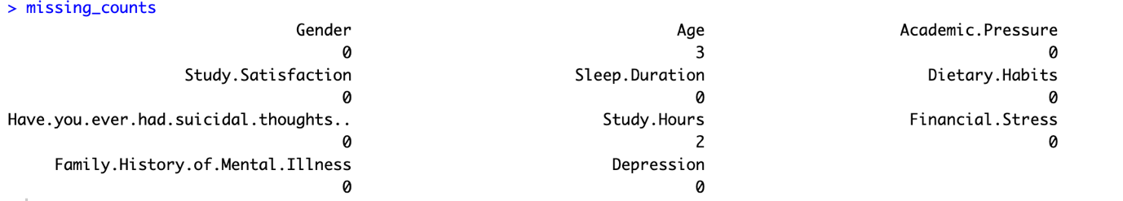

**Figure1**: Missing Values Numerical Attribute

**Figure2**: Missing Values Categorical & Numerical Attribute

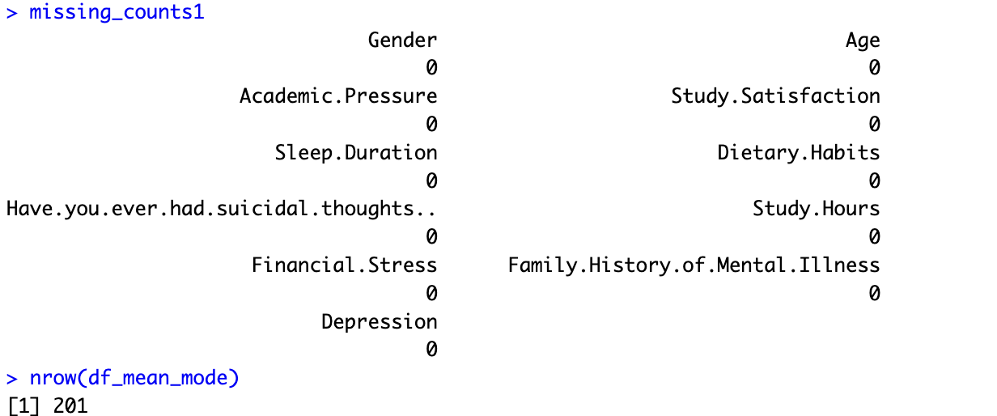

**Figure3**: After handling missing value

**2.We can see missing values on a graph.**

Ans:

**3.We can convert the imbalanced data set into the balanced data set.**

Ans:

Imbalanced data set where the final class any portion dominate more

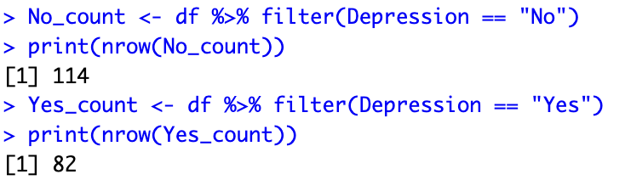

Figure4: Imbalanced data set

Balanced data set where the final class any portion equally dominate

Figure5: Balanced data set (Based on Final class)

**4.We can find and remove duplicate values.**

Ans:

Where Same instance is repeated then it’s called duplicate values

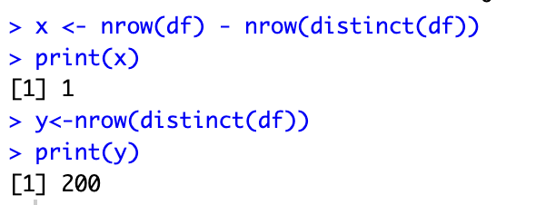

Figure6: Duplicate value check

**5.We can apply some filtering methods to filter the data.**

Ans:

Filtering is the process of selecting a subset of dataset.

Here we have filter the from the main dataset where the age is greater than 30.

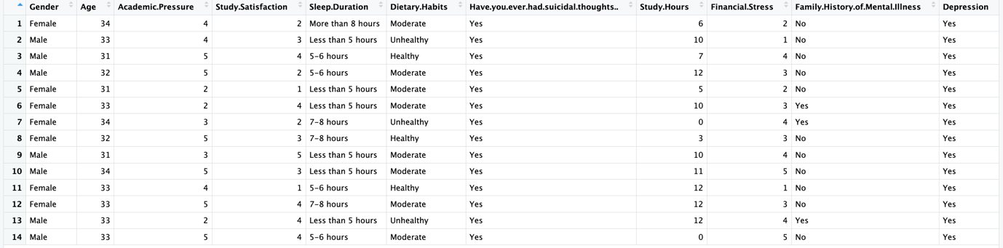

Figure7: Filter data (Age > 30)

**6.We can convert attributes from numeric to categorical or categorical to numeric.**

Ans:

Categorical to numerical

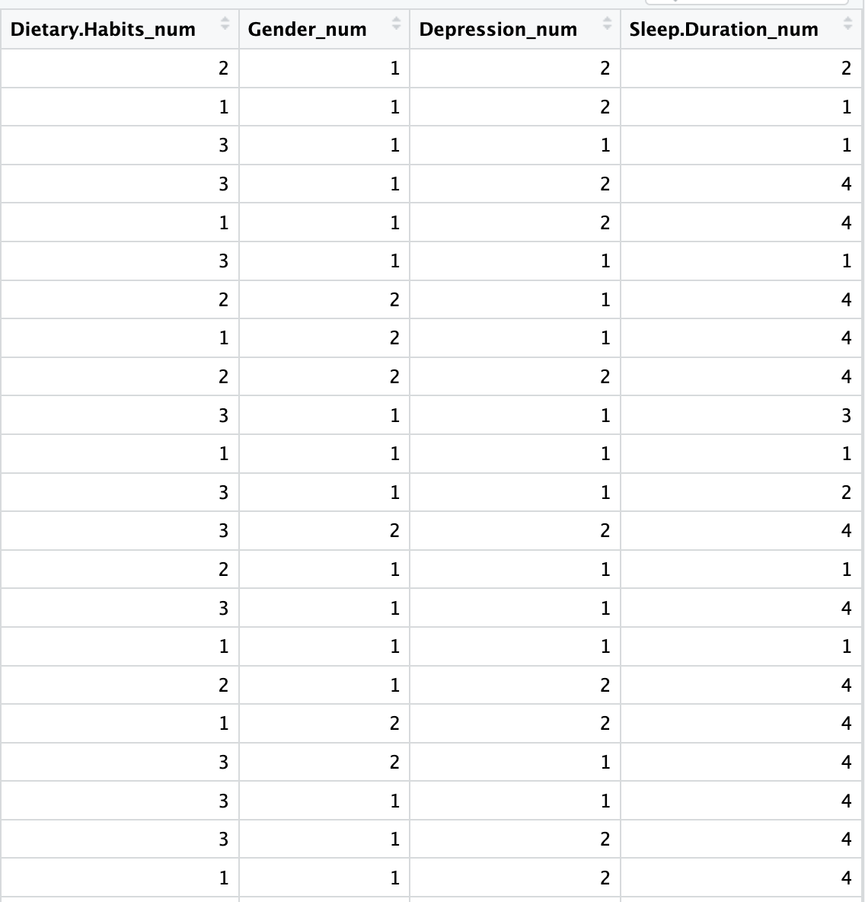

Figure7: Categorical to numerical

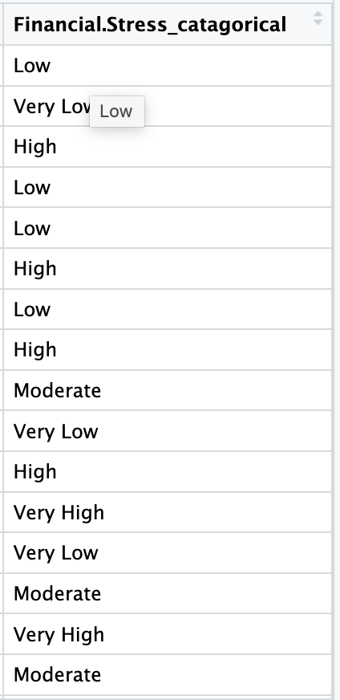

Figure8: Numerical to Categorical

**7.We can apply the normalization method only for one attribute.**

Ans:

Normalization is the process of adjusting values measured on different scales to a common scale, often making all values lie between 0 and 1

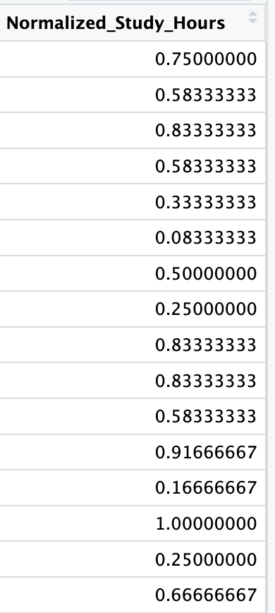

Figure9: Normalized (Study Hour)

If any invalid data/outliers exist in the data set, use the appropriate approach to handle those values.

Ans:

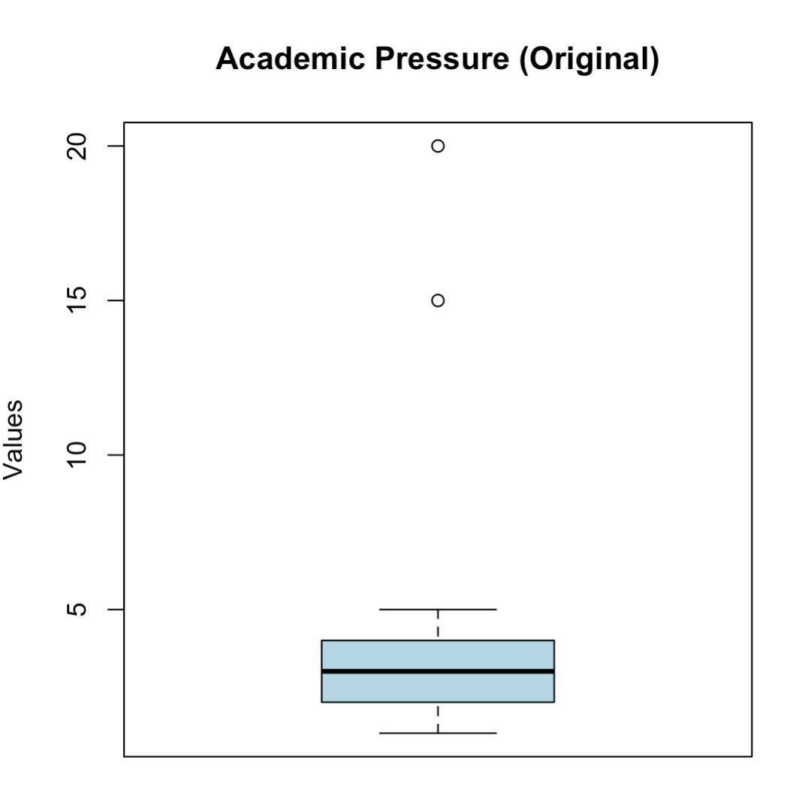

Figure10: Out layer (Academic Pressure)

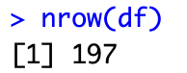

Figure11: Out layer (After deleting out layer 2001 to 197 rows exist)

**Project 2**

**1.Text Cleaning**

After text cleaning we’ll get the text to lowercase, remove punctuation, numbers, special characters, and HTML tags.

**Sample Output of our text after applying text cleaning**:

[1] the international criminal courts chief prosecutor on wednesday asked judges to grant an arrest warrant for myanmars junta chief min aung hlaing over alleged crimes against humanity committed against rohingya muslims

[2] karim khans request to the courts haguebased judges is the first application for an arrest warrant against a highlevel myanmar government official in connection with abuses against the rohingya people

[3] after an extensive independent and impartial investigation my office has concluded that there are reasonable grounds to believe that senior general and acting president min aung hlaing bears criminal responsibility for crimes against humanity khan said in a statement

[4] this included crimes of deportation and persecution allegedly committed between august and december khan added

[5] myanmars junta rejected the prosecutors move saying that as the country is not a member of the court the statements of the icc have never been recognised

[6] the icc prosecutor in opened a probe into suspected crimes committed against the rohingya in myanmars restive rakhine state in and that prompted the exodus of of the muslim minority in the southeast asian country to neighbouring bangladesh

[7] about one million rohingya now live in sprawling camps near the bangladesh border city of coxs bazaar many of those who left accuse the myanmar military of mass killings and rapes

[8] khan said the alleged crimes were committed by myanmars armed forces the tatmadaw supported by the national and border police as well as nonrohingya citizens

[9] this is the first application for an arrest warrant against a highlevel myanmar government official khan said

[10] more will follow warned the prosecutor

[11] myanmar has been racked by conflict between the military and various armed groups opposed to its rule since the army ousted aung san suu kyis elected government in february

[12] the junta is reeling from a major rebel offensive last year that seized a large area of territory much of it near the border with china

[13] earlier this month min aung hlaing told chinas premier li qiang that the military was ready for peace if armed groups would engage according to an account of the meeting in myanmar state media

[14] a military crackdown in myanmar in sent hundreds of thousands of rohingya fleeing into neighbouring bangladesh many with harrowing stories of murder rape and arson

[15] rohingya who remain in myanmar are denied citizenship and access to healthcare and require permission to travel outside their townships

[16] min aung hlaing who was head of the army during the crackdown has dismissed the term rohingya as imaginary

[17] icc judges must now decide whether to grant the arrest warrants if granted the members of the icc would theoretically be obliged to arrest the junta chief if he travelled to their country

[18] china a major ally and arms supplier of myanmars ruling junta is not an icc member

[19] khans request comes just days after the icc issued arrest warrants for israeli prime minister benjamin netanyahu his ex defence minister and a top hamas leader over the war in gaza

[20] rights groups applauded khans myanmar move saying it was an important step toward breaking the cycle of abuses and impunity that has long been a key factor in fuelling the militarys mass violations

[21] the judges will rule on the prosecutors request but icc member countries should recognise this action as a reminder of the courts critical role when other doors to justice are closed said maria elena vignoli a senior international lawyer human rights watch

[22] opening its doors in the haguebased icc is an independent court set up to investigate and prosecute those accused of the worlds worst crimes

**2. Tokenization:**

**Output:**

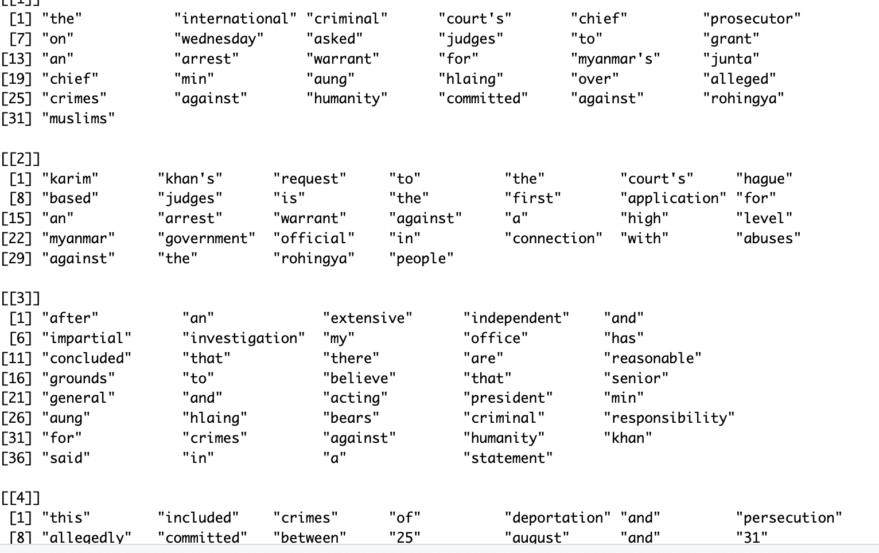

**3. Normalization**

Output:

[1] international criminal courts chief prosecutor wednesday asked judges grant arrest warrant myanmars junta chief min aung hlaing alleged crimes humanity committed rohingya muslims

[2] karim khans request courts haguebased judges first application arrest warrant highlevel myanmar government official connection abuses rohingya people

[3] extensive independent impartial investigation office concluded reasonable grounds believe senior general acting president min aung hlaing bears criminal responsibility crimes humanity khan said statement

[4] included crimes deportation persecution allegedly committed august december khan added

[5] myanmars junta rejected prosecutors move saying country member court statements icc never recognised

[6] icc prosecutor opened probe suspected crimes committed rohingya myanmars restive rakhine state prompted exodus muslim minority southeast asian country neighbouring bangladesh

[7] one million rohingya now live sprawling camps near bangladesh border city coxs bazaar many left accuse myanmar military mass killings rapes

[8] khan said alleged crimes committed myanmars armed forces tatmadaw supported national border police well nonrohingya citizens

[9] first application arrest warrant highlevel myanmar government official khan said

[10] will follow warned prosecutor

[11] myanmar racked conflict military various armed groups opposed rule since army ousted aung san suu kyis elected government february

[12] junta reeling major rebel offensive last year seized large area territory much near border china

[13] earlier month min aung hlaing told chinas premier li qiang military ready peace armed groups engage according account meeting myanmar state media

[14] military crackdown myanmar sent hundreds thousands rohingya fleeing neighbouring bangladesh many harrowing stories murder rape arson

[15] rohingya remain myanmar denied citizenship access healthcare require permission travel outside townships

[16] min aung hlaing head army crackdown dismissed term rohingya imaginary

[17] icc judges must now decide whether grant arrest warrants granted members icc theoretically obliged arrest junta chief travelled country

[18] china major ally arms supplier myanmars ruling junta icc member

[19] khans request comes just days icc issued arrest warrants israeli prime minister benjamin netanyahu ex defence minister top hamas leader war gaza

[20] rights groups applauded khans myanmar move saying important step toward breaking cycle abuses impunity long key factor fuelling militarys mass violations

[21] judges will rule prosecutors request icc member countries recognise action reminder courts critical role doors justice closed said maria elena vignoli senior international lawyer human rights watch

[22] opening doors haguebased icc independent court set investigate prosecute accused worlds worst crimes

**4. Stop words Removal**

**Output:**

[1] intern crimin court chief prosecutor wednesday ask judg grant arrest warrant myanmar junta chief min aung hla alleg crime human commit rohingya muslim

[2] karim khan request court haguebas judg first applic arrest warrant highlevel myanmar govern offici connect abus rohingya peopl

[3] extens independ imparti investig offic conclud reason ground believ senior general act presid min aung hla bear crimin respons crime human khan said statement

[4] includ crime deport persecut alleg commit august decemb khan ad

[5] myanmar junta reject prosecutor move say countri member court statement icc never recognis

[6] icc prosecutor open probe suspect crime commit rohingya myanmar restiv rakhin state prompt exodus muslim minor southeast asian countri neighbour bangladesh

[7] one million rohingya now live sprawl camp near bangladesh border citi cox bazaar mani left accus myanmar militari mass kill rape

[8] khan said alleg crime commit myanmar arm forc tatmadaw support nation border polic well nonrohingya citizen

[9] first applic arrest warrant highlevel myanmar govern offici khan said

[10] will follow warn prosecutor

[11] myanmar rack conflict militari various arm group oppos rule sinc armi oust aung san suu kyi elect govern februari

[12] junta reel major rebel offens last year seiz larg area territori much near border china

[13] earlier month min aung hla told china premier li qiang militari readi peac arm group engag accord account meet myanmar state media

[14] militari crackdown myanmar sent hundr thousand rohingya flee neighbour bangladesh mani harrow stori murder rape arson

[15] rohingya remain myanmar deni citizenship access healthcar requir permiss travel outsid township

[16] min aung hla head armi crackdown dismiss term rohingya imaginari

[17] icc judg must now decid whether grant arrest warrant grant member icc theoret oblig arrest junta chief travel countri

[18] china major alli arm supplier myanmar rule junta icc member

[19] khan request come just day icc issu arrest warrant isra prime minist benjamin netanyahu ex defenc minist top hama leader war gaza

[20] right group applaud khan myanmar move say import step toward break cycl abus impun long key factor fuell militari mass violat

[21] judg will rule prosecutor request icc member countri recognis action remind court critic role door justic close said maria elena vignoli senior intern lawyer human right watch

[22] open door haguebas icc independ court set investig prosecut accus world worst crime

**5. Stemming and Lemmatization**

**Output:**

[1] "c(\"intern crimin court chief prosecutor wednesday ask judg grant arrest warrant myanmar junta chief min aung hla alleg crime human commit rohingya muslim\", \"karim khan request court hagueba judg first applic arrest warrant highlevel myanmar govern offici connect abus rohingya peopl\", \"exten independ imparti investig offic conclud reason ground believ senior general act presid min aung hla bear crimin respon crime human khan said statement\", \"includ crime deport persecut alleg commit august decemb khan ad\", \n\"myanmar junta reject prosecutor move say countri member court statement icc never recogni\", \"icc prosecutor open probe suspect crime commit rohingya myanmar restiv rakhin state prompt exodus muslim minor southeast asian countri neighbour bangladesh\", \"one million rohingya now live sprawl camp near bangladesh border citi cox bazaar mani left accus myanmar militari mass kill rape\", \"khan said alleg crime commit myanmar arm forc tatmadaw support nation border polic well nonrohingya citizen\", \"first applic arrest warrant highlevel myanmar govern offici khan said\", \n\"will follow warn prosecutor\", \"myanmar rack conflict militari various arm group oppo rule sinc armi oust aung san suu kyi elect govern februari\", \"junta reel major rebel offen last year seiz larg area territori much near border china\", \"earlier month min aung hla told china premier li qiang militari readi peac arm group engag accord account meet myanmar state media\", \"militari crackdown myanmar sent hundr thousand rohingya flee neighbour bangladesh mani harrow stori murder rape arson\", \"rohingya remain myanmar deni citizenship access healthcar requir permiss travel outsid township\", \n\"min aung hla head armi crackdown dismiss term rohingya imaginari\", \"icc judg must now decid whether grant arrest warrant grant member icc theoret oblig arrest junta chief travel countri\", \"china major alli arm supplier myanmar rule junta icc member\", \"khan request come just day icc issu arrest warrant isra prime minist benjamin netanyahu ex defenc minist top hama leader war gaza\", \"right group applaud khan myanmar move say import step toward break cycl abus impun long key factor fuell militari mass violat\", \n\"judg will rule prosecutor request icc member countri recogni action remind court critic role door justic close said maria elena vignoli senior intern lawyer human right watch\", \"open door hagueba icc independ court set investig prosecut accus world worst crime\")"

**6. Handling Contractions**

**Output:**

[1] The International Criminal Court's chief prosecutor on Wednesday asked judges to grant an arrest warrant for Myanmar's junta chief Min Aung Hlaing over alleged crimes against humanity committed against Rohingya Muslims.

[2] Karim Khan's request to the court's Hague-based judges is the first application for an arrest warrant against a high-level Myanmar government official in connection with abuses against the Rohingya people.

[3] "After an extensive, independent and impartial investigation, my office has concluded that there are reasonable grounds to believe that Senior General and Acting President Min Aung Hlaing... bears criminal responsibility for crimes against humanity," Khan said in a statement.

[4] This included crimes of deportation and persecution, allegedly committed between 25 August and 31 December 2017, Khan added.

[5] Myanmar's junta rejected the prosecutor's move, saying that as the country is not a member of the court, "the statements of the ICC have never been recognised."

[6] The ICC prosecutor in 2019 opened a probe into suspected crimes committed against the Rohingya in Myanmar's restive Rakhine state in 2016 and 2017, that prompted the exodus of 750,000 of the Muslim minority in the southeast Asian country to neighbouring Bangladesh.

[7] About one million Rohingya now live in sprawling camps near the Bangladesh border city of Cox's Bazaar. Many of those who left accuse the Myanmar military of mass killings and rapes.

[8] Khan said the alleged crimes were committed by Myanmar's armed forces, the Tatmadaw, supported by the national and border police "as well as non-Rohingya citizens."

[9] "This is the first application for an arrest warrant against a high-level Myanmar government official," Khan said.

[10] "More will follow," warned the prosecutor.

[11] Myanmar has been racked by conflict between the military and various armed groups opposed to its rule since the army ousted Aung San Suu Kyi's elected government in February 2021.

[12] The junta is reeling from a major rebel offensive last year that seized a large area of territory, much of it near the border with China.

[13] Earlier this month, Min Aung Hlaing told China's Premier Li Qiang that the military was ready for peace if armed groups would engage, according to an account of the meeting in Myanmar state media.

[14] A military crackdown in Myanmar in 2017 sent hundreds of thousands of Rohingya fleeing into neighbouring Bangladesh, many with harrowing stories of murder, rape and arson.

[15] Rohingya who remain in Myanmar are denied citizenship and access to healthcare and require permission to travel outside their townships.

[16] Min Aung Hlaing -- who was head of the army during the crackdown -- has dismissed the term Rohingya as "imaginary".

[17] ICC judges must now decide whether to grant the arrest warrants. If granted, the 124 members of the ICC would theoretically be obliged to arrest the junta chief if he travelled to their country.

[18] China, a major ally and arms supplier of Myanmar's ruling junta, is not an ICC member.

[19] Khan's request comes just days after the ICC issued arrest warrants for Israeli Prime Minister Benjamin Netanyahu, his ex defence minister and a top Hamas leader over the war in Gaza.

[20] Rights groups applauded Khan's Myanmar move, saying it was "an important step toward breaking the cycle of abuses and impunity that has long been a key factor in fuelling the military's mass violations."

[21] "The judges will rule on the prosecutor's request, but ICC member countries should recognise this action as a reminder of the court's critical role when other doors to justice are closed," said Maria Elena Vignoli, a senior international lawyer Human Rights Watch.

[22] Opening its doors in 2002, the Hague-based ICC is an independent court, set up to investigate and prosecute those accused of the world's worst crimes.

**7. Handling Emojis and Emoticons**

**Output:**

[1] The International Criminal Court's chief prosecutor on Wednesday asked judges to grant an arrest warrant for Myanmar's junta chief Min Aung Hlaing over alleged crimes against humanity committed against Rohingya Muslims.

[2] Karim Khan's request to the court's Hague-based judges is the first application for an arrest warrant against a high-level Myanmar government official in connection with abuses against the Rohingya people.

[3] "After an extensive, independent and impartial investigation, my office has concluded that there are reasonable grounds to believe that Senior General and Acting President Min Aung Hlaing... bears criminal responsibility for crimes against humanity," Khan said in a statement.

[4] This included crimes of deportation and persecution, allegedly committed between 25 August and 31 December 2017, Khan added.

[5] Myanmar's junta rejected the prosecutor's move, saying that as the country is not a member of the court, "the statements of the ICC have never been recognised."

[6] The ICC prosecutor in 2019 opened a probe into suspected crimes committed against the Rohingya in Myanmar's restive Rakhine state in 2016 and 2017, that prompted the exodus of 750,000 of the Muslim minority in the southeast Asian country to neighbouring Bangladesh.

[7] About one million Rohingya now live in sprawling camps near the Bangladesh border city of Cox's Bazaar. Many of those who left accuse the Myanmar military of mass killings and rapes.

[8] Khan said the alleged crimes were committed by Myanmar's armed forces, the Tatmadaw, supported by the national and border police "as well as non-Rohingya citizens."

[9] "This is the first application for an arrest warrant against a high-level Myanmar government official," Khan said.

[10] "More will follow," warned the prosecutor.

[11] Myanmar has been racked by conflict between the military and various armed groups opposed to its rule since the army ousted Aung San Suu Kyi's elected government in February 2021.

[12] The junta is reeling from a major rebel offensive last year that seized a large area of territory, much of it near the border with China.

[13] Earlier this month, Min Aung Hlaing told China's Premier Li Qiang that the military was ready for peace if armed groups would engage, according to an account of the meeting in Myanmar state media.

[14] A military crackdown in Myanmar in 2017 sent hundreds of thousands of Rohingya fleeing into neighbouring Bangladesh, many with harrowing stories of murder, rape and arson.

[15] Rohingya who remain in Myanmar are denied citizenship and access to healthcare and require permission to travel outside their townships.

[16] Min Aung Hlaing -- who was head of the army during the crackdown -- has dismissed the term Rohingya as "imaginary".

[17] ICC judges must now decide whether to grant the arrest warrants. If granted, the 124 members of the ICC would theoretically be obliged to arrest the junta chief if he travelled to their country.

[18] China, a major ally and arms supplier of Myanmar's ruling junta, is not an ICC member.

[19] Khan's request comes just days after the ICC issued arrest warrants for Israeli Prime Minister Benjamin Netanyahu, his ex defence minister and a top Hamas leader over the war in Gaza.

[20] Rights groups applauded Khan's Myanmar move, saying it was "an important step toward breaking the cycle of abuses and impunity that has long been a key factor in fuelling the military's mass violations."

[21] "The judges will rule on the prosecutor's request, but ICC member countries should recognise this action as a reminder of the court's critical role when other doors to justice are closed," said Maria Elena Vignoli, a senior international lawyer Human Rights Watch.

[22] Opening its doors in 2002, the Hague-based ICC is an independent court, set up to investigate and prosecute those accused of the world's worst crimes.

**8. Spell Checking**

**Output:**

[1] The International Criminal Court's chief prosecutor on Wednesday asked judges to grant an arrest warrant for Myanmar's junta chief Min Aung Hlaing over alleged crimes against humanity committed against Rohingya Muslims.

[2] Karim Khan's request to the court's Hague-based judges is the first application for an arrest warrant against a high-level Myanmar government official in connection with abuses against the Rohingya people.

[3] "After an extensive, independent and impartial investigation, my office has concluded that there are reasonable grounds to believe that Senior General and Acting President Min Aung Hlaing... bears criminal responsibility for crimes against humanity," Khan said in a statement.

[4] This included crimes of deportation and persecution, allegedly committed between 25 August and 31 December 2017, Khan added.

[5] Myanmar's junta rejected the prosecutor's move, saying that as the country is not a member of the court, "the statements of the ICC have never been recognised."

[6] The ICC prosecutor in 2019 opened a probe into suspected crimes committed against the Rohingya in Myanmar's restive Rakhine state in 2016 and 2017, that prompted the exodus of 750,000 of the Muslim minority in the southeast Asian country to neighbouring Bangladesh.

[7] About one million Rohingya now live in sprawling camps near the Bangladesh border city of Cox's Bazaar. Many of those who left accuse the Myanmar military of mass killings and rapes.

[8] Khan said the alleged crimes were committed by Myanmar's armed forces, the Tatmadaw, supported by the national and border police "as well as non-Rohingya citizens."

[9] "This is the first application for an arrest warrant against a high-level Myanmar government official," Khan said.

[10] "More will follow," warned the prosecutor.

[11] Myanmar has been racked by conflict between the military and various armed groups opposed to its rule since the army ousted Aung San Suu Kyi's elected government in February 2021.

[12] The junta is reeling from a major rebel offensive last year that seized a large area of territory, much of it near the border with China.

[13] Earlier this month, Min Aung Hlaing told China's Premier Li Qiang that the military was ready for peace if armed groups would engage, according to an account of the meeting in Myanmar state media.

[14] A military crackdown in Myanmar in 2017 sent hundreds of thousands of Rohingya fleeing into neighbouring Bangladesh, many with harrowing stories of murder, rape and arson.

[15] Rohingya who remain in Myanmar are denied citizenship and access to healthcare and require permission to travel outside their townships.

[16] Min Aung Hlaing -- who was head of the army during the crackdown -- has dismissed the term Rohingya as "imaginary".

[17] ICC judges must now decide whether to grant the arrest warrants. If granted, the 124 members of the ICC would theoretically be obliged to arrest the junta chief if he travelled to their country.

[18] China, a major ally and arms supplier of Myanmar's ruling junta, is not an ICC member.

[19] Khan's request comes just days after the ICC issued arrest warrants for Israeli Prime Minister Benjamin Netanyahu, his ex defence minister and a top Hamas leader over the war in Gaza.

[20] Rights groups applauded Khan's Myanmar move, saying it was "an important step toward breaking the cycle of abuses and impunity that has long been a key factor in fuelling the military's mass violations."

[21] "The judges will rule on the prosecutor's request, but ICC member countries should recognise this action as a reminder of the court's critical role when other doors to justice are closed," said Maria Elena Vignoli, a senior international lawyer Human Rights Watch.

[22] Opening its doors in 2002, the Hague-based ICC is an independent court, set up to investigate and prosecute those accused of the world's worst crimes.