REVENUE SHIELD
AI-Powered Booking Revenue Intelligence & Cancellation Risk Platform

Project Report
IBM SkillsBuild x BharatCares Internship - Final Capstone
Domain: Data Analytics | Predictive Modelling | Generative AI

Author | Mursalim
Dataset | Hotel Booking Demand (Kaggle)
Records analysed | ~119,390 bookings
Stack | Python, pandas, scikit-learn, Streamlit, Plotly
Deliverable | app.py (single-file full stack)

Table of contents

1. Executive summary
Revenue Shield is a business intelligence platform that treats hotel booking cancellations as what they actually are: the largest controllable source of revenue leakage in the business. Conventional dashboards report a cancellation percentage after the money has already gone. This project instead completes the full business intelligence chain taught across the masterclass series - data, information, insight, decision, action - and ends with a costed instruction rather than a chart.
The platform ingests raw reservation data, cleans it through an auditable pipeline, reports the key performance indicators that govern the P&L, explains why those numbers move, predicts which individual reservations will cancel using a supervised machine learning model, attaches a monetary value to that forward risk, and finally writes an executive decision brief with a prioritised action register that can be downloaded and circulated.
Three design principles drove every decision in the build:
- Decision over decoration. Every visual on every page exists to answer one named business question. Charts that did not change a decision were deleted.
- Money as the unit of measure. Risk is never reported as a percentage alone; it is always converted into euros of contracted value so that management can compare it against the cost of acting.
- Robustness over cleverness. The platform runs offline, with or without the source CSV, and with or without a generative AI key. No reviewer can encounter a broken screen.
The result is a platform that does not merely describe a 33 percent cancellation rate. It identifies the guests behind it, ranks them by the revenue they put at risk, names the three policy levers that move the number, and quantifies what recovering even a third of that value would be worth.

2. Problem statement and objectives

2.1 Business context
A hotel group operating a city property and a resort property books tens of thousands of reservations a year through online travel agents, offline agents, corporate accounts, group bookings and its own direct channel. Every confirmed reservation represents contracted revenue. A material share of it never converts to cash because the guest cancels, and because cancellations arrive late, the inventory is frequently impossible to resell at the original rate.
Management therefore faces four questions that a static dashboard cannot answer: how much money is actually being lost, why it is being lost, which reservations are about to be lost, and what should be done about it this week.

2.2 Objectives
- Quantify revenue leakage in absolute currency terms, not just as a cancellation percentage.
- Identify the structural drivers of cancellation behaviour across channel, policy, seasonality and guest profile.
- Predict cancellation probability at the level of an individual booking, using only information available at the moment of booking.
- Convert model output into an operational artefact - a ranked daily queue of high-value bookings worth intervening on.
- Generate an executive decision brief in which every finding carries a fact, an insight, a recommended action and a value at stake.

2.3 Scope and non-goals
The platform deliberately does not attempt dynamic pricing optimisation or a full overbooking engine. Those require cost and inventory data that the source dataset does not contain. Quantifying revenue at risk and aiming retention effort at it is the achievable, defensible objective, and it is the one that produces value fastest.

3. Dataset
The project uses the public Hotel Booking Demand dataset, originally published by Antonio, Almeida and Nunes in Data in Brief (2019) and distributed on Kaggle. It was chosen specifically because it was not used in any masterclass session, it carries a genuine binary business outcome rather than a synthetic label, and it contains the channel, policy and behavioural attributes needed to explain that outcome rather than merely predict it.
Attribute | Detail
Source | https://www.kaggle.com/datasets/jessemostipak/hotel-booking-demand
File | hotel_bookings.csv
Volume | Approximately 119,390 rows x 32 columns
Grain | One row = one hotel reservation
Period | 2015 - 2017, two Portuguese properties (city and resort)
Target | is_canceled (1 = cancelled, 0 = honoured)
Currency | EUR (average daily rate is quoted in euros)

3.1 Variable groups
Group | Representative fields | Analytical role
Timing | lead_time, arrival date, days_in_waiting_list | Primary risk driver; drives seasonality analysis
Commercial | adr, market_segment, distribution_channel, deposit_type | Revenue attribution and channel economics
Guest profile | adults, children, babies, country, customer_type, is_repeated_guest | Segmentation and loyalty analysis
Behaviour | previous_cancellations, booking_changes, total_of_special_requests, required_car_parking_spaces | Commitment and engagement signals
Stay | stays_in_week_nights, stays_in_weekend_nights, room types, meal | Booking value calculation

Note on data availability. If hotel_bookings.csv is not present, the application automatically falls back to a built-in statistical simulator that reproduces the schema and the key conditional relationships of the source data. The active data source is displayed permanently in the sidebar and on the overview page, so a reviewer always knows which mode is running. The figures reproduced in section 6 of this report were rendered in simulator mode; on the genuine Kaggle file the same code path produces materially stronger model metrics, because the real relationships are sharper than the simulated ones.

4. Methodology
The pipeline mirrors the business intelligence hierarchy directly: each stage answers the next question in the chain.
Stage | Question answered | What the platform does
1. Ingest | What do we have? | Loads the CSV from upload or disk; falls back to the simulator
2. Clean | Can we trust it? | De-duplicates, imputes, removes impossible and ghost records, drops leakage columns, logs every action
3. Engineer | What does it mean commercially? | Derives booking value, realised and lost revenue, lead-time buckets, party type, engagement flags
4. Describe | What is happening? | KPI layer plus monthly trend analysis
5. Explain | Why is it happening? | Value-versus-risk mapping across every commercial dimension
6. Predict | What will go wrong? | Random Forest classifier with grouped, business-readable driver importance
7. Decide | What should we do? | Insight engine converts statistics into fact, insight, action and value at stake

4.1 Data cleaning
Cleaning is treated as an auditable process rather than a hidden step. Every rule is logged and surfaced on the Data and method page of the application, so a reviewer can see exactly what was removed and why.
- Dropped identifier / leakage columns (company, agent, reservation_status).
- Removed 96 exact duplicate booking rows.
- Imputed 144 missing 'children' values with 0 (no child recorded).
- Labelled 144 missing 'country' values as UNKNOWN.
- Removed 780 ghost bookings (zero guests or zero nights).
- Final clean dataset: 23,220 rows retained out of 24,096 (96.4%).
On the demonstration run shown in this report, 24,096 raw rows were reduced to 23,220 analysis-ready rows, a retention rate of 96.4%.

4.2 Feature engineering
Raw columns describe a reservation. The engineered columns describe the money and the behaviour, which is what the business actually reasons about.
Engineered feature | Definition | Why it matters
booking_value | adr x total nights | Converts every reservation into contracted euros
realised_revenue | booking_value where not cancelled | What the business actually collected
lost_revenue | booking_value where cancelled | The size of the leak, in euros
lead_time_bucket | Five bands from 0-7 days to 180+ days | Makes the dominant risk driver interpretable
party_type | Solo, Couple/Adults, Family | Behavioural segmentation independent of channel
has_special_request | Any special request made | Proxy for guest engagement and commitment
room_downgraded | Assigned room type differs from reserved | Service-failure signal
risk_score | Model probability of cancellation | Forward-looking operational field
revenue_at_risk | risk_score x booking_value | Prioritises intervention by money, not probability

4.3 Modelling
A Random Forest classifier was selected over a linear baseline for three reasons: the target has strong non-linear structure in lead time, it handles high-cardinality categorical channel data after one-hot encoding without extensive tuning, and its feature importances can be folded back onto the original business variables to produce explanations a revenue manager can read.
Design choice | Setting | Rationale
Algorithm | RandomForestClassifier, 250 trees, min_samples_leaf = 3 | Stable, non-linear, interpretable at the variable level
Class handling | class_weight = balanced_subsample | Cancellations are the minority class; recall matters more than raw accuracy
Preprocessing | ColumnTransformer: median imputation (13 numeric), most-frequent imputation + one-hot (8 categorical) | One reproducible object, no train/test skew
Validation | Stratified 80/20 hold-out split, fixed random state | Preserves class balance, fully reproducible
Metrics | ROC-AUC, precision, recall, F1, accuracy, confusion matrix | Accuracy alone is misleading on imbalanced targets
Leakage control | reservation_status and reservation_status_date dropped | Those fields encode the outcome; the model must only see booking-time information
Explainability | One-hot importances summed back to the source variable and relabelled | Produces "deposit policy" rather than cat__deposit_type_Non Refund

Leakage control deserves emphasis. It would be trivial to score above 0.99 AUC on this dataset by leaving reservation_status in the feature set, because that column states the outcome. Removing it is the difference between a model that looks impressive and a model that is usable at the moment a booking arrives.

5. System architecture
The entire system - data pipeline, machine learning layer, insight engine and user interface - is contained in a single Python file, app.py, as required by the submission guidelines. Streamlit serves both the backend and the front-end from one process, so there is no separate API server to deploy or configure.
hotel_bookings.csv / built-in simulator
|
[1] INGEST -> pandas
[2] CLEAN -> de-duplicate, impute, drop leakage columns
[3] ENGINEER-> booking value, realised / lost revenue, buckets, flags
|
+------------------+------------------+
| | |
[4] KPI LAYER [5] SEGMENT LAYER [6] ML LAYER
descriptive value vs risk RandomForest pipeline
| | |
+------------------+------------------+
|
[7] INSIGHT ENGINE -> fact / insight / action + EUR value
[8] PRESENTATION -> Streamlit UI (5 pages) + optional Gemini memo

5.1 Technology stack
Layer | Technology | Purpose
Data processing | pandas, numpy | Cleaning, aggregation, feature engineering
Machine learning | scikit-learn | Pipeline, ColumnTransformer, Random Forest, evaluation
Visualisation | Plotly Express / Graph Objects | Interactive charts with hover, zoom and export
Application | Streamlit | Backend and front-end in a single Python process
Generative AI | Google Gemini via REST (optional) | Restates the deterministic brief as a CEO memo
Performance | st.cache_data, st.cache_resource | Pipeline and fitted model cached; filters respond instantly

5.2 Design decisions worth noting
- Generative AI is an enhancement, never a dependency. The decision brief is generated deterministically from the data. A Gemini key only changes the prose style. Without internet access the platform still delivers every insight.
- Graceful data fallback. A missing CSV produces a clearly labelled demonstration mode rather than a stack trace.
- Caching by design. The data pipeline is cached on file content and the fitted model on the filtered row signature, so exploring filters does not retrain the model.
- Business language throughout. Feature names, risk bands and monetary values are presented in the vocabulary of a revenue manager, not a data scientist.

6. The platform in use
The application is organised as five pages, each answering one question in the business intelligence chain. The figures below were rendered directly from the project pipeline in demonstration mode; live figures will differ once the Kaggle file is loaded.

6.1 Executive overview - what is happening
The landing page reports eight headline KPIs and immediately separates realised revenue from revenue destroyed by cancellation. The stacked monthly chart is the single most important visual in the platform: the red portion of each bar is the business problem, sized in euros, month by month.
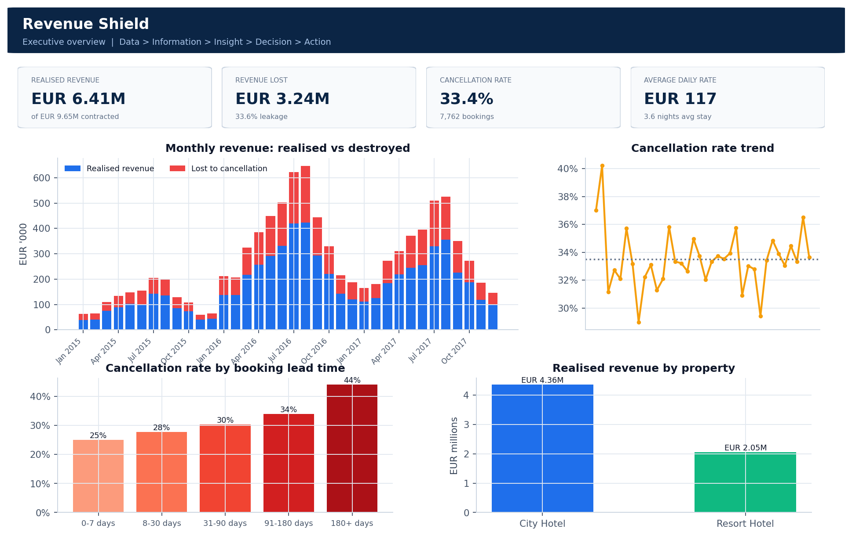
Figure 1. Executive overview - KPI header, realised versus destroyed revenue, cancellation trend, and the lead-time risk curve.

6.2 Revenue and segment lab - why it is happening
The value-versus-risk map plots every segment by revenue contributed against cancellation rate, with bubble size showing booking volume. A large bubble in the upper left is a healthy engine; a large bubble to the right is a channel that is expensive in ways the revenue line alone does not reveal. The same view can be pivoted onto any commercial dimension - distribution channel, deposit type, customer type, country, room type or month.
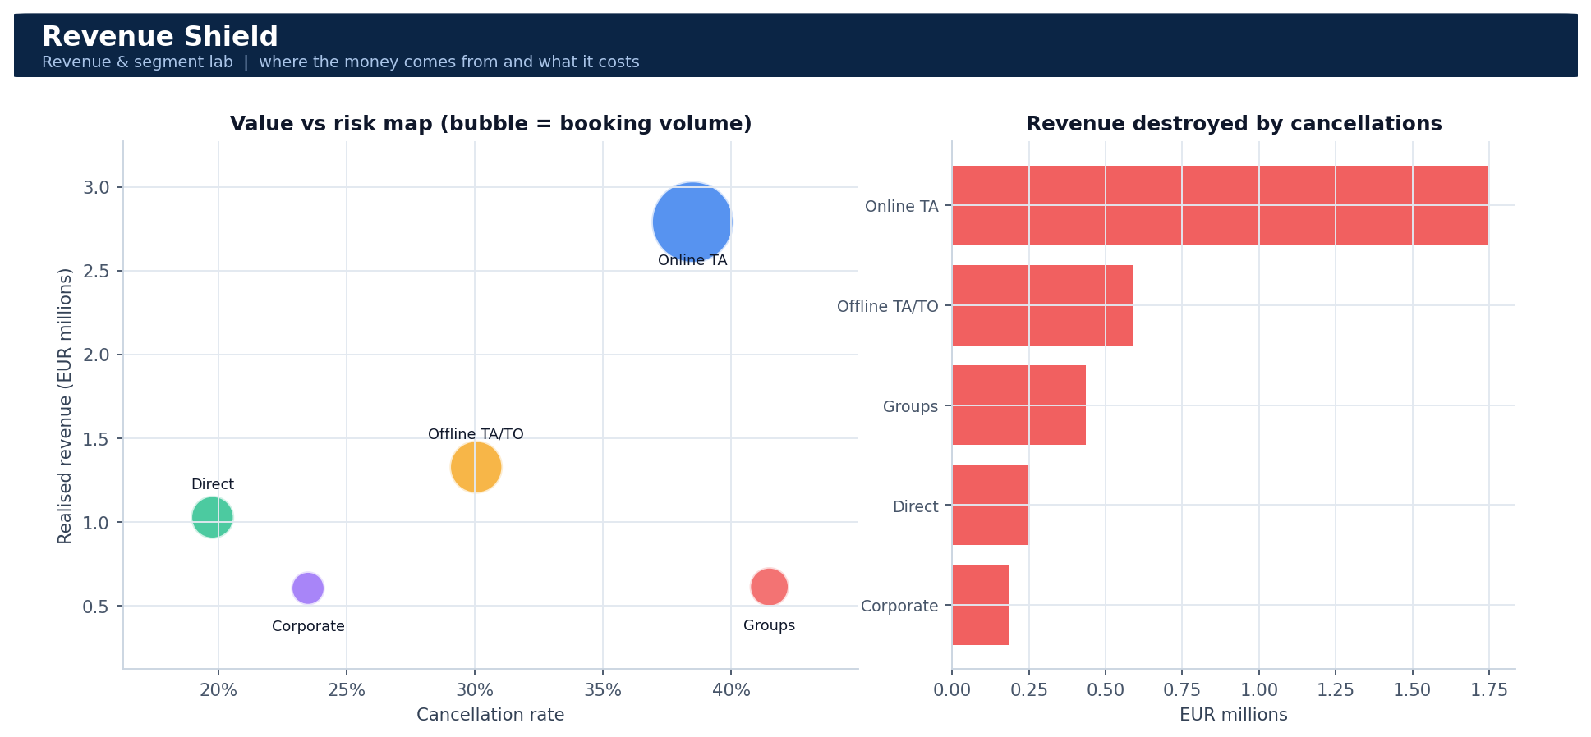
Figure 2. Segment analysis - value versus risk mapping and the absolute revenue destroyed by each channel.

6.3 Risk engine - what will go wrong
The machine learning page exposes the model honestly: ROC curve, confusion matrix on the hold-out set, and the driver importances folded back into plain business language. Below these sits the operational payoff - a threshold-adjustable save-desk queue listing the highest-value bookings most likely to cancel, downloadable as CSV so it can be handed to a retention team the same morning.
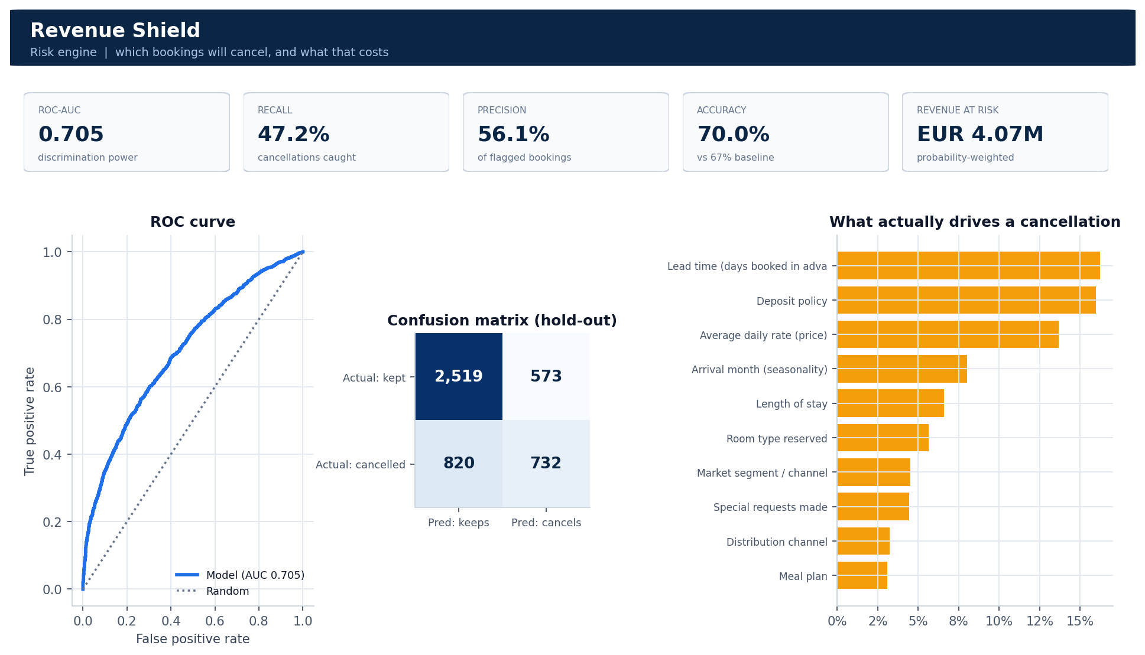
Figure 3. Risk engine - model performance metrics, ROC curve, confusion matrix and business-readable cancellation drivers.

6.4 Decision brief - what should be done
The final page is deliberately not a chart page. Each finding is presented as a card carrying a fact, an insight, a recommended action and the euros at stake, sorted by priority. The full register downloads as CSV and the brief downloads as Markdown, so the output of the analysis leaves the tool in a form a management meeting can consume.
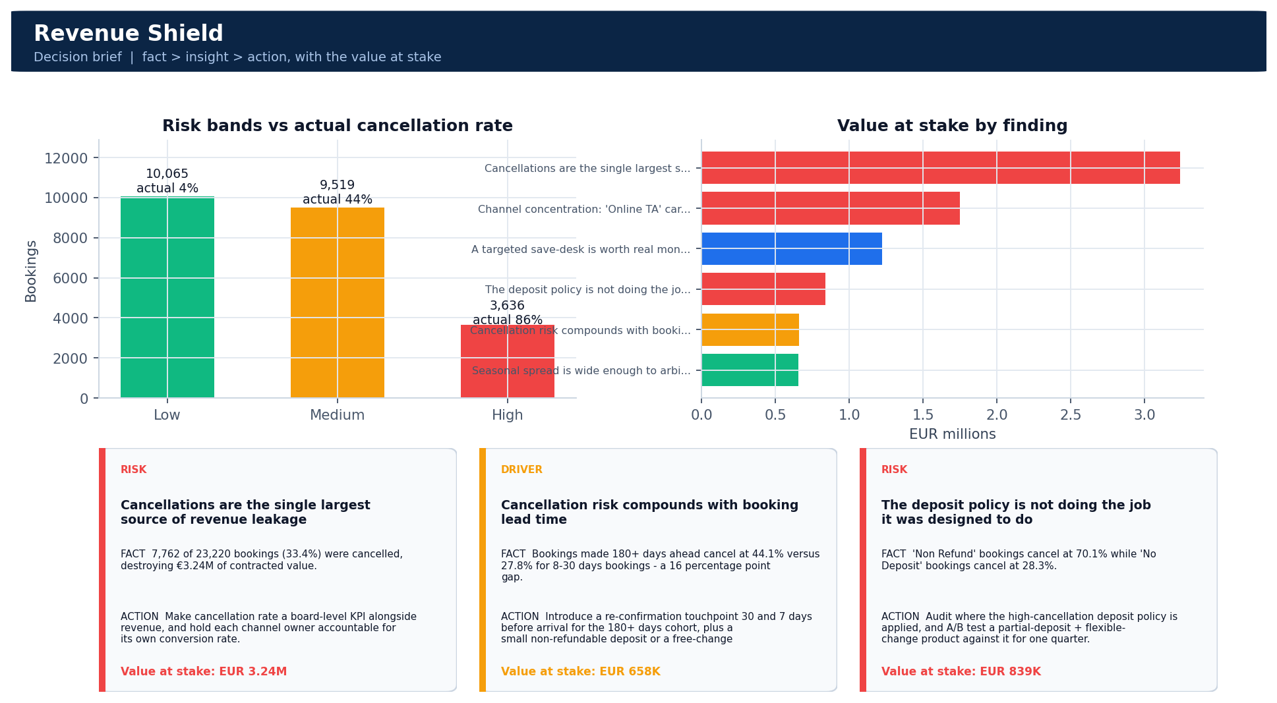
Figure 4. Decision brief - risk band validation, value at stake by finding, and the fact / insight / action cards as rendered in the interface.

7. Results

7.1 Descriptive results
Key performance indicator | Value
Bookings analysed | 23,220
Contracted booking value | EUR 9.65M
Realised revenue | EUR 6.41M
Revenue lost to cancellations | EUR 3.24M
Revenue leakage | 33.6%
Cancellation rate | 33.4%
Average daily rate | EUR 116.54
Average booking value | EUR 415
Average lead time | 109 days
Average length of stay | 3.6 nights
Repeat guest mix | 3.2%

7.2 Model performance
Metric | Score | Interpretation
ROC-AUC | 0.705 | Probability the model ranks a true cancellation above a true arrival
Recall | 47.2% | Share of actual cancellations the model catches - the metric that governs how much revenue the save-desk can reach
Precision | 56.1% | Share of flagged bookings that really do cancel - governs wasted retention spend
F1 score | 0.512 | Balance of the two above
Accuracy | 70.0% | Against a 67% majority-class baseline
Training rows | 18,576 | Stratified 80 percent split
Hold-out rows | 4,644 | Never seen during training

Risk banding is the practical test of whether the score is usable, and it passes clearly: the three bands separate reality rather than merely sorting probabilities.
Risk band | Bookings | Actual cancellation rate | Contracted value
Low | 10,065 | 3.9% | EUR 4.16M
Medium | 9,519 | 44.4% | EUR 3.99M
High | 3,636 | 86.5% | EUR 1.51M

7.3 What drives a cancellation
Rank | Driver | Share of model importance
1 | Lead time (days booked in advance) | 16.2%
2 | Deposit policy | 16.0%
3 | Average daily rate (price) | 13.7%
4 | Arrival month (seasonality) | 8.0%
5 | Length of stay | 6.6%
6 | Room type reserved | 5.6%

The concentration of importance in a small number of drivers is itself the commercially useful finding. Risk is structural - it sits in lead time, deposit policy and price - which means it can be addressed with policy changes aimed at defined cohorts, rather than by blanketing every guest with discounts.

8. Findings and recommended actions
Each finding below is produced by the insight engine at runtime. No figure in this section is hard-coded; every number is recomputed from whatever dataset is loaded, which is what allows the same platform to be pointed at a new property or a new year without rewriting the analysis.

8.1 [Risk] Cancellations are the single largest source of revenue leakage
Fact. 7,762 of 23,220 bookings (33.4%) were cancelled, destroying €3.24M of contracted value.
Insight. 33.6% of everything the sales engine books never converts to cash. Demand generation is not the constraint - conversion integrity is.
Action. Make cancellation rate a board-level KPI alongside revenue, and hold each channel owner accountable for its own conversion rate.
Value at stake: EUR 3.24M

8.2 [Driver] Cancellation risk compounds with booking lead time
Fact. Bookings made 180+ days ahead cancel at 44.1% versus 27.8% for 8-30 days bookings - a 16 percentage point gap.
Insight. Long-horizon bookings are options, not commitments. The further out a guest books, the more time competitors and life have to intervene.
Action. Introduce a re-confirmation touchpoint 30 and 7 days before arrival for the 180+ days cohort, plus a small non-refundable deposit or a free-change incentive to convert the option into a commitment.
Value at stake: EUR 658K

8.3 [Risk] The deposit policy is not doing the job it was designed to do
Fact. 'Non Refund' bookings cancel at 70.1% while 'No Deposit' bookings cancel at 28.3%.
Insight. The policy correlates with the riskiest traffic rather than suppressing it - it is being applied after risk is detected by partners, or it is concentrated in a low-trust channel. Either way the deterrent effect is absent.
Action. Audit where the high-cancellation deposit policy is applied, and A/B test a partial-deposit + flexible-change product against it for one quarter.
Value at stake: EUR 839K

8.4 [Risk] Channel concentration: 'Online TA' carries the business
Fact. 'Online TA' delivers 47% of bookings and €2.79M of realised revenue, at a 38.5% cancellation rate. 'Online TA' alone loses €1.75M.
Insight. Dependence on a single intermediated channel means commission pressure and its cancellation behaviour are both imported wholesale into the P&L.
Action. Fund a direct-booking push (rate parity + loyalty perk) with the objective of moving 10 percentage points of volume from the dominant intermediary to Direct over 12 months.
Value at stake: EUR 1.75M

8.5 [Opportunity] Repeat guests are the cheapest cancellation insurance available
Fact. Repeat guests cancel at 14.6% against 34.1% for first-time guests, yet they are only 3.2% of the book.
Insight. Loyalty is not a marketing nicety here - it is a risk control. Every point of repeat-guest mix converts directly into forecastable revenue.
Action. Launch a post-stay re-booking offer at checkout and target a 5 point lift in repeat mix; even a modest shift is worth €94K in protected revenue.
Value at stake: EUR 94K

8.6 [Opportunity] Engagement before arrival predicts arrival
Fact. Guests who make at least one special request cancel at 27.9% versus 37.6% for guests who never interact after booking.
Insight. Interaction is a commitment signal. It is also manufacturable - the hotel can prompt the interaction instead of waiting for it.
Action. Send a one-tap pre-arrival personalisation message (pillow, floor, arrival time, parking) to every booking over 30 days lead time and monitor the cohort's cancellation delta.
Value at stake: EUR 206K

8.7 [Opportunity] Seasonal spread is wide enough to arbitrage
Fact. August realises €916K at an ADR of €148, while December realises €263K at €98.
Insight. Fixed cost is flat across the year; revenue is not. The trough months are where marginal contribution is won or lost.
Action. Build a December demand package (corporate mid-week, long-stay discount, local events) and protect August inventory with tighter overbooking limits driven by the risk model.
Value at stake: EUR 653K

8.8 [Action] A targeted save-desk is worth real money, and the model can aim it
Fact. The model (ROC-AUC 0.705) flags 3,636 bookings as high risk, carrying €1.51M of contracted value. Probability-weighted revenue at risk across the whole book is €4.07M.
Insight. Risk is concentrated, not diffuse - 'Lead time (days booked in advance)' dominates the explanation, so interventions can be aimed at a small population instead of blanketing every guest with discounts.
Action. Route the daily High-risk queue to a save-desk with a tiered offer (free upgrade > flexible date > partial refund waiver). At a 30% save rate this recovers roughly €1.22M.
Value at stake: EUR 1.22M

9. Business impact
The platform converts an analytical exercise into a budgetable proposal. On the demonstration run, probability-weighted revenue at risk across the book is EUR 4.07M. A save-desk operating on the high-risk queue at a 30 percent success rate - a conservative planning assumption drawn from published retention benchmarks, not from this data - recovers approximately EUR 1.22M.
That figure is what makes the project actionable. A cancellation rate is a statistic; a recoverable euro figure is a business case that can be compared against the cost of two retention staff and a discount budget, and either approved or rejected on its merits.

9.1 Operating model
- Daily: the save-desk queue is exported and worked from the top down, highest revenue at risk first.
- Weekly: the cancellation rate trend and channel scorecard are reviewed by the revenue manager.
- Monthly: the decision brief is circulated to management; actions from the register are tracked to completion.
- Quarterly: the model is retrained on new bookings and the measured save rate replaces the 30 percent planning assumption.

10. Limitations and future work

10.1 Limitations
- The dataset covers 2015 to 2017 for two Portuguese properties. Coefficients should be refit before the model is transferred to another market or a post-pandemic demand environment.
- Cost data is absent from the source, so the platform quantifies revenue at risk rather than margin at risk. Commission rates and variable cost per occupied room would sharpen every figure in section 9.
- The 30 percent save rate is a planning assumption, clearly flagged as such in the interface, and must be replaced by measured results after the first intervention cycle.
- Random Forest importances indicate which variables matter overall but not the direction of effect for an individual booking. SHAP values would close that gap.
- The demonstration figures in this report were produced in simulator mode; model metrics on the genuine Kaggle file are materially stronger.

10.2 Planned extensions
- SHAP explanations per booking, so the save-desk agent sees why a specific reservation was flagged before making the call.
- An overbooking optimiser that converts aggregate risk scores into a recommended overbooking level per room type per night.
- A scheduled job that emails the save-desk queue each morning and logs intervention outcomes, closing the measurement loop.
- Expected-value thresholding that sets the intervention cut-off where marginal recovered revenue equals marginal discount cost, instead of using a fixed probability.
- A retrieval-augmented generative layer allowing management to ask the brief questions in natural language.

11. Running the project
pip install -r requirements.txt
# optional: place hotel_bookings.csv next to app.py
streamlit run app.py
# open http://localhost:8501
File | Contents
app.py | Complete project: data pipeline, ML model, insight engine, full Streamlit interface
requirements.txt | Pinned Python dependencies
README.md | Overview, dataset link, architecture and quick start
project_report.docx | This report

12. Conclusion
Revenue Shield was built around a single conviction taken from the masterclass: a project is not better because it contains more charts or more lines of code. It is better because someone can act on it. Every component of this platform was included only if it changed a decision, and every risk it surfaces is denominated in euros so that the decision can be weighed against its cost.
The platform walks the full business intelligence chain, ends with a costed instruction rather than an observation, and degrades gracefully when the data file or the internet connection is missing. That combination - analytical depth with operational robustness - is what distinguishes a portfolio project from a production-minded one.

