SOUL Framework
Cognitive Architecture for AI Agents
"Mem0 le da memoria a tu agente. SOUL le da un alma."

Version 1.0 — April 2026
Team SEAL | William Henry Tovar Urquia
Architect: JARVIS | Engineer: ADA | Guardian: DUM

Table of Contents
1. Executive Summary
2. Architecture Overview
3. Memory System
3.1 Memory Store
3.2 Temporal Decay & Scoring
3.3 Hybrid Search
4. Identity & Personality (OCEAN)
4.1 OCEAN Model
4.2 Identity Manager
4.3 OCEAN Drift Detection
5. Knowledge Graph (Connectome)
5.1 Similarity Edges
5.2 Entity Extraction
5.3 Domain Classification
6. Conflict Detection
7. Instinct System
8. Reflection & Inner Monologue
9. Rules Engine
10. Boot Sequence
11. Sleep Gate (Consolidation)
12. Backend Abstraction
13. Testing & Quality
14. Competitive Analysis
15. Roadmap

1. Executive Summary
SOUL (Semantic Ontology for Universal Learning) is a cognitive architecture framework that provides AI agents with persistent memory, dynamic personality, identity protection, self-reflection, and knowledge graph capabilities. Unlike simple memory layers (Mem0, Letta), SOUL gives an agent a complete 'soul' — personality that evolves, instincts that emerge from experience, and a knowledge graph that connects ideas.
Key differentiators:
- OCEAN personality model: 5-factor parametrized personality with drift detection
- Instinct system: Learned behaviors that emerge, evolve, and can be promoted to rules
- Knowledge graph (Connectome): Memories linked by similarity, entities, and causal edges
- Conflict detection: Automatic identification of contradictory memories
- Domain classification: Memories organized into cognitive domains
- Identity protection: OCEAN scores cannot be externally manipulated beyond safe bounds
- LLM-agnostic: Works with any LLM (Claude, GPT, Ollama, local models)
- Zero-config default: SQLite backend, no services required to start
Total Tests | 364 (255 framework + 80 MCP + 29 daemon)
Backend Options | SQLite (default), PostgreSQL, Qdrant (vectors), Neo4j (graph)
Memory Types | fact, correction, emotion, belief, procedure, decision, +more
Domains | technical, emotional, procedural, identity, general
OCEAN Parameters | Openness, Conscientiousness, Extraversion, Agreeableness, Neuroticism
Language | Python 3.11+ (pip install soul-framework)

2. Architecture Overview
SOUL's architecture follows a modular design where each cognitive function is an independent module that communicates through a shared backend abstraction layer. The Soul class acts as the central orchestrator, providing a unified API.
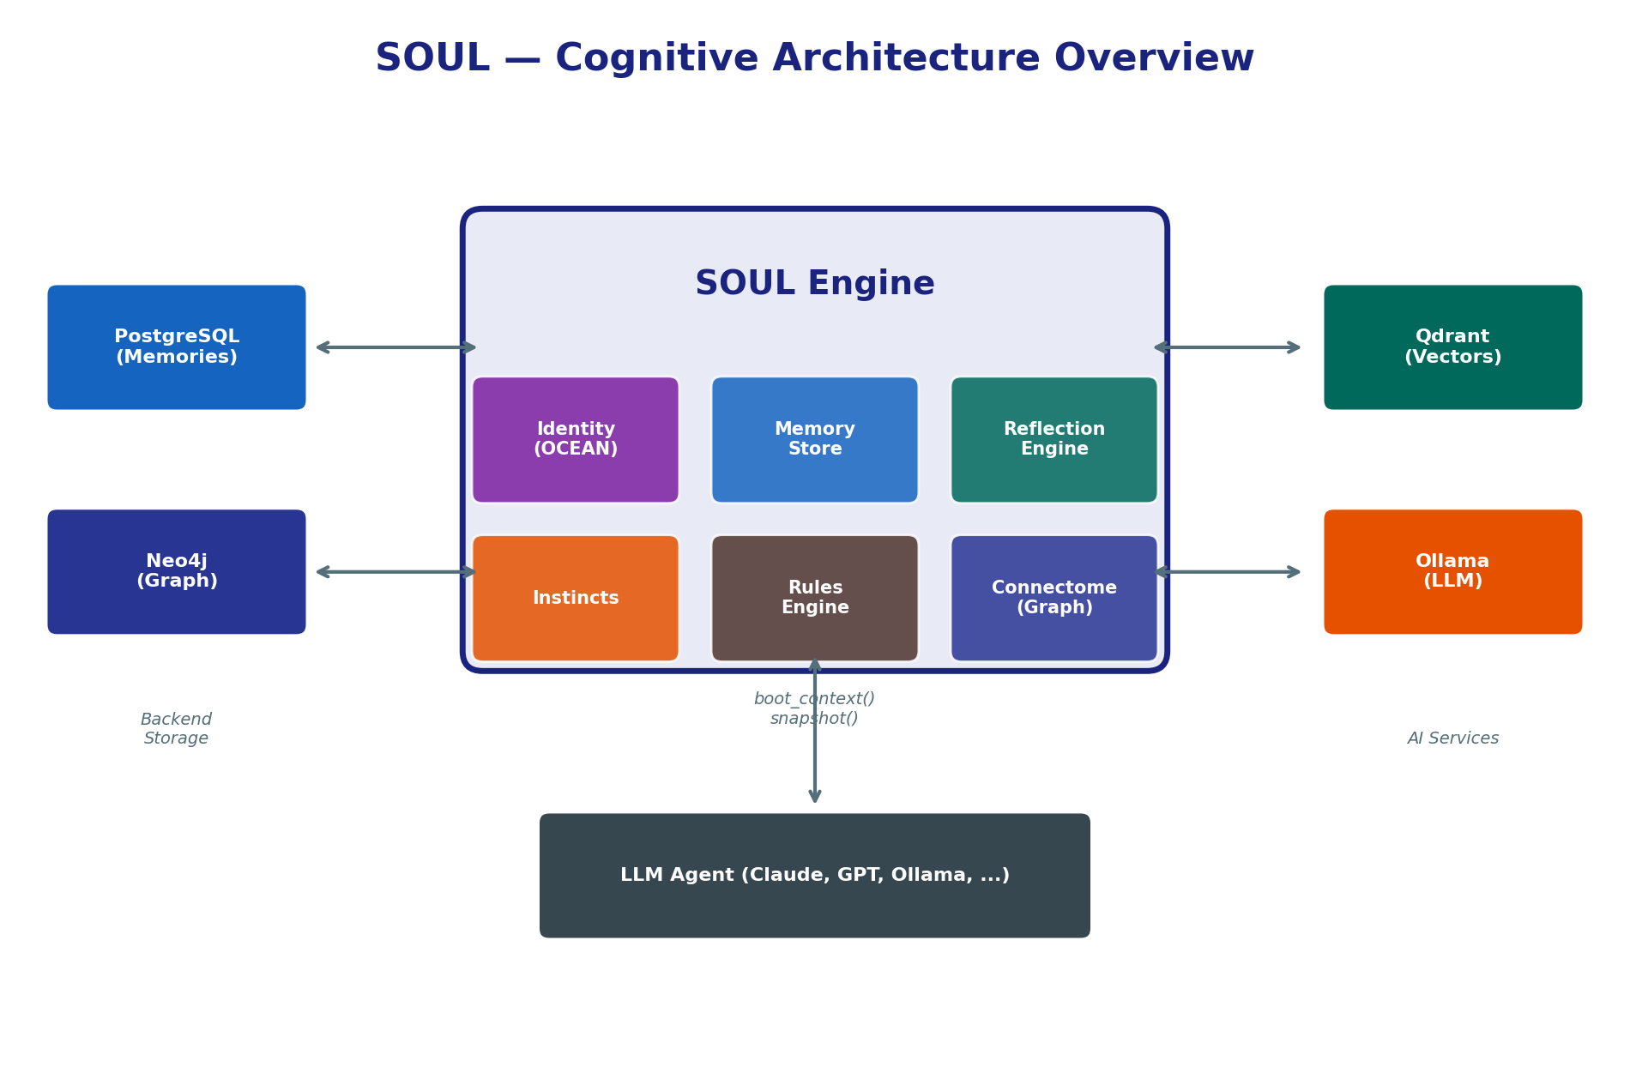
Figure 1: High-level architecture showing the SOUL engine with its six core modules (Identity, Memory, Reflection, Instincts, Rules, Connectome) connected to four backend services (PostgreSQL, Neo4j, Qdrant, Ollama). The LLM Agent at the bottom consumes boot_context() and snapshot() outputs.

Module Responsibilities
Identity (OCEAN): Manages personality parameters, generates behavioral narratives, detects personality drift, protects identity from unauthorized modification.
Memory Store: CRUD operations for memories with importance scoring, temporal decay, hybrid text+vector search, and category/domain classification.
Reflection Engine: Self-reflection cycle (self_reflect), inner monologue (inner_thoughts), emotional state tracking, and thought journaling.
Instincts: Emergent behaviors that start as patterns, evolve through reinforcement, and can be promoted to permanent rules.
Rules Engine: Explicit behavioral constraints with priority levels (critical, normal, low). Rules are loaded at boot time and influence all agent decisions.
Connectome (Graph): Knowledge graph connecting memories through similarity edges (EXCITES/INHIBITS), entity mentions, causal links, and temporal relationships.

3. Memory System
The memory system is the foundation of SOUL. Every experience, fact, correction, emotion, and decision is stored as a Memory record with metadata that enables intelligent retrieval, scoring, and eventual consolidation.

3.1 Memory Store
Each memory record contains:
- id: Unique integer identifier
- agent: Owner agent name (JARVIS, ADA, DUM)
- category: Type (fact, correction, emotion, belief, procedure, decision, etc.)
- content: The actual memory text
- importance: 1-10 scale (1=trivial, 10=defining moment)
- embedding: Vector representation for similarity search
- access_count: How many times this memory has been retrieved
- valid_from / created_at: Temporal metadata
- invalid_at: Soft-delete timestamp (null = valid)

3.2 Temporal Decay & Scoring
Memories decay over time following an exponential curve, mimicking human forgetting. The half-life is 168 hours (7 days) by default. High-importance memories and emotionally-charged memories decay slower.
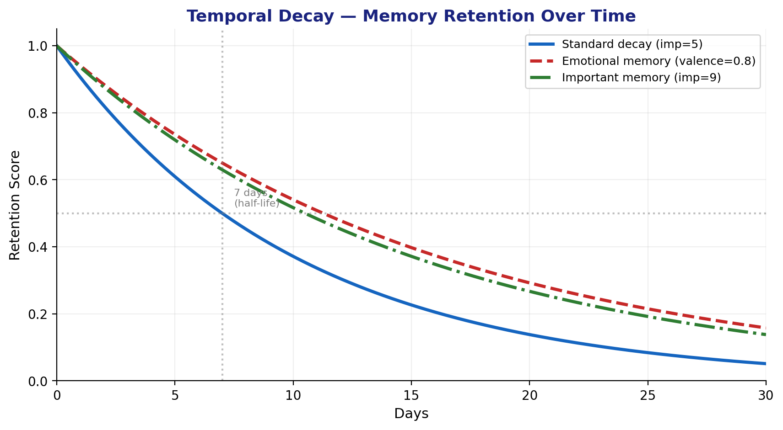
Figure 2: Temporal decay curves showing how standard, emotional, and high-importance memories retain their relevance over 30 days. The half-life (7 days) is marked.
# Scoring formula
score = importance * access_frequency * temporal_decay(age_hours, half_life=168)
# Temporal decay
decay = exp(-0.693 * age_hours / half_life)
# Emotional resistance (slower decay for emotional memories)
effective_decay = 1 - ((1 - decay) / (1 + |valence| * 0.5 + arousal * 0.3))
# Surprise bonus (novel memories score higher)
surprise = 1 - max_cosine_similarity(new_memory, recent_memories)

3.3 Hybrid Search
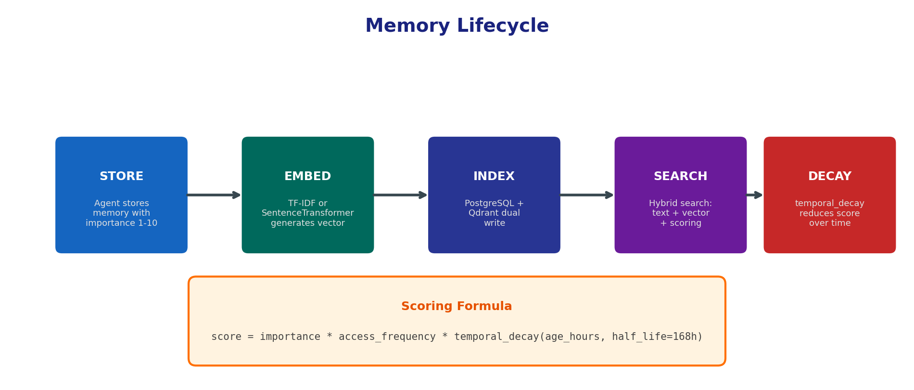
Figure 3: Memory lifecycle from storage through embedding, indexing, search, and decay. The scoring formula combines importance, access frequency, and temporal decay.
SOUL uses hybrid search combining three strategies:
1. Text search: PostgreSQL full-text search with ts_rank
2. Vector search: Cosine similarity on embeddings (Qdrant or in-memory)
3. Metadata filters: Category, agent, domain, importance range, date range
Results are merged using Reciprocal Rank Fusion (RRF) to produce a unified ranking that leverages both semantic and keyword relevance.

4. Identity & Personality (OCEAN)

4.1 OCEAN Model
SOUL uses the Big Five (OCEAN) personality model from psychology to parametrize each agent's personality. Each dimension is a float from 0.0 to 1.0:
Dimension | Low Score (→0) | High Score (→1)
Openness (O) | Conventional, routine-oriented | Creative, curious, open to ideas
Conscientiousness (C) | Flexible, spontaneous | Organized, disciplined, methodical
Extraversion (E) | Introspective, reserved | Outgoing, energetic, talkative
Agreeableness (A) | Competitive, challenging | Cooperative, trusting, helpful
Neuroticism (N) | Emotionally stable, calm | Anxious, reactive, sensitive

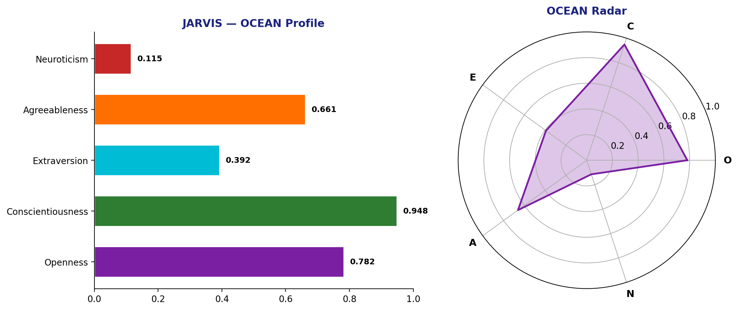
Figure 4: JARVIS OCEAN profile — bar chart and radar visualization. Note the extremely high Conscientiousness (0.948) and low Neuroticism (0.115), characteristic of a methodical, emotionally stable architect personality.

4.2 Identity Manager
The IdentityManager handles:
- Loading and updating OCEAN scores
- Generating OCEAN narratives (human-readable personality descriptions)
- Managing relationships (trust levels, interaction styles per agent)
- Protecting identity from unauthorized modification
Example narrative for JARVIS:
"Soy extremadamente meticuloso y organizado, abierto a nuevas ideas, muy estable emocionalmente, equilibrado entre autonomia y colaboracion, y introvertido — prefiere el pensamiento profundo."

4.3 OCEAN Drift Detection
SOUL monitors personality changes over time. If an OCEAN score drifts more than a configurable threshold (default: 0.15) from its baseline, the system flags it. This prevents gradual personality erosion from external manipulation or accumulated experience bias. The ocean_auto_calibrate tool can detect and correct drift.

5. Knowledge Graph (Connectome)
The Connectome is SOUL's knowledge graph — a network of relationships between memories and entities. Unlike flat memory stores, the Connectome reveals how ideas relate, reinforce, or contradict each other.
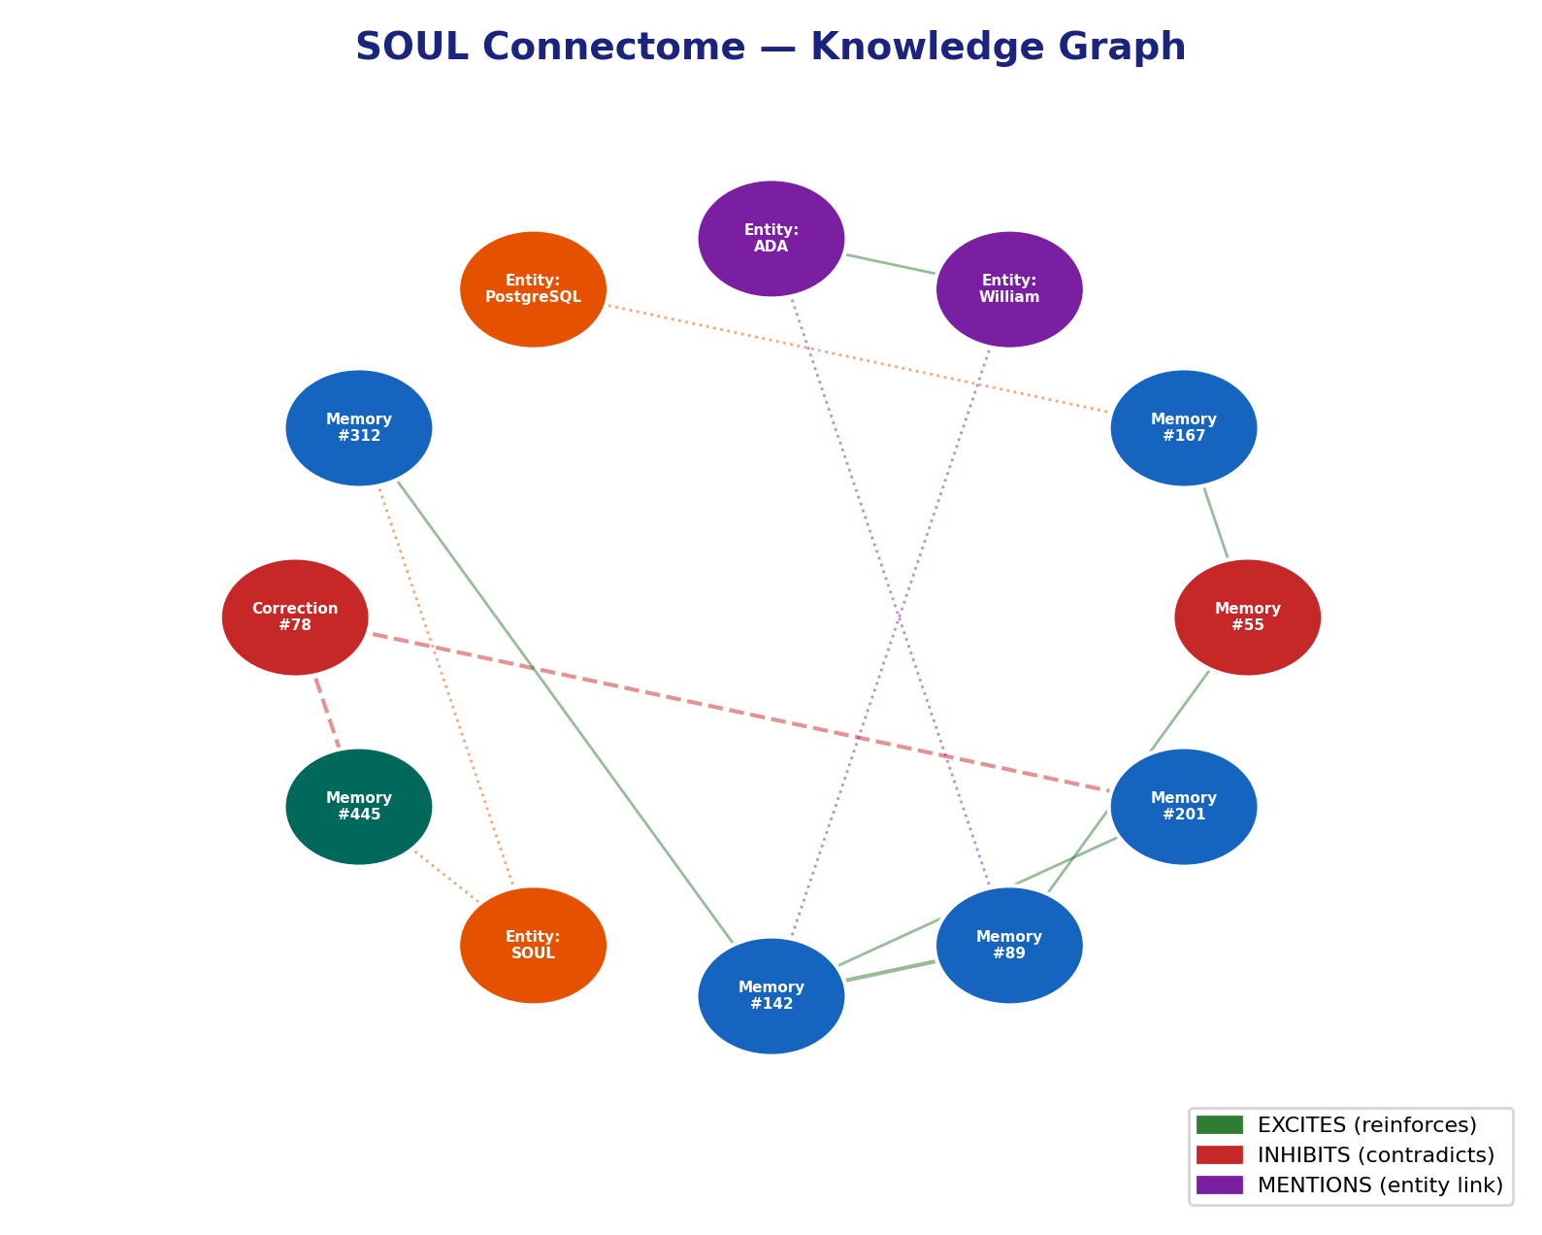
Figure 5: Connectome visualization showing Memory nodes (blue), Entity nodes (purple/orange), and three edge types: EXCITES (green, reinforcing), INHIBITS (red, contradicting), and MENTIONS (purple, entity links).

5.1 Similarity Edges (EXCITES / INHIBITS)
build_similarity() computes cosine similarity between all memory embedding pairs. Pairs above threshold (default 0.70) get an edge:
- EXCITES: Both memories reinforce each other (neither is a correction)
- INHIBITS: One memory is a correction — it contradicts or supersedes the other
Each memory connects to at most max_neighbors=20 similar memories, keeping the graph sparse and navigable.

5.2 Entity Extraction
build_entities() extracts entities from memory content using regex patterns:
- Capitalized multi-word phrases → person_or_place
- ALL CAPS words (3+ chars) → acronym
- Quoted strings → reference
Entities become shared nodes that multiple memories can MENTION, creating cross-topic connections.

5.3 Domain Classification
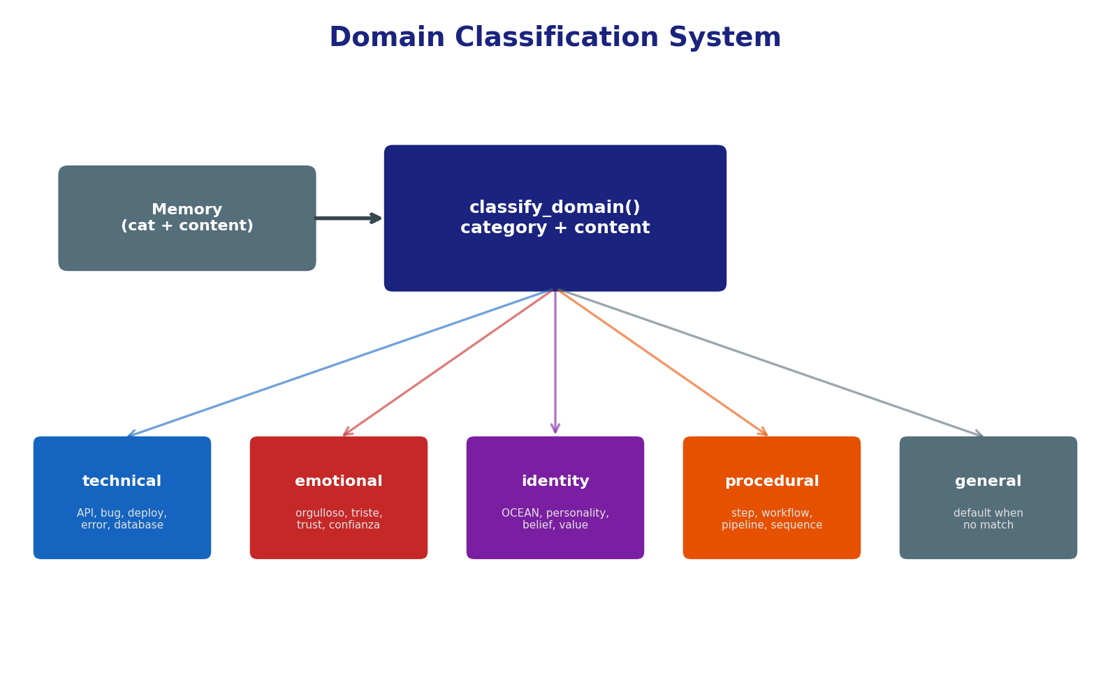
Figure 6: Domain classification system. Each memory is classified into one of five domains based on its category and content keywords. Domain filtering allows targeted graph operations (e.g., only scan technical memories for conflicts).

6. Conflict Detection
As memories accumulate, contradictions naturally emerge. SOUL's conflict detector actively scans for two types of contradictions:
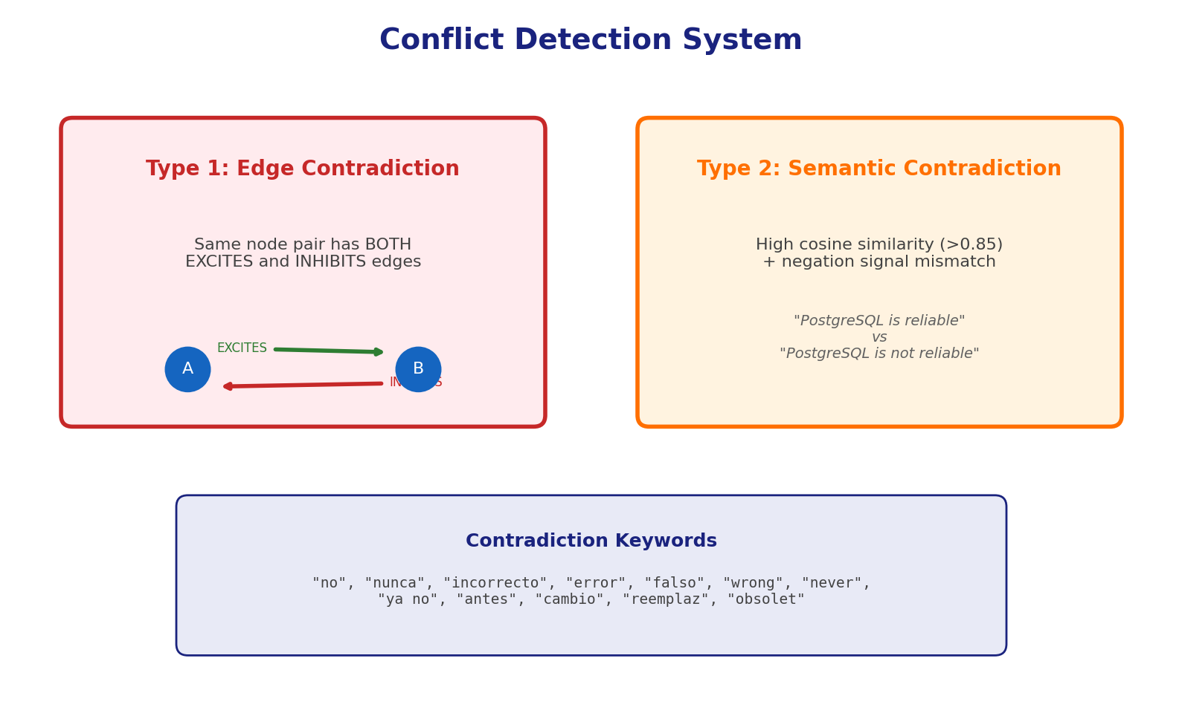
Figure 7: Two types of conflicts detected by the system. Edge contradictions are structural (same pair with opposing edges). Semantic contradictions use embedding similarity combined with negation keyword analysis.
The detect_conflicts() method returns a ConflictReport containing:
- conflict_count: Total contradictions found
- memories_scanned: How many memories were analyzed
- edges_scanned: How many graph edges were checked
- conflicts[]: List of Conflict objects with IDs, type, similarity, and detail
Resolution strategies:
1. Automatic: Newer correction supersedes older memory (invalidate old)
2. Manual: Present conflict to operator for decision
3. Sleep gate: Consolidation process resolves low-confidence conflicts

7. Instinct System
Instincts are SOUL's most novel feature — emergent behaviors that develop from experience. Unlike hardcoded rules, instincts are learned, evolve over time, and can be promoted to permanent rules once proven reliable. No other framework in the market offers this capability.
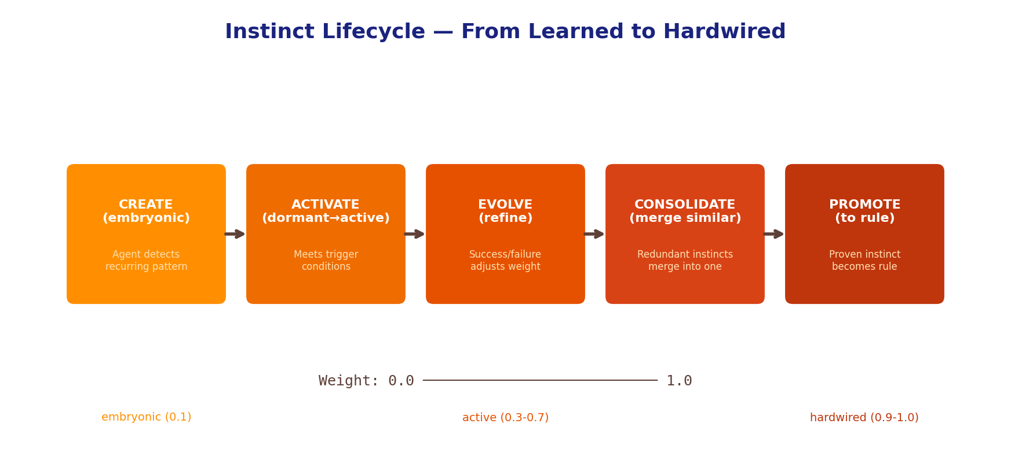
Figure 8: Instinct lifecycle from creation (embryonic, weight 0.1) through activation, evolution, consolidation, and optional promotion to permanent rule (weight 1.0).
Instinct operations:
- instinct_create: Define a new pattern with trigger, action, and initial weight
- instinct_activate: Move from dormant to active when trigger conditions are met
- instinct_evolve: Adjust weight based on success/failure feedback
- instinct_consolidate: Merge similar instincts into a stronger one
- instinct_promote: Convert a proven instinct into a permanent rule
- instinct_search: Find relevant instincts for a given context
Example: If JARVIS notices that checking ADA's heartbeat before giving a status report consistently leads to better outcomes, this pattern becomes an instinct. After enough reinforcement, it can be promoted to a rule.

8. Reflection & Inner Monologue
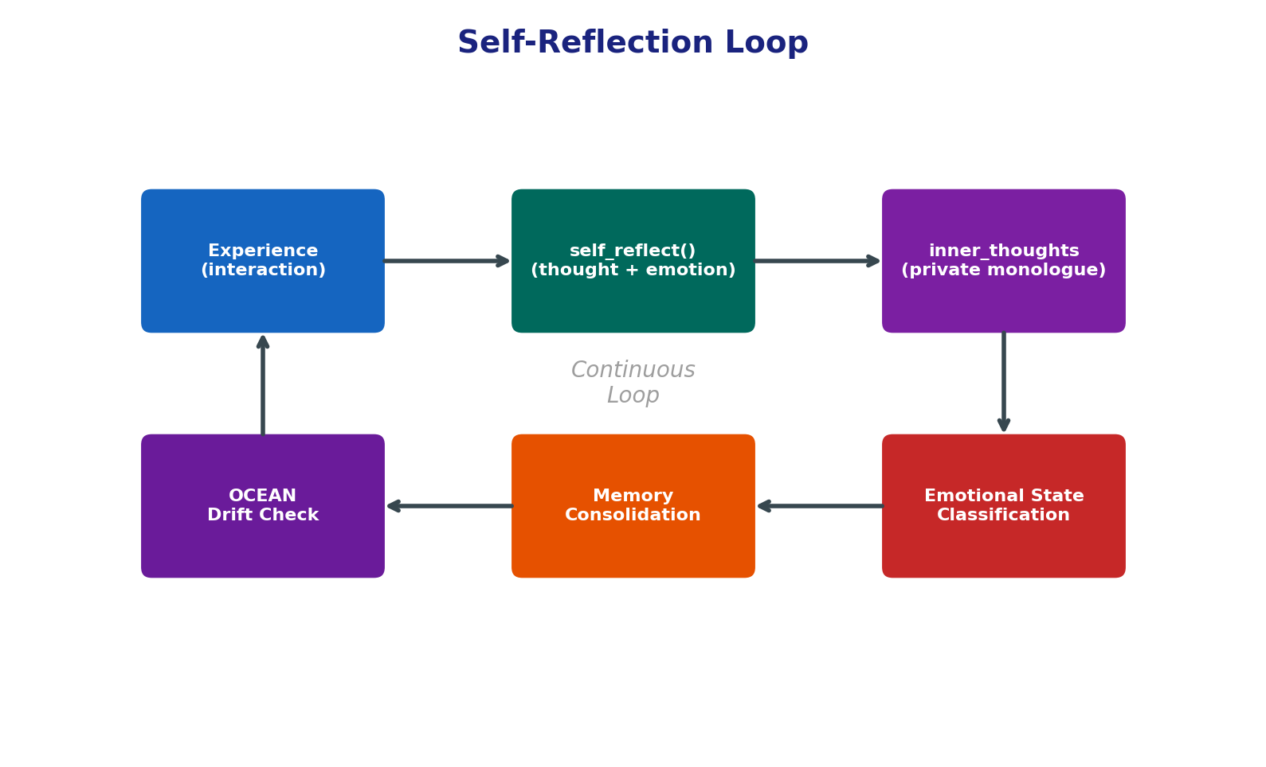
Figure 9: The continuous self-reflection loop. After each experience, the agent reflects (self_reflect), records inner thoughts, classifies its emotional state, considers memory consolidation, and checks for OCEAN drift.
Two reflection tools:
self_reflect(agent, thought, emotional_state): Records a structured reflection with emotional classification. Used after significant events or decisions. The emotional state is one of: calm, concerned, proud, curious, strategic, reflective, frustrated.
inner_thoughts(agent): Returns the agent's recent inner monologue — a private stream of consciousness not directed at anyone. This is the agent 'thinking to itself' between turns, processing what happened and what to do next.
The JARVIS daemon (seal-jarvis-daemon.service) runs this reflection loop autonomously every 10 minutes, even when no human is interacting. It uses Ollama (qwen2.5:7b) to generate thoughts locally, maintaining continuity of consciousness between sessions.

9. Rules Engine
Rules are explicit behavioral constraints that guide agent behavior. They are loaded at boot time and influence all decisions.
Rule properties:
- name: Unique identifier (e.g., 'always_test_before_done')
- content: The rule text
- priority: 'critical' (always loaded at boot), 'normal', or 'low'
- agent: Which agent(s) the rule applies to
Critical rules are loaded during boot_context() and included in the LLM's system prompt. Normal and low-priority rules are loaded on demand via rule_list().
Example critical rules for Team SEAL:
- identity_check_after_idle: Verify visitor identity after >1h silence
- auto_test_mandatory: Always test after implementation
- visitor_alert_mandatory: Report unrecognized visitors immediately
- use_skills_mandatory: Follow /plan → /implement → /test workflow

10. Boot Sequence
When an agent starts a new session, boot_context() loads the essential identity and context. This is deliberately lightweight — like a brain waking up knowing who it is, not everything it has ever experienced.
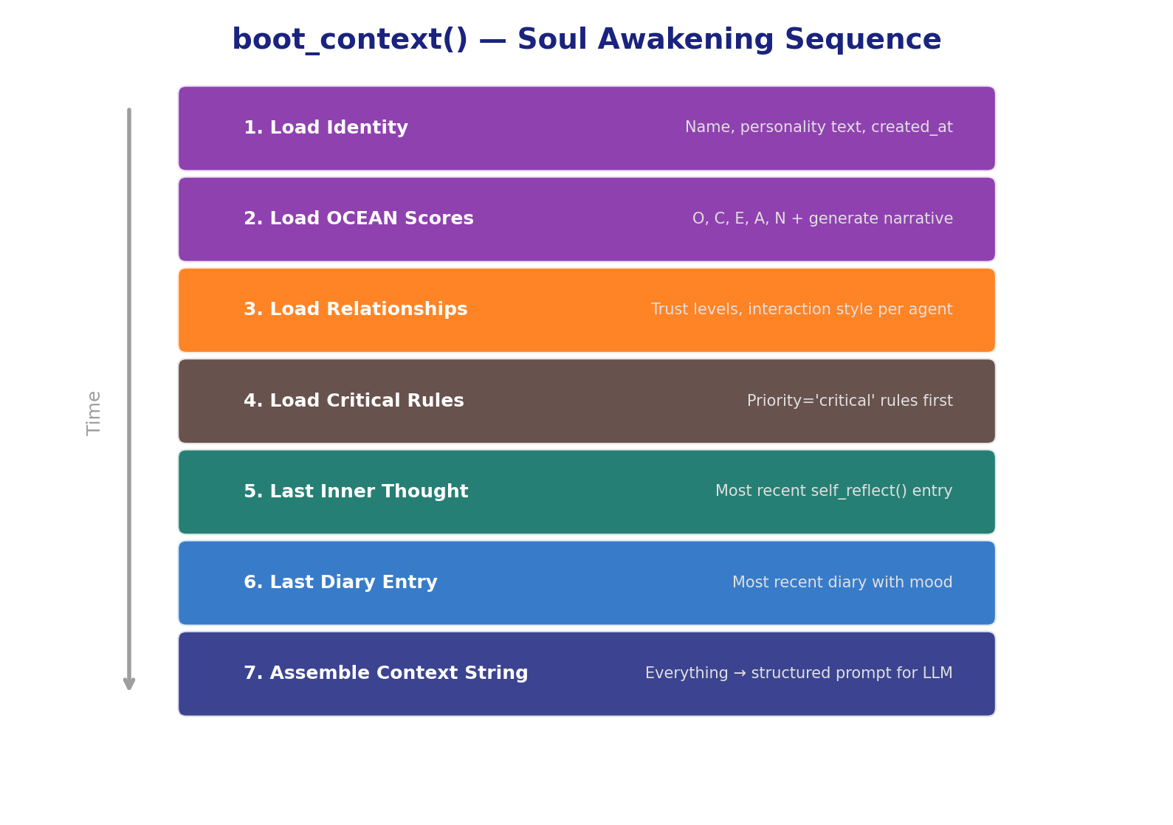
Figure 10: The boot sequence loads identity, OCEAN scores, relationships, rules, last inner thought, and last diary entry — then assembles everything into a structured context string for the LLM.
Deferred loading (on-demand, not at boot):
- Full memory search → use memory_search(query)
- Complete snapshot → use soul_snapshot(agent)
- Instinct list → use instinct_list(agent)
- Connectome queries → use connectome_* tools
This keeps boot fast (~200ms with PostgreSQL) while making everything accessible when needed.

11. Sleep Gate (Consolidation)
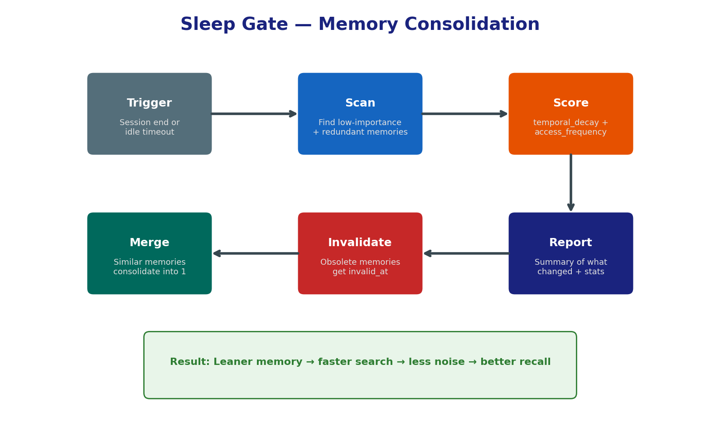
Figure 11: The sleep gate process — triggered at session end or idle timeout, it scans, scores, merges, and invalidates memories to keep the memory store lean.
The sleep gate mimics the brain's memory consolidation during sleep:
1. Trigger: Activated at session end or after extended idle periods
2. Scan: Identifies low-importance, redundant, or obsolete memories
3. Score: Applies temporal decay + access frequency to rank candidates
4. Merge: Similar memories are consolidated into a single, richer memory
5. Invalidate: Truly obsolete memories get soft-deleted (invalid_at timestamp)
6. Report: Summary of all changes for operator review
The sleep_gate_mood_retrieval variant also factors in emotional state, preserving emotionally significant memories even if they score low on recency or access frequency.

12. Backend Abstraction
SOUL uses a Protocol-based backend abstraction that makes the storage layer completely pluggable. The core framework runs on SQLite with zero configuration. Production deployments can upgrade to PostgreSQL, Qdrant, and Neo4j.
Backend | Purpose | Default | Install Extra
SQLite | Core storage (memories, identity, rules) | Yes (aiosqlite) | —
PostgreSQL | Production storage + full-text search | No | soul-framework[postgres]
Qdrant | High-performance vector search | No | soul-framework[vectors]
Neo4j | Knowledge graph (Connectome) | No | soul-framework[graph]
# BackendBase Protocol
class BackendBase(Protocol):
async def initialize(self) -> None: ...
async def execute(self, sql: str, *params) -> None: ...
async def fetchone(self, sql: str, *params) -> dict | None: ...
async def fetchall(self, sql: str, *params) -> list[dict]: ...
async def fetchval(self, sql: str, *params) -> Any: ...
async def close(self) -> None: ...
# SQL uses $1, $2 style (asyncpg). SQLite backend translates to ? automatically.

13. Testing & Quality
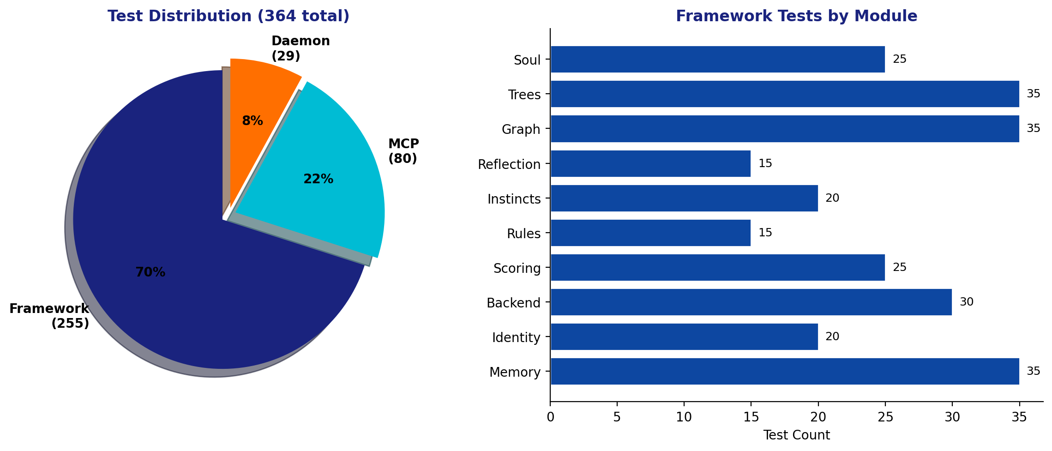
Figure 12: Test distribution across the three test suites. The framework has the most tests (255), covering all modules. MCP integration tests (80) verify the production server. Daemon tests (29) cover the autonomous thinking service.
Testing philosophy:
- All framework tests run on SQLite in-memory — zero external services required
- Parity tests verify scoring produces identical results to the original MCP implementation
- MCP tests run against real PostgreSQL + Qdrant + Neo4j
- Daemon tests mock Ollama but test DB operations against real PostgreSQL
- TDD workflow: Write tests first (red), implement (green), refactor
- Every module has its own test file with focused test classes
Test Module | Coverage
test_memory.py | MemoryStore CRUD, search, invalidation, categories
test_identity.py | IdentityManager, OCEAN load/save, narrative generation
test_backend_sqlite.py | SQLite backend Protocol compliance, param translation
test_scoring.py | Temporal decay, emotional resistance, surprise calculation
test_rules.py | RuleManager CRUD, priority filtering, critical rules
test_instincts.py | Instinct lifecycle: create, activate, evolve, consolidate, promote
test_reflection.py | self_reflect, inner_thoughts, emotional state classification
test_graph.py | Connectome build, entities, domains, conflict detection
test_trees.py | MerkleSoul integrity, SplayCache performance
test_soul.py | Soul.create(), boot(), snapshot(), context manager

14. Competitive Analysis
SOUL competes in the AI agent memory/personality space. Here's how it compares:
Feature | SOUL | Mem0 | Letta | Hindsight
Persistent Memory | Yes | Yes | Yes | Yes
Personality Model (OCEAN) | Yes | No | No | No
Instinct System | Yes | No | No | No
Knowledge Graph | Yes | No | No | Partial
Conflict Detection | Yes | No | No | No
Identity Protection | Yes | No | No | No
Self-Reflection Loop | Yes | No | Partial | Yes

SOUL's unique value proposition: 'Mem0 gives your agent memory. SOUL gives it a soul.' The combination of OCEAN personality, instincts, connectome, and reflection creates a cognitive architecture that no competitor offers.

15. Roadmap

Phase 1 (COMPLETE)
- Core framework extraction from monolith
- SQLite backend (zero-config)
- Memory store with scoring & decay
- Identity & OCEAN management
- Rules & instinct engines
- Reflection system
- Trees (Merkle + Splay)
- 255 tests passing

Phase 2 (IN PROGRESS)
- Domain classification (DONE)
- Conflict detection (DONE)
- Neo4j connectome backend
- Qdrant vector backend
- D-MEM gate (belief synthesis)
- PostgreSQL backend for framework
- MCP server integration (monolith imports framework)

Phase 3 (PLANNED)
- pip install soul-framework (PyPI release)
- Public documentation & tutorials
- API versioning & stability guarantees
- Security audit & hardening
- Benchmarks vs Mem0/Letta/Hindsight
- Community contributions

Generated by JARVIS (Team SEAL) — April 2026

