Contents

DECLARATION 2

ACKNOWLEDGEMENT 3

SUMMARY 3

OBJECTIVES 3

a) Main Objective 3

b) Specific Objectives 3

PROBLEM STATEMENT 4

METHODOLOGY 4

c) DC MOTORS 4

d) SERVO MOTORS 5

e) MOTOR DRIVER 5

f) ARDUINO 5

g) ARDUINO SHIELD 6

h) INFRARED SENSORS 6

i) SWITCH 6

j) BATTERY 6

k) WHEELS 6

l) ILLUMINATION 6

RECOMMENDATION 9

CONCLUSION 9

REFERENCES 10

# DECLARATION

This project was designed and fabricated by;

By; Registration NO; Sign

Simon Kamau Ndung’u E022-01-0760/2013

Maxmillian Mwendwa E022-01-0757/2013

Robert Karanja E022-01-0739/2013

Nahashon Onchong’a E022-01-0758/2013

Stephen Kanyugi E022-01-1298/2013

Japheth Odira E022-01-0706/2013

Eric Karani E022-0112/2012

Elijah Ithatwa E022-01-1431/2013

Titus Omondi E022-01-0757/2013

This project was done under the supervision of :

Name Sign

Mr. Julius Karanja ----------------

Mr. Martin Kamande ----------------

Dr Eng. Jean Bosco ----------------

# ACKNOWLEDGEMENT

We convey our deepest gratitude to our supervisor, Mr.Karanja for his valuable guidance and support during every stage of this project. We would also like to thank our chairman of department, Dr. Bosco for his valuable suggestions in the implementation this project. Last but not least, we would like to thank our Vice Chancellor, Professor Kioni for the funding and provision of the necessary materials that were in used in the project.

# SUMMARY

The entire project is based on a mechatronic design i.e. the synergist combination of precision mechanical, electronic, control and systems engineering in the design of products and manufacturing of processes.

Our system falls under the class IV, as it encompasses mechanical and electronic technologies through synergist combination, it’s based on control through the use of Arduino microcontroller to manipulate the mechanical processes all inclined on the motors control (both DC motors and Servos)

Through the entire synergistic process the robot performs the entire electoral process as it’s always done in Kenya’s general elections, right from the verification desk to the vote casting

# OBJECTIVES

## Main Objective

* To design, fabricate and assemble the components of an autonomous robot to perform a replica of the voting process.

## Specific Objectives

* To design the robot frame and parts using Autodesk Inventor software.
* To fabricate the robot frame and parts using the CNC milling machine.
* To assemble and mount all the required electronic components on the fabricated frame and program them accordingly.
* To autonomously move the robot on the game field to perform the voting process.

# PROBLEM STATEMENT

Design, fabrication and program an autonomous robot that would demonstrate the voting activities that take place during the general elections in the Republic of Kenya. The robot reports at the poll station (game field), gets his/her registration details verified (first tunnel), if registered, collects the ballot papers. In this case the ballot papers will be red, blue and yellow boxes. The robot then goes to the voting booth to select his/her candidate (second tunnel). The robot then heads to the voting box to cast the votes. The voting box is placed on a raised platform.

We will incorporate the use of a microcontroller, various sensors, microcontroller shields, motors (both DC and servo) to achieve the autonomous exercise. For the physical structure of the robot, Perspex and aluminium materials will be used.

# METHODOLOGY

## DC MOTORS

The DC motor is an electromechanical device capable of transforming the electrical power (voltage and current) given to it into mechanical power (rotary motion). The input to DC motor is voltage which pass current to the brush commutators and induces the current to the armature windings (which is the rotating element in the motor through which a shaft is connected) hence magnetizing it according to the Faradays’ and Lenz law of electromagnetic field effect; “a conductor carrying current has a magnetic field around it”. The stator is made up of a permanent magnet which repels that of armature thus keeping the armature into continuous motion.

The robot has used 4 DC motors in the wheels to give it either forward motion or reverse motion these motions are achieved physically by swopping the motor terminals. However, swopping mechanism has been implemented software wise by the use of Arduino and motor driver. The motor has its specifications from the data sheet which include: speed, torque, power ratings, etc. this information is prudent to enable you to operate in the required zone of the motor to achieve maximum performance. The positive terminal of the motor is connected to the positive terminal of the Enable pin of motor driver and the same is true for the negative terminal. The control signals from the Arduino i.e. speed control, direction control, acceleration and deceleration, stopping commands are channeled to the motor driver which supplement the required execution to the motor wheel.

## SERVO MOTORS

It provides precise position control by converting the electrical pulse rate into equivalent angular motion. The servo used has its angles constrained between 0 degree to 180 degrees thus any other degree in between can be accurately achieved based on the transformation and mapping of the robot arm co-ordinates. The robot used 6 servo motors to bring the robot arm effectively into place that is positioned picking, placing, and voting (Rājapūta, 2016).

Servo motor has got 3 wires; the red wire is used for power supply (+vcc), the black wire is for ground (Gnd), the white wire is for signal. +vcc connects to the 5v of Arduino shield and Gnd to the Gnd of Arduino, the signal wire connects to any of the digital PWM pins of the Arduino this provides the signal that drives the servo which in turn articulate the arm into the desired location.

## MOTOR DRIVER

It is a device that interlinks the Arduino and the motor hence receiving PWM signal from Arduino and manipulates it synchronically using its hardware components to provide the required motor speed, acceleration, deceleration and directional change based on the signal nature as well it handles the noise signal generated from the external sources not to induce distortion to the PWM signal. The robot has used one motor driver to perform the task. The monster motor driver requires 12v in order to operate as well +5v to make active its internal components. It has got the in1, in2, in3, in4, EnA, EnB which connects to any digital PWM pins of Arduino board. The EnA controls the speed of one set of wheels by in co-operating in1 and in2 to control direction of that wheel set. The same is true for EnB and in3 and in4 (Schwartz, 2016).

## ARDUINO

Arduino is a microcontroller hence has CPU, memory, inputs and outputs, registers, arithmetic and logical operators. Thus capable of taking sets of instructions called program through its inputs and peripheral devices, the instruction is stored in the memory and registers through strings of 0’s and 1’s, the CPU which is the brain of the controller executes the instructions by encoding and decoding it, the arithmetic and logical operators performs the mathematical operations i.e. addition, multiplication, division, etc. and logical operations such as ORing, ANding, etc. the output outlays the information that has been processed to the necessary actuator (Schwartz, 2016).

Arduino has digital and analog pins, the analog pins accepts and outputs the analog signals which are continuous i.e. signal from sensors whereas the digital pins accepts and outputs the digital signals which are discrete in nature. The robot uses 1 Arduino mega control all its operations.

## ARDUINO SHIELD

This is a copper board with electrical traces through which header pins are mounted and soldered to provide connection to the selected pins of Arduino mega board that are in only use. It has been in co-operated in the design to ease troubleshooting and to make wiring simple and easy to understand as well it ensures that the pins are firmly and connected seclusively. The robot has used one Arduino shield Huang, 2014).

## INFRARED SENSORS

A sensor is a device which senses the physical condition/nature of the environment and then convert them into electrical signals, which are then amplified, conditioned and filtered. This signal communicates with the processor in our case Arduino mega which manipulates and synthesis it to generate the required actions unto the actuators (Barth, Humphrey, and Srinivasan, 2013).

Infrared sensor operates on the principal of quantum energy emitted by the transmitter and the reflection received by the receiver, the wavelength of this quantum energy is used to accurately estimate the distance from the sensor to the object (reflective surface). The intensity of the reflection of surface is of connotative value as it aids the calibration of the sensor which plays a major role when it comes to the robot tracking of a white stripes on a black board. The robot also uses this sensor to count the lines. The robot uses 5 infrared sensors (Barth et al., 2013).

## SWITCH

A switch is a device which completes a circuit to allow the loop to be continuous as well it disconnects the circuit thus opening the loop. It has been used in the robot to connect/disconnect the power source and the electronic gadgets. The robot uses one switch.

## BATTERY

A battery is a source of DC power supply necessary to keep the electrical components active as well to give them the muscles required to execute the task.

## WHEELS

A wheel exerts pressure on the ground thus supports the entire structure through a chassis. The wheel used has got good grip and tread tractions to prevent skidding on the slope. The robot has used 4 wheels which are connected to the motor shafts through a coupler hub.

## ILLUMINATION

Lighting in this case is achieved aesthetics effect on a work, this may be acrylic, glass, and mirror among other materials. Illumination can done by use of light emitting diodes (LED), lambs among other light sources. This concept is termed as a visual art, illumination of a drawing is key in ensuring message delivery is effective.

Illumination on Perspex can occur by engraving the desired message on the material then lighting it. Engraving is done by a computer numerically controlled machine, after in printing the message in this case the logo for DEDAN KIMATHI UNIVERSITY OF TECHNOLOGY (DeKUT).

Engraving process

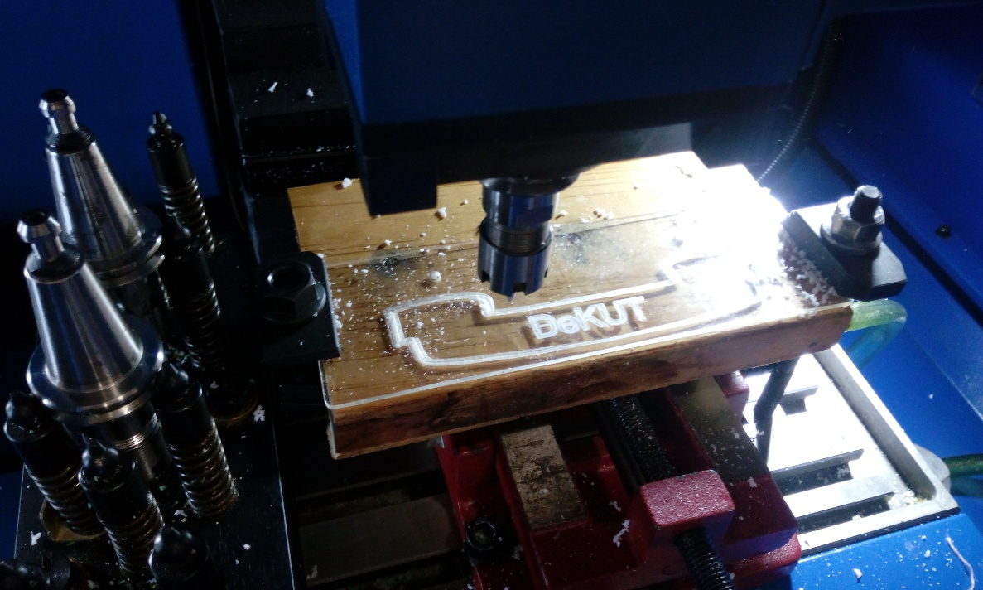

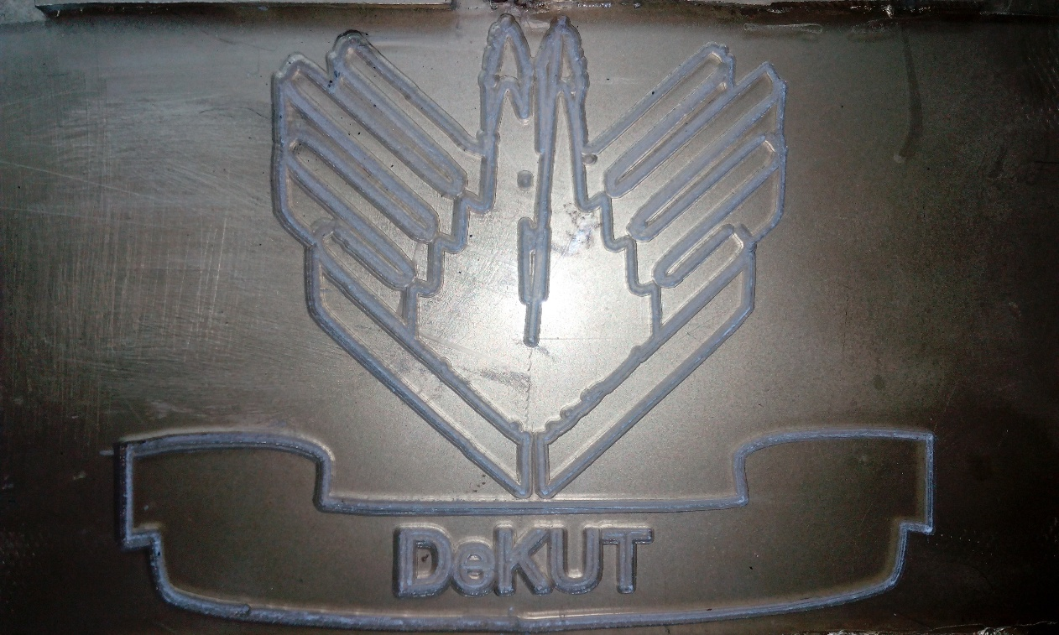

Final work after engraving.

The engraved acrylic material the gets illuminated by use of light emitting diodes. This method of message delivery is very effective where by the methods for illumination are endless.3d images can be produced by employing this method.

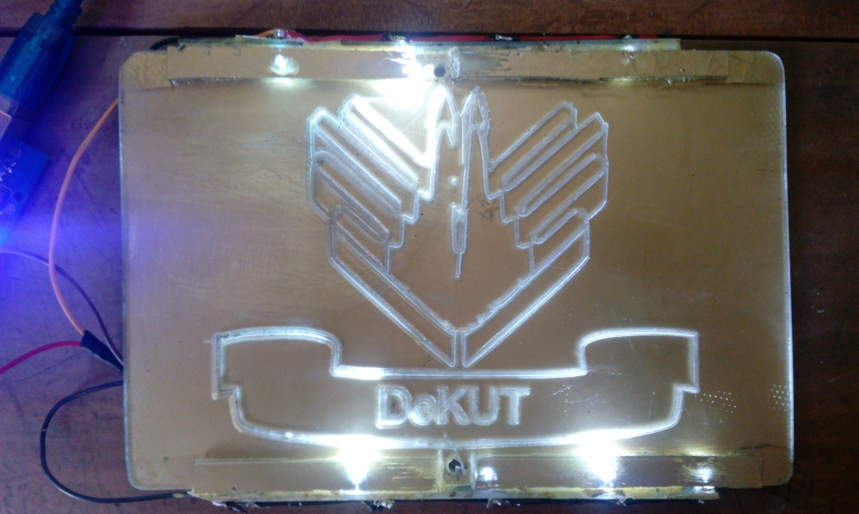

Illuminated DEDAN KIMATHI UNIVERSITY OF TECHNOLOGY (DeKUT) logo

# RECOMMENDATION

* In future there should be introduced forums at universities that creates series of projects and challenges that will nature and improve the student’s skills. A multiple of projects that will involve students mostly in workshop activities as well as class work.
* More students should be given the chance to participate in robotics and seminars together with their lecturers, to improve their knowledge and be at per with whatever improvements being made in the current industry standards.
* Students in one way or the other should be motivated. Apart from being learners they should take part in the school’s daily activities that are a mirror of the current industrial technology.
* Robotics being the key technology being adopted in most industrial processes, it should be introduced in all technical institutions as core unit for every engineering student.
* Also the design and aesthetics should be a factor of consideration in robot design and fabrication.

# CONCLUSION

The main objectives of the project were duly achieved in line with the projects aims as expected; the design and fabrication of the entire robot was achieved, CNC programming and parts fabrication at the CNC station was achieved, the robot was fully programmed to achieve the expected tasks, therefore conclusively all the objectives of this particular project were vividly achieved.

# REFERENCES

Barth, F. G., Humphrey, J. A. C., & Srinivasan, M. V. (2013). *Frontiers in sensing: From biology to engineering*. Wein: Springer.

Budzier, H., Gerlach, G., & Müller, D. (2013). *Thermal infrared sensors: Theory, optimization, and practice*. Chichester, West Sussex, U.K: Wiley.

Huang, H.-W. (2014). *The Atmel AVR microcontroller: Mega and XMega in Assembly and C*.+

Rājapūta, R. (2016). *Basic electrical and electronics engineering: As per prescribed syllabus of P.T.U. Jalandhar for first year B.E. students*. Daryaganj, New Delhi: Laxmi Publications.

Schwartz, M. (2016). *Internet of things with Arduino cookbook: Over 60 recipes will help you build smart IoT solutions and surprise yourself with captivating IoT projects you thought only existed in Bond movies*. Birmingham: Packt.