**DEVELOPMENT OF REACTIVE ELECTROMAGNETIC IMPULSE MOTOR**

**I am looking for collaborators!**

Hello everyone,

I am currently working on an interesting project involving the development of a reactive impulse engine model. The goal of the project is to create a mathematical model, simulate its behavior, and then construct a physical model of the engine to test it in real conditions and its behavior on a vessel in water.

**What I have achieved so far:**

* I developed the basic mathematical model. Of Reactive Electromagnetic Iimpulse Motor

*.The operation of such an engine is based on basic physical laws:

- energy conservation law,

- law of conservation of momentum (law of action and reaction)

-resonance

- -periodic oscillation and symmetry

The conversion of electro-magnetic energy into mechanical energy of motion in a device that I called REIM is the subject of the project. During the conversion of electromagnetic energy into mechanical energy of motion, a force impulse appears on the REIM and also on the system in which the REIM is installed, and this leads to a change in the amount of motion. of the system, the result of which can be a change in the position of the system in space. The force on the system depends on where the system is located.

- on the ground

- on the water

- under water

- in the air

- in space

* I have conducted initial simulations that show promising results

*. I constructed simple physical models for initial testing.

Using physical laws when converting electrical energy by electric motors into mechanical energy of motion of a system with a mass of 30 kg, we arrive at the following with the model:

Two original linear pumped oscillators phase-shifted by 180 oscillator degrees give a combined force acting on a system of mass m=30 kg.

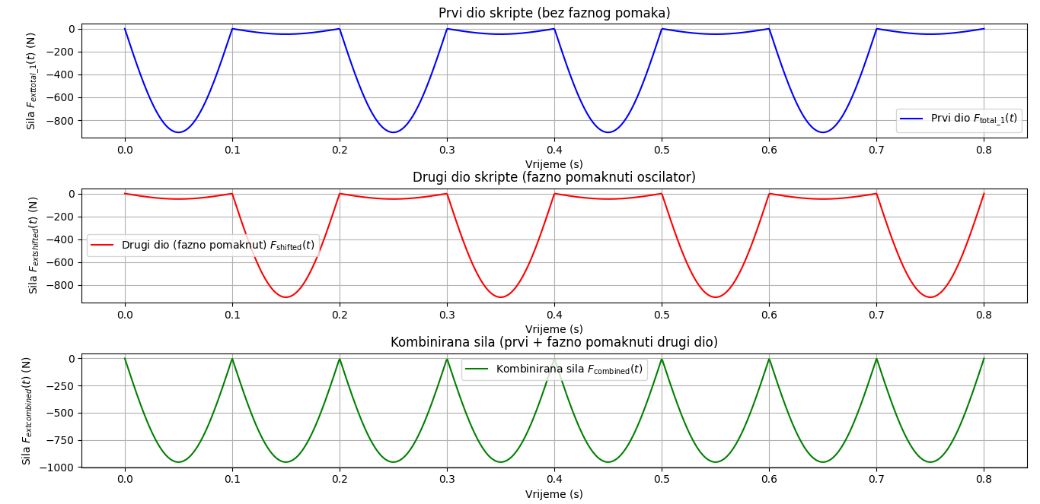

The picture visualizes the total force on the system, which will change the speed of the system, but also the displacement of the system, which is what is shown in the following graphs.

The impulse of the combined force after 4T or 0.8 s is: -486.2752 Ns

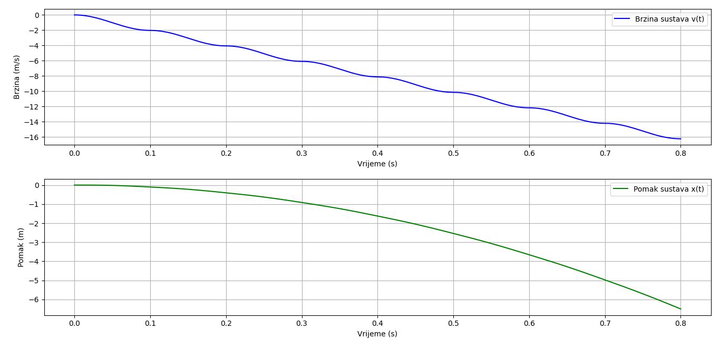

The displacement of the system after four periods with two linear oscillators is: -6.4967 m

The total energy of the four electric motors that input (pump energy into the two linear oscillators) corresponds to the change in the kinetic energy of the moving system. The speed of the system should be reduced by energy losses caused by friction

**What I plan next:**

• Optimize the mathematical model for better performance.

• Perform additional tests and analyses.

• Improve the design of the physical model.

**How you can help:**

• If you have experience in simulations, modeling or constructing physical models, your help would be greatly appreciated.

• If you are interested in this project, you can join and contribute your knowledge and skills.

I will be happy to answer all questions, and I can send all relevant materials and information upon your request.

I look forward to cooperation and your ideas!

Split, september 30, 2024

Thanks!

Stjepan Knežević,

[stjepan.knezevic@st.t-com.hr](mailto:stjepan.knezevic@st.t-com.hr)

sknezev52@gmail.com