Skylar Knickerbocker

Assignment Hadoop

After extracting the data from the cluster, I pulled the data into tableau to visualize the sensor data. I first started by creating a timestamp field using the hour and minute fields so I could look at the data across the day. I then used this timestamp in conjunction with the speed and sensor information to display the speeds for each sensor across the day (figure 1). From this figure one sensor had speeds significantly lower than the other sensors and was averaging between 50-60 mph on a 65mph speed limit interstate. There were also multiple times throughout the day where speeds dropped to zero signifying some problem with the sensor.

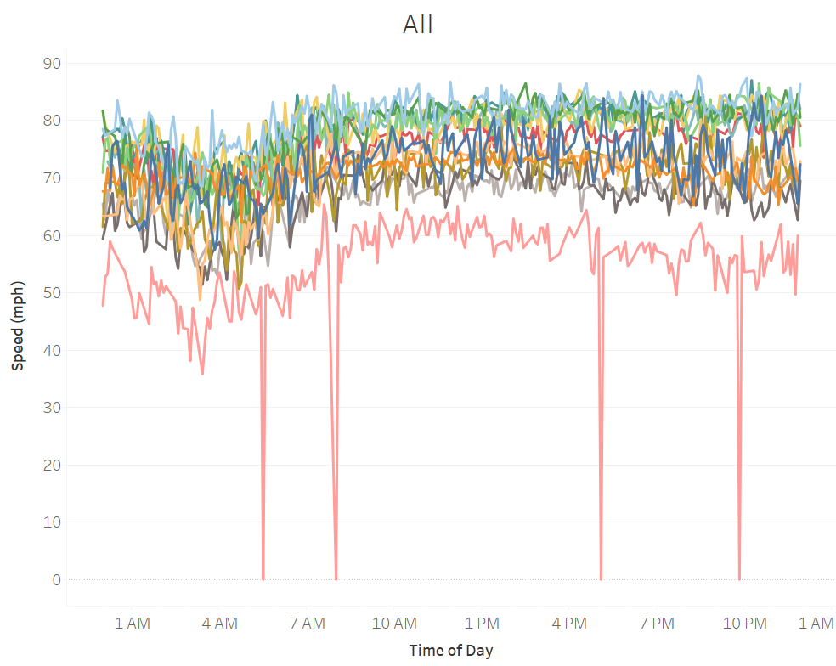

Figure 1

A cumulative distribution function was also created for each sensors speed data and shown in Figure 2. This plot confirmed the speed distribution for sensor “I-35 NB @ US 30 North”. The speeds are lower throughout the day compared to other sensors and had speeds less than 57 mph 52% of the day.

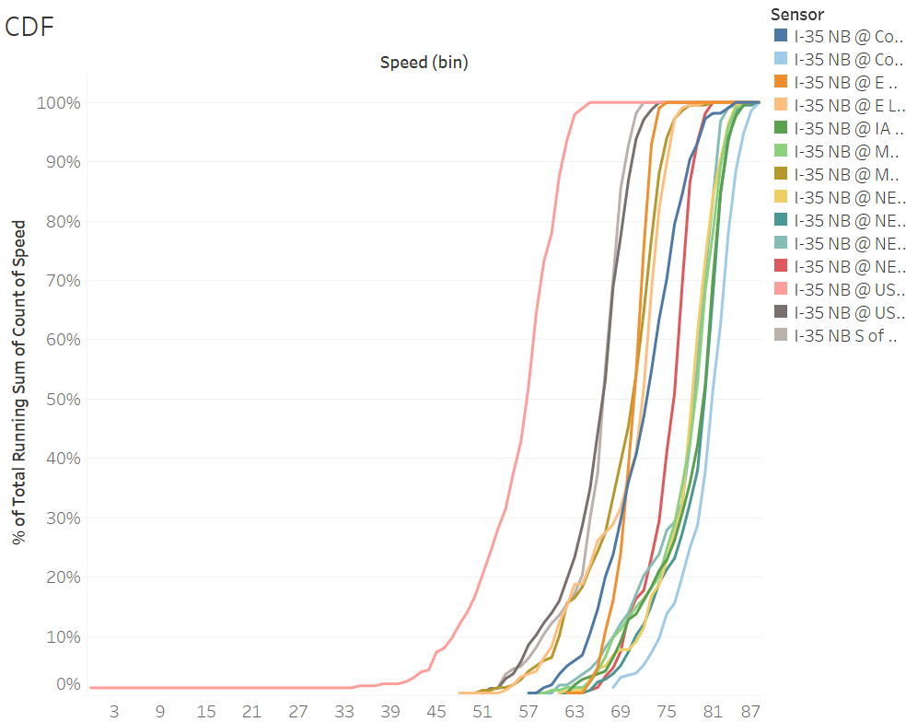

Figure 2

A detailed look at each sensor allowed for analysis of the potential causes of the sensor error by looking at the speed by time of day, the CDF, and the speed vs hourly volume. Most sensors had charts similar to figure 3. The speeds were consistent throughout the day with just dips at night which is common for wavetronix sensors. The speed vs hourly volume were very consistent.

Figure 4 shows the problem sensor identified as “I-35 NB @ US 30 North”. Speeds were consistently low throughout the day which may signify that there is a calibration error or it is in a location where speeds are lower due to either a transition or ramp. In this case, since it is at the interchange of I-35 and US 30, it is likely detecting slower speeds from traffic slowing down to exit or trying to speed up while entering the interstate. The speed vs volume chart also had a wider spread in speeds at lower volumes which may indicate the effects the ramp has regularly.

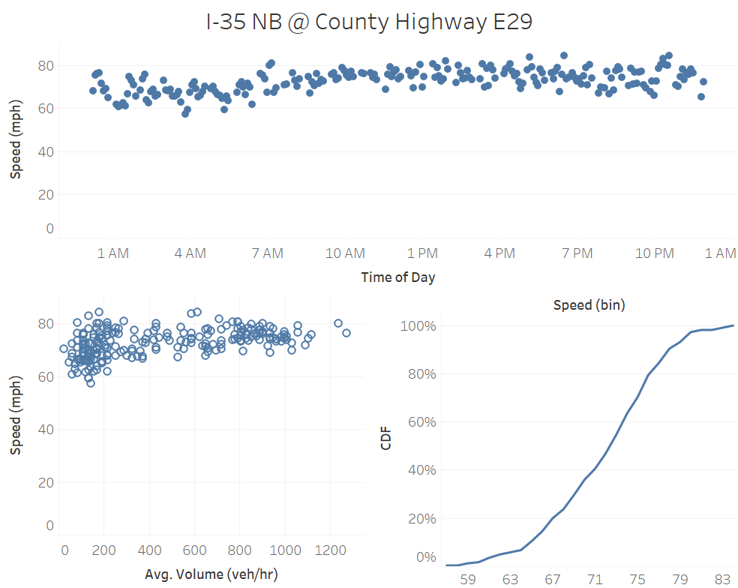

Figure 3

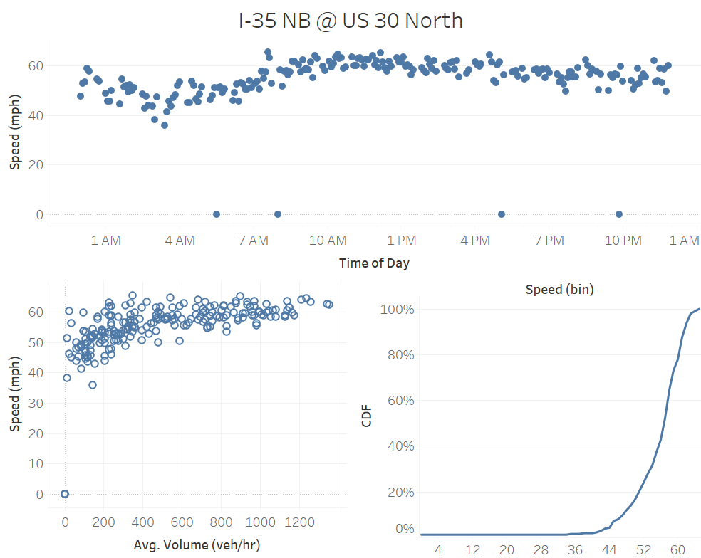

Figure 4