**DAILY ONLINE ACTIVITIES SUMMARY**

|  |  |  |  |  |  |
| --- | --- | --- | --- | --- | --- |
| **Date:** | **11/06/20** | | **Name:** | | **Shaikh Numaan** |
| **Sem & Sec** | **4 sem & B sec** | | **USN:** | | **4AL18CS076** |
| **Online Test Summary** | | | | | |
| **Subject** | **-** | | | | |
| **Max. Marks** | **30** | | **Score** | | - |
| **Certification Course Summary** | | | | | |
| **Course** | **Introduction to Cyber Security** | | | | |
| **Certificate Provider** | **Great Learning Academy** | | **Duration** | **5.5 hrs** | |
| **Coding Challenges** | | | | | |
| **Problem Statement: Write a Java Program to Segregate Even and Odd numbers** | | | | | |
| **Status: Completed** | | | | | |
| **Uploaded the report in Github** | | **Yes** | | | |
| **If yes Repository name** | | <https://github.com/sknum/Lockdown_JavaCoding/blob/master/segregateEvenOdd.java> | | | |
| **Uploaded the report in slack** | | **Yes** | | | |

**Certification Course Details:**

Today I have started the certificate course - Introduction to Cyber Security and learnt how block chain technology can be used effectively in cyber security.

**Snapshot:**

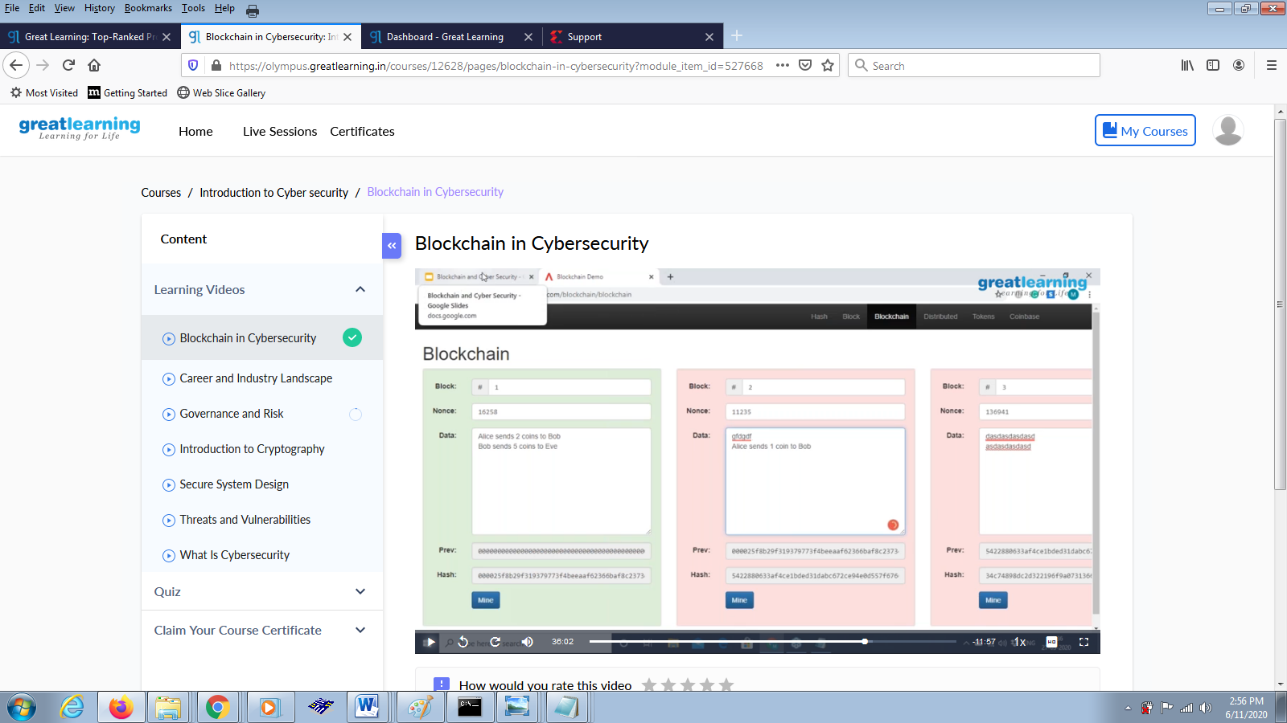

**Coding Challenges Details:**

**Problem Statement:**

Write a Java Program to Segregate Even and Odd numbers

**Snapshot:**

