**DAILY ONLINE ACTIVITIES SUMMARY**

|  |  |  |  |  |  |  |  |
| --- | --- | --- | --- | --- | --- | --- | --- |
| **Date:** | **15/06/2020** | | | | **Name:** | **Shaikh Numaan** | |
| **Sem & Sec** | **4th sem B sec** | | | | **USN:** | **4al18cs076** | |
| **Online Test Summary** | | | | | | | |
| **Subject** | | **-** | | | | | |
| **Max. Marks** | | **30** | **Score** | | | **-** | |
| **Certification Course Summary** | | | | | | | |
| **Course** | **1.Introduction to Cyber Security** | | | | | | |
| **Certificate Provider** | **1.Great Learning Academy** | | | | **Duration** | | **1)5.5 hrs** | |
| **Coding Challenges** | | | | | | | |
| **Problem Statement:** **1)Write a java program to find if a string is K palindrome or not**.  **2) Write a C/C++program to perform the operation of triply linked list** | | | | | | | |
| **Status: Completed** | | | | | | | |
| **Uploaded the report in Github** | | | | **Yes** | | | |
| **If yes Repository name** | | | | <https://github.com/sknum/Lockdown_JavaCoding/blob/master/Palindrome.java>  <https://github.com/sknum/Lockdown_Coding/blob/master/triplylinkedlist.cpp> | | | |
| **Uploaded the report in slack** | | | | **Yes** | | | |

**Certification Course Details:**

Today I completed Introduction to Cyber Security certification course and the snapshot of certificate is given below.

**Snapshot:**

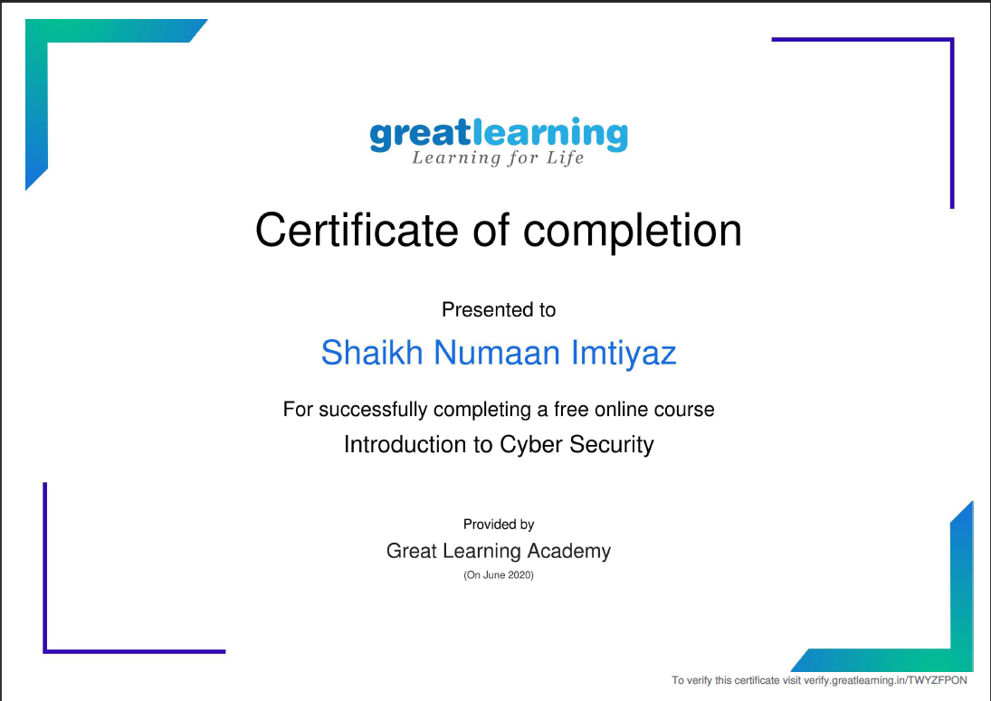

**Coding Challenges Details:**

**Problem Statements**

1)Write a java program to find if a string is K palindrome or not.

**Snapshot**:

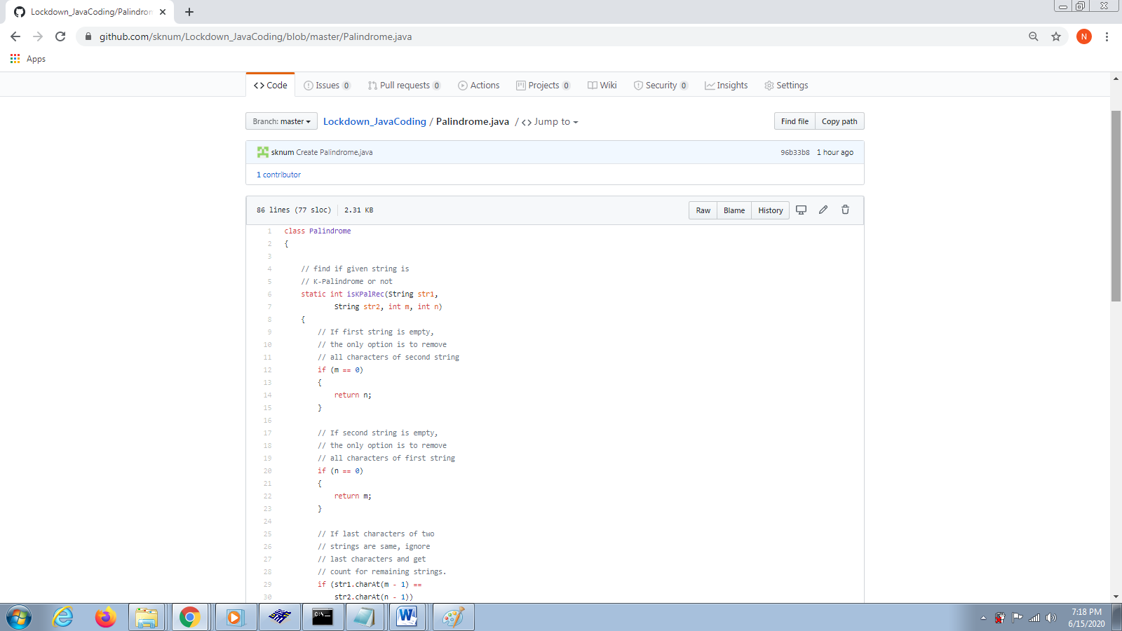

2) Write a C/C++program to perform the operation of triply linked list

**Snapshot:** 