**DAILY ONLINE ACTIVITIES SUMMARY**

|  |  |  |  |  |  |  |  |
| --- | --- | --- | --- | --- | --- | --- | --- |
| **Date:** | **18/06/2020** | | | | **Name:** | **Shaikh Numaan** | |
| **Sem & Sec** | **4th sem B sec** | | | | **USN:** | **4al18cs076** | |
| **Online Test Summary** | | | | | | | |
| **Subject** | | **-** | | | | | |
| **Max. Marks** | | **30** | **Score** | | | **-** | |
| **Certification Course Summary** | | | | | | | |
| **Course** | **1.Introduction to Ethical Hacking** | | | | | | |
| **Certificate Provider** | **1.Great Learning Academy** | | | | **Duration** | | **1)4.0 hrs** | |
| **Coding Challenges** | | | | | | | |
| **Problem Statement: 1) Write a C Program to generate first N Magic Numbers**. | | | | | | | |
| **Status: Completed** | | | | | | | |
| **Uploaded the report in Github** | | | | **Yes** | | | |
| **If yes Repository name** | | | | <https://github.com/sknum/Lockdown_Coding/blob/master/MagicNo.c> | | | |
| **Uploaded the report in slack** | | | | **Yes** | | | |

**Certification Course Details:**

Today I had gone through an overview of Ethical Hacking in Network Architecture where its demonstration was shown.

**Snapshot:**

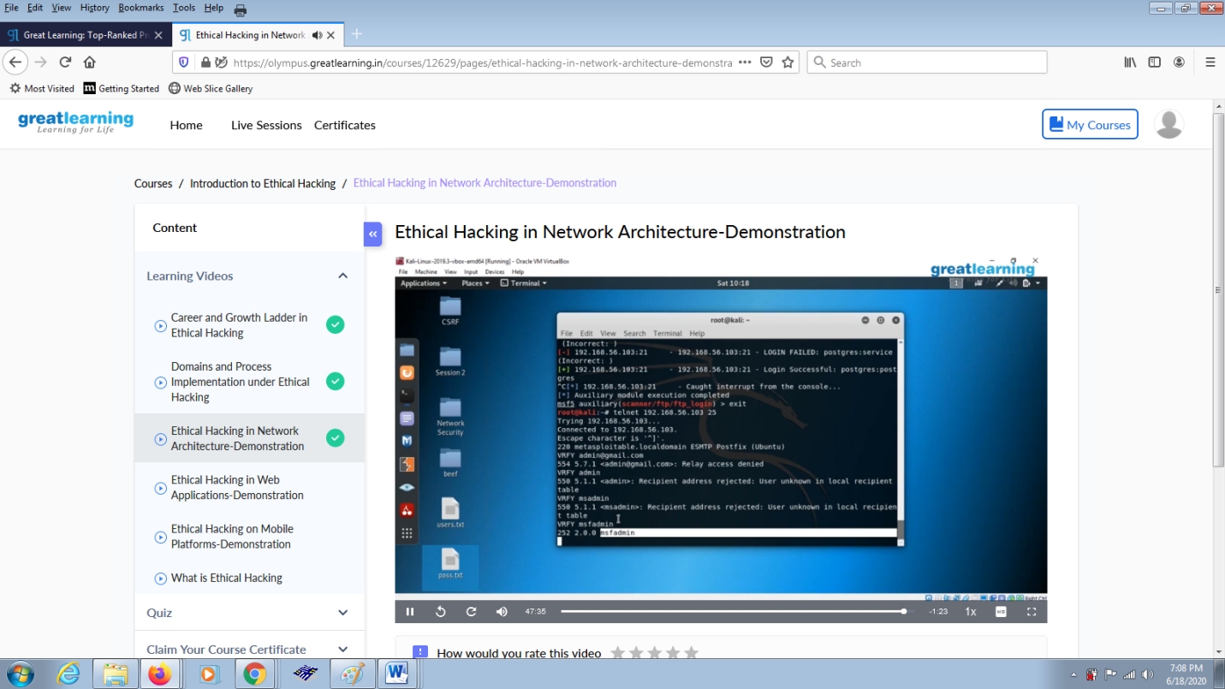

**Coding Challenges Details:**

**Problem Statements**

1) Write a C Program to generate first N Magic Numbers.

**Snapshot**:

