**DAILY ONLINE ACTIVITIES SUMMARY**

|  |  |  |  |  |  |  |  |  |
| --- | --- | --- | --- | --- | --- | --- | --- | --- |
| **Date:** | **18/05/20** | | | | | **Name:** | **Shaikh Numaan** | |
| **Sem & Sec** | **4 sem & B sec** | | | | | **USN:** | **4AL18CS076** | |
| **Online Test Summary** | | | | | | | | |
| **Subject** | | Complex analysis, probability and statistical methods | | | | | | |
| **Max. Marks** | | **30** | | **Score** | | | N/A | |
| **Certification Course Summary** | | | | | | | | |
| **Course** | **Python for Machine Learning** | | | | | | | |
| **Certificate Provider** | | | Great Learning Academy | | **Duration** | | | **5 hrs** |
| **Coding Challenges** | | | | | | | | |
| **Problem Statement:** An Anagram of a string is another string that contains same characters, only the order of characters can be different. For example, "act" and "cat" are anagram of each other. | | | | | | | | |
| **Status: Completed** | | | | | | | | |
| **Uploaded the report in Github** | | | | | **YES** | | | |
| **If yes Repository name** | | | | | <https://github.com/sknum/Lockdown_Coding/blob/master/anagram.c> | | | |
| **Uploaded the report in slack** | | | | | **YES** | | | |

**Online Test Details:**

The online test was from module 4 which was about curve fitting and statistical method. There were 30 questions and the duration was 30 minutes. The score of the test was not displayed after the test .

**Certification Course Details:**

In the first day I went through the first two sections of the course Python in machine Learning course provided by Great Learning academy .The first part tells us about the Introduction to Python where I learnt about what is python and IDE used for coding. The second part is about installation of anaconda used for coding Python language.

**Snapshot:**

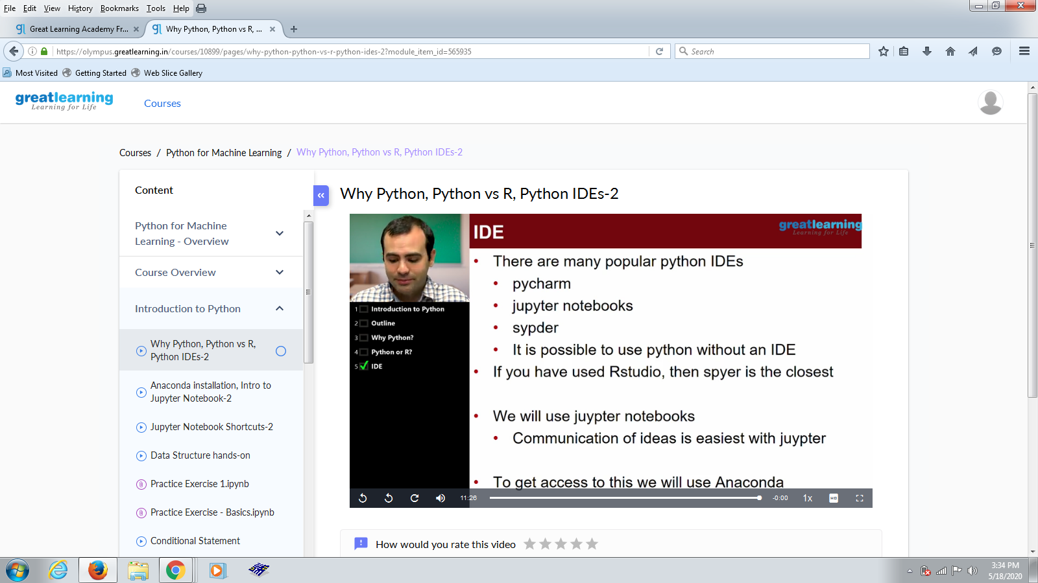

Coding Challenges Details:

Problem Statement:

An Anagram of a string is another string that contains the same characters, only the order of characters can be different. For example, "act" and "cat" are anagram of each other.

Snapshot:

