**DAILY ONLINE ACTIVITIES SUMMARY**

|  |  |  |  |  |  |  |  |
| --- | --- | --- | --- | --- | --- | --- | --- |
| **Date:** | **19/06/2020** | | | | **Name:** | **Shaikh Numaan** | |
| **Sem & Sec** | **4th sem B sec** | | | | **USN:** | **4al18cs076** | |
| **Online Test Summary** | | | | | | | |
| **Subject** | | **Microcontroller and Embedded System** | | | | | |
| **Max. Marks** | | **20** | **Score** | | | **20** | |
| **Certification Course Summary** | | | | | | | |
| **Course** | **1.Introduction to Ethical Hacking** | | | | | | |
| **Certificate Provider** | **1.Great Learning Academy** | | | | **Duration** | | **1)4.0 hrs** | |
| **Coding Challenges** | | | | | | | |
| **Problem Statement:1) Write a C Program to Count total set bits in all numbers from 1 to n**  **2) Write a C Program to rotate a Matrix by 90 Degree in Clockwise or Anticlockwise Direction. Implement (Both the rotations in single program using switch case statement).** | | | | | | | |
| **Status: Completed** | | | | | | | |
| **Uploaded the report in Github** | | | | **Yes** | | | |
| **If yes Repository name** | | | | 1)<https://github.com/sknum/Lockdown_Coding/blob/master/countbits.c>  2)<https://github.com/sknum/Lockdown_Coding/blob/master/Matrix_Rotation.c> | | | |
| **Uploaded the report in slack** | | | | **Yes** | | | |

**Online Test Details:**

Online test of MES was conducted .It was based on 3rd module .There where 20 questions of 1 mark each and time duration was 30 minutes.

**Snapshot:**

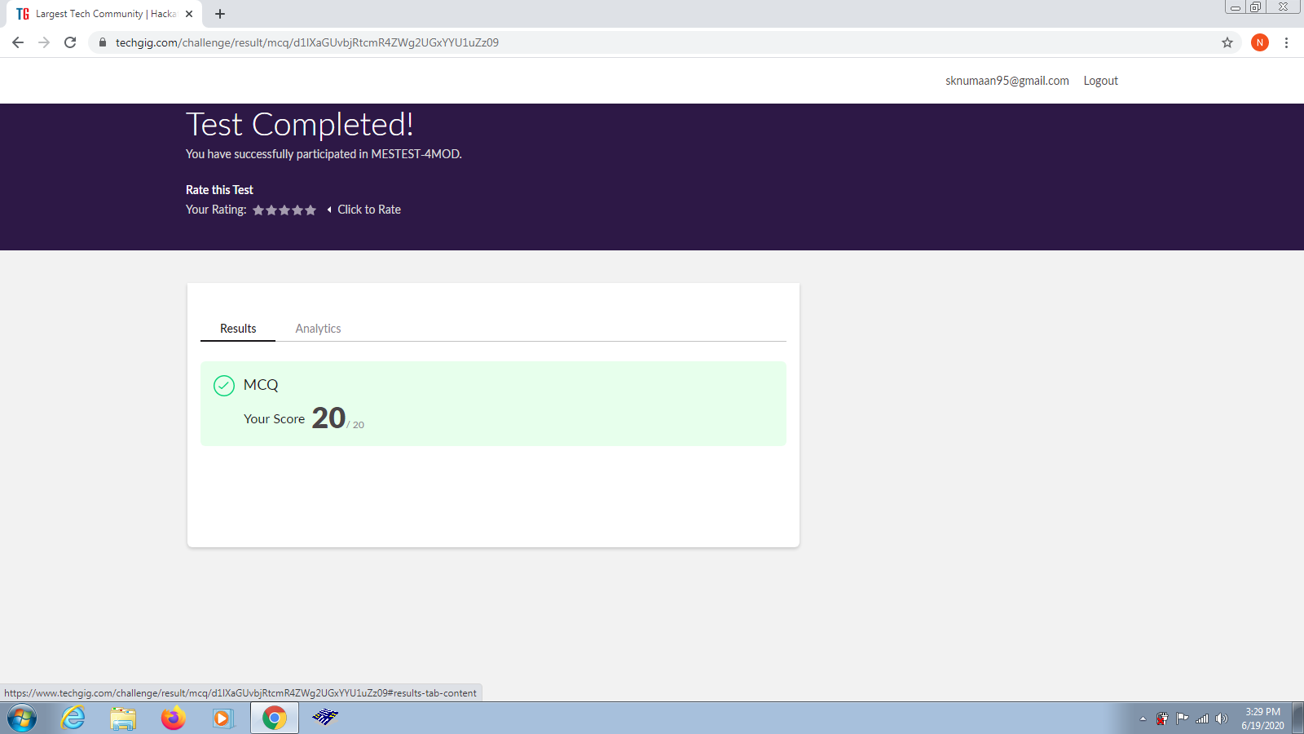

**Certification Course Details:**

Today I had gone through an overview of Ethical Hacking in Web Applications and mobile platforms where its demonstration was shown.

**Snapshot:**

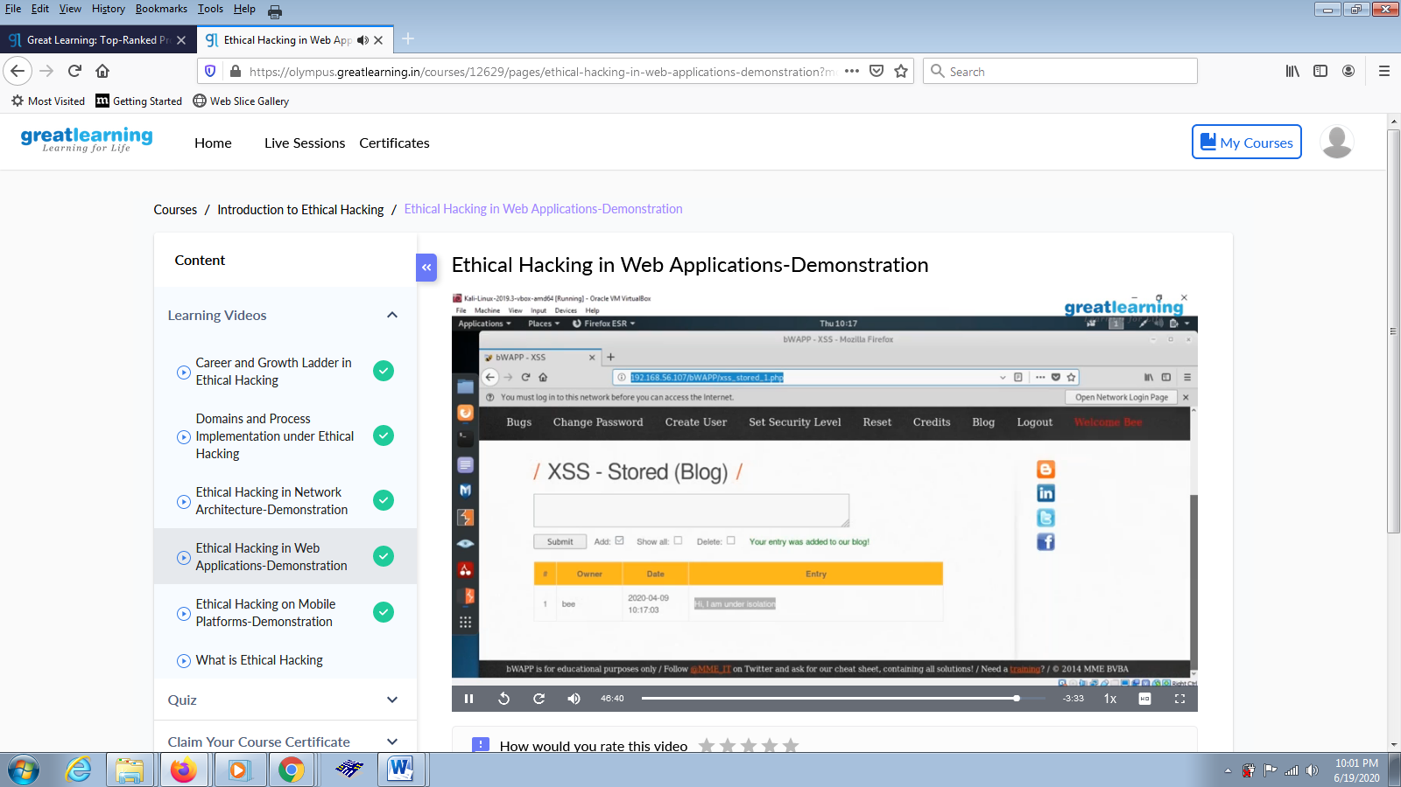

**Coding Challenges Details:**

**Problem Statements**

1)Write a C Program to Count total set bits in all numbers from 1 to n

**Snapshot:**

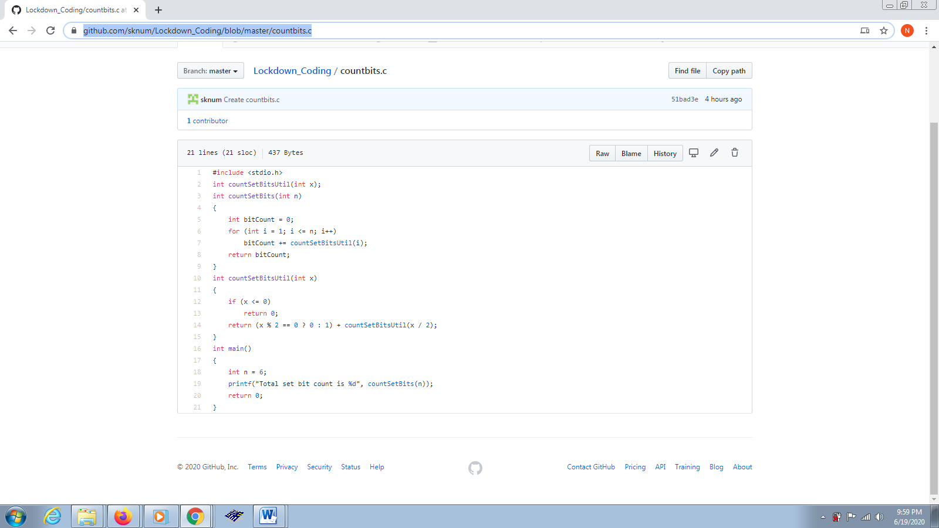

2) Write a C Program to rotate a Matrix by 90 Degree in Clockwise or Anticlockwise Direction. Implement (Both the rotations in single program using switch case statement).

**Snapshot:** 