**DAILY ONLINE ACTIVITIES SUMMARY**

|  |  |  |  |  |  |  |  |  |
| --- | --- | --- | --- | --- | --- | --- | --- | --- |
| **Date:** | **19/05/20** | | | | | **Name:** | **Shaikh Numaan** | |
| **Sem & Sec** | **4 sem & B-sec** | | | | | **USN:** | **4AL18CS076** | |
| **Online Test Summary** | | | | | | | | |
| **Subject** | | **Design and analysis of algorithm** | | | | | | |
| **Max. Marks** | | **30** | | **Score** | | | **19** | |
| **Certification Course Summary** | | | | | | | | |
| **Course** | **Python for Machine Learning** | | | | | | | |
| **Certificate Provider** | | | **Great Learning Academy** | | **Duration** | | | **5 hrs** |
| **Coding Challenges** | | | | | | | | |
| **Problem Statement: 1.** A user will input two strings, and we find if one of the strings is a sub sequence of the other. Program prints “yes” if either the first string is a sub sequence of the second string or the second string is a sub sequence of the first string.  **2**.Given an array of distinct Integers .The task is to count all the triplets such that sum of two elements is equal to the third element | | | | | | | | |
| **Status: Completed** | | | | | | | | |
| **Uploaded the report in Github** | | | | | **Yes** | | | |
| **If yes Repository name** | | | | | <https://github.com/sknum/Lockdown_Coding> | | | |
| **Uploaded the report in slack** | | | | | **Yes** | | | |

**Online Test Details:**

Online test of Design and Analysis of Algorithm was conducted .It was based on first module There where 20 questions of 1mark each and 5 questions of 2marks each.

Snapshot:

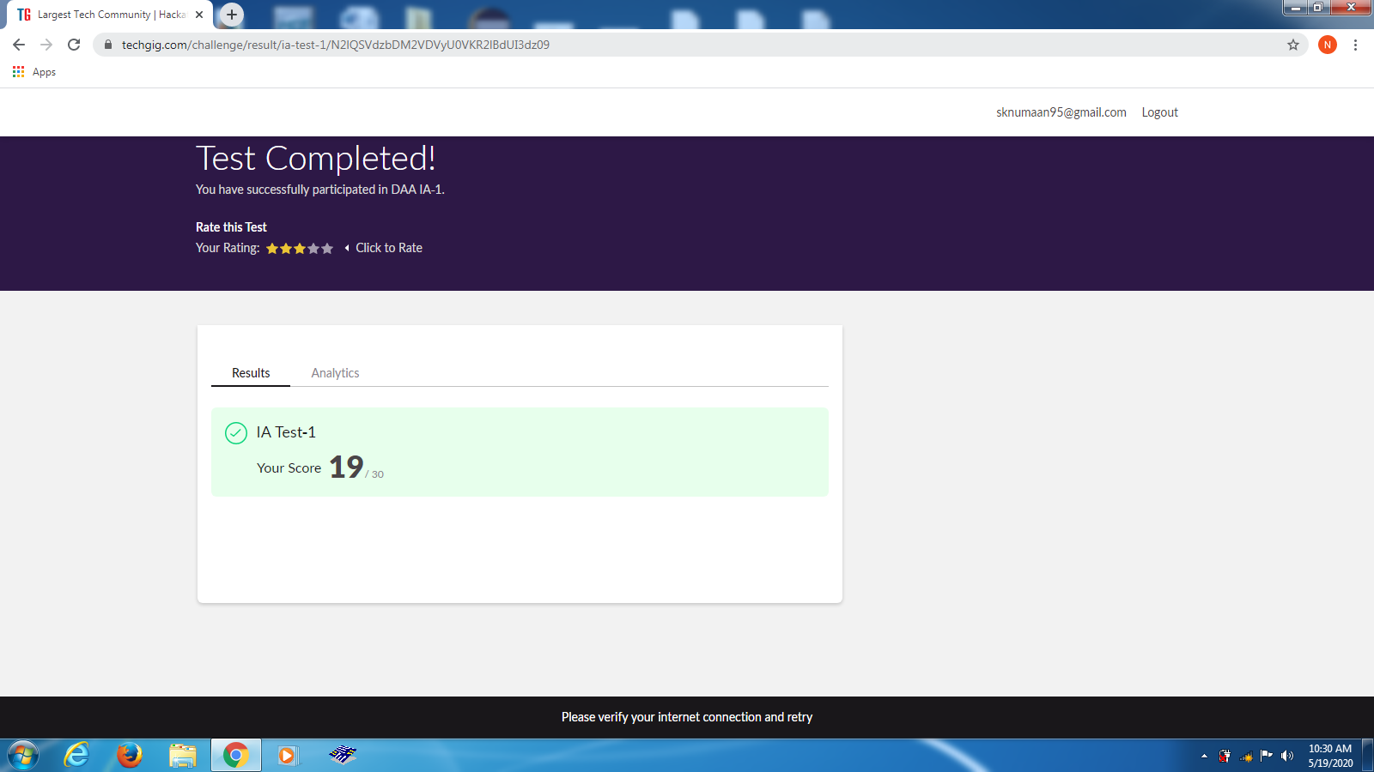

**Certification Course Details:**

Today I got familiarize by some of the important Jupyter notebook keyboard shortcuts for easy access and also I learned about the logical operators , strings, hands on for data structures in python language.

Snapshot:

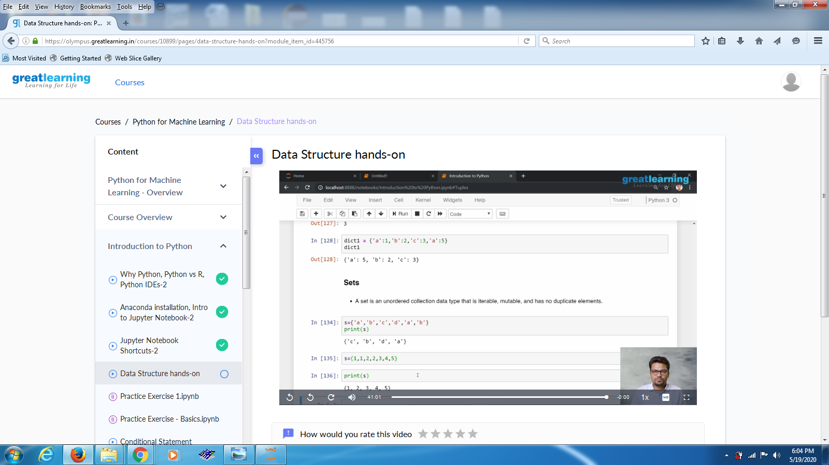

Coding Challenges Details:

Problem Statements

1. A user will input two strings, and we find if one of the strings is a sub sequence of the other. Program prints “yes” if either the first string is a sub sequence of the second string or the second string is a sub sequence of the first string.

Snapshot:

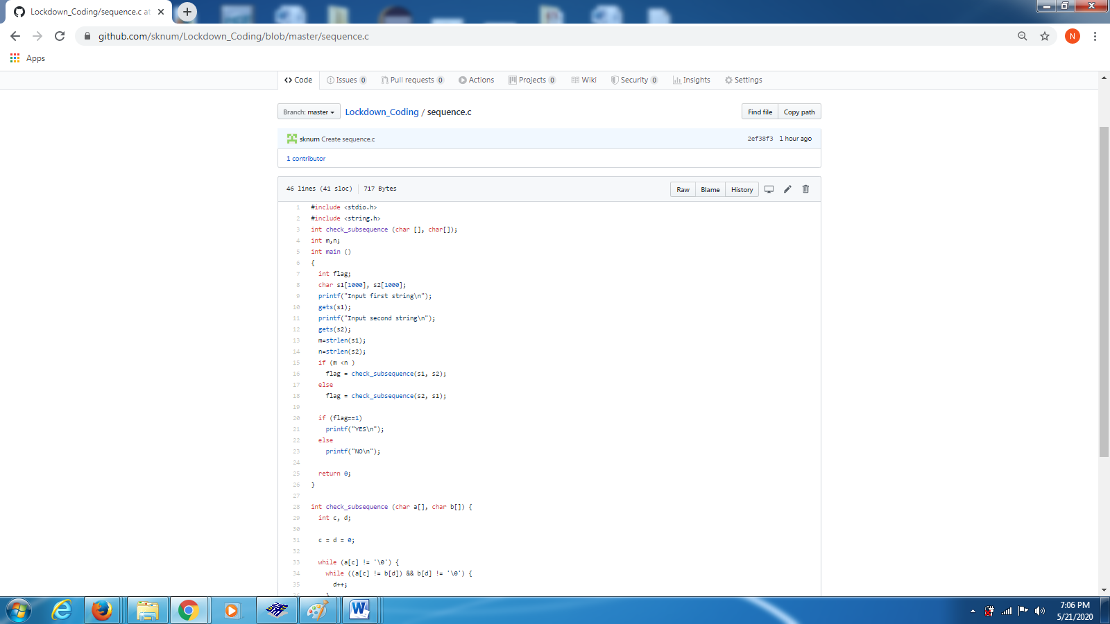

2.Given an array of distinct Integers .The task is to count all the triplets such that sum of two elements is equal to the third element.

Snapshot: