**DAILY ONLINE ACTIVITIES SUMMARY**

|  |  |  |  |  |  |  |  |  |  |
| --- | --- | --- | --- | --- | --- | --- | --- | --- | --- |
| **Date:** | **01/06/2020** | | | | | **Name:** | | **Shaikh Numaan** | |
| **Sem & Sec** | **4th sem B sec** | | | | | **USN:** | | **4AL18CS076** | |
| **Online Test Summary** | | | | | | | | | |
| **Subject** | | **Complex analysis ,Probability and Statistical Method** | | | | | | | |
| **Max. Marks** | | **30** | | **Score** | | | | **27** | |
| **Certification Course Summary** | | | | | | | | | |
| **Course** | | | **1.Java Programming** | | | | | | |
| **Certificate Provider** | | | **1.Great Learning Academy** | | | | **Duration** | | **1)3.5 hrs** |
| **Coding Challenges** | | | | | | | | | |
| **Problem Statement**: **1.Write a java program to count of subarrays such that each subarray has exactly K distinct elements.**  **2. Write a java program to find the distance between two points.** | | | | | | | | | |
| **Status: completed** | | | | | | | | | |
| **Uploaded the report in Github** | | | | | **Yes** | | | | |
| **If yes Repository name** | | | | | 1.<https://github.com/sknum/Lockdown_JavaCoding/blob/master/subarray_distinct_ele.java>  2. <https://github.com/sknum/Lockdown_JavaCoding/blob/master/point.java> | | | | |
| **Uploaded the report in slack** | | | | | **Yes** | | | | |

Online Test Details**:**

Online test of Complex analysis Probability and Statistical Method was conducted .It was based on 5th module .There where 10 questions of 1mark each and 10 questions of 2 mark each

Snapshot:

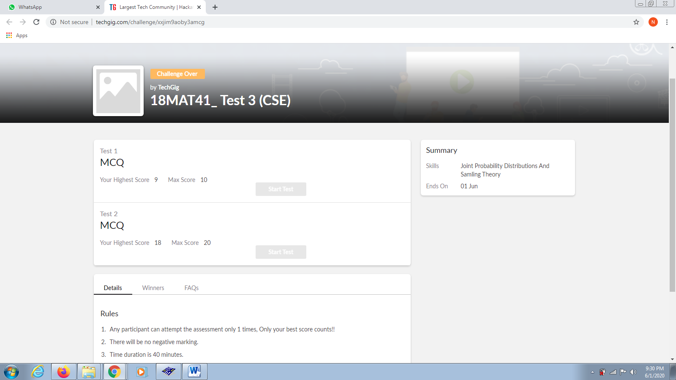

Certification Course Details:

Today I have started the certificate course of Programming in Java which is about 3.5 hrs

Snapshot:

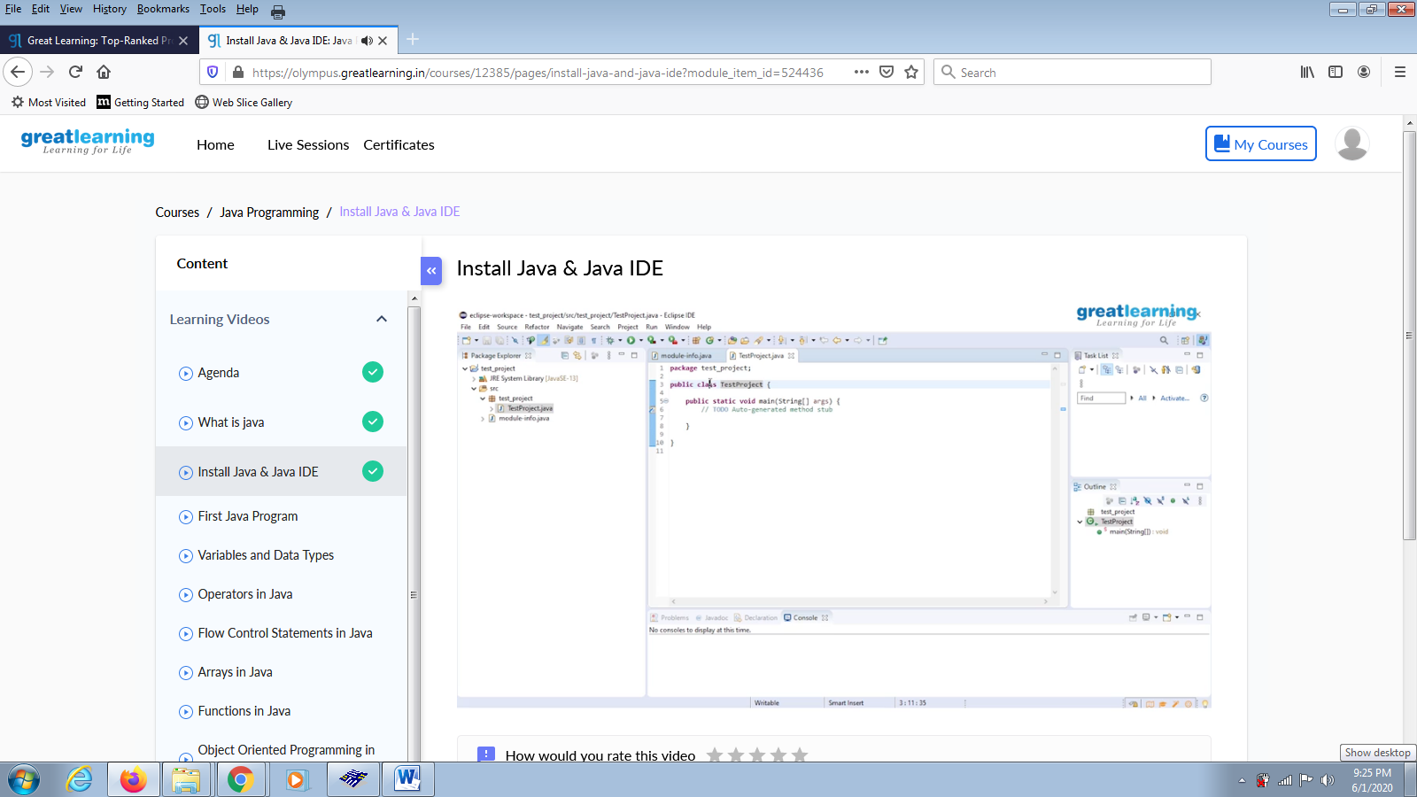

Coding Challenges Details:

Problem Statements

1.Write a java program to count of subarrays such that each subarray has exactly K distinct elements.

Snapshot:

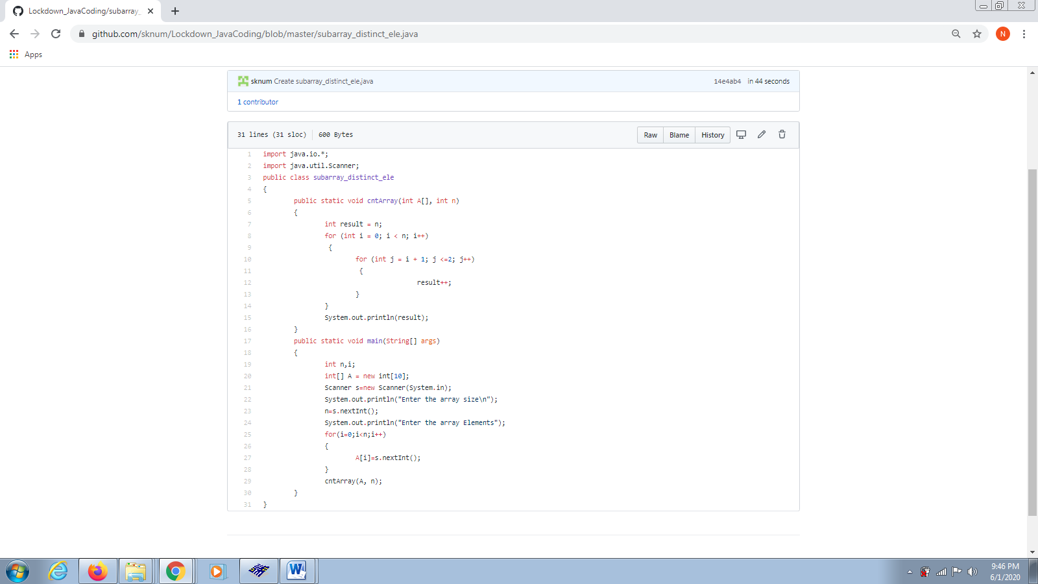

2. Write a java program to find the distance between two points

Snapshot:

