**DAILY ONLINE ACTIVITIES SUMMARY**

|  |  |  |  |  |  |  |  |  |
| --- | --- | --- | --- | --- | --- | --- | --- | --- |
| **Date:** | **20/06/2020** | | | | **Name:** | **Shaikh Numaan** | | |
| **Sem & Sec** | **4th sem & B sec** | | | | **USN:** | **4al18cs076** | | |
| **Online Test Summary** | | | | | | | | |
| **Subject** | | **Data Communication** | | | | | | |
| **Max. Marks** | | **30** | **Score** | | | **23** | | |
| **Certification Course Summary** | | | | | | | | |
| **Course** | **1.Introduction to Ethical Hacking** | | | | | | | |
| **Certificate Provider** | **1.Great Learning Academy** | | | | **Duration** | | **1)4.0 hrs.** |
| **Coding Challenges** | | | | | | | | |
| **Problem Statement:1) Write a Java program to count number of bits to be flipped to convert A to B.**  **2)** **Write a C Program to rotate an array by K positions.**  **3) Program that compares counting words in files using an ArrayList and a Map.** | | | | | | | | |
| **Status: Completed** | | | | | | | | |
| **Uploaded the report in Github** | | | | **Yes** | | | | |
| **If yes Repository name** | | | | **1)**<https://github.com/sknum/Lockdown_Coding/blob/master/FlippedCount.c>  **2)**<https://github.com/sknum/Lockdown_Coding/blob/master/Rotate_Array.c>  **3)**<https://github.com/sknum/Lockdown_JavaCoding/blob/master/SimpleWordCounter.java> | | | | |
| **Uploaded the report in slack** | | | | **Yes** | | | | |

**Online Test Details:**

Online test of Data Communication was conducted .It was based on first and second module .There where 30 questions of 1 mark eachand time duration was 30 minutes

**Snapshot:**

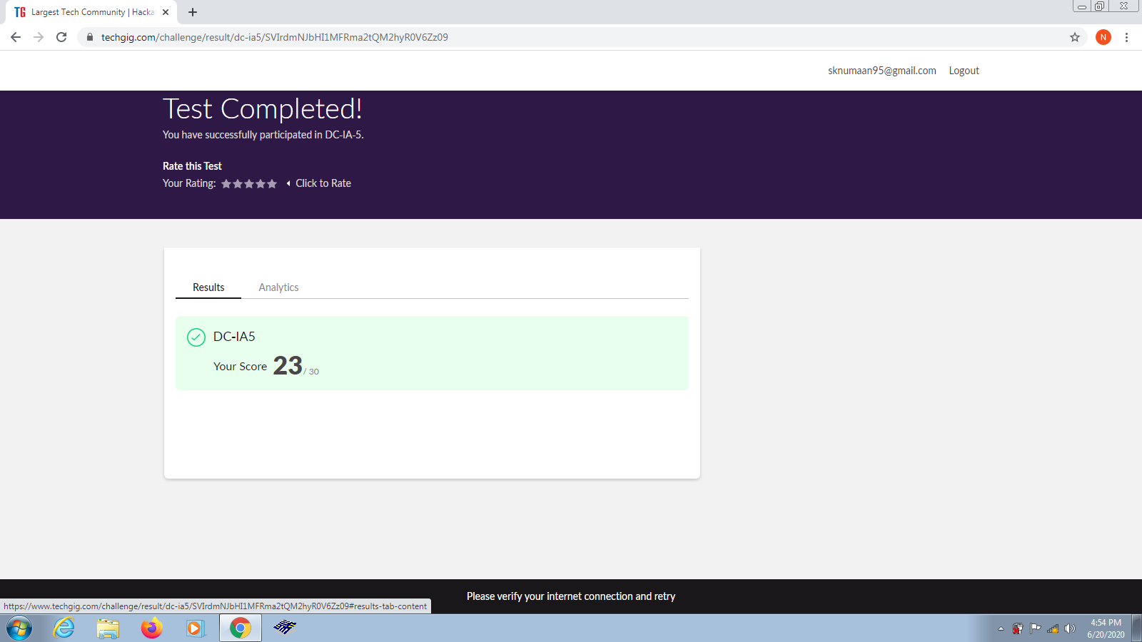

**Certification Course Details:**

Today I had completed Introduction to Ethical Hacking certification course.

**Snapshot:**

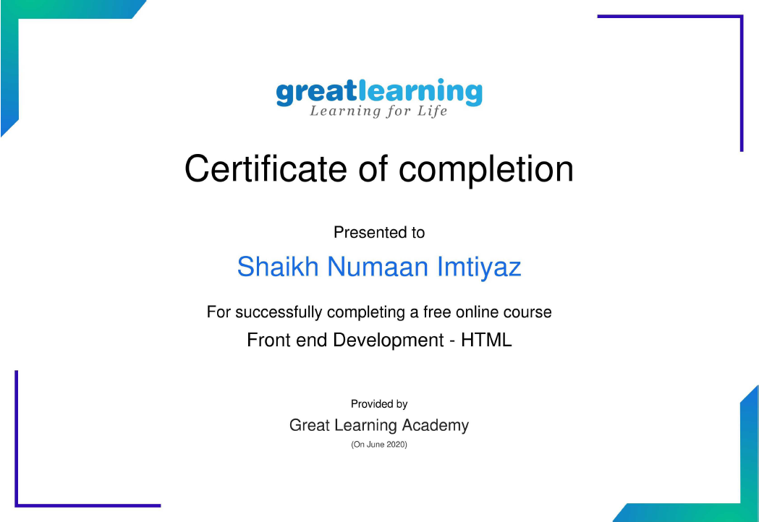

**Coding Challenges Details:**

**Problem Statements:**

1) Write a Java program to count number of bits to be flipped to convert A to B

**Snapshot:**

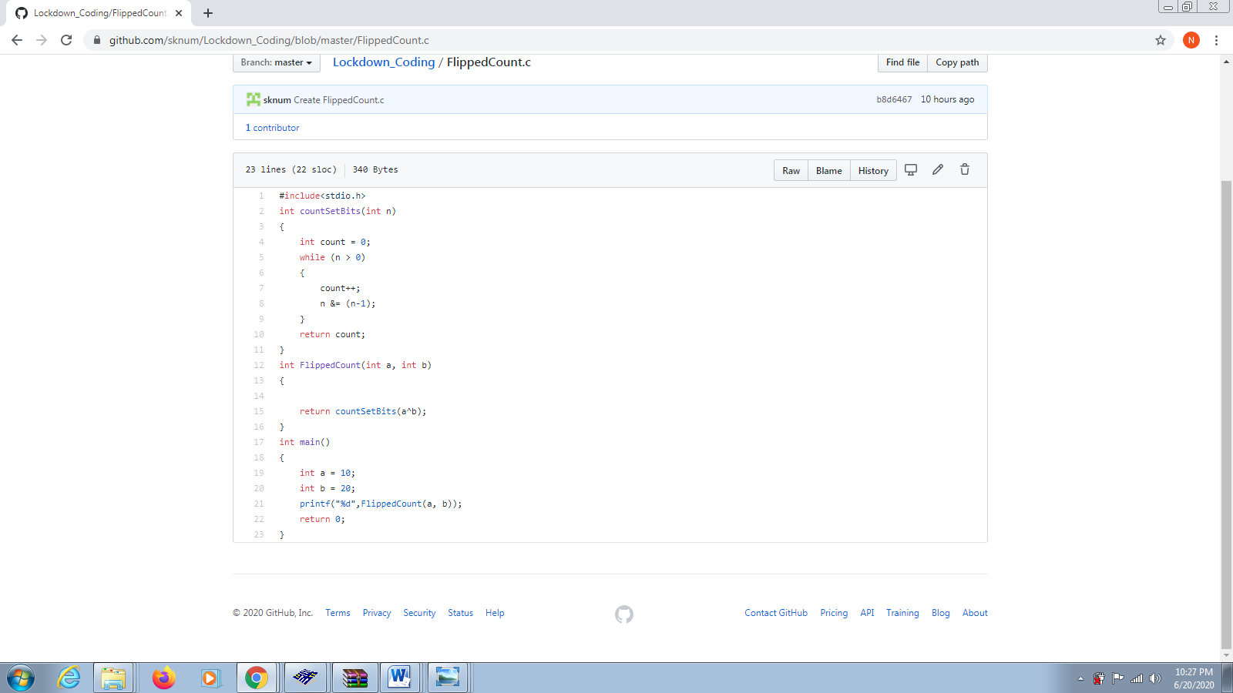

2) Write a C Program to rotate an array by K positions

**Snapshot:** 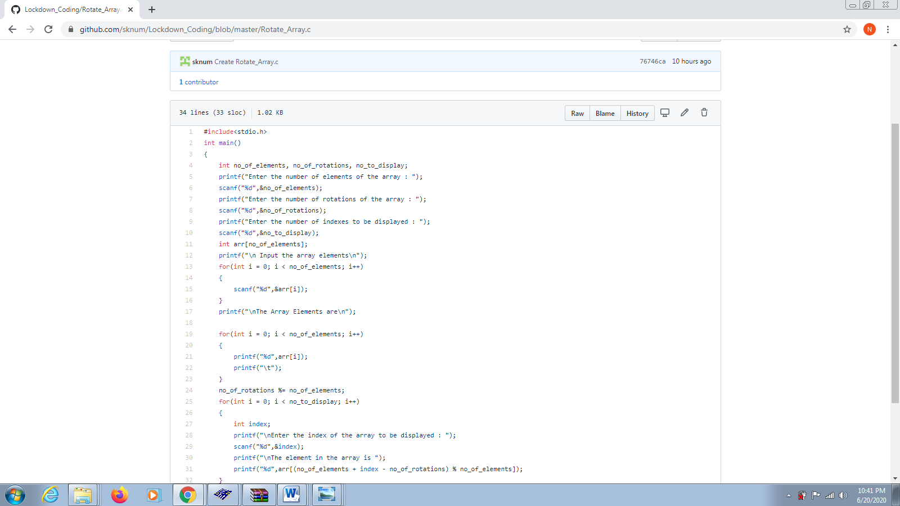

3) Program that compares counting words in files using an ArrayList and a Map.

**Snapshot:**

