**DAILY ONLINE ACTIVITIES SUMMARY**

|  |  |  |  |  |  |  |  |  |
| --- | --- | --- | --- | --- | --- | --- | --- | --- |
| **Date:** | **20/05/20** | | | | | **Name:** | **Shaikh Numaan** | |
| **Sem & Sec** | **4 sem & B sec** | | | | | **USN:** | **4AL18CS076** | |
| **Online Test Summary** | | | | | | | | |
| **Subject** | | **Object oiented concepts** | | | | | | |
| **Max. Marks** | | **30** | | **Score** | | | **17** | |
| **Certification Course Summary** | | | | | | | | |
| **Course** | **Python for machine learning** | | | | | | | |
| **Certificate Provider** | | | **Great Learning Academy** | | **Duration** | | | **5 hrs** |
| **Coding Challenges** | | | | | | | | |
| **Problem Statement: 1.** Given an array a[] of size n which contains elements from 0 to n-1, write a program print Duplicates which prints the duplicate elements of the given array. If no duplicate element is found.  **2**. Write a C Program to Reverse a Linked List (SLL) in groups of given size.  . 2  **2**e a C Program to Reverse a Linked List (SLL) in groups of given size. | | | | | | | | |
| **Status: Completed** | | | | | | | | |
| **Uploaded the report in Github** | | | | | **Yes** | | | |
| **If yes Repository name** | | | | | <https://github.com/sknum/Lockdown_Coding> | | | |
| **Uploaded the report in slack** | | | | | **Yes** | | | |

**Online Test Details:**

Online test of object oriented concepts was conducted .It was based on first module There where 30 questions of 1mark each and time duration is 40 minutes.

Snapshot:

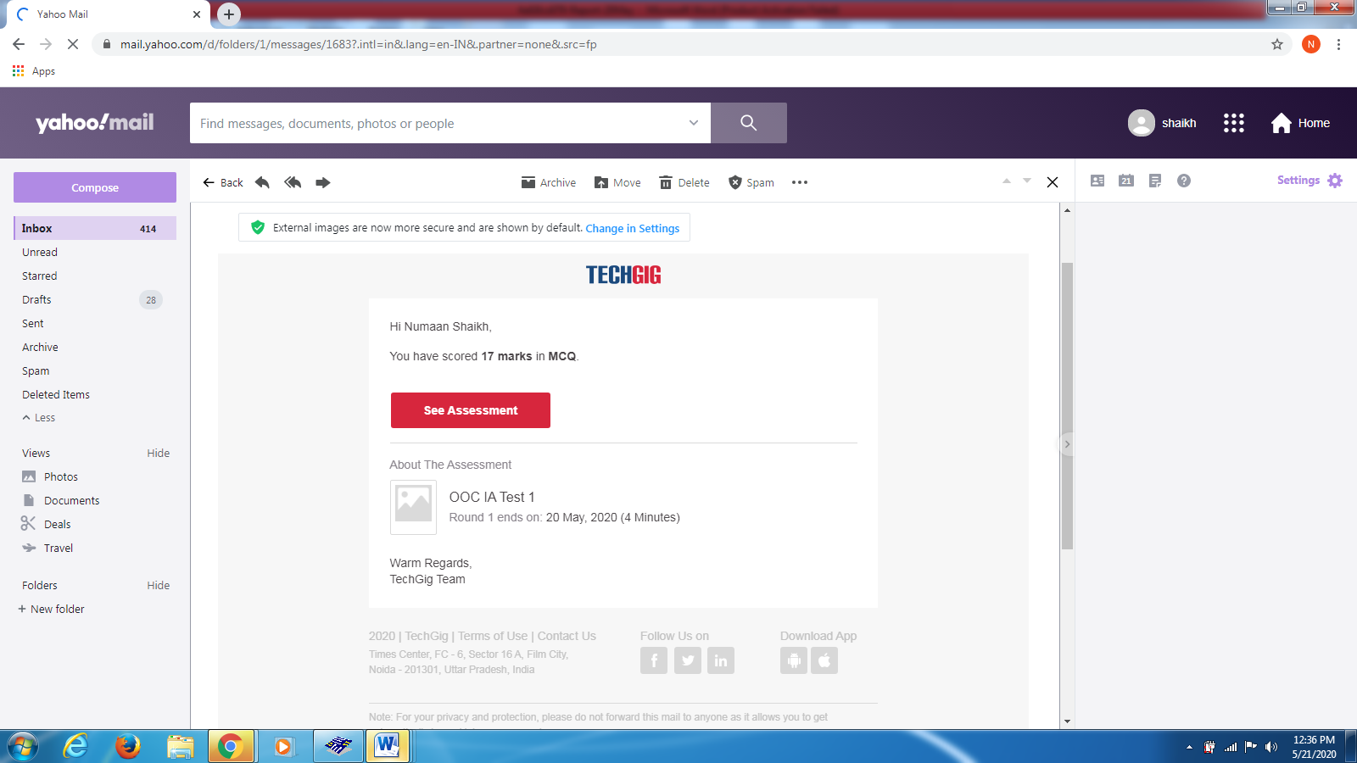

**Certification Course Details:**

I learned about the conditional statements that are commonly used in python programming language.

Snapshot:

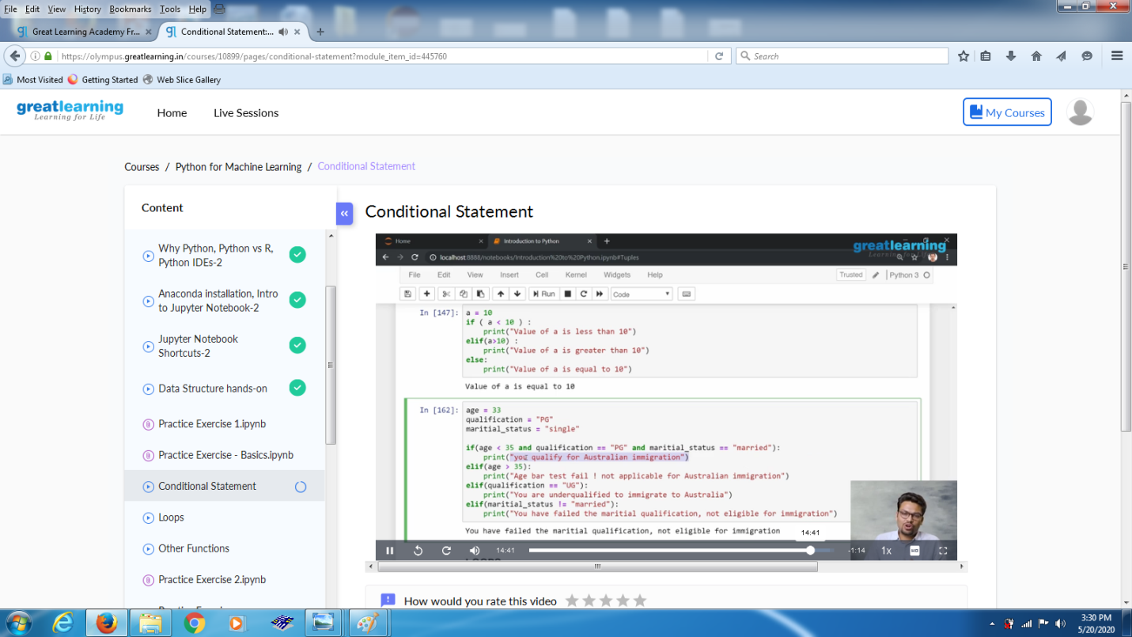

Coding Challenges Details:

Problem Statements

1. Given an array a[] of size n which contains elements from 0 to n-1, write a program print Duplicates which prints the duplicate elements of the given array. If no duplicate element is found print -1..

Snapshot:

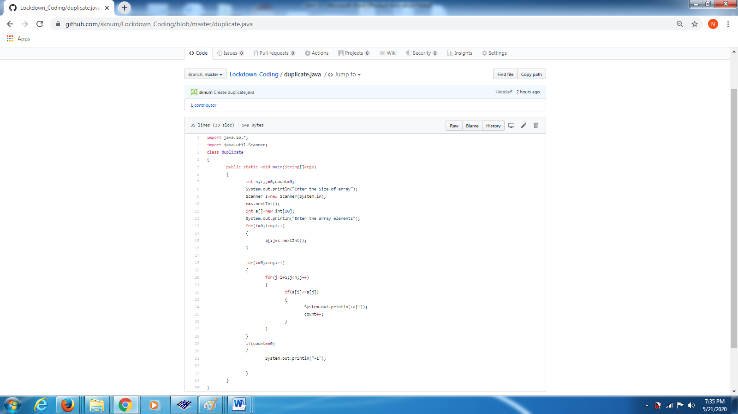

2.Given an array a[] of size n which contains elements from 0 to n-1, write a program print Duplicates which prints the duplicate elements of the given array. If no duplicate element is found.

Write a C Program to Reverse a Linked List (SLL) in groups of given size.

Test Case 1:  
If a linked list is: 1 → 2 → 3 → 4 → 5 → 6 → 7 → 8  
The value of size k is 2  
Then the linked list looks like: 2 → 1 → 4 → 3 → 6 → 5 → 8 → 7

Test Case 2:  
If a linked list is: 1 → 2 → 3 → 4 → 5 → 6 → 7 → 8  
The value of size k is 3  
Then the linked list looks like: 3 → 2 → 1 → 6 → 5 → 4 → 8 → 7

