**DAILY ONLINE ACTIVITIES SUMMARY**

|  |  |  |  |  |  |  |  |  |
| --- | --- | --- | --- | --- | --- | --- | --- | --- |
| **Date:** | **21/05/20** | | | | | **Name:** | **Shaikh Numaan** | |
| **Sem & Sec** | **4 sem & B-sec** | | | | | **USN:** | **4AL18CS76** | |
| **Online Test Summary** | | | | | | | | |
| **Subject** | | **Microcontroller and embedded systems** | | | | | | |
| **Max. Marks** | | **30** | | **Score** | | | **26** | |
| **Certification Course Summary** | | | | | | | | |
| **Course** | **Python for machine learning** | | | | | | | |
| **Certificate Provider** | | | **Great Learning Academy** | | **Duration** | | | **5 hrs** |
| **Coding Challenges** | | | | | | | | |
| **Problem Statement: 1.** Write C Program to create Singly Liked List with n elements and reverse the elements using C  2.write a java program to print the frequency of characters repeated in the string | | | | | | | | |
| **Status : Completed** | | | | | | | | |
| **Uploaded the report in Github** | | | | | **Yes** | | | |
| **If yes Repository name** | | | | | <https://github.com/sknum/Lockdown_Coding> | | | |
| **Uploaded the report in slack** | | | | | **Yes** | | | |

Online Test Details:

Online test of Microcontroller and Embedded systems was conducted .It was based on first module .There where 30 questions of 1 mark each and 30 minutes was alloted.

Snapshot:

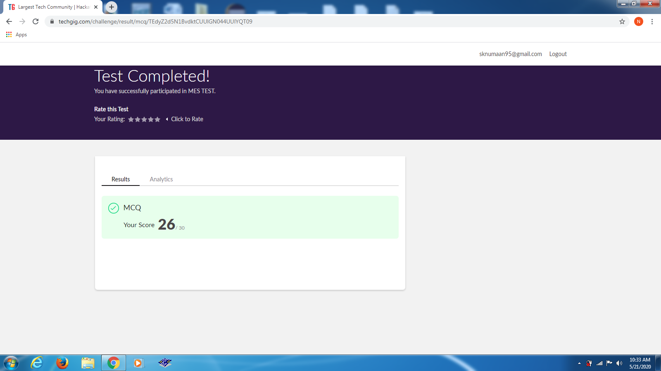

Certification Course Details:

Today I learned about the different types of loops and how to write functions in python programming language.

**Snapshot:**

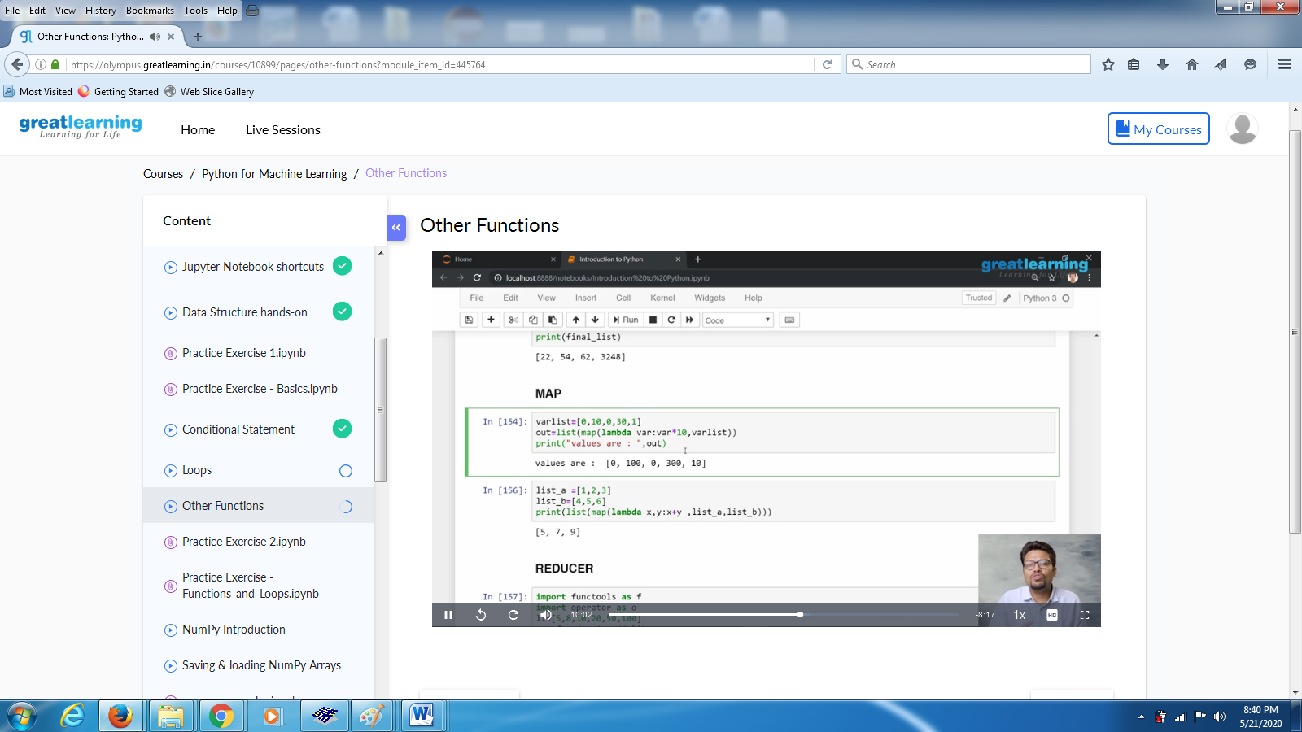

Coding Challenges Details:

Problem Statements

1. Write C Program to create Singly Liked List with n elements and reverse the elements using C

Snapshot:

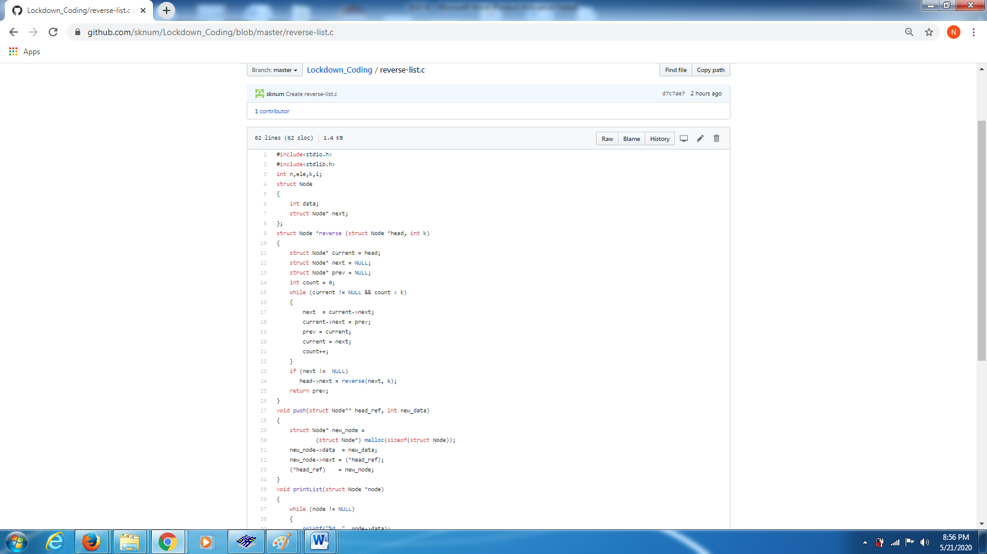

2. write a java program to print the frequency of characters repeated in the string

Snapshot:

