**DAILY ONLINE ACTIVITIES SUMMARY**

|  |  |  |  |  |  |  |  |
| --- | --- | --- | --- | --- | --- | --- | --- |
| **Date:** | **22/05/2020** | | | | **Name:** | **Shaikh Numaan** | |
| **Sem & Sec** | **4th sem B sec** | | | | **USN:** | **4AL18CS076** | |
| **Online Test Summary** | | | | | | | |
| **Subject** | | **Operating System** | | | | | |
| **Max. Marks** | | **30** | **Score** | | | **16** | |
| **Certification Course Summary** | | | | | | | |
| **Course** | | **Python for Machine Learning** | | | | | |
| **Certificate Provider** | | **Great Learning Academy** | | | **Duration** | | **5 hrs** |
| **Coding Challenges** | | | | | | | |
| **Problem Statement:** Write a java applet program to check whether given number is armstrong or not | | | | | | | |
| **Status: Completed** | | | | | | | |
| **Uploaded the report in Github** | | | | **Yes** | | | |
| **If yes Repository name** | | | | <https://github.com/sknum/Lockdown_JavaCoding/blob/master/ArmstrongApplet.java> | | | |
| **Uploaded the report in slack** | | | | **Yes** | | | |

Online Test Details:

Online test of Operating System was conducted .It was based on first module .There where 30 questions of 1 mark each and 40 minutes was alloted for test.

Snapshot:

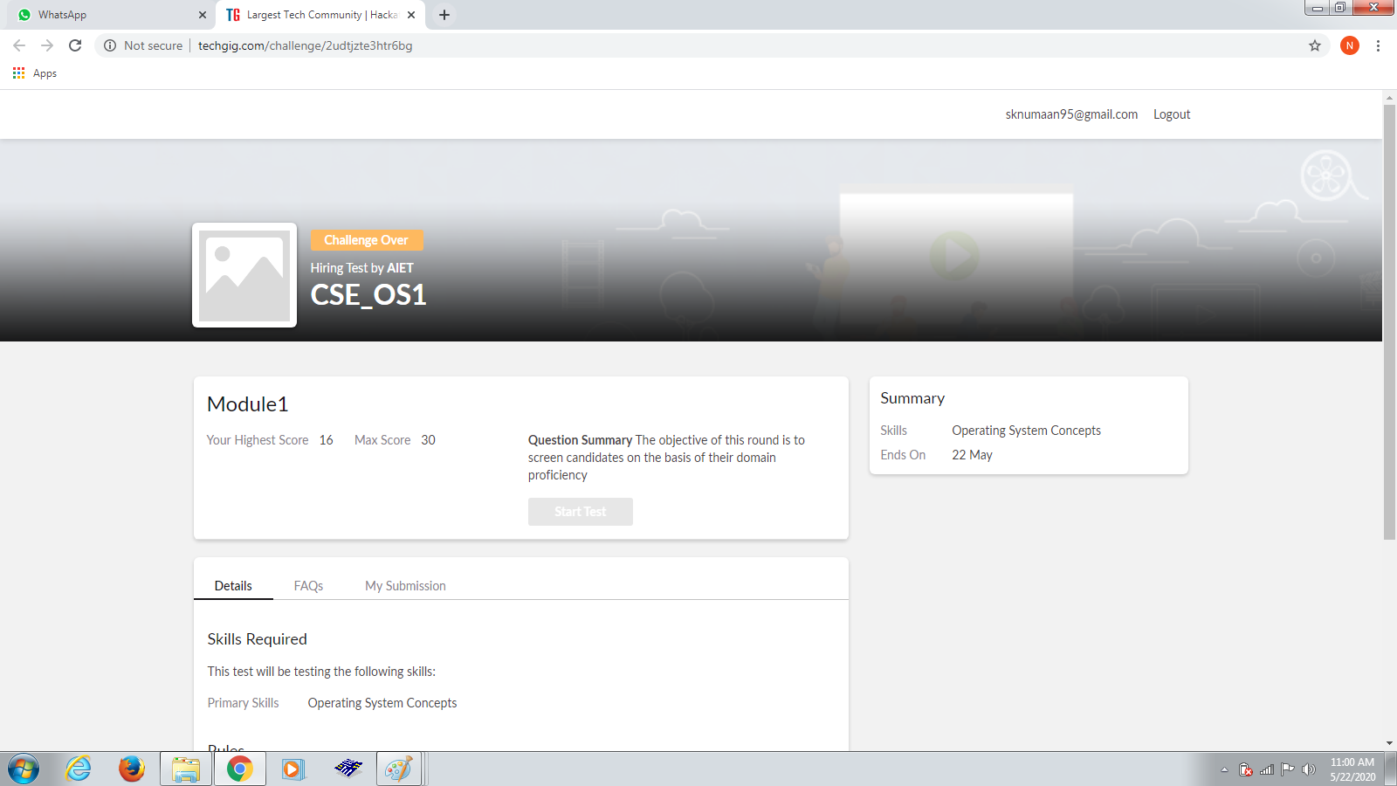

Certification Course Details:

Today I have done the certificate courses of Python For Machine Learning in which I learnt about the Numpy the one of the package of the python to perform complex mathematical operations.

Snapshot:

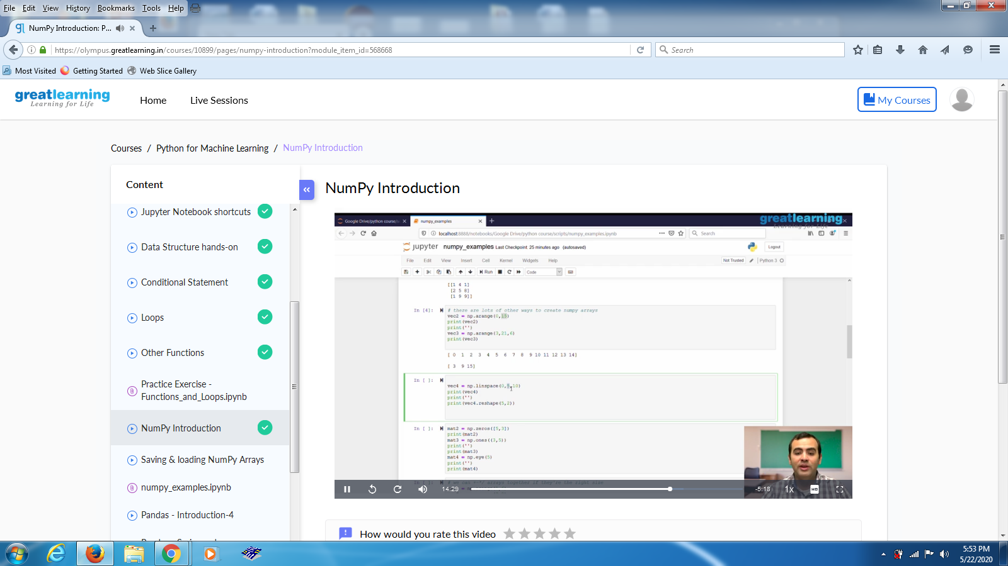

Coding Challenges Details:

Problem Statements

Write a java applet program to check whether given number is armstrong or not

Description  
Armstrong Number :A positive number is called armstrong number if it is equal to the sum of cubes of its digits for example 0, 1, 153, 370, 371, 407 etc.

Let's try to understand why 153 is an Armstrong number.  
153 = (111)+(555)+(333)  
where:  
(111)=1  
(555)=125  
(333)=27  
So:  
1+125+27=15

