**DAILY ONLINE ACTIVITIES SUMMARY**

|  |  |  |  |  |  |  |  |  |
| --- | --- | --- | --- | --- | --- | --- | --- | --- |
| **Date:** | **25/06/2020** | | | | **Name:** | **Shaikh Numaan** | | |
| **Sem & Sec** | **4th sem & B sec** | | | | **USN:** | **4al18cs076** | | |
| **Online Test Summary** | | | | | | | | |
| **Subject** | | **-** | | | | | | |
| **Max. Marks** | | **30** | **Score** | | | **-** | | |
| **Certification Course Summary** | | | | | | | | |
| **Course** | 1. Python for Data Science | | | | | | | |
| **Certificate Provider** | **Cognitive Class** | | | | **Duration** | | **5 hrs** |
| **Coding Challenges** | | | | | | | | |
| **Problem Statement:1)** **Write a C Program to reverse the rows in a 2d Array** | | | | | | | | |
| **Status: Completed** | | | | | | | | |
| **Uploaded the report in Github** | | | | **Yes** | | | | |
| **If yes Repository name** | | | | <https://github.com/sknum/Lockdown_Coding/blob/master/reverse_array.c> | | | | |
| **Uploaded the report in slack** | | | | **Yes** | | | | |

**Certification Course Details:**

Today I learned some data structures in python, which include list, tuples, sets and dictionaries in python for data science online course.

**Snapshot:**

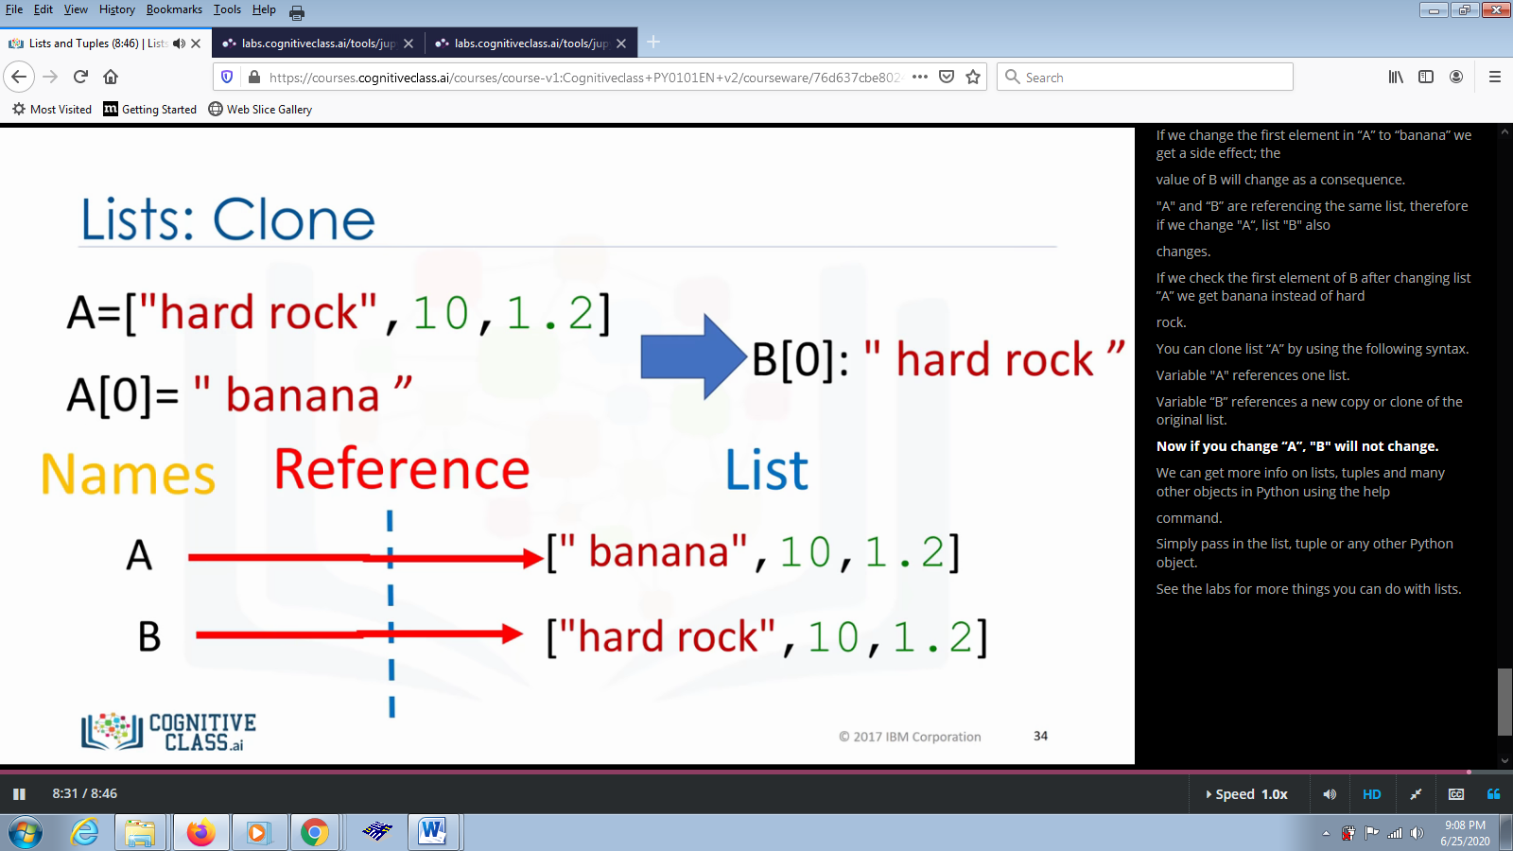

**Coding Challenges Details:**

**Problem Statements:**

1. Write a C Program to reverse the rows in a 2d Array

**Snapshot:**

