**DAILY ONLINE ACTIVITIES SUMMARY**

|  |  |  |  |  |  |  |  |  |
| --- | --- | --- | --- | --- | --- | --- | --- | --- |
| **Date:** | **27/05/2020** | | | | | **Name:** | | **Shaikh Numaan** |
| **Sem & Sec** | **4th sem & B sec** | | | | | **USN:** | | **4AL18CS076** |
| **Online Test Summary** | | | | | | | | |
| **Subject** | | **Object Oriented Concepts** | | | | | | |
| **Max. Marks** | | **30** | | **Score** | | | | **23** |
| **Certification Course Summary** | | | | | | | | |
| **Course** | | | **Python For Machine Learning** | | | | | |
| **Certificate Provider** | | | **Great Learning Academy** | | **Duration** | | **5 hrs** | | |
| **Coding Challenges** | | | | | | | | |
| **Problem Statement:**  1.C program to print all the permutations of a given string using pointers.  2.Given an array A of size n where the array elements contains values from 1 to n with duplicatesthe taskis to find total number of subarray which start and end with the same element. | | | | | | | | |
| **Status: Completed** | | | | | | | | |
| **Uploaded the report in Github** | | | | | **Yes** | | | |
| **If yes Repository name** | | | | | <https://github.com/sknum/Lockdown_Coding/blob/master/PermutationString.c>  <https://github.com/sknum/Lockdown_JavaCoding/blob/master/subarray_end_sameElement.java> | | | |
| **Uploaded the report in slack** | | | | | **Yes** | | | |

Online Test Details:

Online test of Object Oriented Concepts was conducted .It was based on fifth module .There where 30 questions ,each carrying 1 mark and time duration was 30 minutes.

Snapshot:

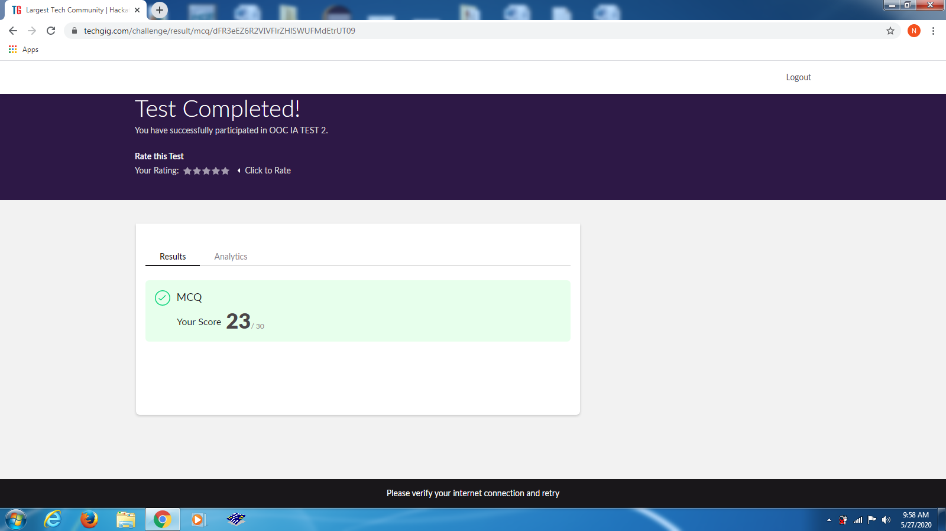

Certification Course Details:

The main use of pandas is that it creates two new data types for storing data : series and dataframe and today I leaned about how to create series and dataframes and how to access and modify them.

Snapshot:

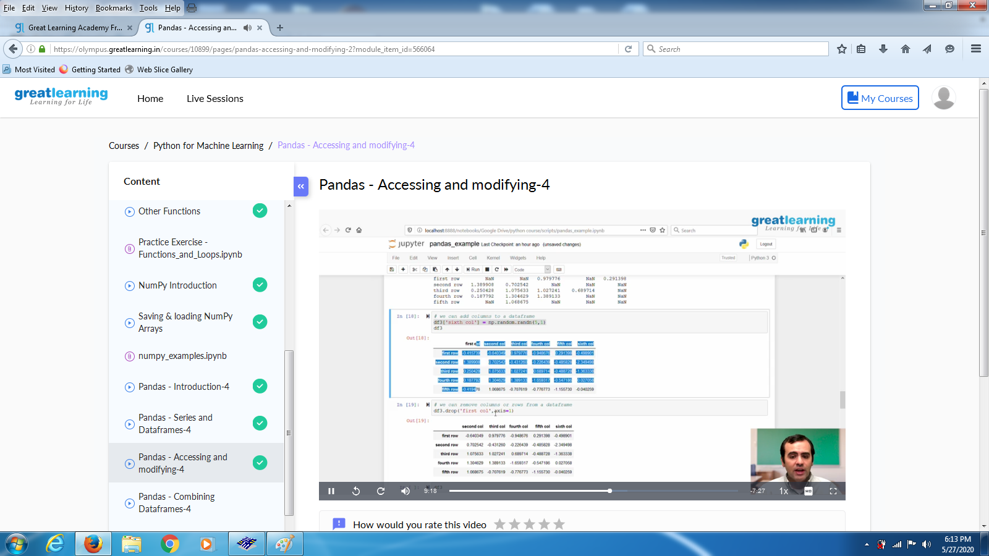

Coding Challenges Details:

Problem Statements

1.C program to print all the permutations of a given string using pointers.

Snapshot:

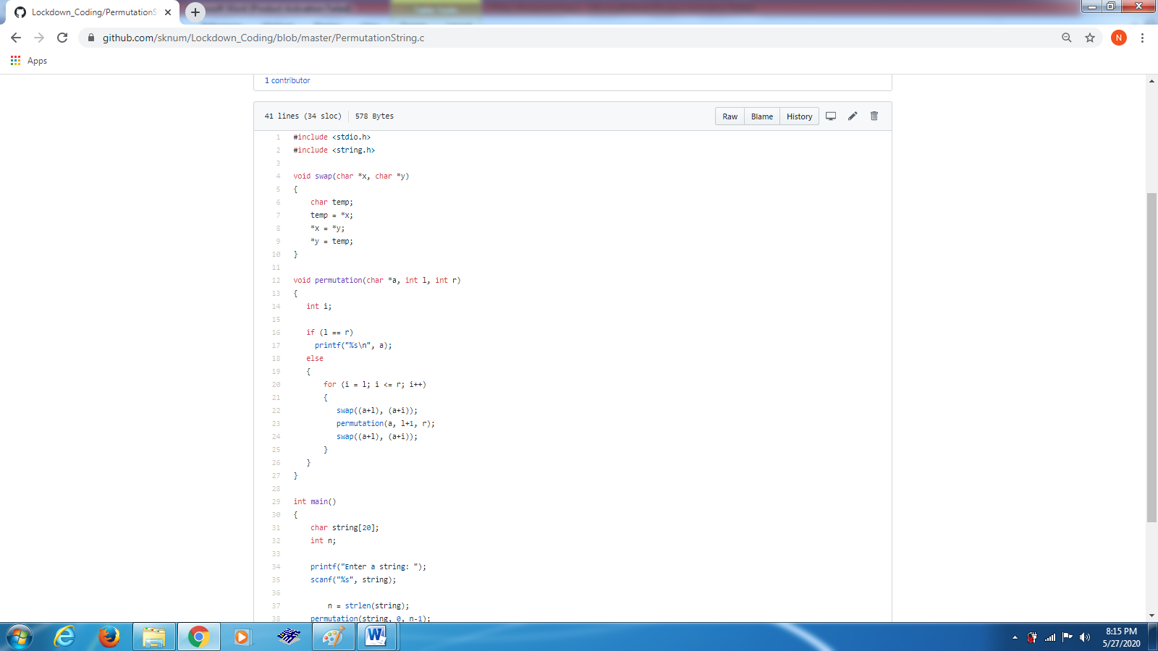

2. Given an array A of size n where the array elements contains values from 1 to n with duplicatesthe taskis to find total number of subarray which start and end with the same element

