**DAILY ONLINE ACTIVITIES SUMMARY**

|  |  |  |  |  |  |  |  |  |
| --- | --- | --- | --- | --- | --- | --- | --- | --- |
| **Date:** | **27/06/2020** | | | | **Name:** | **Shaikh Numaan** | | |
| **Sem & Sec** | **4th sem & B sec** | | | | **USN:** | **4al18cs076** | | |
| **Online Test Summary** | | | | | | | | |
| **Subject** | | **Data Communication** | | | | | | |
| **Max. Marks** | | **30** | **Score** | | | **24** | | |
| **Certification Course Summary** | | | | | | | | |
| **Course** | **1.Python for Data Science** | | | | | | | |
| **Certificate Provider** | **1.Great Learning Academy** | | | | **Duration** | | **1)5 hrs** |
| **Coding Challenges** | | | | | | | | |
| **Problem Statement:1)** **Write a C program to print kth digit** | | | | | | | | |
| **Status: Completed** | | | | | | | | |
| **Uploaded the report in Github** | | | | **Yes** | | | | |
| **If yes Repository name** | | | | **1)**<https://github.com/sknum/Lockdown_Coding/blob/master/kth_digit.c> | | | | |
| **Uploaded the report in slack** | | | | **Yes** | | | | |

**Online Test Details:**

Online test of Data Communication was conducted .It was based on fifth module. There were 30 questions of 1 mark eachand time duration was 30 minutes.

**Snapshot:**

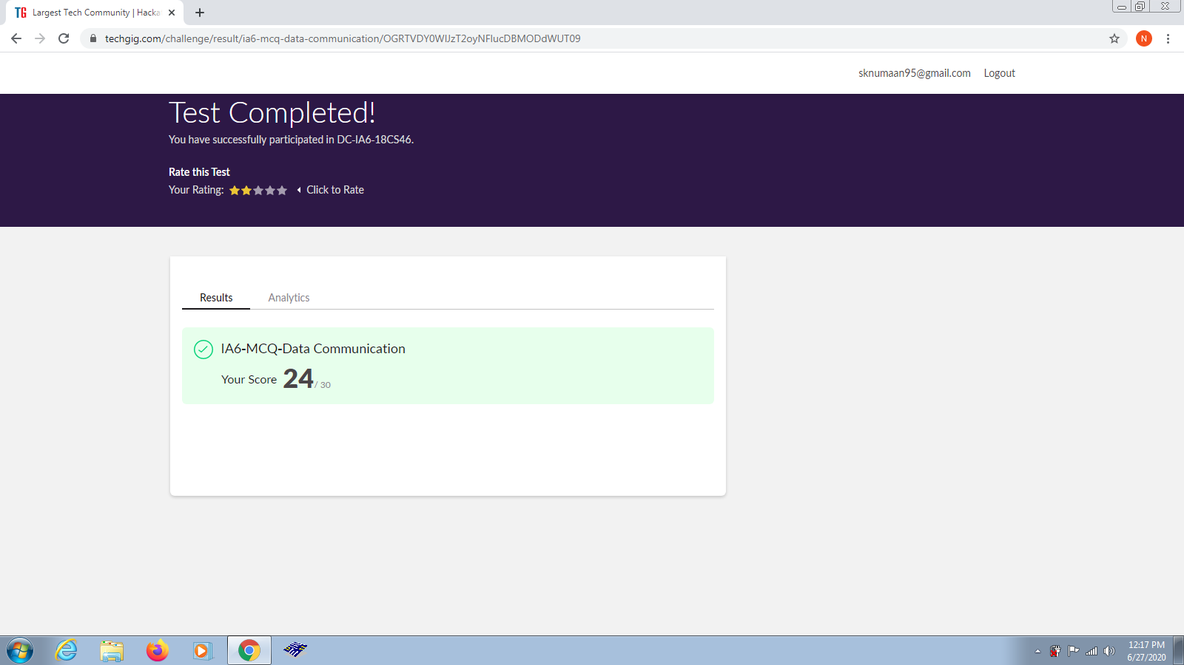

**Certification Course Details:**

Today I learned how to read and write files and loading data with pandas in “python for data science” online course

**Snapshot:**

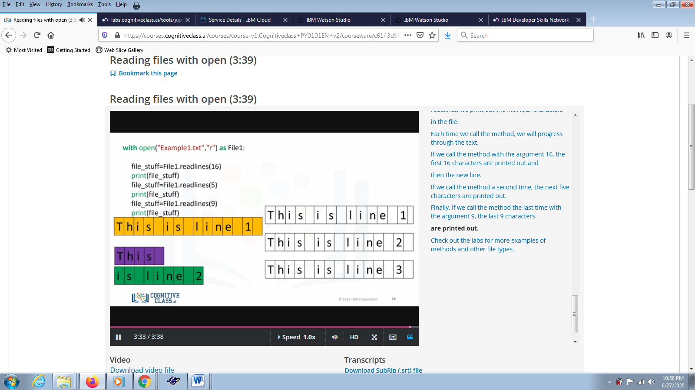

**Coding Challenges Details:**

**Problem Statements:**

1. Write a C program to print kth digit.

**Snapshot:**

