**DAILY ONLINE ACTIVITIES SUMMARY**

|  |  |  |  |  |  |  |
| --- | --- | --- | --- | --- | --- | --- |
| **Date:** | **28/05/2020** | | | **Name:** | | **Shaikh Numaan** |
| **Sem & Sec** | **4th sem & B sec** | | | **USN:** | | **4AL18CS076** |
| **Online Test Summary** | | | | | | |
| **Subject** | **1.Microcontroller and embedded systems**  **2.Vyavaharika kannada** | | | | | |
| **Max. Marks** | **1).20**  **2).50** | **Score** | | | | **1).19**  **2).49** |
| **Certification Course Summary** | | | | | | |
| **Course** | **Python For Machine Learning** | | | | | |
| **Certificate Provider** | **Great Learning Academy** | | **Duration** | | **5 hrs** | | |
| **Coding Challenges** | | | | | | |
| **Problem Statement:**  1.C program to find digital root of a number. | | | | | | |
| **Status: Completed** | | | | | | |
| **Uploaded the report in Github** | | | **Yes** | | | |
| **If yes Repository name** | | | <https://github.com/sknum/Lockdown_Coding/blob/master/digitalroot.c> | | | |
| **Uploaded the report in slack** | | | **Yes** | | | |

Online Test Details:

Online test of Microcontroller and embedded system was conducted .It was based on second module .There where 20 questions ,each carrying 1 mark and time duration was 40 minutes.

Snapshot:

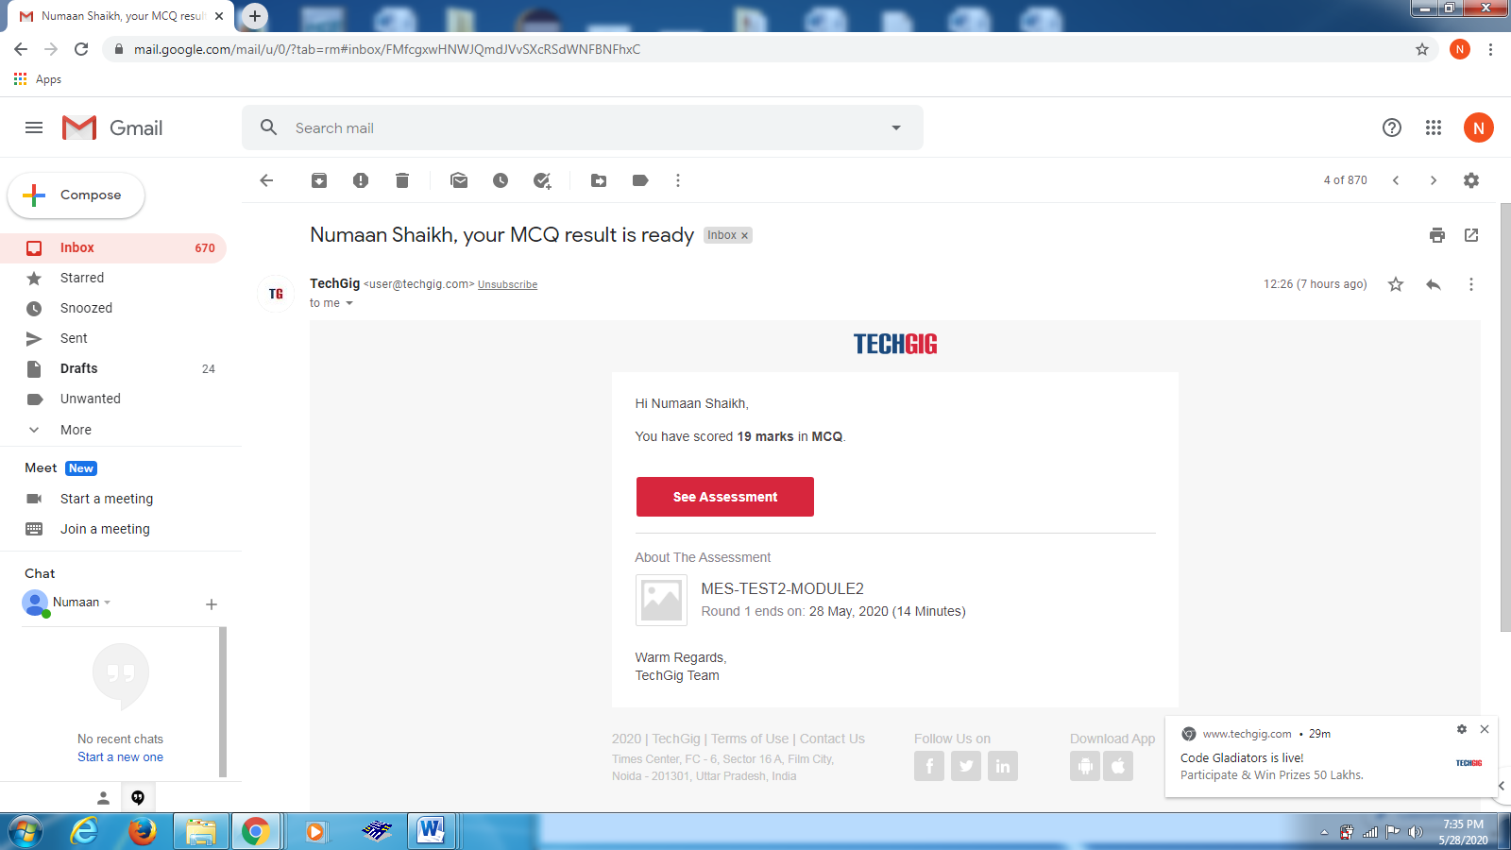

Online test of Vyavaharika Kannada was conducted between 2:00pm to 2:50pm. The portion was five chapters.

Snapshot:

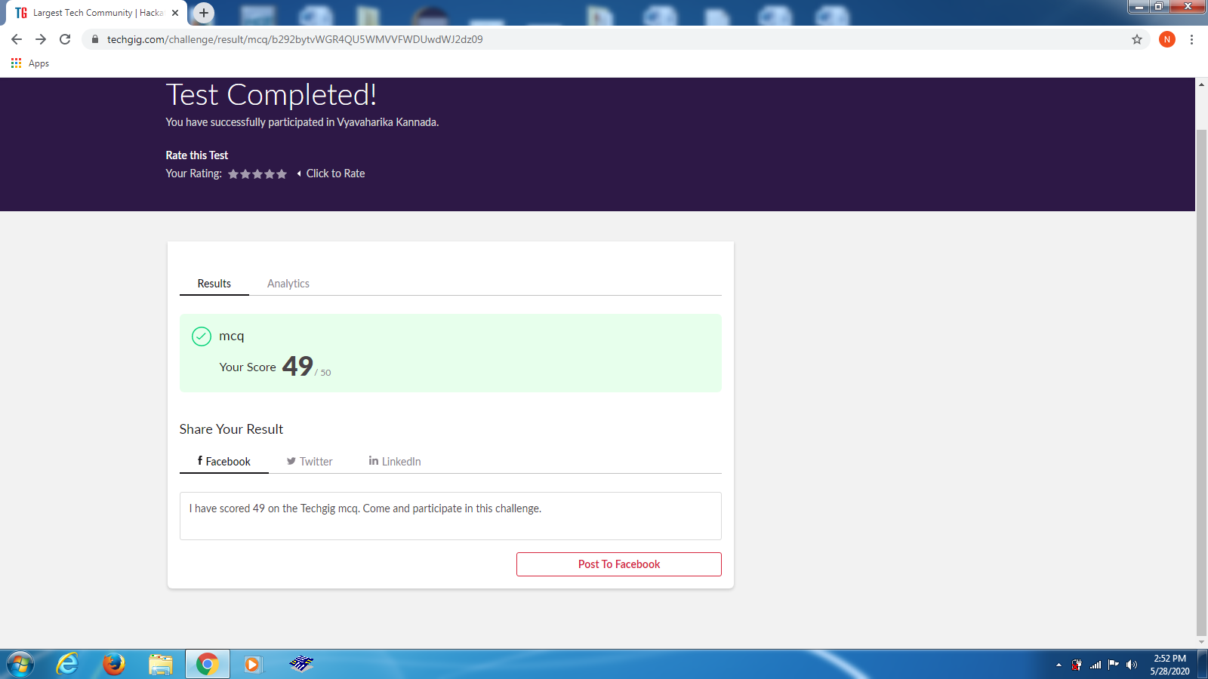

Certification Course Details:

Today I learned about combining Data Frames in pandas it is similar to SQL. There are three methods for combining data frames they are concat , join and merge.

Snapshot:

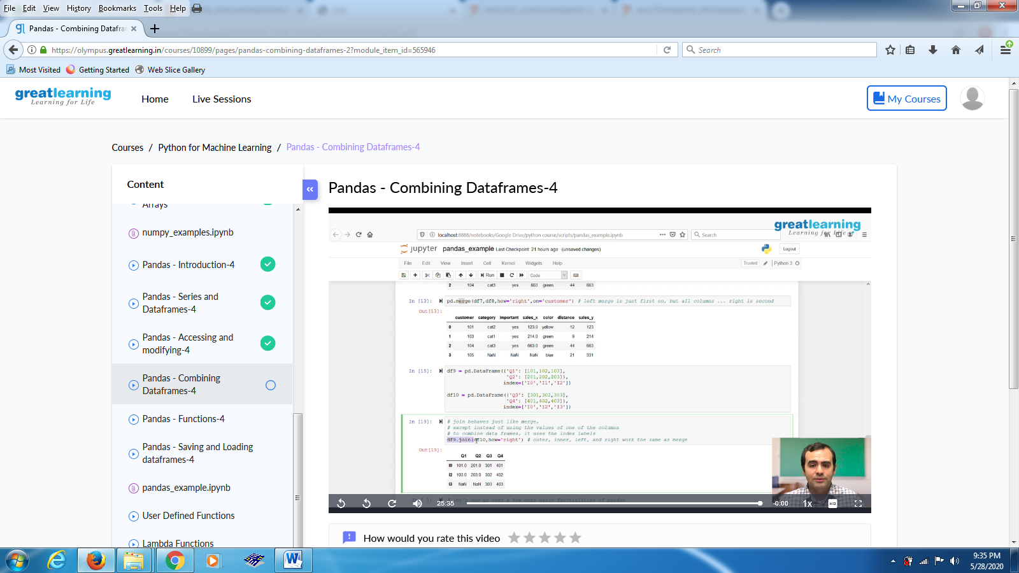

Coding Challenges Details:

Problem Statements

C program to find digital root of a number

Snapshot:

