**DAILY ONLINE ACTIVITIES SUMMARY**

|  |  |  |  |  |  |  |  |  |
| --- | --- | --- | --- | --- | --- | --- | --- | --- |
| **Date:** | **29/05/2020** | | | | | **Name:** | | **Shaikh Numaan** |
| **Sem & Sec** | **4th sem & B sec** | | | | | **USN:** | | **4AL18CS076** |
| **Online Test Summary** | | | | | | | | |
| **Subject** | | **Operating Systems** | | | | | | |
| **Max. Marks** | | **30** | | **Score** | | | | **28** |
| **Certification Course Summary** | | | | | | | | |
| **Course** | | | **Python For Machine Learning** | | | | | |
| **Certificate Provider** | | | **Great Learning Academy** | | **Duration** | | **5 hrs** | | |
| **Coding Challenges** | | | | | | | | |
| **Problem Statement:**  **1.Write a java program to find the size of the largest ‘+’ formed by all the ones in the Binary matrix .** | | | | | | | | |
| **Status: Completed** | | | | | | | | |
| **Uploaded the report in Github** | | | | | **Yes** | | | |
| **If yes Repository name** | | | | | <https://github.com/sknum/Lockdown_JavaCoding/blob/master/matrix.java> | | | |
| **Uploaded the report in slack** | | | | | **Yes** | | | |

Online Test Details:

Online test of Operating Systems was conducted .It was based on Second module .There where 30 questions ,each carrying 1 mark and time duration was 45 minutes.

Snapshot:

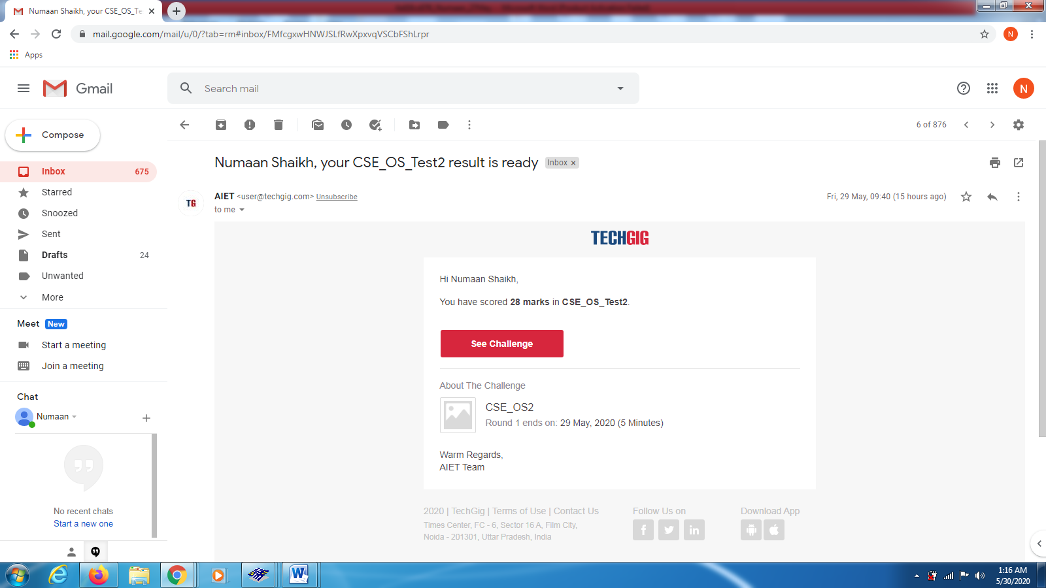

Certification Course Details:

Today I learned about functions that are used with data frames in pandas and also about saving and loading data frames…

Snapshot:

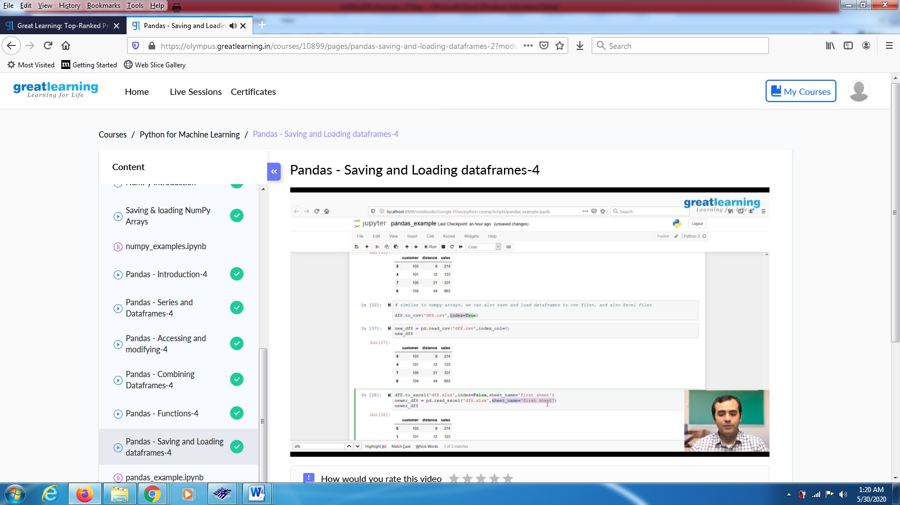

Coding Challenges Details:

Problem Statements

**1.Write a java program to find the size of the largest ‘+’ formed by all the ones in the**

**Binary matrix**

.

Snapshot:

