**DAILY ONLINE ACTIVITIES SUMMARY**

|  |  |  |  |  |  |  |  |  |  |
| --- | --- | --- | --- | --- | --- | --- | --- | --- | --- |
| **Date:** | **2/06/20** | | | | | **Name:** | | **Shaikh Numaan** | |
| **Sem & Sec** | **4 sem & B sec** | | | | | **USN:** | | **4AL18CS076** | |
| **Online Test Summary** | | | | | | | | | |
| **Subject** | | **NA** | | | | | | | |
| **Max. Marks** | | **30** | | **Score** | | | | NA | |
| **Certification Course Summary** | | | | | | | | | |
| **Course** | | | **Java Programming** | | | | | | |
| **Certificate Provider** | | | **Great Learning Academy** | | | | **Duration** | | **3.5 hrs** |
| **Coding Challenges** | | | | | | | | | |
| **Problem Statement: 1. Write a c program to find leaders in the array**  **2. write a c program to find inversion count of array** | | | | | | | | | |
| **Status: Completed** | | | | | | | | | |
| **Uploaded the report in Github** | | | | | **YES** | | | | |
| **If yes Repository name** | | | | | **1.**<https://github.com/sknum/Lockdown_Coding/blob/master/Leaders_in_array.c>  **2.** <https://github.com/sknum/Lockdown_Coding/blob/master/Inversion.c> | | | | |
| **Uploaded the report in slack** | | | | | **YES** | | | | |

**Certification Course Details:**

Today I learned about variables and data types, operators and flow control statements and how to write simple java programs using the same.

**Snapshot:**

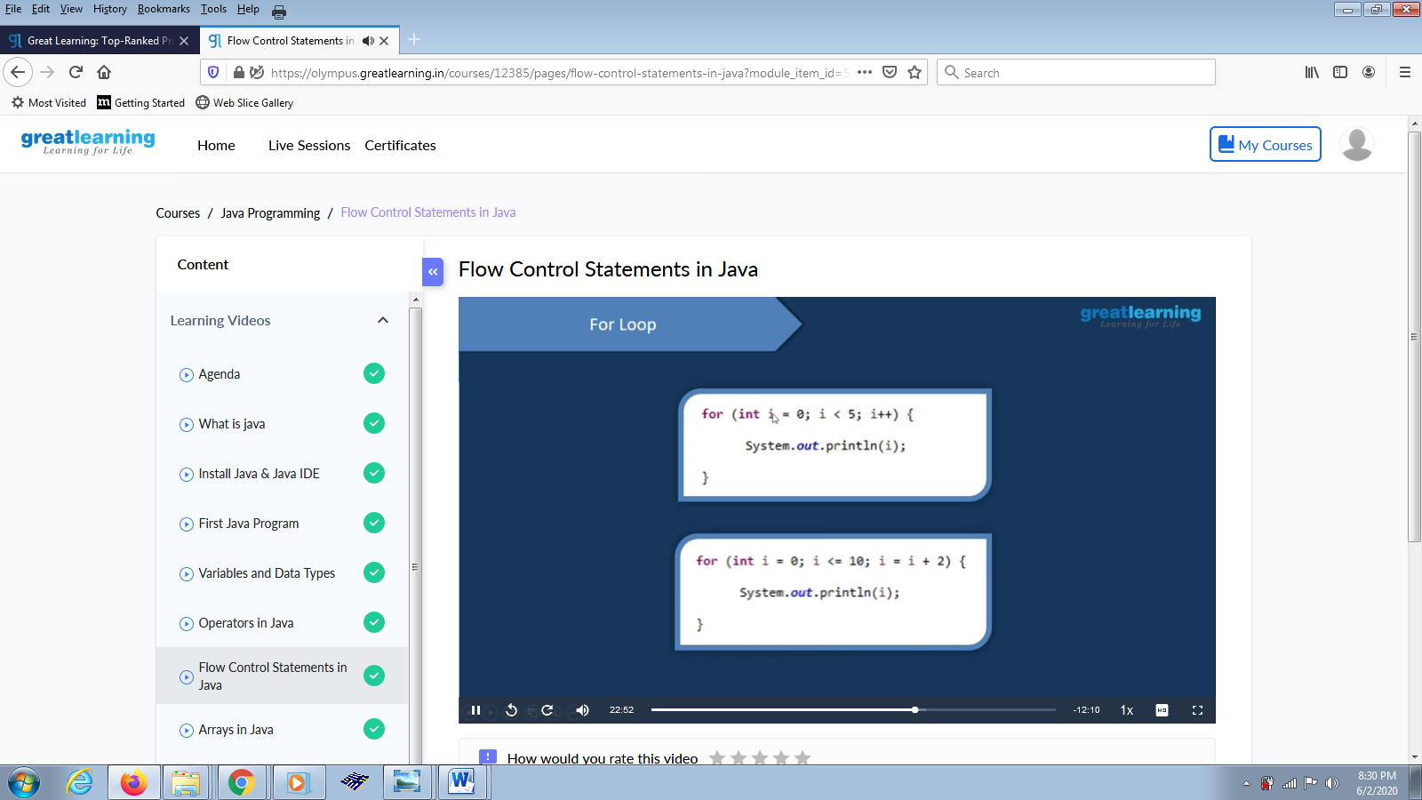

Coding Challenges Details:

Problem Statement:

1.Write a c program to find leaders in the array

Snapshot:

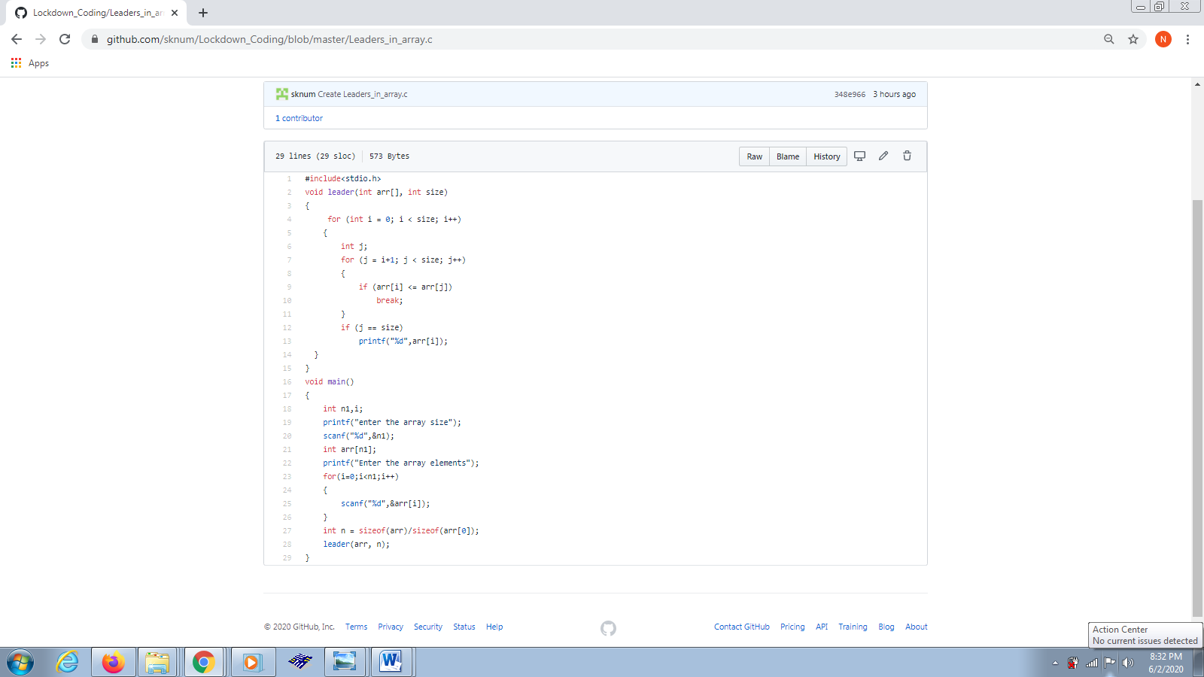

2.write a c program to find inversion count of array

Snapshot:

