**DAILY ONLINE ACTIVITIES SUMMARY**

|  |  |  |  |  |  |  |
| --- | --- | --- | --- | --- | --- | --- |
| **Date:** | **30/05/2020** | | | **Name:** | | **Shaikh Numaan** |
| **Sem & Sec** | **4th sem & B sec** | | | **USN:** | | **4AL18CS076** |
| **Online Test Summary** | | | | | | |
| **Subject** | **1.Data Communication**  **2.Complex analysis, probability and statistical method** | | | | | |
| **Max. Marks** | **1).30**  **2).30** | **Score** | | | | **1).20**  **2).27** |
| **Certification Course Summary** | | | | | | |
| **Course** | **Python For Machine Learning** | | | | | |
| **Certificate Provider** | **Great Learning Academy** | | **Duration** | | **5 hrs** | | |
| **Coding Challenges** | | | | | | |
| **Problem Statement:**  **1**.**Write a C program to count the Uppercase Lowercase Numbers and Special Characters in a given String** | | | | | | |
| **Status: Completed** | | | | | | |
| **Uploaded the report in Github** | | | **Yes** | | | |
| **If yes Repository name** | | | <https://github.com/sknum/Lockdown_Coding/blob/master/Uppercase_Lowercsase.c> | | | |
| **Uploaded the report in slack** | | | **Yes** | | | |

Online Test Details:

Online test of Data Communication was conducted .It was based on third and fourth module .There where 30 questions ,each carrying 1 mark and time duration was 45 minutes.

Snapshot:

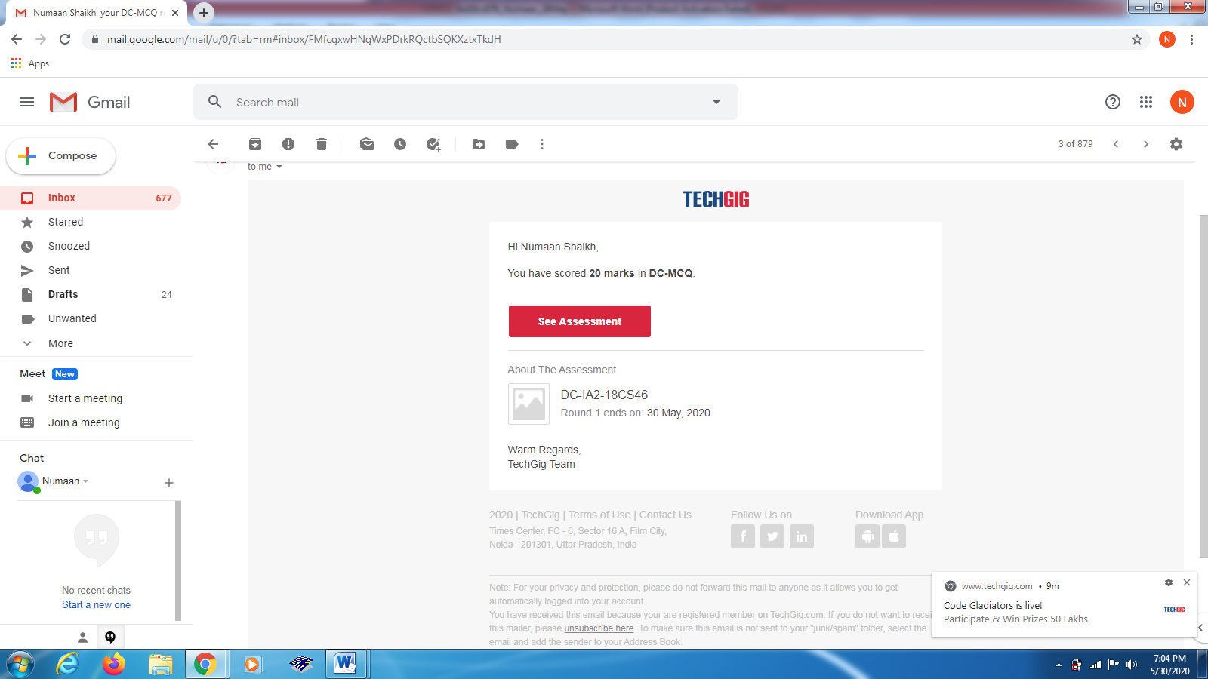

Online test of Complex Analysis Probability and Statistical method was also conducted at 3:00 PM. There were 10 questions 1 mark each and 10 questions 2 mark each

Snapshot:

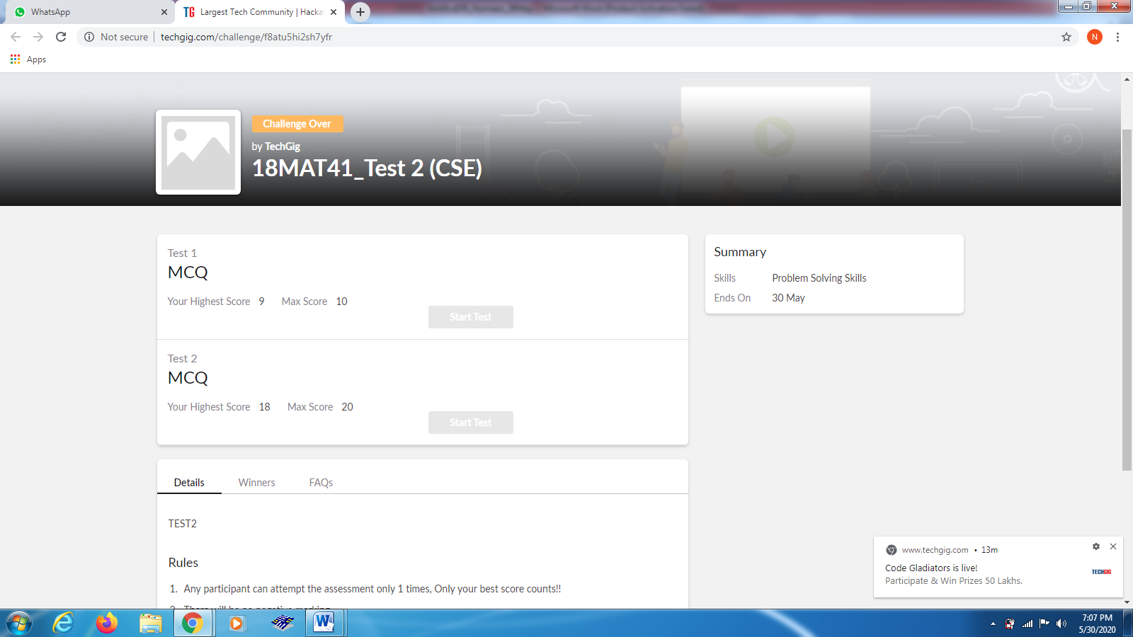

Certification Course Details:

Today I learned about writing functions in python.There are two ways of writing functions one is lambda functions and other is user defined functions. I also learned about writing classes and object in python language.

Snapshot:

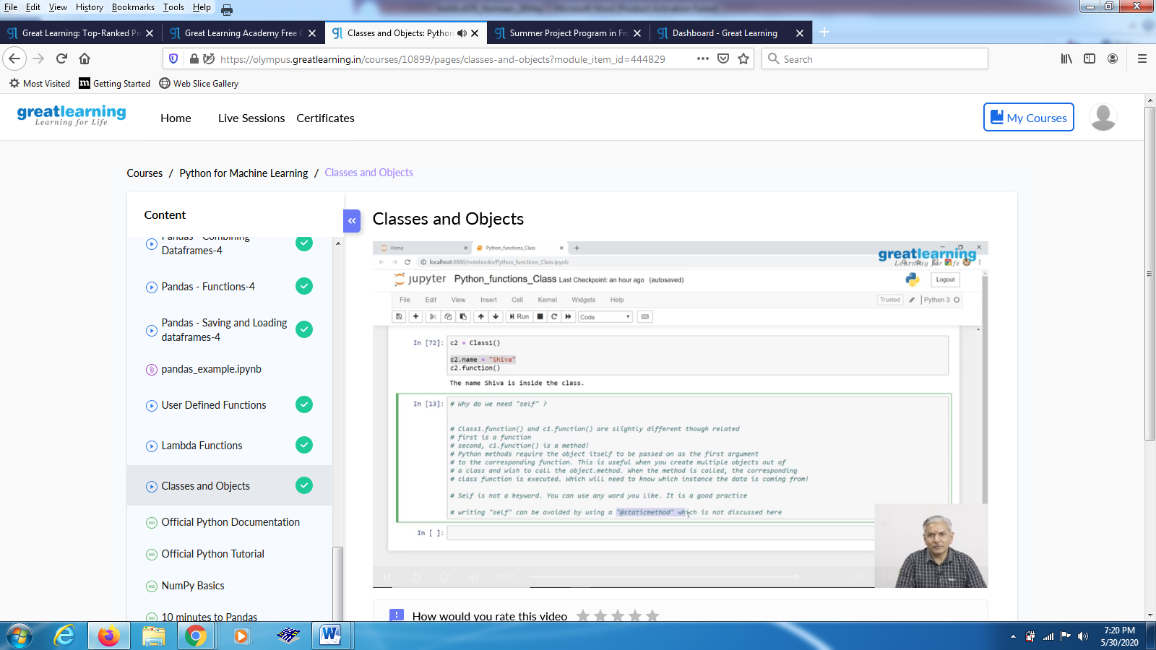

Coding Challenges Details:

Problem Statements

1.**Write a C program to count the Uppercase Lowercase Numbers and Special Characters in a given String**

Snapshot:

