**DAILY ONLINE ACTIVITIES SUMMARY**

|  |  |  |  |  |  |  |  |  |  |
| --- | --- | --- | --- | --- | --- | --- | --- | --- | --- |
| **Date:** | **31/05/20** | | | | | | **Name:** | **Shaikh Numaan** | |
| **Sem & Sec** | **4 sem & B sec** | | | | | | **USN:** | **4AL18CS076** | |
| **Online Test Summary** | | | | | | | | | |
| **Subject** | | - | | | | | | | |
| **Max. Marks** | | **30** | | **Score** | | | | - | |
| **Certification Course Summary** | | | | | | | | | |
| **Course** | | | **Python for Machine Learning** | | | | | | |
| **Certificate Provider** | | | **Great Learning Academy** | | | **Duration** | | | 5 hrs |
| **Coding Challenges** | | | | | | | | | |
| **Problem Statement: write a java program to find npr** | | | | | | | | | |
| **Status: Completed** | | | | | | | | | |
| **Uploaded the report in Github** | | | | | **YES** | | | | |
| **If yes Repository name** | | | | | <https://github.com/sknum/Lockdown_JavaCoding/blob/master/permutation.java> | | | | |
| **Uploaded the report in slack** | | | | | **YES** | | | | |

**Certification Course Details:**

Today I completed Pyton For Machine Learning certification course.

**Snapshot:**

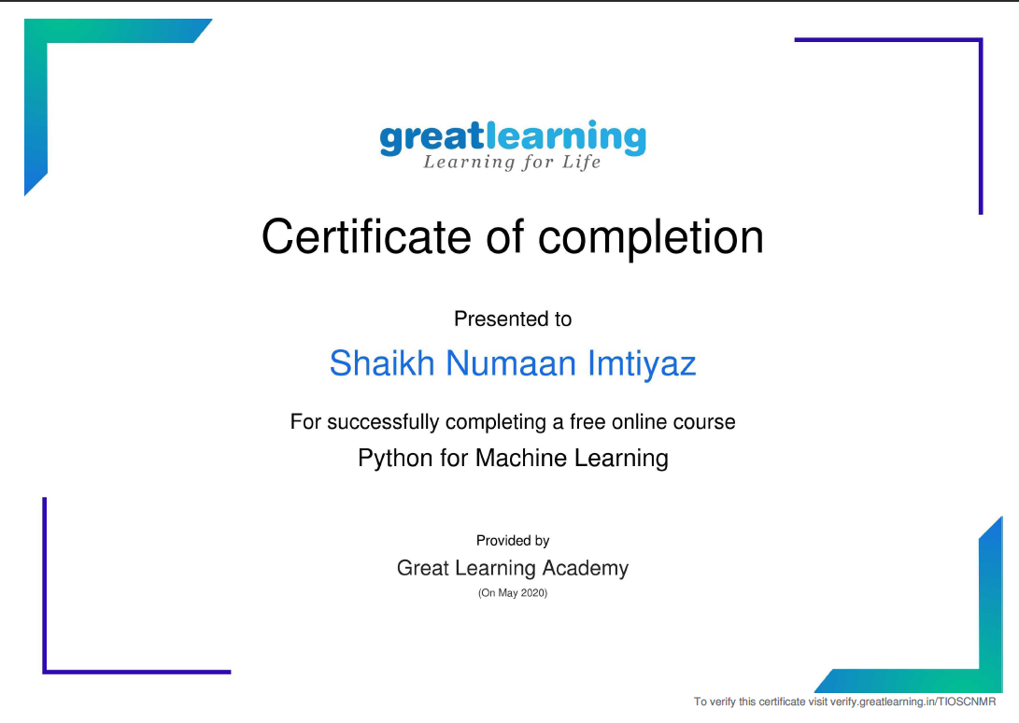

Coding Challenges Details:

Problem Statement:

Write a java program to find NPR

Snapshot:

