**DAILY ONLINE ACTIVITIES SUMMARY**

|  |  |  |  |  |  |  |  |  |  |
| --- | --- | --- | --- | --- | --- | --- | --- | --- | --- |
| **Date:** | **03/06/2020** | | | | | | **Name:** | **Shaikh Numaan** | |
| **Sem & Sec** | **4th sem B sec** | | | | | | **USN:** | **4al18cs076** | |
| **Online Test Summary** | | | | | | | | | |
| **Subject** | | **Object Oriented Concepts** | | | | | | | |
| **Max. Marks** | | **30** | | **Score** | | | | **10** | |
| **Certification Course Summary** | | | | | | | | | |
| **Course** | | | **1.Java Programming** | | | | | | |
| **Certificate Provider** | | | **1.Great Learning Academy** | | | **Duration** | | | **1)3.5 hrs** | |
| **Coding Challenges** | | | | | | | | | |
| **Problem Statement: 1. Write a Java program to find Last Digit of a^b (a to the power b) for Large Numbers** | | | | | | | | | |
| **Status: Completed** | | | | | | | | | |
| **Uploaded the report in Github** | | | | | **Yes** | | | | |
| **If yes Repository name** | | | | | **1.**<https://github.com/sknum/Lockdown_JavaCoding/blob/master/lastdigit.java> | | | | |
| **Uploaded the report in slack** | | | | | **Yes** | | | | |

Online Test Details:

Online test of Object Oriented Concepts was conducted .It was based on 2nd and 3rd module. There where 30 questions of 1mark each and time duration was 45 minutes.

Snapshot:

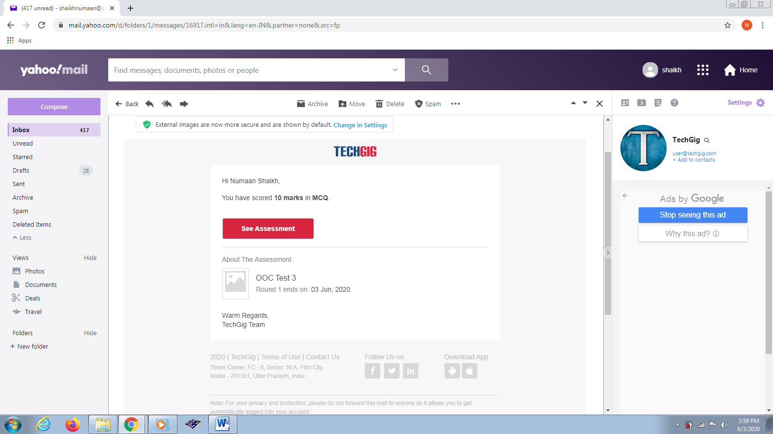

Certification Course Details:

Today I learned about arrays and functions used in java programming language and also I learned about concept of Inheritance.

Snapshot:

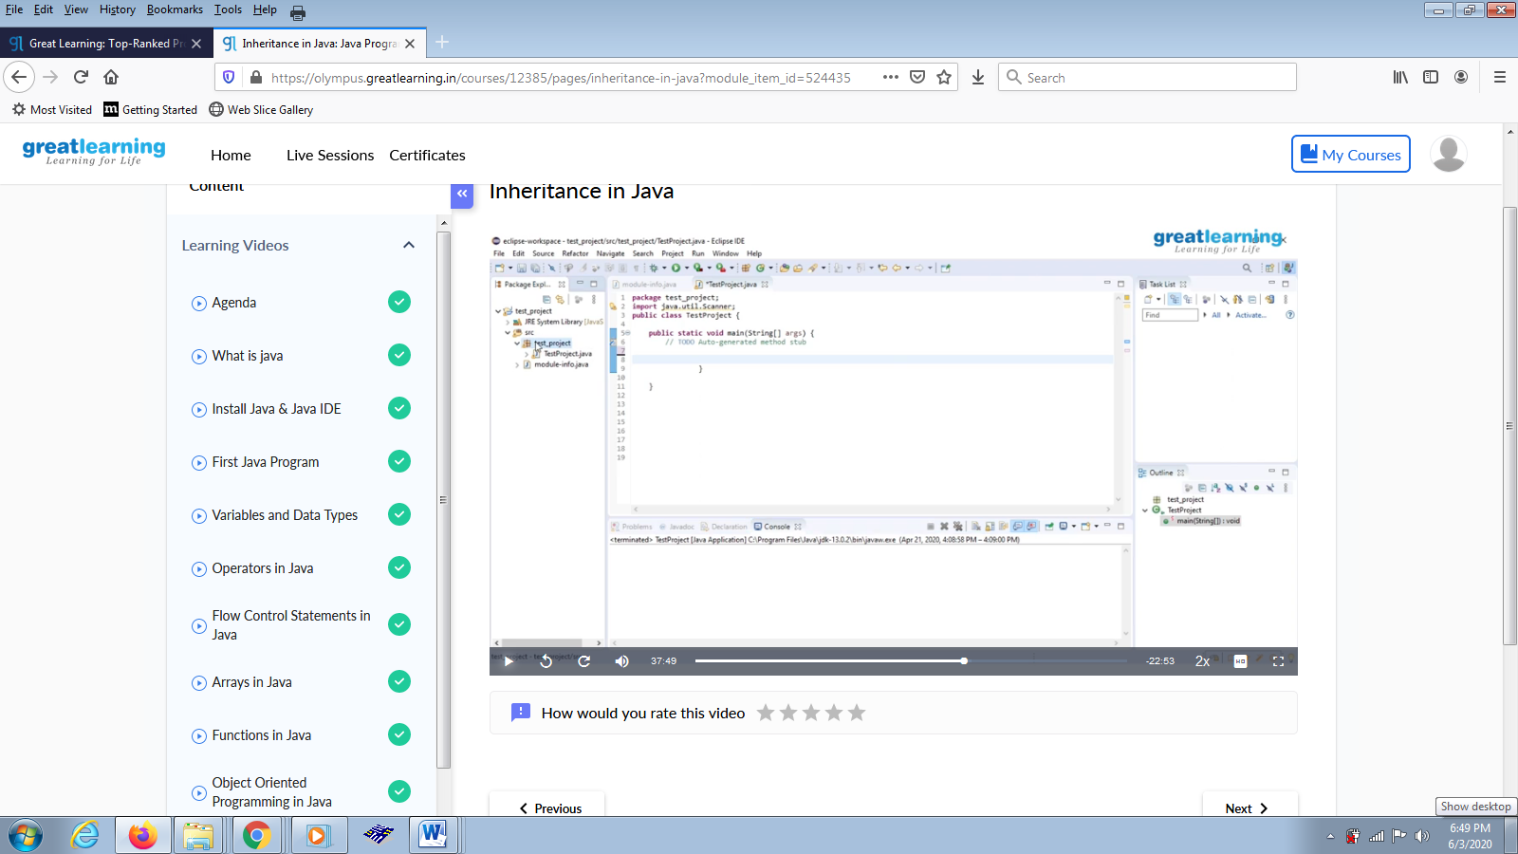

Coding Challenges Details:

Problem Statements

1. Write a Java program to find Last Digit of a^b (a to the power b) for Large Numbers

Snapshot:

