**DAILY ONLINE ACTIVITIES SUMMARY**

|  |  |  |  |  |  |  |  |  |  |
| --- | --- | --- | --- | --- | --- | --- | --- | --- | --- |
| **Date:** | **04/06/2020** | | | | | **Name:** | | **Shaikh Numaan** | |
| **Sem & Sec** | **4th sem B sec** | | | | | **USN:** | | **4al18cs076** | |
| **Online Test Summary** | | | | | | | | | |
| **Subject** | | **Microcontroller and Embedded System** | | | | | | | |
| **Max. Marks** | | **20** | | **Score** | | | | **17** | |
| **Certification Course Summary** | | | | | | | | | |
| **Course** | | | **1.Java Programming** | | | | | | |
| **Certificate Provider** | | | **1.Great Learning Academy** | | | | **Duration** | | **1)3.5 hrs** | |
| **Coding Challenges** | | | | | | | | | |
| **Problem Statement: 1. write a java program to read three integer values from the keyboard and find the sum of the values. Declare a variable "sum" of type int and store the result in it.**  **2.Write a C++ program to find a missing number in array.** | | | | | | | | | |
| **Status: Completed** | | | | | | | | | |
| **Uploaded the report in Github** | | | | | **Yes** | | | | |
| **If yes Repository name** | | | | | 1.<https://github.com/sknum/Lockdown_JavaCoding/blob/master/Sum.java>  2.<https://github.com/sknum/Lockdown_Coding/blob/master/MissingNo.cpp> | | | | |
| **Uploaded the report in slack** | | | | | **Yes** | | | | |

**Online Test Details:**

Online test of MES was conducted .It was based on 3rd module .There where 20 questions of 1 mark each and time duration was 30 minutes.

Snapshot:

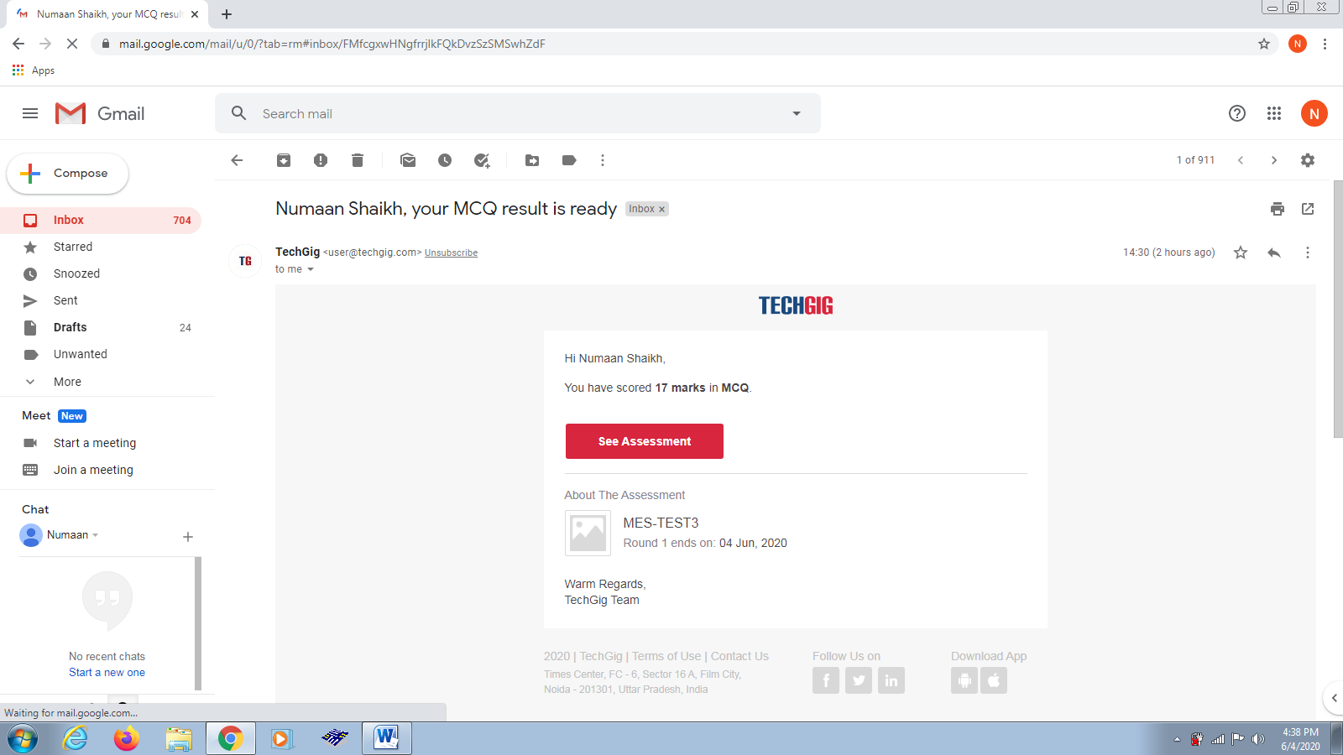

**Certification Course Details**:

Today I completed programming in java certification course.

Snapshot:

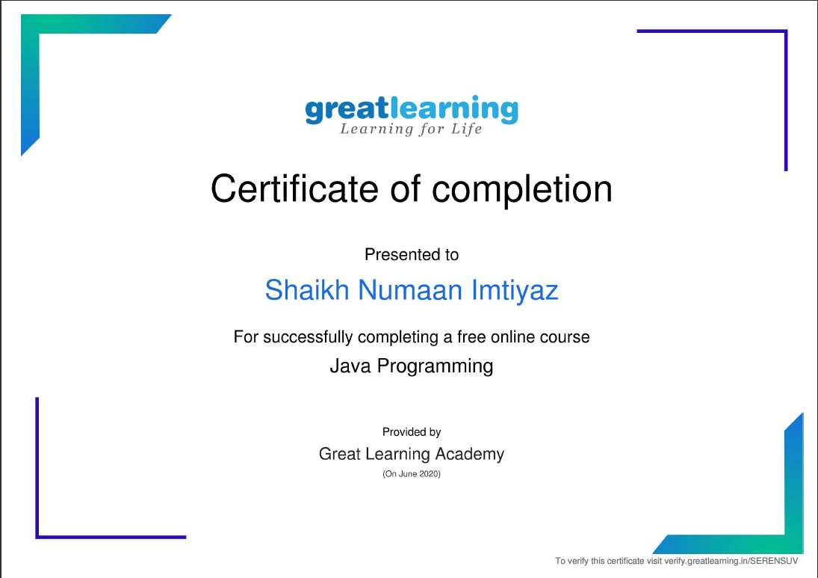

**Coding Challenges Details:**

**Problem Statements**

1.write a java program to read three integer values from the keyboard and find the sum of the values. Declare a variable "sum" of type int and store the result in it.

Snapshot:

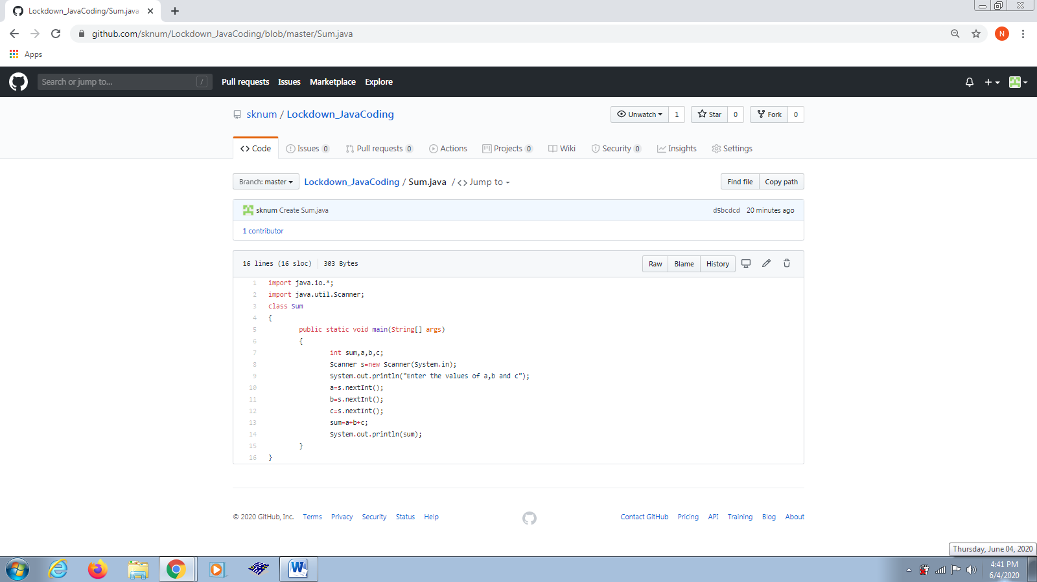

2.Write a C++ program to find a missing number in array.

Snapshot: 