**DAILY ONLINE ACTIVITIES SUMMARY**

|  |  |  |  |  |  |  |  |  |
| --- | --- | --- | --- | --- | --- | --- | --- | --- |
| **Date:** | **06/06/2020** | | | **Name:** | | | | **Shaikh Numaan** |
| **Sem & Sec** | **4th sem B sec** | | | **USN:** | | | | **4al18cs076** |
| **Online Test Summary** | | | | | | | | |
| **Subject** | | **Data Communication** | | | | | | |
| **Max. Marks** | | **30** | | | **Score** | | | **27** |
| **Certification Course Summary** | | | | | | | | |
| **Course** | | | **1.Front end Development - HTML** | | | | | |
| **Certificate Provider** | | | **1.Great Learning Academy** | **Duration** | | | **1)3.5 hrs** | | |
| **Coding Challenges** | | | | | | | | |
| **Problem Statement:**  **1.Write a C program to rotate an array by N position.**  **2.Write a java program to sort an array containing 0s and 1s.** | | | | | | | | |
| **Status: Completed** | | | | | | | | |
| **Uploaded the report in Github** | | | | | | **Yes** | | |
| **If yes Repository name** | | | | | | 1.<https://github.com/sknum/Lockdown_Coding/blob/master/rotatearray.c>  2.<https://github.com/sknum/Lockdown_JavaCoding/blob/master/Sort.java> | | |
| **Uploaded the report in slack** | | | | | | **Yes** | | |

**Online Test Details:**

Online test of Data Communication was conducted .It was based on 5th module .There where 30 questions of 1mark each and time duration was 45 minutes.

**Snapshot:**

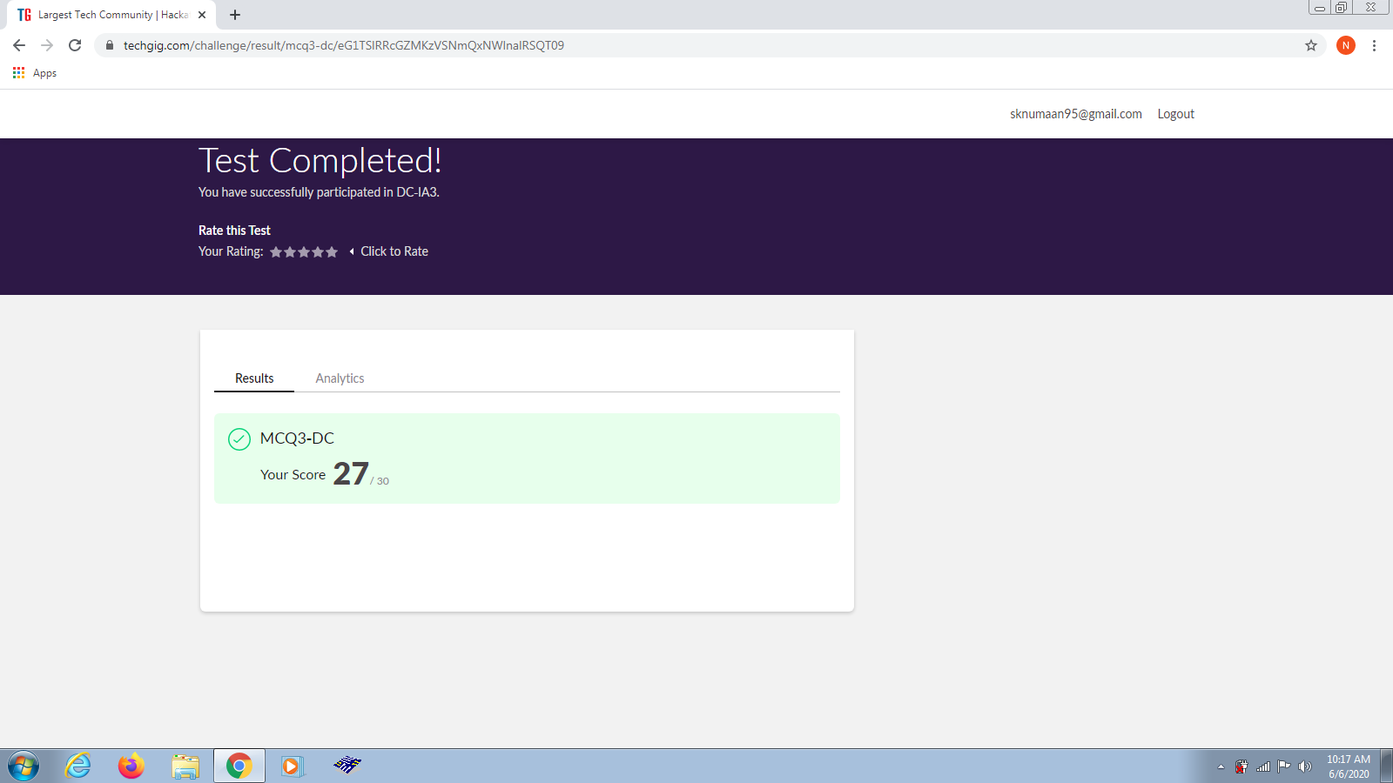

**Certification Course Details:**

Today I learned how to create hyperlinks to link to other pages and to different sections of the same web page.

**Snapshot:**

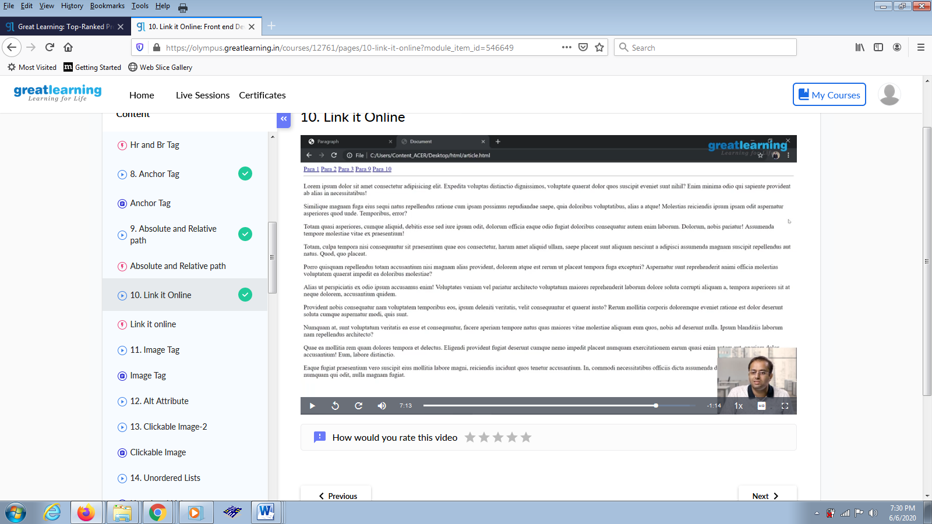

**Coding Challenges Details:**

**Problem Statements**

1. Write a program in C to rotate an array by N positions.

**Snapshot:** 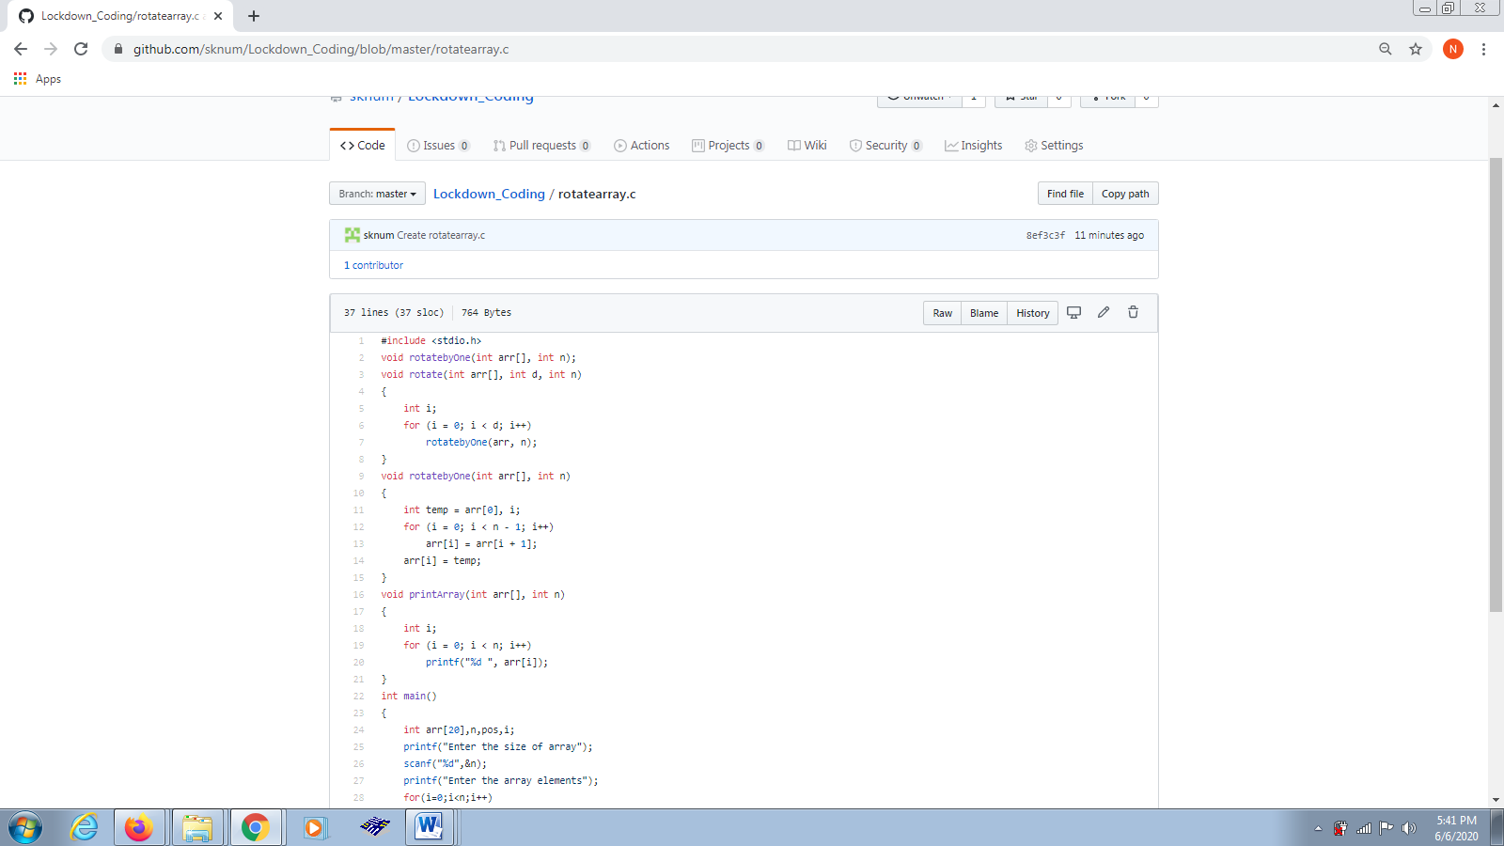

2. Write a Java program to Sort an array containing 0s and 1s.

**Snapshot:** 