**DAILY ONLINE ACTIVITIES SUMMARY**

|  |  |  |  |  |  |  |  |
| --- | --- | --- | --- | --- | --- | --- | --- |
| **Date:** | | **07/06/2020** | **Name:** | | | **Shaikh Numaan** | |
| **Sem & Sec** | | **4th sem B sec** | **USN:** | | | **4al18cs076** | |
| **Online Test Summary** | | | | | | | |
| **Subject** | **-** | | | | | | |
| **Max. Marks** | **30** | | | **Score** | | **-** | |
| **Certification Course Summary** | | | | | | | |
| **Course** | | **1.Front end Development - HTML** | | | | | |
| **Certificate Provider** | | **1.Great Learning Academy** | **Duration** | | | | **1)3.5hours** | |
| **Coding Challenges** | | | | | | | |
| **Problem Statement: 1.Write a C++ program to swap two numbers using Friend function.** | | | | | | | |
| **Status: Completed** | | | | | | | |
| **Uploaded the report in Github** | | | | | **Yes** | | |
| **If yes Repository name** | | | | | <https://github.com/sknum/Lockdown_Coding/blob/master/swap.cpp> | | |
| **Uploaded the report in slack** | | | | | **Yes** | | |

**Certification Course Details**:

Today I learned how to create lists and tables in html.

**Snapshot:**

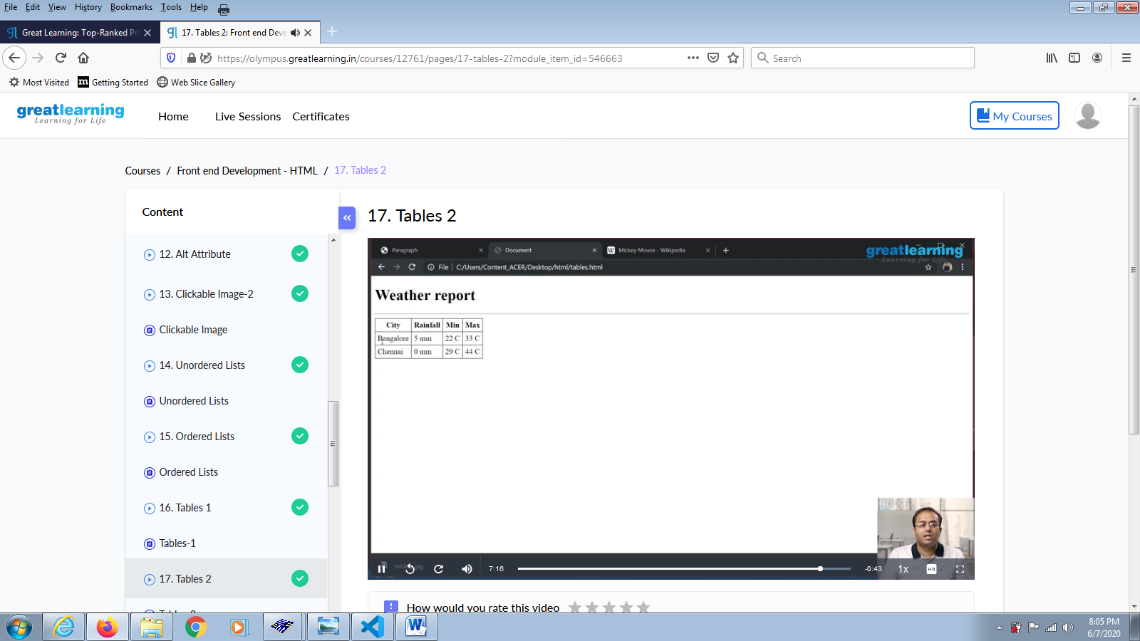

**Coding Challenges Details:**

**Problem Statements**

1.Write a C++ program to swap two numbers using Friend function**.**

**Snapshot:**

