**DAILY ONLINE ACTIVITIES SUMMARY**

|  |  |  |  |  |  |  |  |  |
| --- | --- | --- | --- | --- | --- | --- | --- | --- |
| **Date:** | **08/06/2020** | | | | | **Name:** | **Shaikh Numaan** | |
| **Sem & Sec** | **4th sem B sec** | | | | | **USN:** | **4al18cs076** | |
| **Online Test Summary** | | | | | | | | |
| **Subject** | | **Complex Analysis Probability and Statistical Method** | | | | | | |
| **Max. Marks** | | **30** | **Score** | | | | **22** | |
| **Certification Course Summary** | | | | | | | | |
| **Course** | **1.Front End Development - HTML** | | | | | | | |
| **Certificate Provider** | **1.Great Learning Academy** | | | | **Duration** | | | **1)3.5 hrs** | |
| **Coding Challenges** | | | | | | | | |
| **Problem Statement: 1. C Program to Generate All the Set Partitions of n Numbers Beginning from 1 and so on** | | | | | | | | |
| **Status: Completed** | | | | | | | | |
| **Uploaded the report in Github** | | | | **Yes** | | | | |
| **If yes Repository name** | | | | <https://github.com/sknum/Lockdown_Coding/blob/master/PartitionOfNumbers.c> | | | | |
| **Uploaded the report in slack** | | | | **Yes** | | | | |

**Online Test Details:**

Online test of Complex Analysis Probability and Statistical Method was conducted .It was based on 2nd module .There where 15 questions of 2 mark each and time duration was 40 minutes.

**Snapshot:**

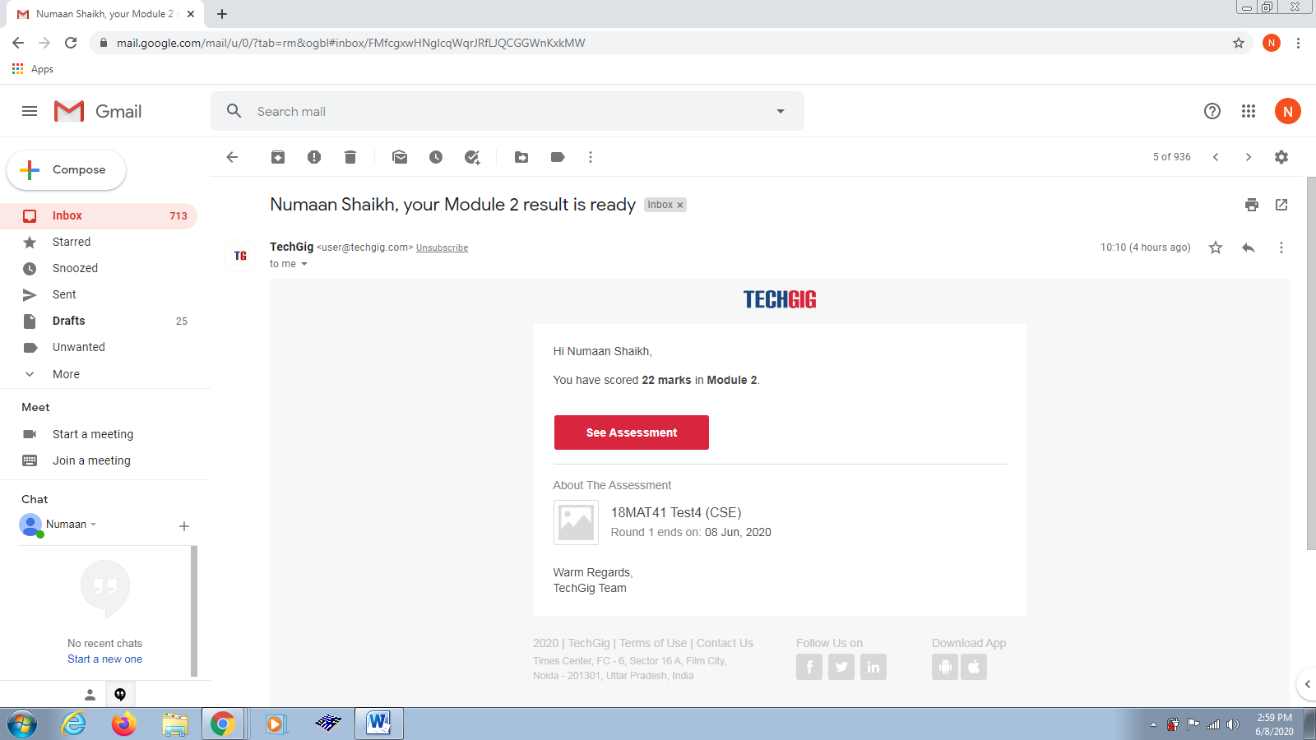

**Certification Course Details:**

Today I learned how to create forms using html. In that I understood how to create labels and textboxes and also some well known attributes of html.

**Snapshot:**

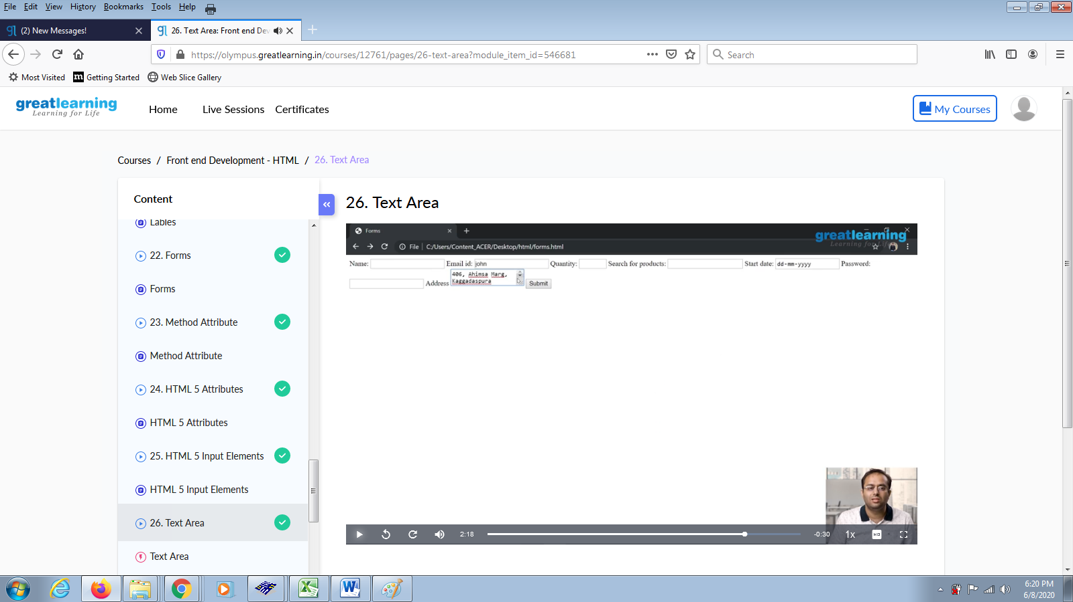

**Coding Challenges Details:**

**Problem Statements:**

1.C Program to Generate All the Set Partitions of n Numbers Beginning from 1 and so on.

**Snapshot:**

