DAILY ONLINE ACTIVITIES SUMMARY

|  |  |  |  |  |  |  |  |
| --- | --- | --- | --- | --- | --- | --- | --- |
| **Date:** | **09/06/2020** | | | | **Name:** | **Shaikh Numaan** | |
| **Sem & Sec** | **4th sem B sec** | | | | **USN:** | **4al18cs076** | |
| **Online Test Summary** | | | | | | | |
| **Subject** | | **-** | | | | | |
| **Max. Marks** | | **30** | **Score** | | | **-** | |
| **Certification Course Summary** | | | | | | | |
| **Course** | **1.Front end Development - HTML** | | | | | | |
| **Certificate Provider** | **1.Great Learning Academy** | | | | **Duration** | | **1)3.5 hrs** | |
| **Coding Challenges** | | | | | | | |
| **Problem Statement:**   1. **Write a C Program to rotate the matrix by K times.** 2. **Write a Java Program to check whether the given matrix is magic matrix or not** | | | | | | | |
| **Status: Completed** | | | | | | | |
| **Uploaded the report in Github** | | | | **Yes** | | | |
| **If yes Repository name** | | | | **1.**[**https://github.com/sknum/Lockdown_Coding/blob/master/rotatematrix.c**](https://github.com/sknum/Lockdown_Coding/blob/master/rotatematrix.c)  **2.**[**https://github.com/sknum/Lockdown_JavaCoding/blob/master/magicmatrix.java**](https://github.com/sknum/Lockdown_JavaCoding/blob/master/magicmatrix.java) | | | |
| **Uploaded the report in slack** | | | | **Yes** | | | |

**Certification Course Details**:

Today I learned about how to add radio buttons and check boxes in web pages as well as difference between inline elements and block level elements used in html.

**Snapshot**:

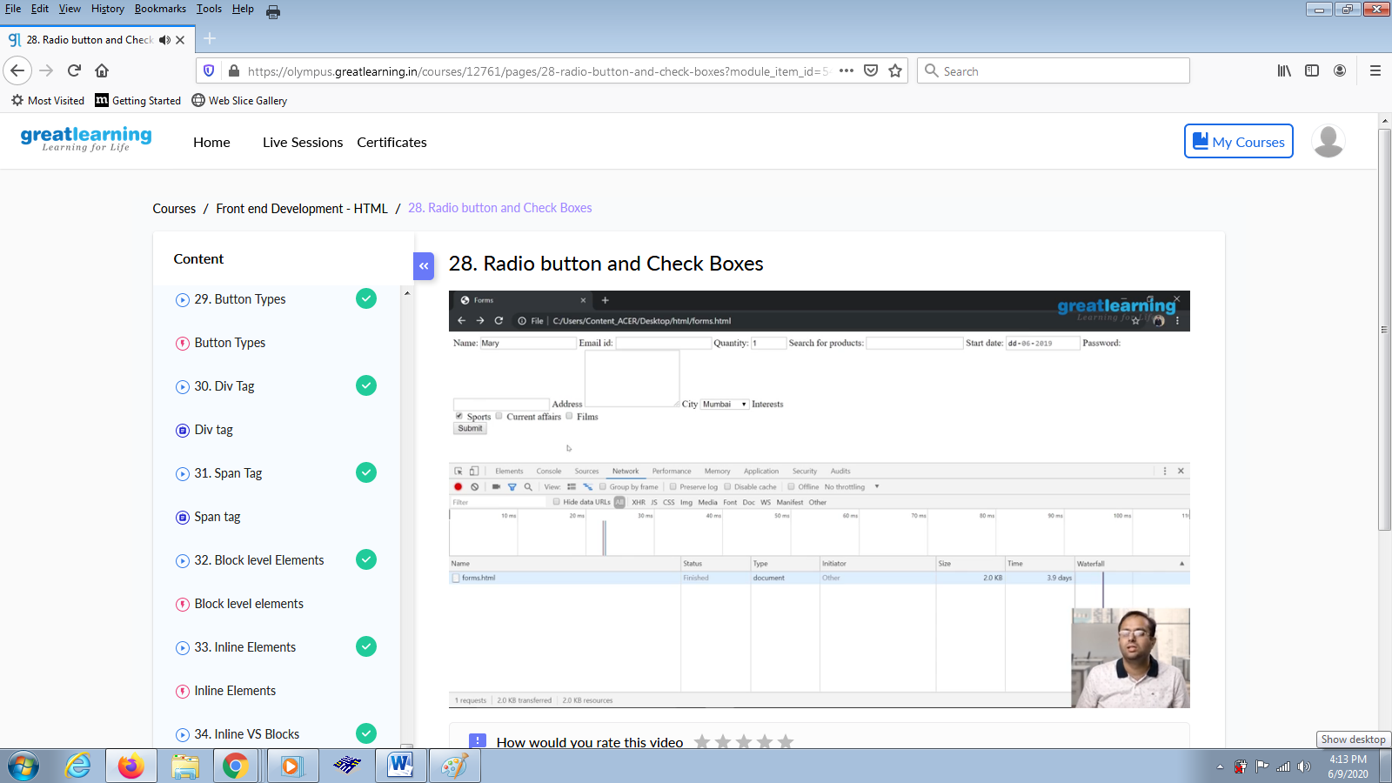

**Coding Challenges Details:**

**Problem Statements**

1.Write a C Program to rotate the matrix by K times.

**Snapshot**

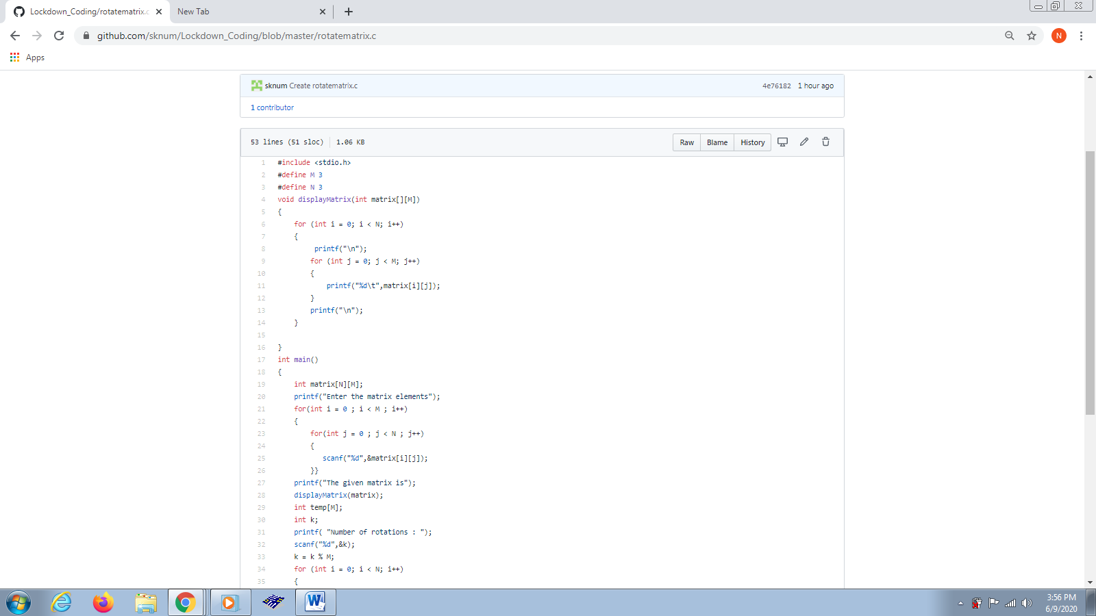

2.Write a Java Program to check whether the given matrix is magic matrix or not

**Snapshot**