**Milestone 1.** URL below with dbConn () … String dbAndPass="sallyk_3308?user=sallyk&pass …

Worth 2 points (of 10) for being able to install and run the sample code to insert a web user record into Sally's DB using URL tampering.

URL tamper: http://localhost:8080/3308-LA07a-insert/webAPIs/insertUserSimpleAPI.jsp?jsonData={ "webUserId": "", "userEmail": "userLA07a","userPassword": "p", "userPassword2": "p", "birthday": "", "membershipFee": "", "userRoleId": "1","userRoleType": "","image":"https://cis.temple.edu/sites/default/files/styles/portrait-small/public/user_pictures/picture-172-1437482759.jpg?itok=d4Ujy1ti","errorMsg": "Please try again"}

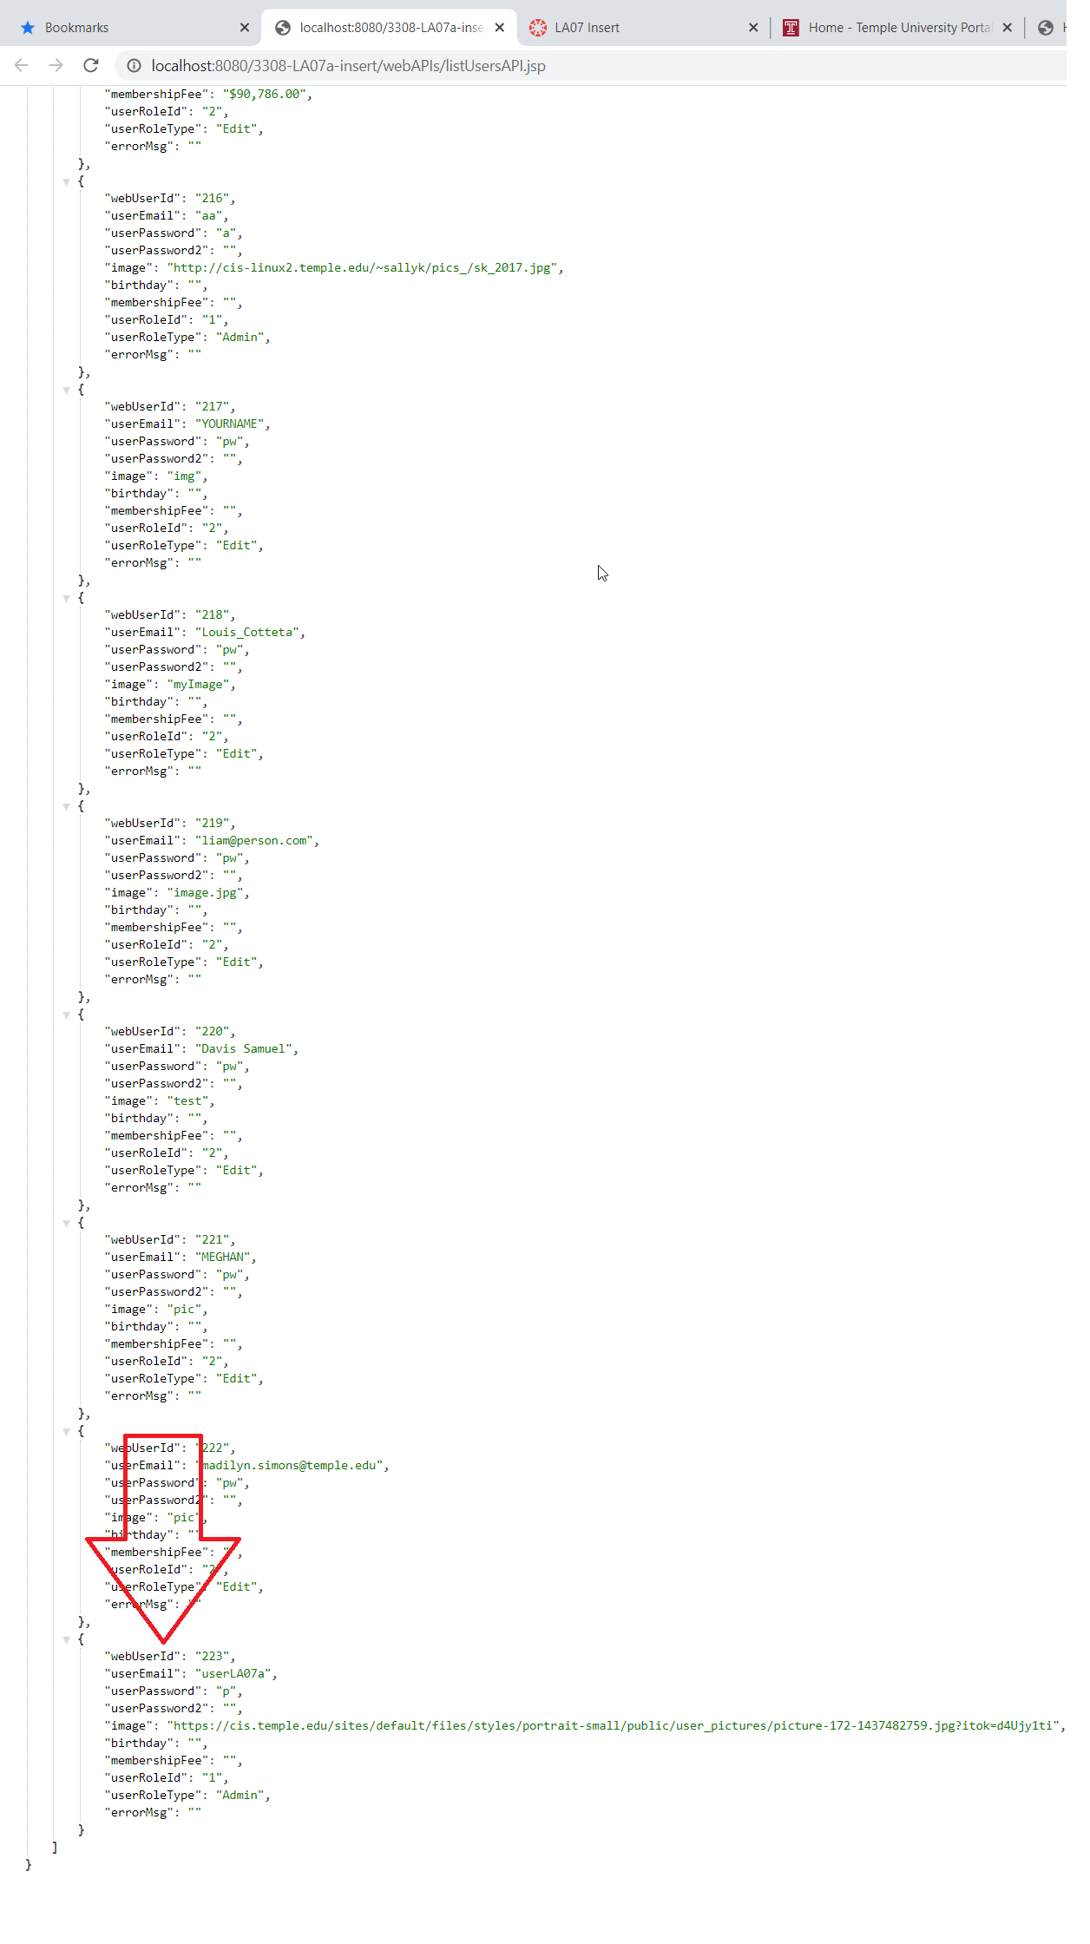

**Milestone 2.**  URL below with dbConn () … String dbAndPass="SP20_3308_tun49199?user=tun49199& …

Worth 2 more points (4/10 so far) for being able to insert a web_user record into your database by URL tampering the Insert Web API from the lab activity sample code.

URL tamper: http://localhost:8080/3308-LA07a-insert/webAPIs/insertUserSimpleAPI.jsp?jsonData={ "webUserId": "", "userEmail": "userLA07a","userPassword": "p", "userPassword2": "p", "birthday": "", "membershipFee": "", "userRoleId": "1000","userRoleType": "","image":"https://cis.temple.edu/sites/default/files/styles/portrait-small/public/user_pictures/picture-172-1437482759.jpg?itok=d4Ujy1ti","errorMsg": "Please try again"}

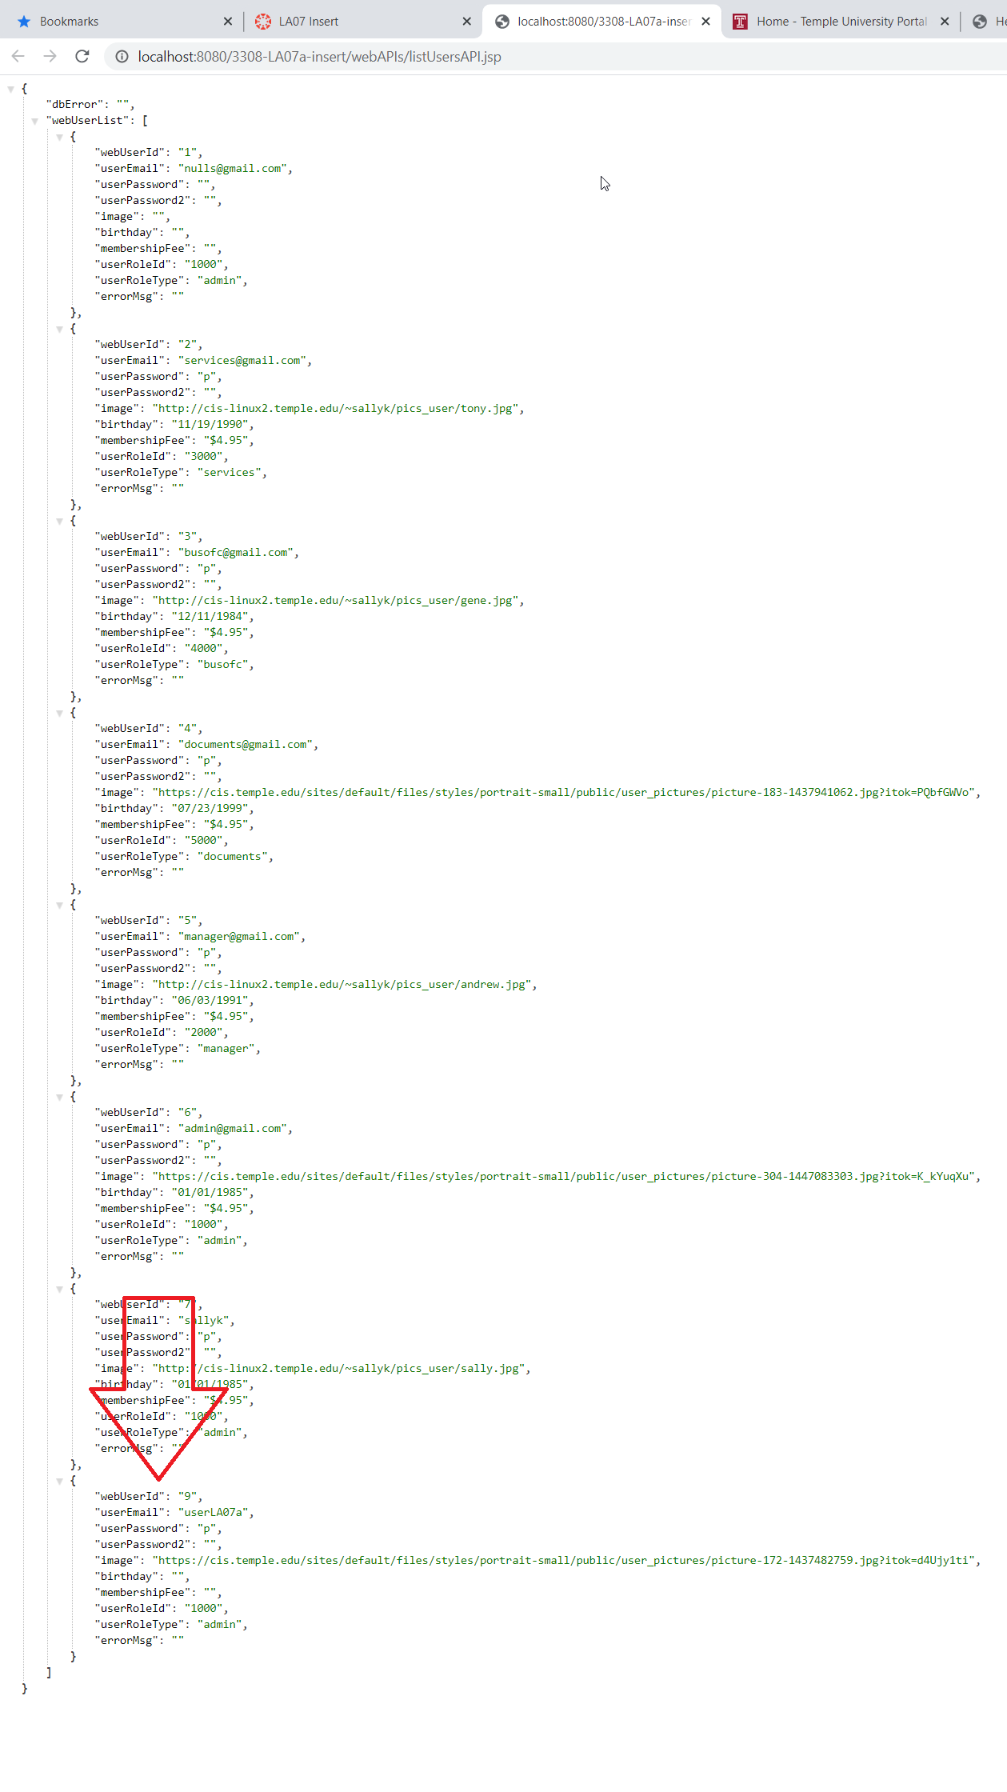

**Milestone 3.**

Worth 1 more point (5/10 so far) for being able to insert a web_user record into your database by running index.html.

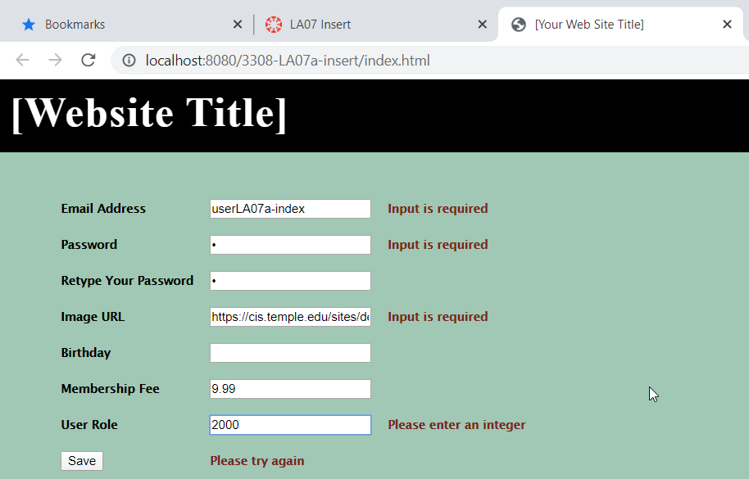

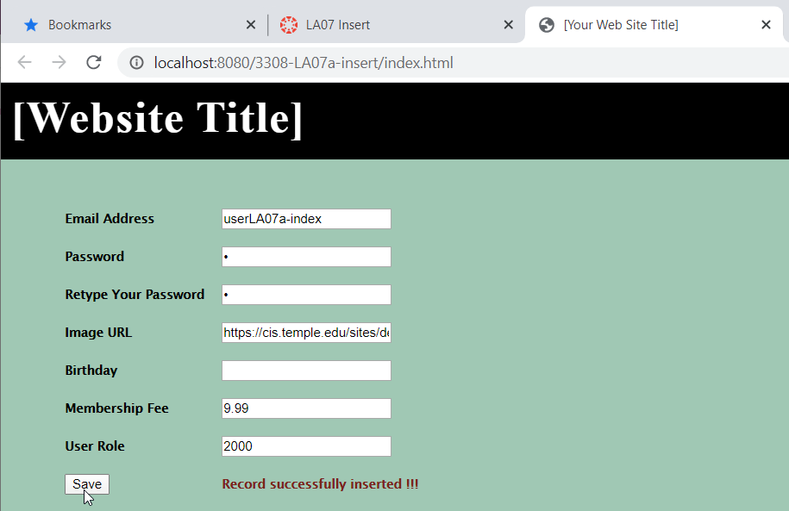

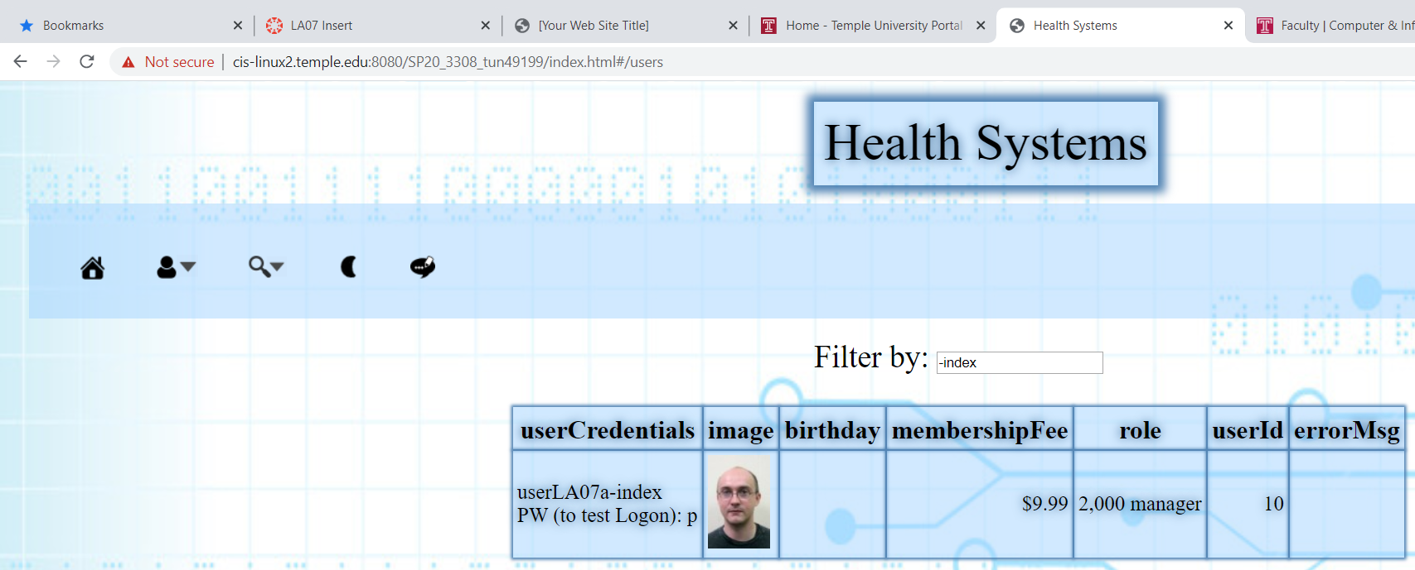

**Milestone 4.**

Worth 2 more points (7/10) for being able to insert a record with the character fields and foreign key into your 'other' table using a Web API you wrote.  
Worth 3 more points (10/10) for being able to insert a record with all fields into your 'other' table using a Web API you wrote.

URL tamper:

http://localhost:8080/3308-LA07a-insert/webAPIs/insertPatientVisitSimpleAPI.jsp?jsonData={"patientName":"LA07a, Sudhir","imageUrl":"https://cis.temple.edu/sites/default/files/styles/portrait-small/public/user_pictures/picture-306-1445703546.jpg?itok=RZ9qp8Ep","medRecNo":"TUN37331","description":"Vaccination","visitDateTime":"03/16/2020 2:35 PM","diagnosis":"Influenza virus vaccine","visitCharge":"52.50","webUserId":"10","errorMsg": ""}

GlassFish log: (accidentally reused unique data from previous milestone, fixed good 2nd time)

Info: insertData received and is {"patientName":"LA07a, Sudhir","imageUrl":"https://cis.temple.edu/sites/default/files/styles/portrait-small/public/user_pictures/picture-306-1445703546.jpg?itok=RZ9qp8Ep","medRecNo":"TUN20200316","description":"Vaccination","visitDateTime":"03/16/2020 2:35 PM","diagnosis":"Influenza virus vaccine","visitCharge":"52.50","webUserId":"10","errorMsg": ""}

Info: DB connection OK to proceed

Info: ====> PrepStatement: Exception in executeUpdate(). Sql is INSERT INTO PatientVisit (PatientName, ImageUrl, MedRecNo, Description, VisitDateTime, Diagnosis, VisitCharge, web_user_id_fk) values (?,?,?,?,?,?,?,?). Error Msg: Duplicate entry 'TUN20200316' for key 'MedRecNo_uidx'

Info: insertData received and is {"patientName":"LA07a, Sudhir","imageUrl":"https://cis.temple.edu/sites/default/files/styles/portrait-small/public/user_pictures/picture-306-1445703546.jpg?itok=RZ9qp8Ep","medRecNo":"TUN37331","description":"Vaccination","visitDateTime":"03/16/2020 2:35 PM","diagnosis":"Influenza virus vaccine","visitCharge":"52.50","webUserId":"10","errorMsg": ""}

Info: DB connection OK to proceed

Info: *** Ready to call allUsersAPI

No errors returned from API: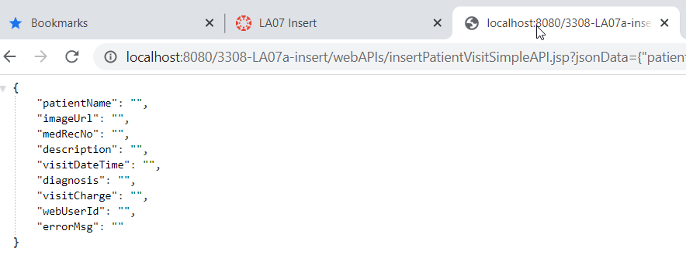

Dbase query shows inserted data: 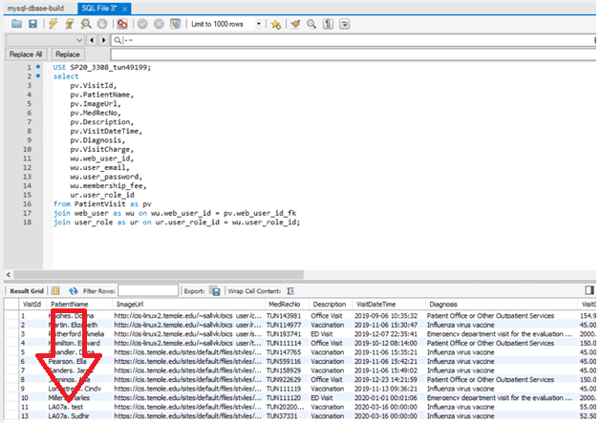

Webpage also shows inserted data:

