Name: James Skomsky

NetAccess User Name: TUN49199

Web Site Title: Health Systems

Home Page Mission Statement: Health Systems simplifies health care and focuses on financial accountability. Health Services and the resulting charges can be overwhelming. The Health Systems workflow provided by our Business Office eases the complicated payments and adjustments process following a health care episode. Our Document Management system provides access and standardization of patient records. Email [tun49199@temple.edu](mailto:tun49199@temple.edu) to find out more.

# Paste a screen capture of the following table designs:

1 of 3: table design of user_role (right click the table, select “alter table”, click on the “columns” tab).

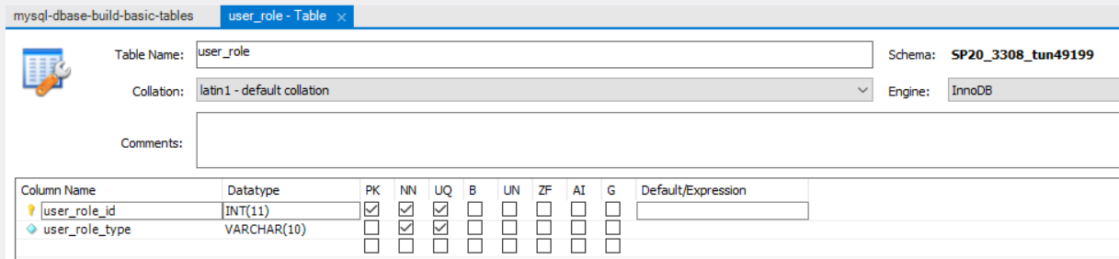

2 of 3: table design of web_user plus the “foreign keys” tab (with foreign key from web_user to user_role).

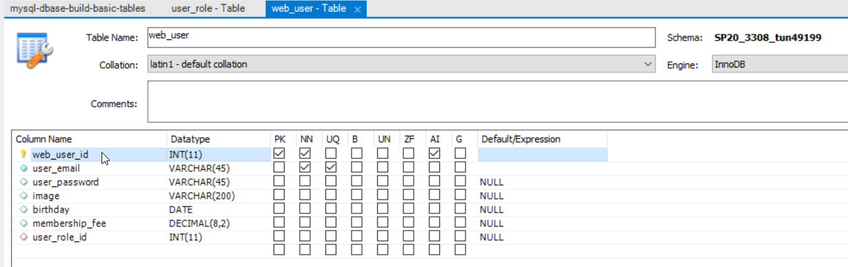

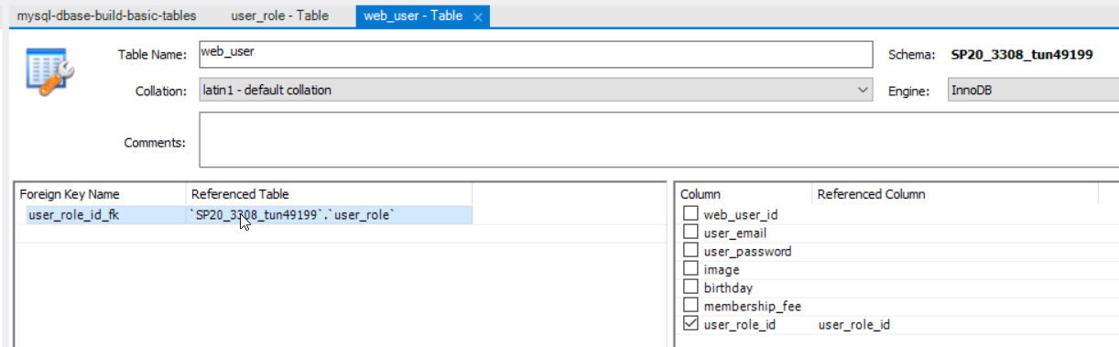

3 of 3: table design of “other” table plus “foreign keys” (with foreign key from other table to web_user).

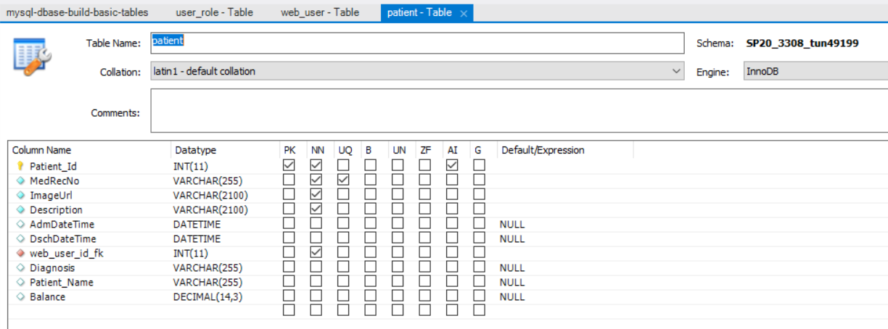

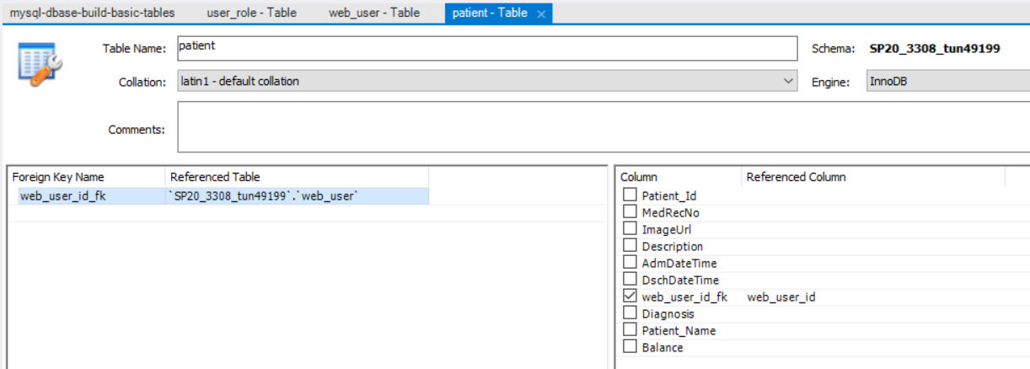

# Run SQL Select Statements:

a. Run a SELECT statement that lists all the columns of all the records of your “other” table, selecting out each column and presenting them in an order that you think users would like to view the data (don't use SELECT * ). Sort the data by whichever column you decided to show first. 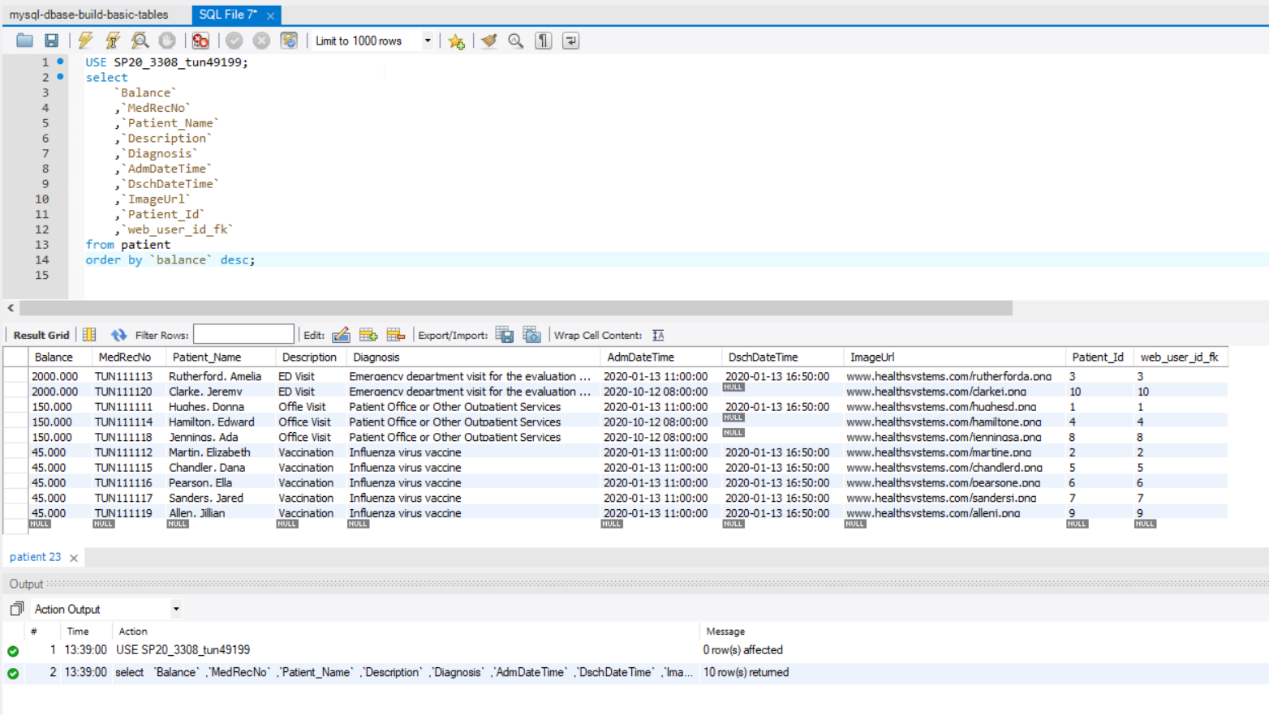

b. The SELECT statement above but adding a WHERE clause so that you see some of the records but not all. 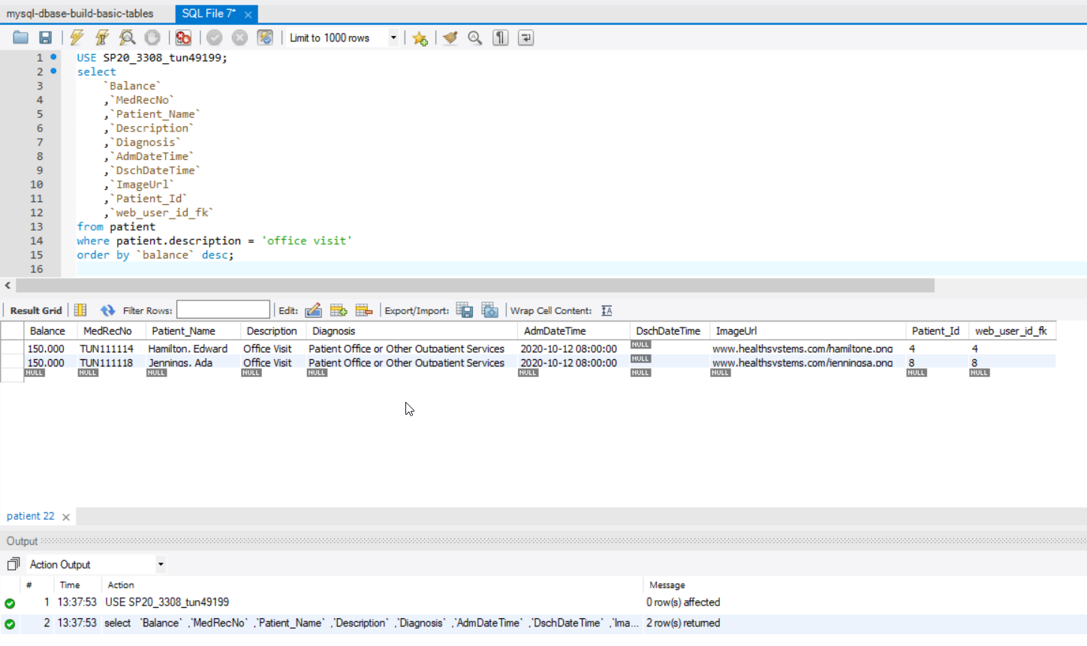

c. A SELECT statement that shows all the records from the web_user table joined with the user_role table. Show the role name first, then email address then all the other columns (from both tables) in an order you think users would like to see the data – except don’t list the role id twice. Order the records of the result set by the first columns (primary sort role name, secondary sort email address). Note: There should be as many rows in your result set as you have records in your user table. If you have a lot more (and see duplication), you have forgotten the WHERE clause that joins the two tables together.

