3308 React Activity: Display Data
Your Name: James Skomsky
Expected Grade: 20/20

Worth 6 points (6/10 so far) for being able to write and invoke a couple of simple React components. Add the following screen captures to your screen capture document:
- how your index page looks after clicking the "User List" menu option
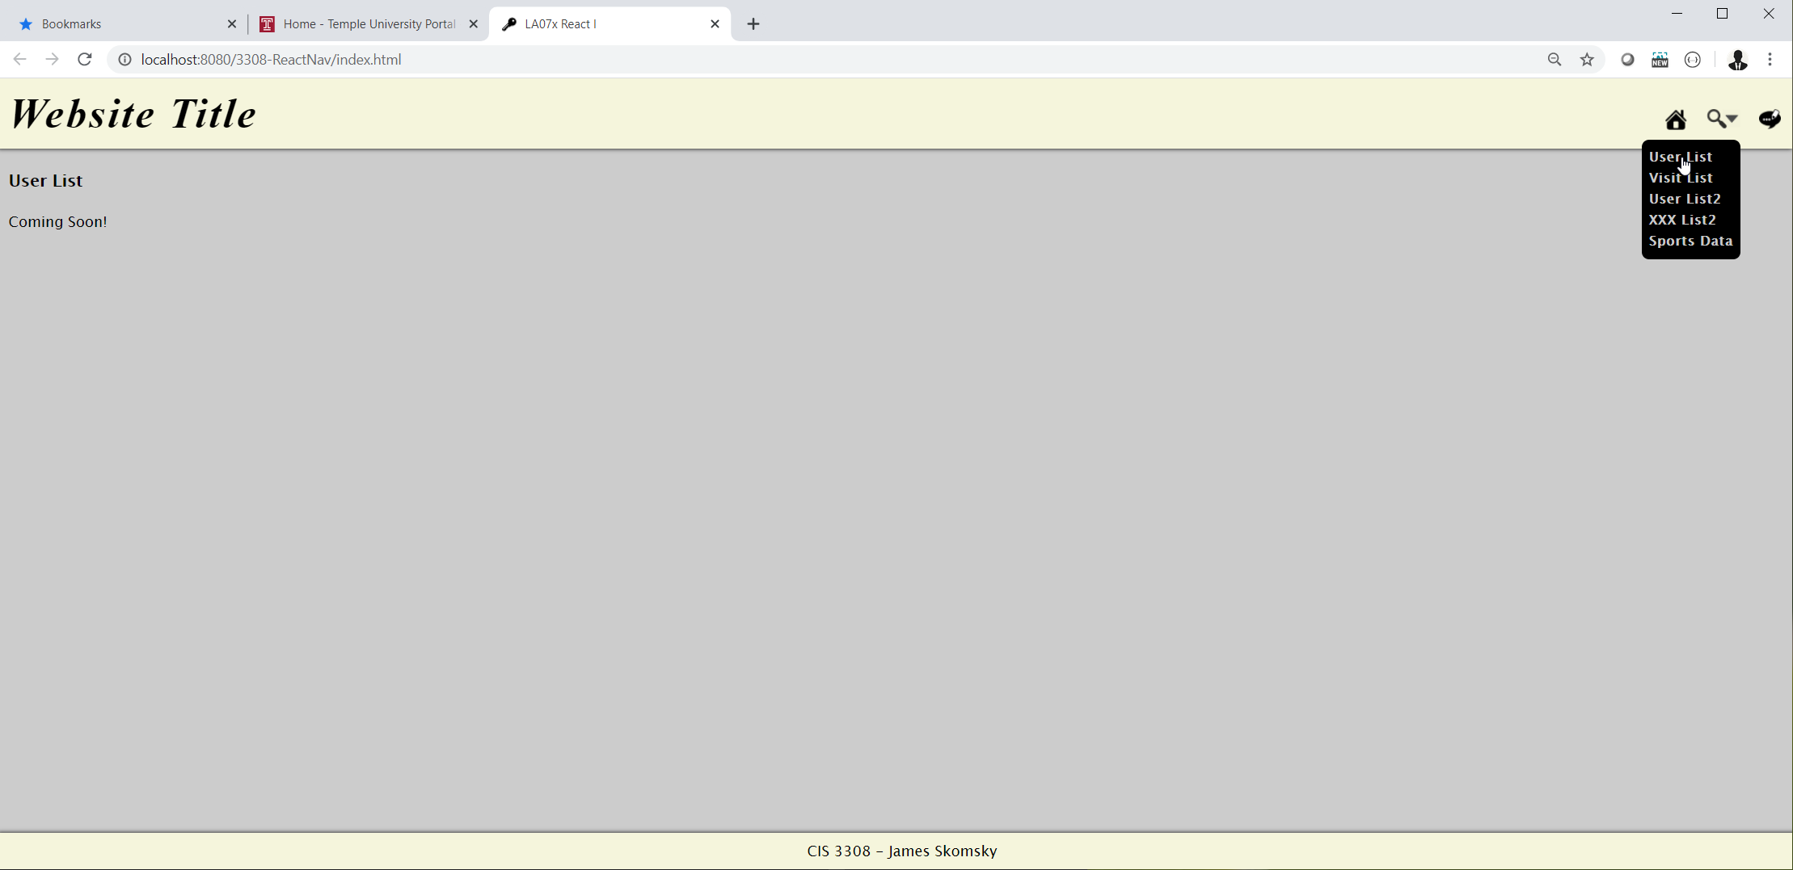
- how your index page looks after clicking the "Xxx List" menu option (change Xxx to whatever you called your "other" DB table).
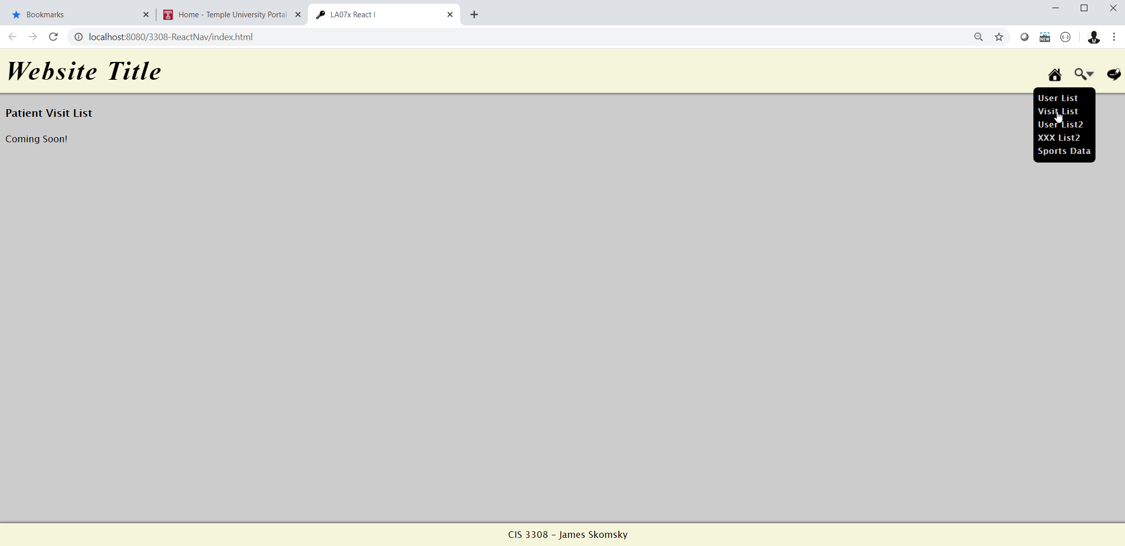
- the NetBeans code for your "User/Patient Visit list coming soon" React Component.
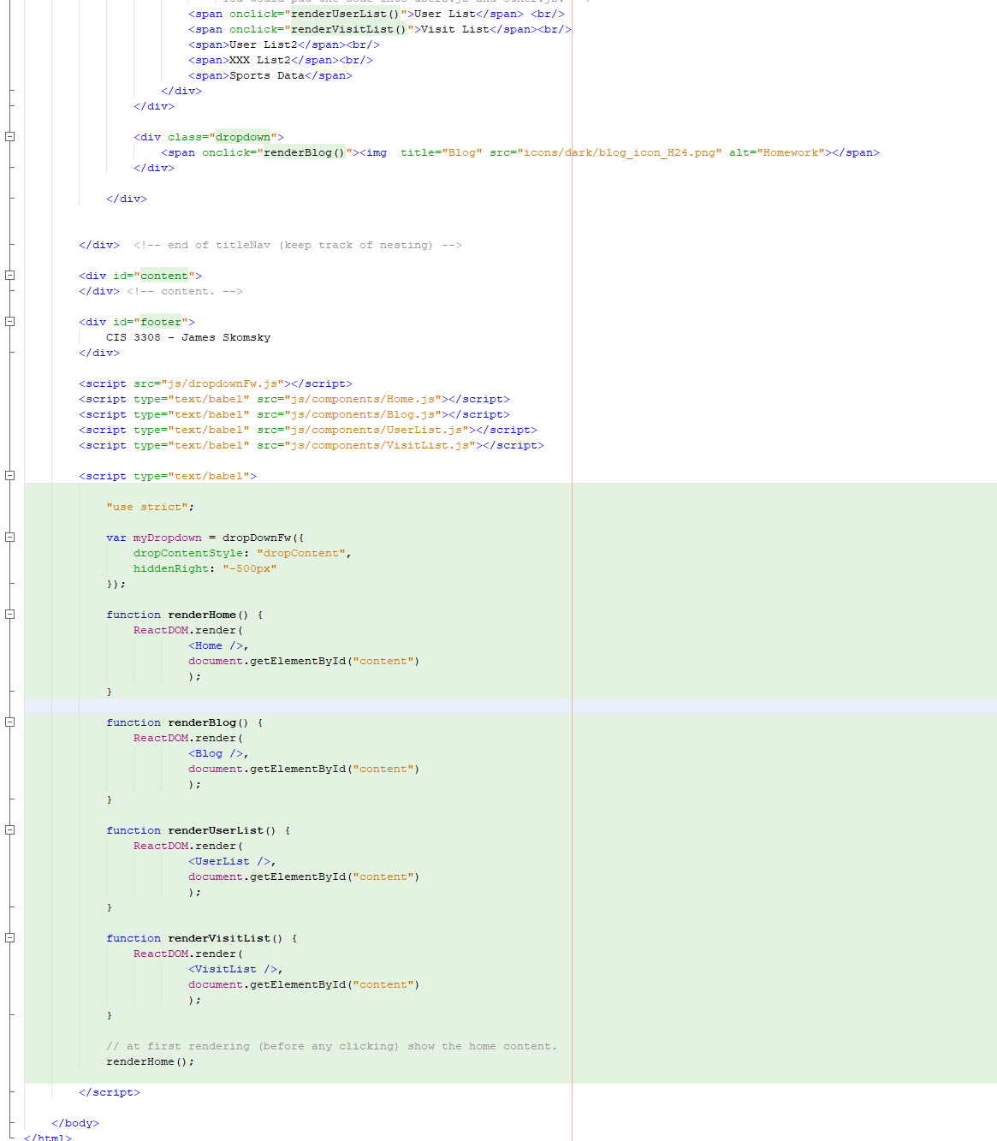

Worth 8 more points (14/20 so far) for writing a single component that can output a different message depending on the property passed into it (component defined using "fat arrow" notation and destructuring of the input parameter). Add the following screen captures to your screen capture document:
- how your index page looks after clicking the "User List2" menu option
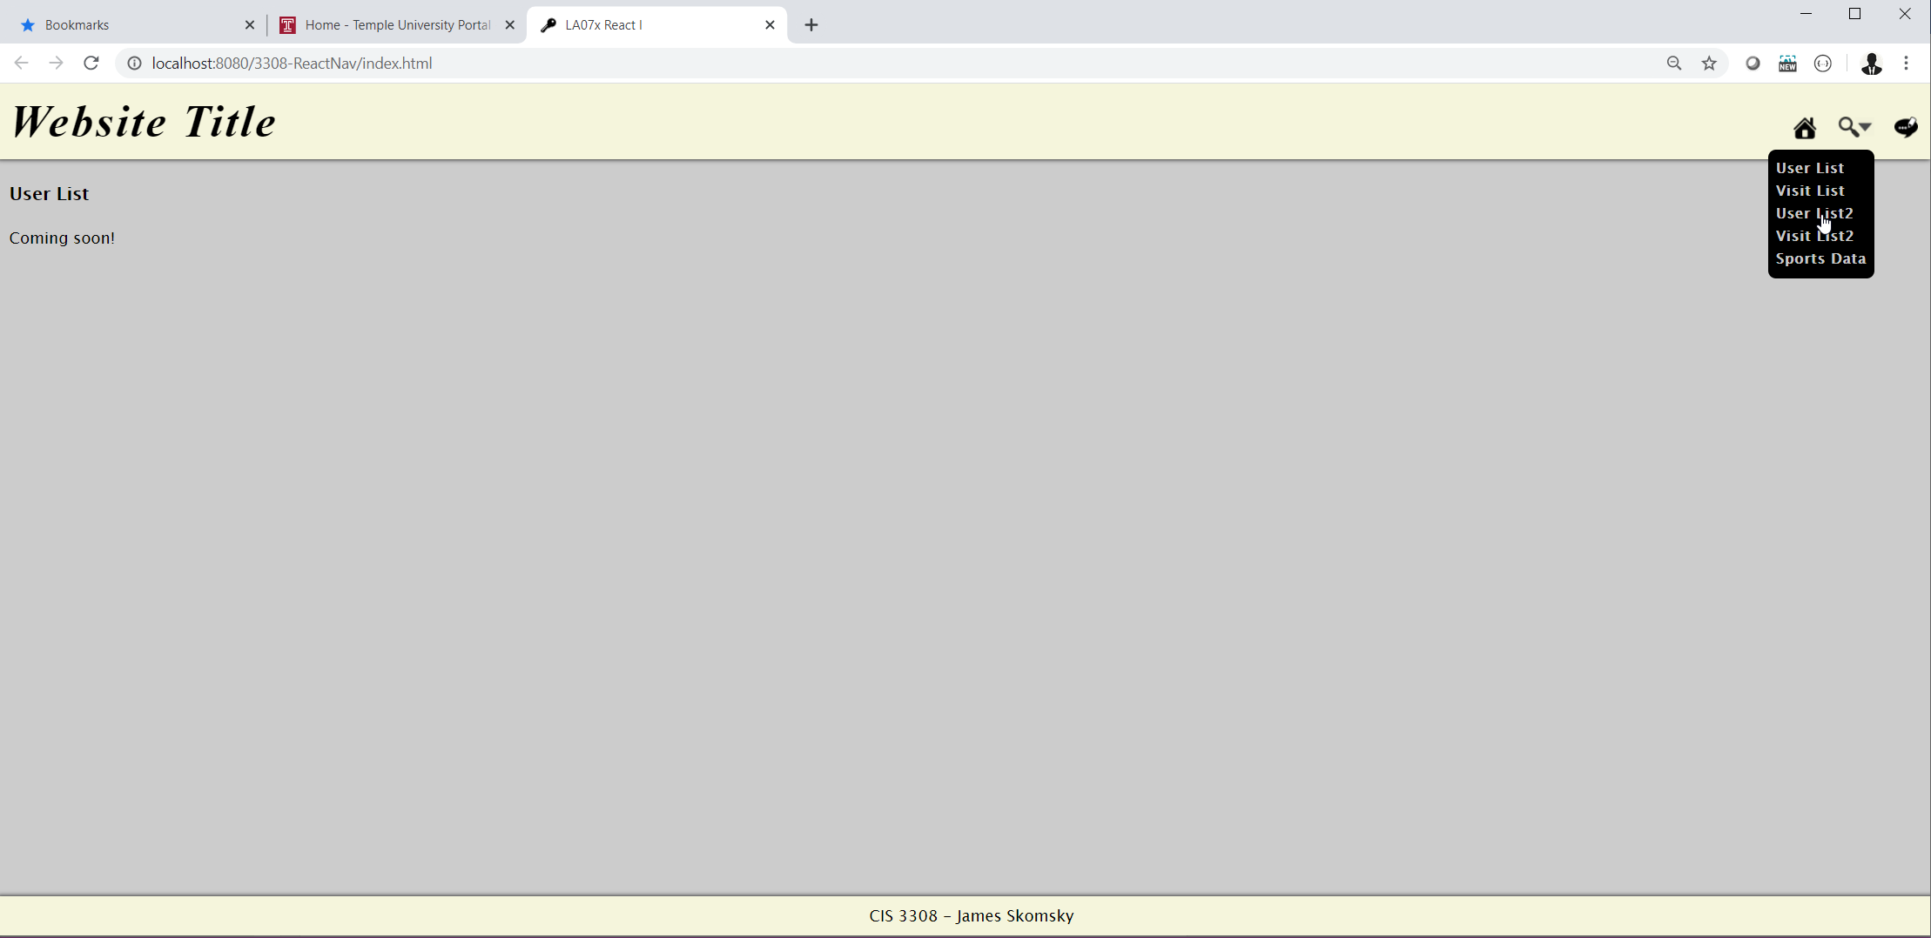
- how your index page looks after clicking the "Xxx List2" menu option (where Xxx is whatever you called your "other" DB table).
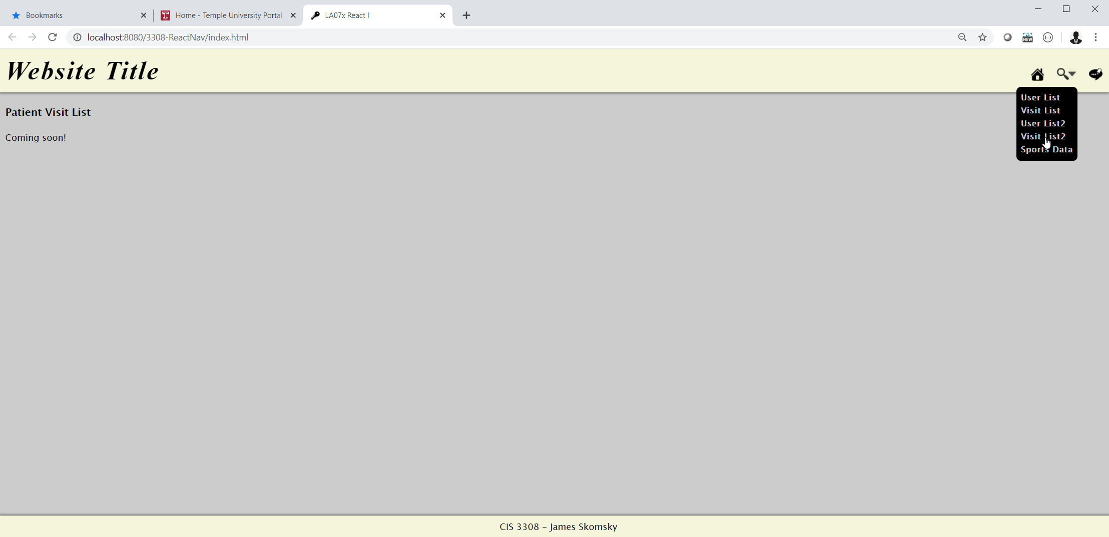

- the NetBeans code for your "general purpose coming soon" React Component.
1 of 3:
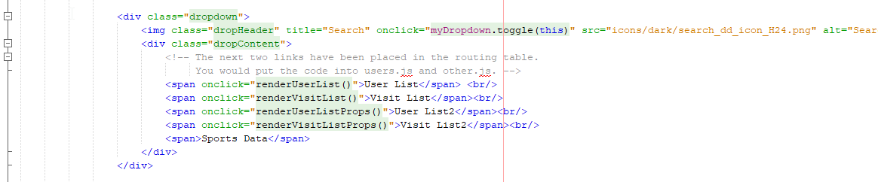
2 of 3:
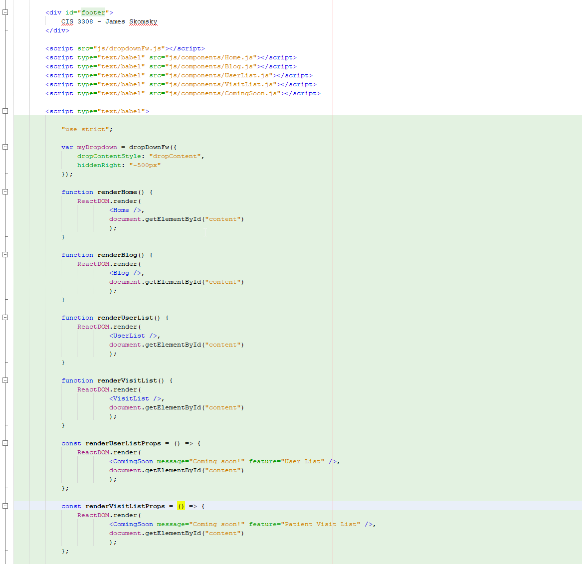
3 of 3:
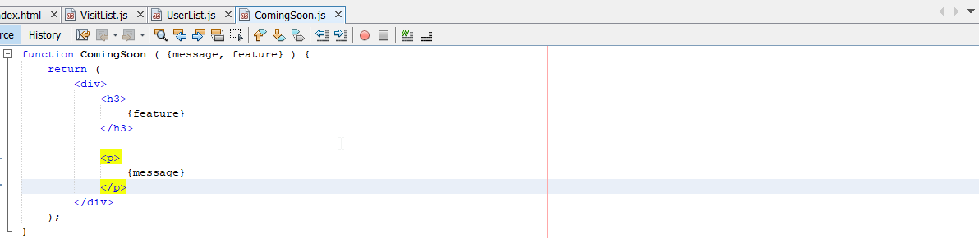

Worth 3 more points (17/20 so far) for being able to write write a React Component that outputs an HTML table from an array of objects (using the map function). Add the following screen captures to your screen capture document:
- how 05d_conditional_rendering.html (in ReactNav) looks when you render it (showing a nicely formatted HTML table full of sports products).
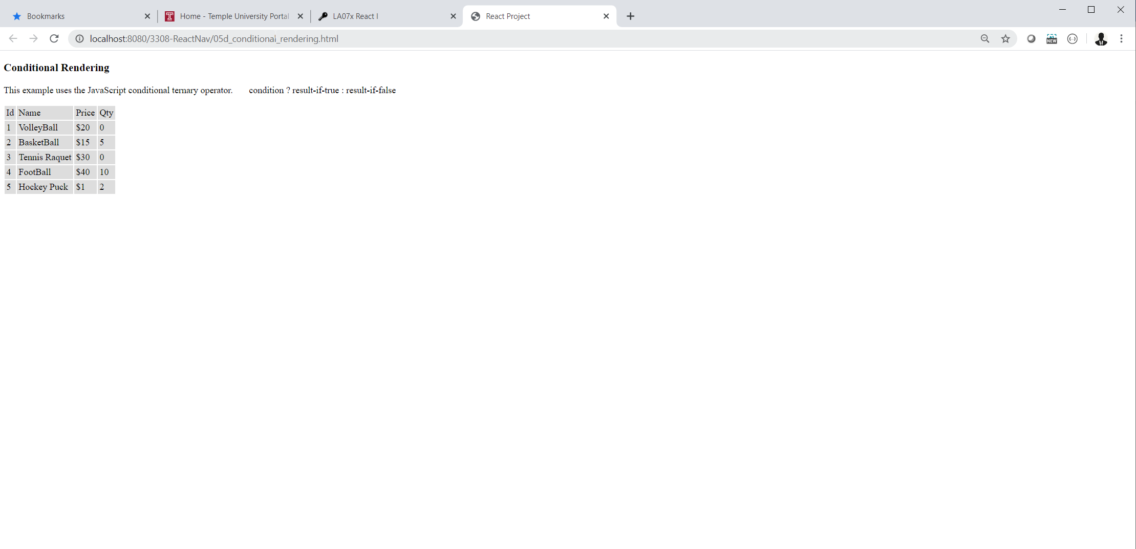
- the React Component (in NetBeans) that output the HTML table.
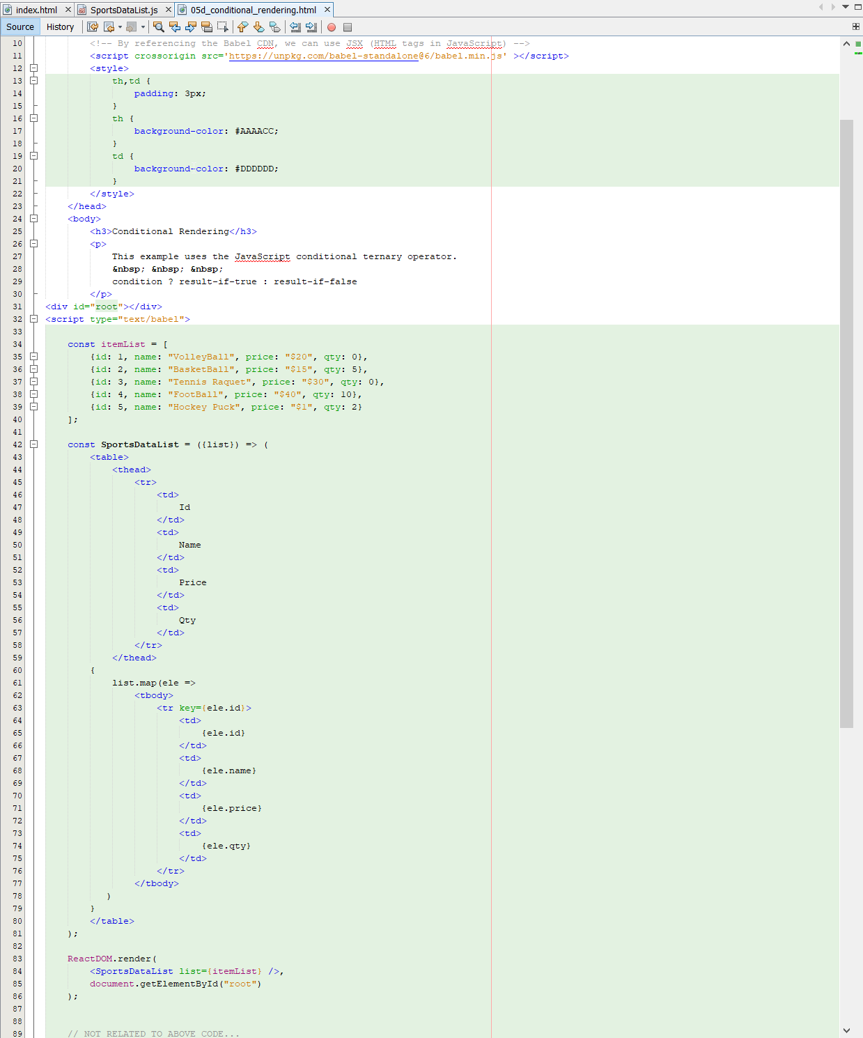

Worth 3 more points (20/20) for incorporating the HTML table component into index.html of project ReactNav. Add the following screen capture to your screen capture document:
- how (ReactNav) index looks after you click the last link under the search icon.
- 