* **Created a sample input file in linux VM, using gedit editor.**

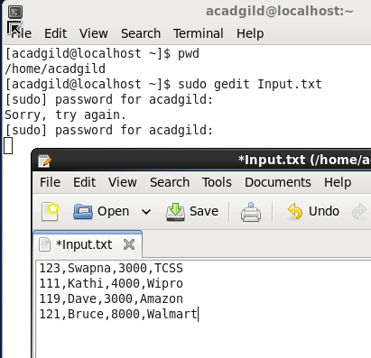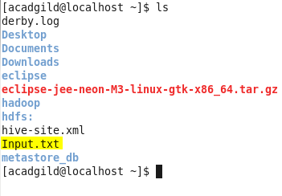

* **Created the directory inside the HDFS**



* **Copied the file inside the HDFS directory from local**



* **Files present inside the HDFS**

